Date: 18-April-2024

GOOGLE MLKIT TEXT RECOGNITION

version: 1.0.0

OVERVIEW
The MLKit Text recognition component can recognize text from the camera and images. Under the hood, the component contains NFIs that use the Google MLKit Text Recognition API.

Use case:
- An event organizer app, where a user needs to read the text from the image through the Camera.
- A text translator app that scans the text from the boards and translate into required language.
B . Percentage of re-use:
Approximate 90 % of reuse.

C. Features

- The component utilizes Google MLKit Text Recognition SDK for Recognizing the text.
- It supports the following languages: https://developers.google.com/ml-kit/vision/text-recognition/languages

2. GETTING STARTED

A. Prerequisites
Before you start using the Google MLKit Text Recognition component, ensure the following
• Volt MX Iris

Platforms Supported

Mobile

iOS

Android

Importing the component

You can import the Forge components only into the apps that are of the Reference Architecture type.

To import the Google MLKit Text Recognition component, do the following:

Open your app project in Volt MX Iris.
2. In the Project Explorer, click the Templates tab.
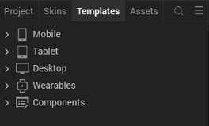
3. Right-click Components, and then select Import Component. The Import Component dialog box appears.
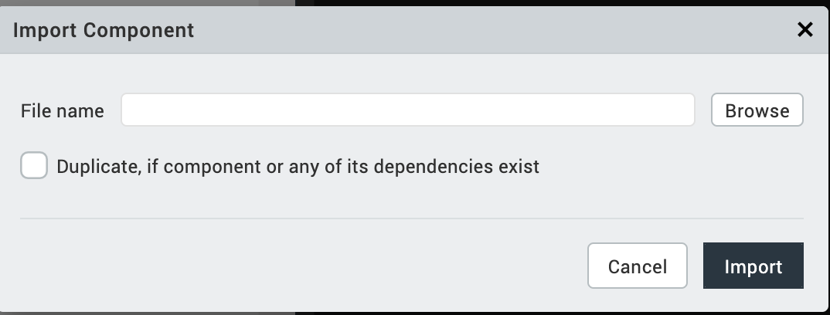
4. Click Browse to navigate to the location of the component, select the component, and then click Import. The component and its associated widgets and modules are added to your project.

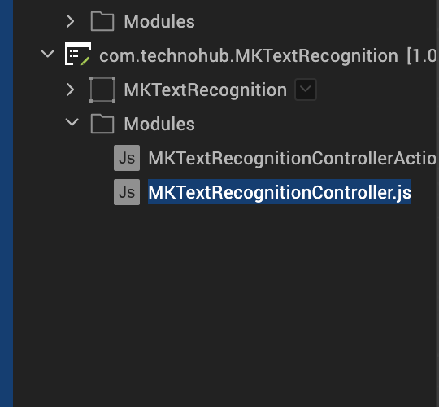

Once you have imported a component to your project, you can easily add the component to a form. For more information, refer Add a Component to a Form

D. Building and previewing the app
After performing all the above steps, you can build your app and run it on your device. For more information, you can refer to the Building and Viewing an Application section of the Volt MX User Guide.
You can then run your app to see the Text Recognition work in real time.

3. REFERENCES

Dynamic Usage
You can also add Google MLKit Text recognition component dynamically. To do so,
1. In the Project Explorer, on the Projects tab, click Controllers section to access the respective Form Controller. Create a method and implement the code snippet similar to the sample code mentioned below.

/* Creating Google MLKit Text Recognition component instance */

var MKTextRecognition = new com.technohub.MKTextRecognition({
"height": "50%",
"id": "MKTextRecognitio",
"isVisible": true,
"left": "0dp",
"masterType": constants.MASTER_TYPE_USERWIDGET,
"isModalContainer": false,
"skin": "slFbox",
"top": "0dp",
"width": "100%",
"zIndex": 1,
"overrides": {
" MKTextRecognition ": {
"right": "viz.val_cleared",
"bottom": "viz.val_cleared",
"minWidth": "viz.val_cleared",
"minHeight": "viz.val_cleared",
"maxWidth": "viz.val_cleared",
"maxHeight": "viz.val_cleared",
"centerX": "viz.val_cleared",
"centerY": "viz.val_cleared"
}
}
}, {
"overrides": {}
}, {
"overrides": {}
});

/*Adding the Google MLKit Text Recognition component to a Form*/

this.view.add(MKTextRecognition);

},
In the code snippet, you can edit the properties of the component as per your requirement. For more information, see Setting Properties.
2. Save the file

Configuring Native Settings (iOS)
To configure the native settings for iOS, follow these steps:
- From the Project explorer, go to Assets and expand Media.
- Right-click Common, and then select Resource Location. Volt MX Iris opens the common resources folder in a file explorer.
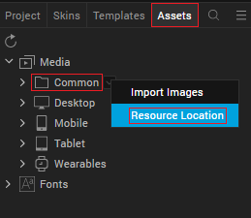
- Open the infoplist_configuration.json file with a text or code editor.
- At the end of the file, type the following code. You can change the description based on your preference.
"NSCameraUsageDescription" : "Your Description"

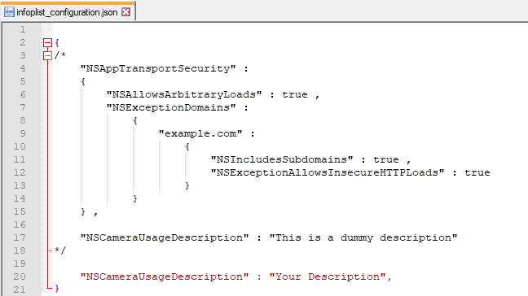

5. Save the file.

Configuring Deployment Target
- From the left navigation menu, click Project Settings.
- In the Project Settings window, go to Native → iPhone/iPad.
- Under Target Versions, from the iOS Version list, select 11.0 or higher.
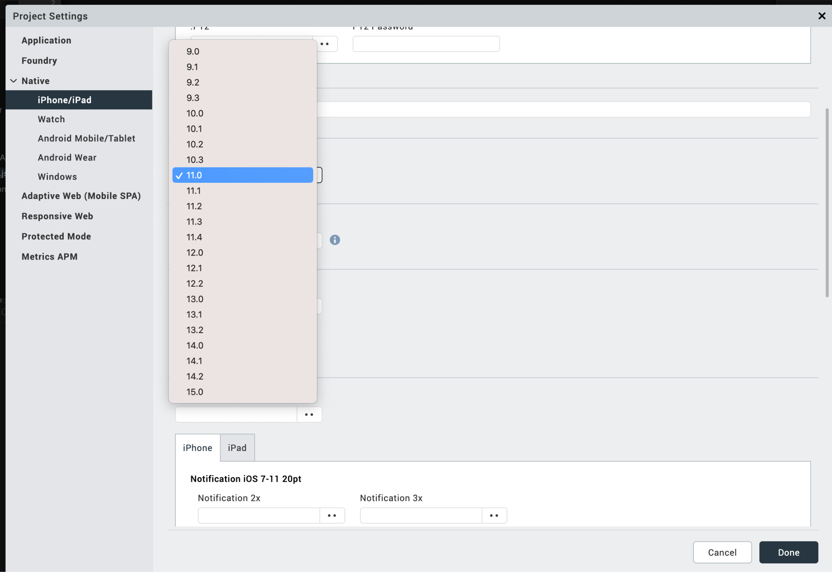

After you configure the native settings, you can Build and Run your app to see the Google MLKit Text Recognition component work in real time for iOS.

Configuring Native Settings (Android)

To configure the native settings for Android, follow these steps:
1. From the left navigation menu, click Project Settings.
2. In the Project Settings window, go to Native → Android Mobile/Tablet.
3. Set the CAMERA permission to true.
To set a permission to true, select the permission from the left panel, and then click Add >.
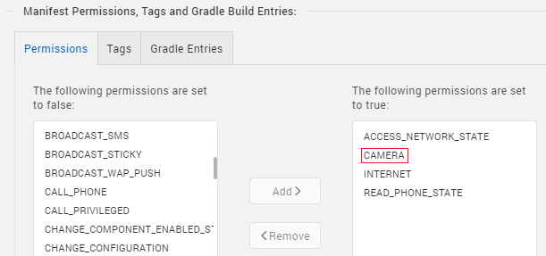
4. Switch to the Gradle Entries tab.
5. In the build.gradle entries to Suffix box, type the given code based on the version of the component.
dependencies {

// CameraX
implementation "androidx.camera:camera-camera2:1.0.0-beta11"
implementation "androidx.camera:camera-lifecycle:1.0.0-beta11"
implementation "androidx.camera:camera-view:1.0.0-alpha18"

// MLKit Text recognitions

implementation 'com.google.android.gms:play-services-mlkit-text-recognition:18.0.0'
implementation 'org.jetbrains:annotations:15.0'

}
// used for 32 bit support
android { defaultConfig { renderscriptSupportModeEnabled false}}
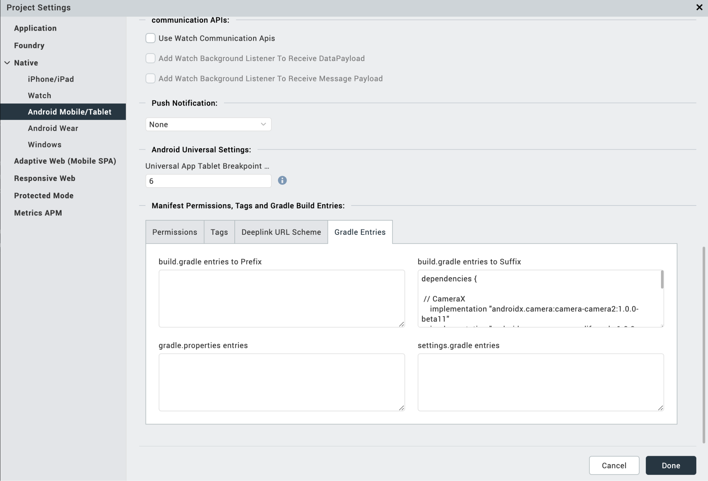
NOTE :
- If you do not add the Gradle entries to your project, the app crashes.
- You can update the Play Services version in the later builds of your app.

After you configure the native settings, you can Build and Run your app to see the Barcode/QR Code Scanner component work in real time.

API’s

i. startScaning

Description: | Starts the scanning.
Syntax: | startScaning ()
Parameters: | None
Return Value: | None
Remarks: | Call this API first time to start the Camera Session.
Example: | this.view.MKTextRecognition.startScaning ();

ii. stopScaning

Description: | Stops the scanning.
Syntax: | stopScaning ()
Parameters: | None
Return Value: | None
Remarks: | Call this API after successful scan to avoid the continues scan.  And call this API when app moves to background.
Example: | this.view.MKTextRecognition.stopScaning ();

iii. resultFromImageURL

Description: Recognise the text from the URL contains image. | Turns on/off the device Flash light.
Syntax: resultFromImageURL() | enableFlash ()
Parameters: String, Result callback | None
Return Value: None | None
Example: this.view. MKTextRecognition. resultFromImageURL (“URL”); | this.view.MLKitBCScanner.enableFlash(true/false);

iv. resultFromImage

Description: | Recognise the text from the native image.
Syntax: | resultFromImage ()
Parameters: | UIImage/Image, Result callback
Return Value: | None
Remarks: | Call this API to recognize the text from the native UIImage/Image object
Example: | this.view.MKTextRecognition.resultFromImage ();

v. resultFromBase64

Description: | Recognise the text from the base 64 string.
Syntax: | resultFromBase64 ()
Parameters: | String, Result Callback
Return Value: | None
Remarks: | Call this API to recognize the text from the native UIImage/Image object
Example: | this.view.MKTextRecognition.resultFromBase64();

C. Events

i. setScanResultCallback

Description: | Invoked after the component recognises the text. This setScanResultCallback should be invoked in onNavigate function.
Syntax: | setScanResultCallback
Parameters: | Callback, And in callback, data[JSON] : The data that is recognised
Remarks: | If you want the camera to recognise text continuously, do not call the stopSession() in setScanResultCallback.
Example: | onNavigate: function(){  this.view.MLKitBCScanner. setScanResultCallback(callback);  },

ii. addInitCompleteCallback

Description: | Invoked after the component completes the initialization.
Syntax: | addInitCompleteCallback
Parameters: | function(): a call back function
Remarks: | startSession() invocation must be in this callback only.
Example: | this.view.MLKitBCScanner. addInitCompleteCallback(callback);

- REVISION HISTORY

App version 1.0.0:

A. Limitations

1. Do not have support for Landscape mode.
2. This component supports only 64 bit devices.

B. Known Issue

NA

