News and Weather

Asset Version: 2.0.1

The News and Weather omni channel app enables a user to browse through news headlines with different categories such as ‘Top Stories’, ‘World’, ‘Science’, ‘Technology’, and ‘Sports’, etc. The news items in the app are powered by "NewsAPI.org". Apart from that, the app lets the user glance through local weather conditions. Also, it comes with an in-built learning module, Knowledge Framework, with overview and tutorials for Integration and Orchestration services.

Requirements:

- Volt MX Iris
- Volt MX Foundry
Devices:
  - Mobile
  - Tablet
  - Desktop

Platforms:
  - Android
  - IOS

Latest Updates:
- Available in Mobile, Desktop, and tablet channels
- Responsive web output for desktop app
- Desktop web UI generated using sketch plugin

Features
- Easy Setup: Import the app and run, you should be ready to launch the app after updating your personal api keys for the weather and news backends.
To obtain API keys, sign up for a free license at:
https://newsapi.org and https://openweathermap.org and update the keys in the Foundry App. Alternatively, you can change the APIs to point at your preferred backend as well.
- Explore News items and get to know about weather conditions
- Comes integrated with Knowledge Framework which showcases the ‘What’s and ‘How’s of the app features
- Learn about Integration and Orchestration Service capabilities of Volt MX Foundry

Overview :
The News and Weather app allows users to browse through news headlines for different categories such as Top Stories, General, Business, Technology, Entertainment, and so on. Furthermore, the app lets users glance through the news and weather conditions. The app makes use of Integration and Orchestration services of Volt MX Foundry to fetch data from third-party APIs, and then populates the data to the front end of the app.
For information on how to import the News and Weather app to Volt MX Iris and run the app, visit the Getting Started page.

App Functionality :
The News and Weather app is an omni-channel application. This section explains the functionality of the News and Weather app in Mobile, Tablet, and Desktop Web platforms.

Mobile Application :
In the mobile channel, the landing page of the News and Weather app is the News and Weather screen.

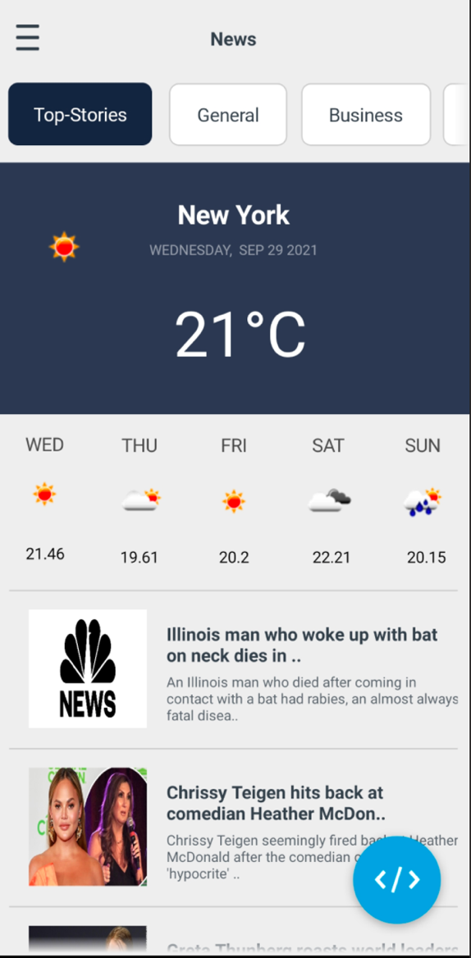
The News and Weather screen displays news headlines as well as a category bar that showcases various categories of news, such as Top Stories, General, Business, Technology, Entertainment, and so on. You can select any news category tab to read the news headlines associated with it. By default, the News and Weather screen displays the Top Stories category.
The Top Stories category illustrates the important news headlines and also provides information on the weather, based on your location. You can click on any news headline that is displayed on the screen to open the news article associated with it. The weather details constitute information such as the current temperature and the predicted temperature for the next few days.

The News and Weather screen also contains a hamburger menu. The hamburger menu contains details about Volt MX Resources and Volt MX Iris Documentation. To open the hamburger menu, click on the hamburger menu icon at the upper-left corner of the screen.

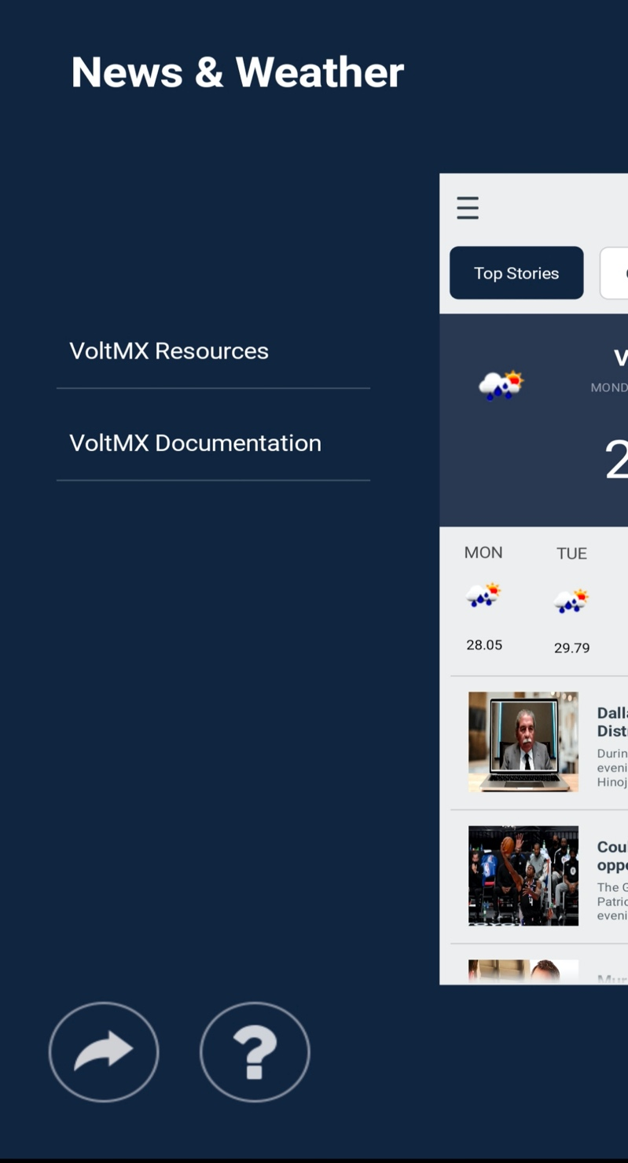

Tablet Application :
In the Android Tablet channel, the landing page of the News and Weather app is the News and Weather screen.

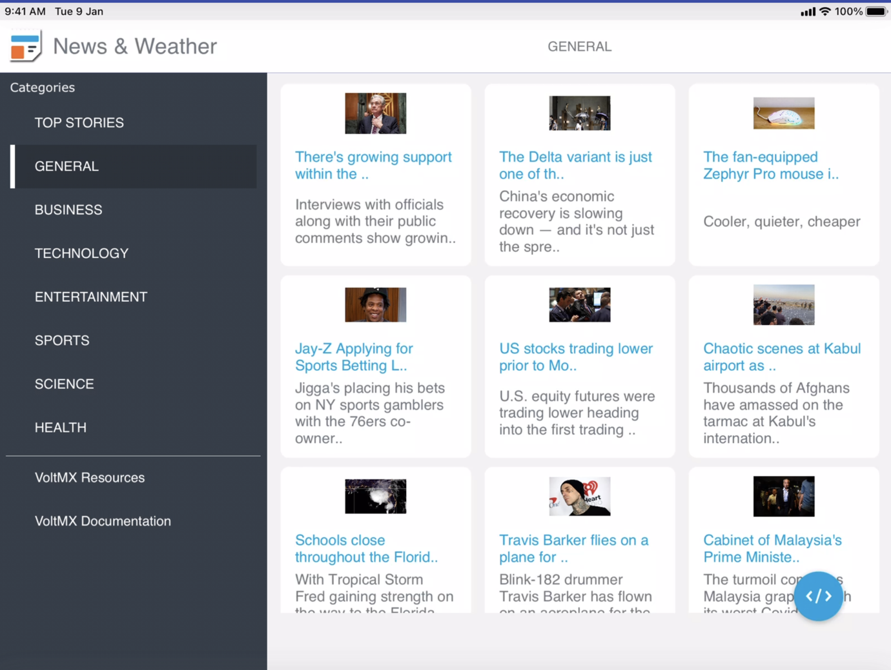

The News and Weather screen showcases all the headlines along with a list of news categories. By default, the News and Weather screen showcases the Top Stories category. The Top Stories category illustrates important news headlines and also displays information on the weather, based on your location. The weather details comprise of information such as the current temperature and the predicted temperature for the next few days.
The news headlines are arranged in a card format. You can select any news item (card) to open the news article associated with it. When you click any news item, the app opens a window that showcases the news article. If you want to view the news article in your browser, click Open in Browser.

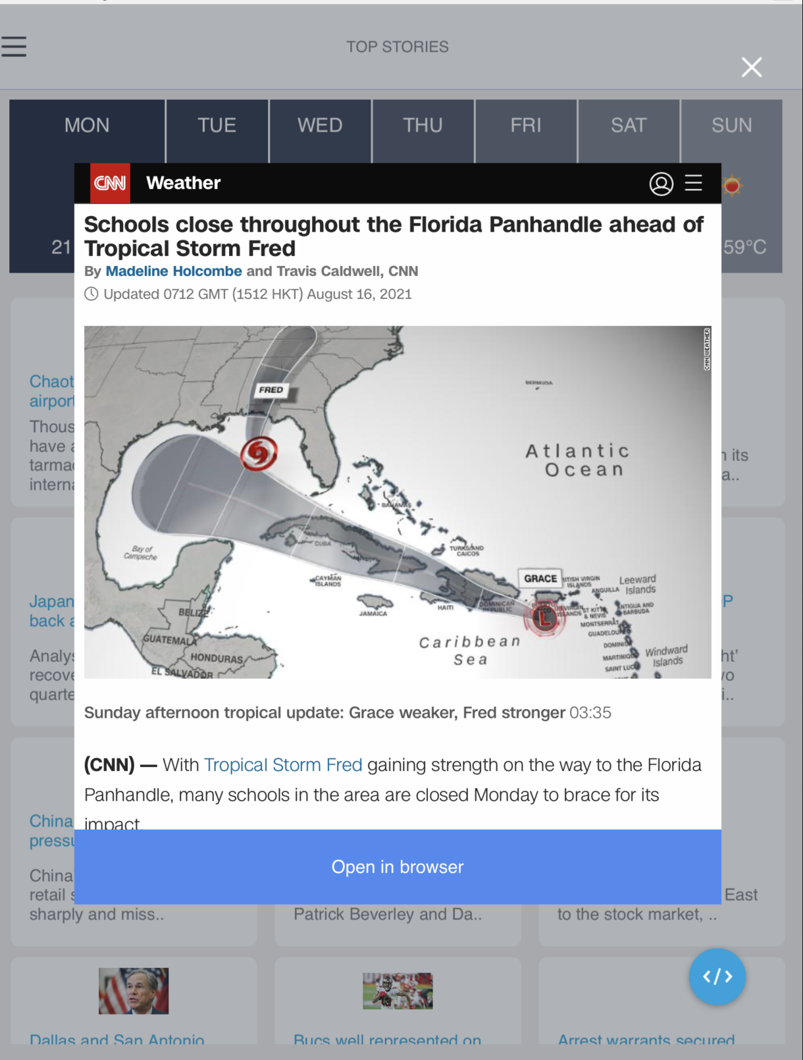

You can browse through the categories to read different kinds of news stories such as General, Business, Technology, Entertainment, and so on. When you select any category from the list, the respective headlines associated with the news category is displayed.
Note: In tablet devices, when the device orientation is set to Landscape mode, the menu is visible by default. When the device orientation changes to Portrait mode, the entire menu collapses into an icon. To view the menu while the device is in Portrait mode, click on the menu icon.

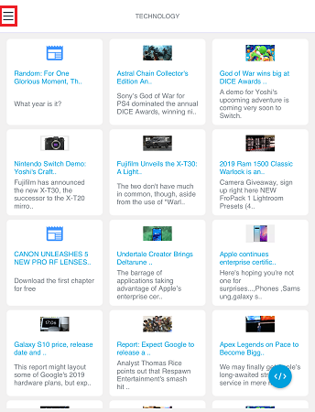

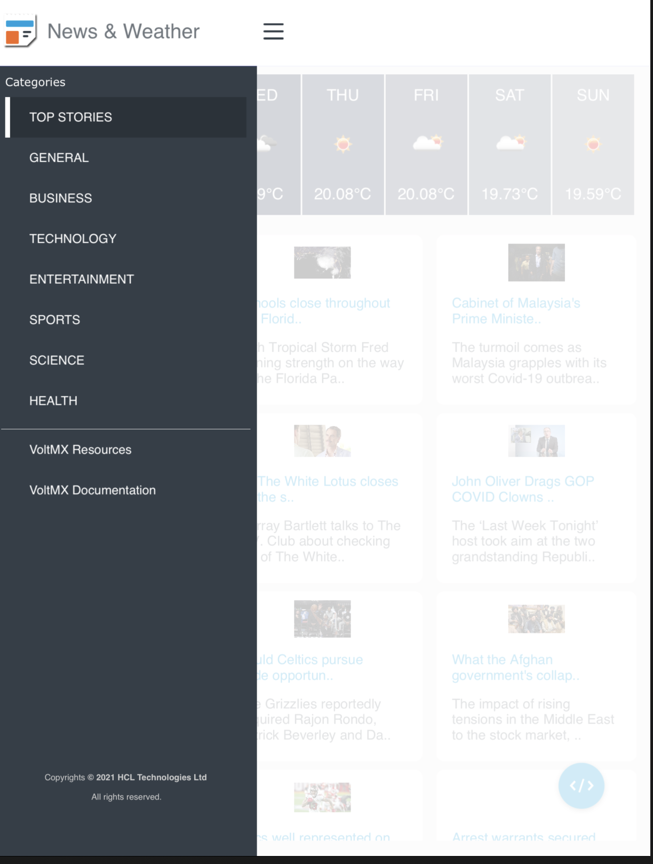

Desktop Web Application :
In the Desktop Web channel, the landing page of the News and Weather app is the News and Weather screen.

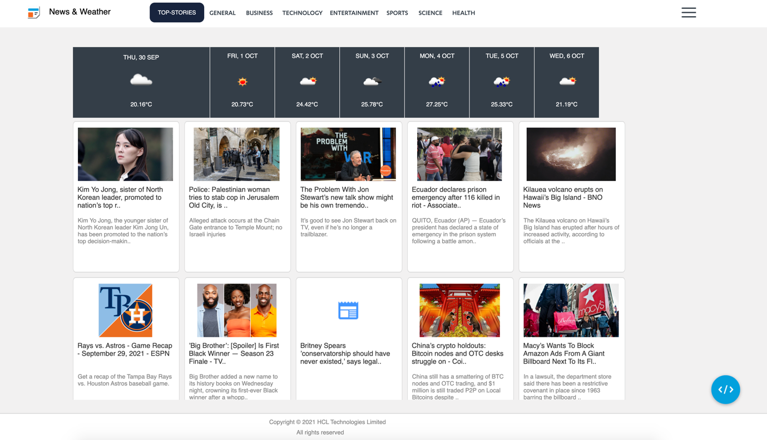
The News and Weather screen displays news headlines belonging to various categories such as Top Stories, General, Business, Technology, Entertainment, and so on. The news categories are displayed at the top of the screen near the title bar. By default, the News and Weather screen showcases the Top Stories category. The Top Stories category illustrates important news headlines and also provides you information on the weather, based on your location. You can browse through the category list at the top and click on any particular news category to load the content related to that category.
The weather details comprise of information such as the current temperature and the predicted temperature for the next few days.
The news headlines are arranged in a card format. You can click on any news item (card) present on the screen to open the news article associated with it. When you click the news item, the app navigates to the respective news article page on your desktop browser.

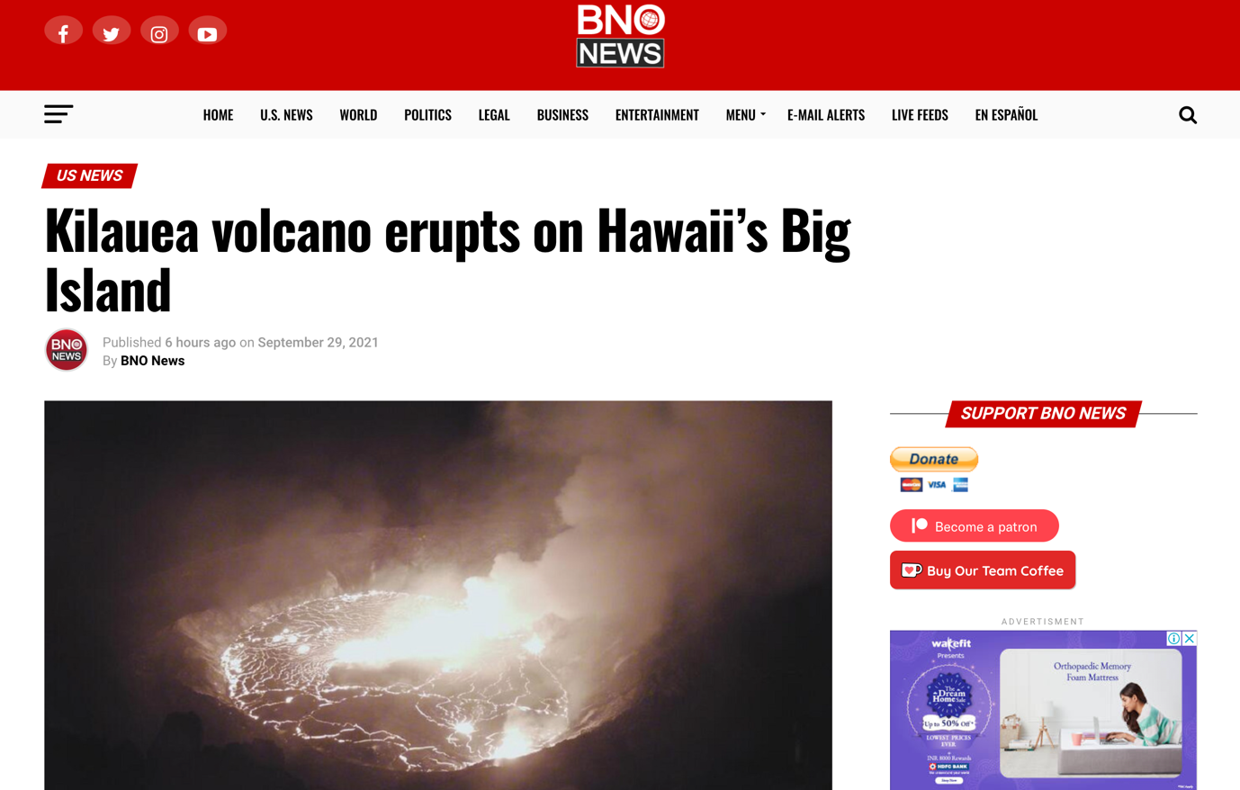
Click on the menu icon at the upper-right corner of the screen to find links to Volt MX Resources and Volt MX Iris Documentation.
The News and Weather app is responsive in nature. As you shrink the screen size, the cards present on the canvas arrange themselves according to the screen size. All the news categories collapse into a menu list format with a menu icon. Once you shrink the screen size to a particular size, the menu icon appears. Click the menu icon to open the menu containing all the news categories.

Import the App
To import the News and Weather app into your workspace, follow these steps:
- Open Volt MX Iris
- On the main menu select Forge → Browse.
- Search for the News and Weather app, and then click Import to Workspace. The app is imported to your workspace.
A dialog box appears, confirming that the app has been imported. Click OK.
- Switch to your project containing the News and Weather app. To switch to your project, click File → Open → Reference Architecture → <project name>

Live Preview
After importing the News and Weather app, you can preview the app on any channel by using Live Preview.
Note: To preview the app on your mobile or tablet device, ensure that you install the latest version of the Volt MX Iris App Viewer app on your mobile or tablet device from the App Store or from Google Play.
To preview the app by using Live Preview, follow these steps:
- In Volt MX Iris Starter, click Build → Live Preview Settings from the main menu. The Live Preview Settings window opens.
Note: In Volt MX Iris Enterprise, click Preview → Run from the main menu to open the Live Preview Settings window.
- Select any application channel such as Mobile Native, Tablet Native, or Responsive Web along with the respective platform(s) on which you want to preview the app. Click Save & Run.
After a successful preview build for Mobile and Tablet channels, a window appears containing a QR code. You can scan this QR code from the Volt MX Iris App Viewer application on your mobile or tablet device to preview the app.
For more information on Volt MX Iris App Viewer, you can refer the Volt MX Iris App Viewer Documentation.
After a successful preview build for the Desktop Web channel, the Iris Preview window opens displaying the News and Weather Desktop Web application.

News and Weather Volt MX Foundry Services:
The News and Weather app contains an Integration Service :
- NewsSampleService : This service is used to retrieving live articles from all over the web.
Operations :
  - CategorizedNews - Used to get different categories of news
  - TopStories - Used to get the top headlines of a news

- WeatherSampleService
Operations :
- WeatherForecast – Used to get the weather temperature
- LocationSampleService
Operations :
- LocationService – Used to get the current location

And an Orchestration Service :
- Top Stories and Weather – Used to get both top headlines and Weather
- Weather and Location – Used to get both Weather and current location

Limitations :
- Landscape mode is not available for all devices.
- If browser height is minimized then UI might get distorted.

