Date: 28 - 11 - 2025

NLP CLOUD ADAPTER

version: 1.0.0

OVERVIEW
The NLP Cloud Adapter is a cloud-based REST integration layer that provides unified access to multiple NLP and Generative AI capabilities through a single adapter. It supports a comprehensive set of endpoints— including text generation, summarization, translation, sentiment analysis, entity extraction, classification, and more—powered by advanced AI models such as LLaMA, GPT-OSS, ChatDolphin, Falcon, and other modern open-source and proprietary models.

Why Use the NLP Cloud Adapter

The NLP Cloud Adapter enables developers to seamlessly integrate a wide range of AI-powered NLP features into their applications using a single, unified interface, reducing complexity and development time.

Features:
- Unified NLP Operations: Access all NLP capabilities—generation, analysis, summarization, translation, and more—through a single adapter.
- Entity & Keyphrase Extraction : Identify names, dates, places, organizations, medical terms, and important keywords from text.
- Sentiment & Emotion Analysis : Detect user sentiment (positive/negative/neutral) and emotional tone in text.
- Text Classification : Categorize text into topics, intent labels, spam detection, or custom-defined classes.
- Summarization & Rewriting : Convert long text into concise summaries or rephrase content naturally.
- Translation & Multilingual NLP : Translate text across multiple languages and process multilingual inputs.
- Content & Text Generation:Generate responses, explanations, or creative text as part of supported endpoints.

Percentage of re-use:
Approximately (80-90) % of reuse.

GETTING STARTED

Prerequisites

Before you start using the NLP Cloud Adapter, ensure the following:
- HCL Foundry
- Volt MX Iris
- NLP Cloud API Key

Creating an NLP Cloud Account and API Key:

- Go to https://nlpcloud.com/ and create a free account.
- After signing up, go to the Dashboard.
- Navigate to API Key and Copy the generated API key and store it securely.

Importing the Data Adapter

You can import NLP Cloud Adapter into HCL Foundry directly from the Volt MX website or by importing the data adapter zip file.

To import the Data Adapter to Volt Foundry, do the following:
- Sign in to the HCL Foundry.
- From the left navigation menu, select API Management.
- In API Management, select Custom Data Adapters.
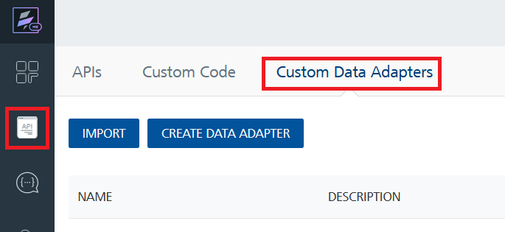
- Click IMPORT to import a custom data adapter.
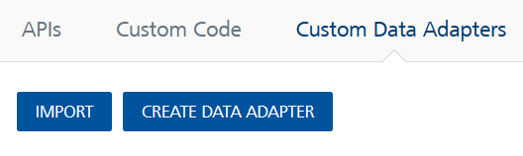

- On the Import Data Adapter dialog box, click browser to import.
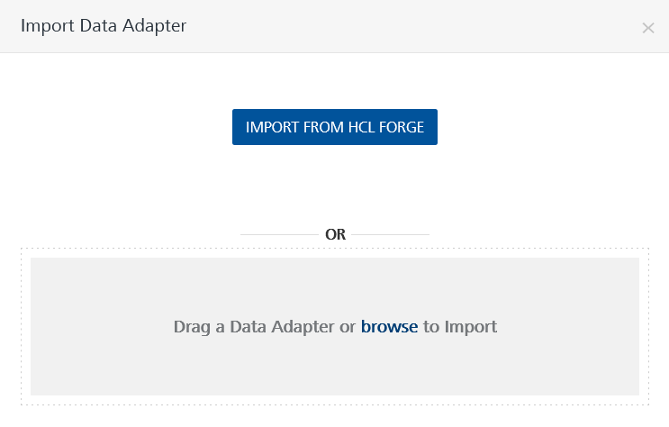
- Drag the data adapter zip file into the Drag a Data Adapter box.
Or
Click browse. The Open dialog appears.
Navigate to the location where you downloaded the data adapter (zip file) on your computer, select the data adapter, and click Open. The Import Data Adapter dialog shows the selected data adapter.
Note: Click Remove if the selected data adapter is not the one that you want to import.

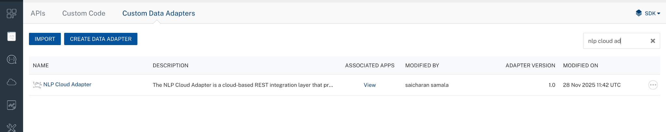

To import the data adapter zip file, do the following:
- Perform steps 1 through 4 in the above procedure
- Drag the data adapter zip file into the Drag a Data Adapter box.
Or
Click browse. The Open dialog appears.
Navigate to the location where you downloaded the data adapter (zip file) on your computer, select the data adapter, and click Open. The Import Data Adapter dialog shows the selected data adapter.

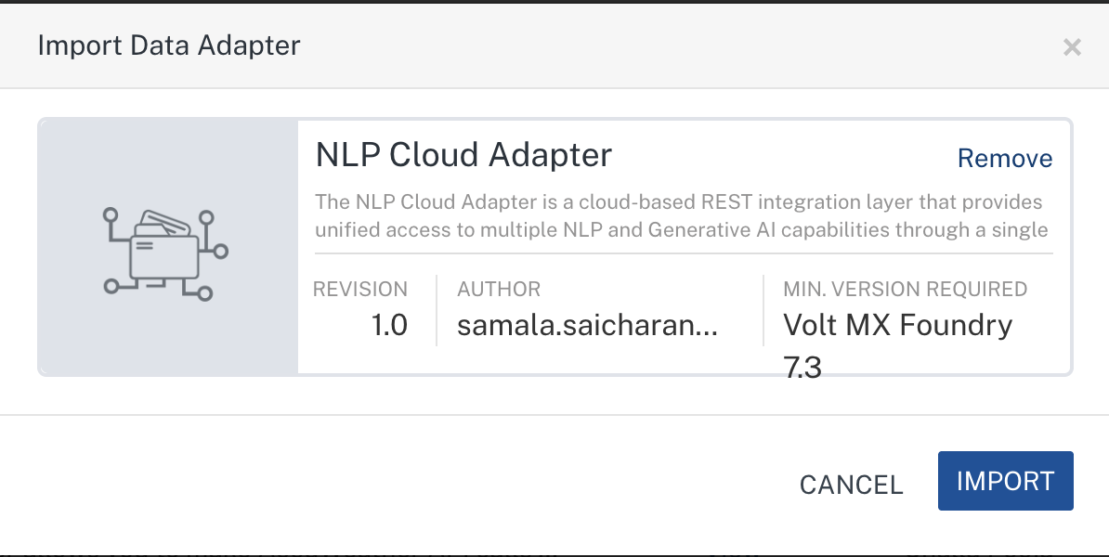

Note: Click Remove if the selected data adapter is not the one that you want to import.

Creating an Integration Service with NLP Cloud Adapter
After you import NLP Cloud Adapter into Foundry, you must create an integration service with service type as NLP Cloud Adapter to connect with your NLP Cloud developer site.
To create an integration service with NLP Cloud Adapter, do the following:
- Log on to your Foundry. The Dashboard page appears by default.
- In the left panel, click the API Management menu. The APIs tab opens by default.
- Click the Integration tab. The Integration tab opens with a list of existing integration services.
- Click CONFIGURE NEW. The Service Definition tab opens.
- In the Name box, type a unique name for your service.
- From the Service Type list, select NLP Cloud Adapter.
Note: The NLP Cloud Adapter is listed only after you import the NLP Cloud Adapter Data Adapter into Volt MX Foundry.
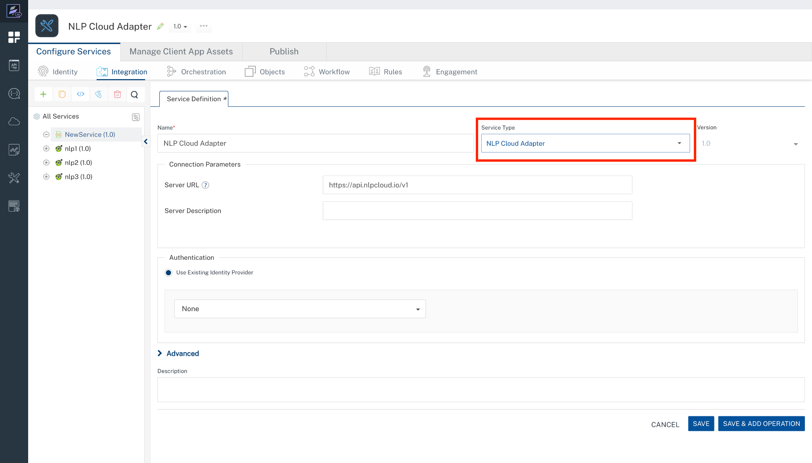

- Click Save.
If the details provided are valid, the Foundry service connects to your NLP Cloud Adapter developer site and allows you to make the API calls.
Refer to Integration Services for more information on creating and using integration services.

- Creating an operation

To make any API call in the Foundry console, you must create an selected operation for the respective API and then execute the operation. Executing an operation involves making the API call and displaying the response. For more information, see Executing an operation.

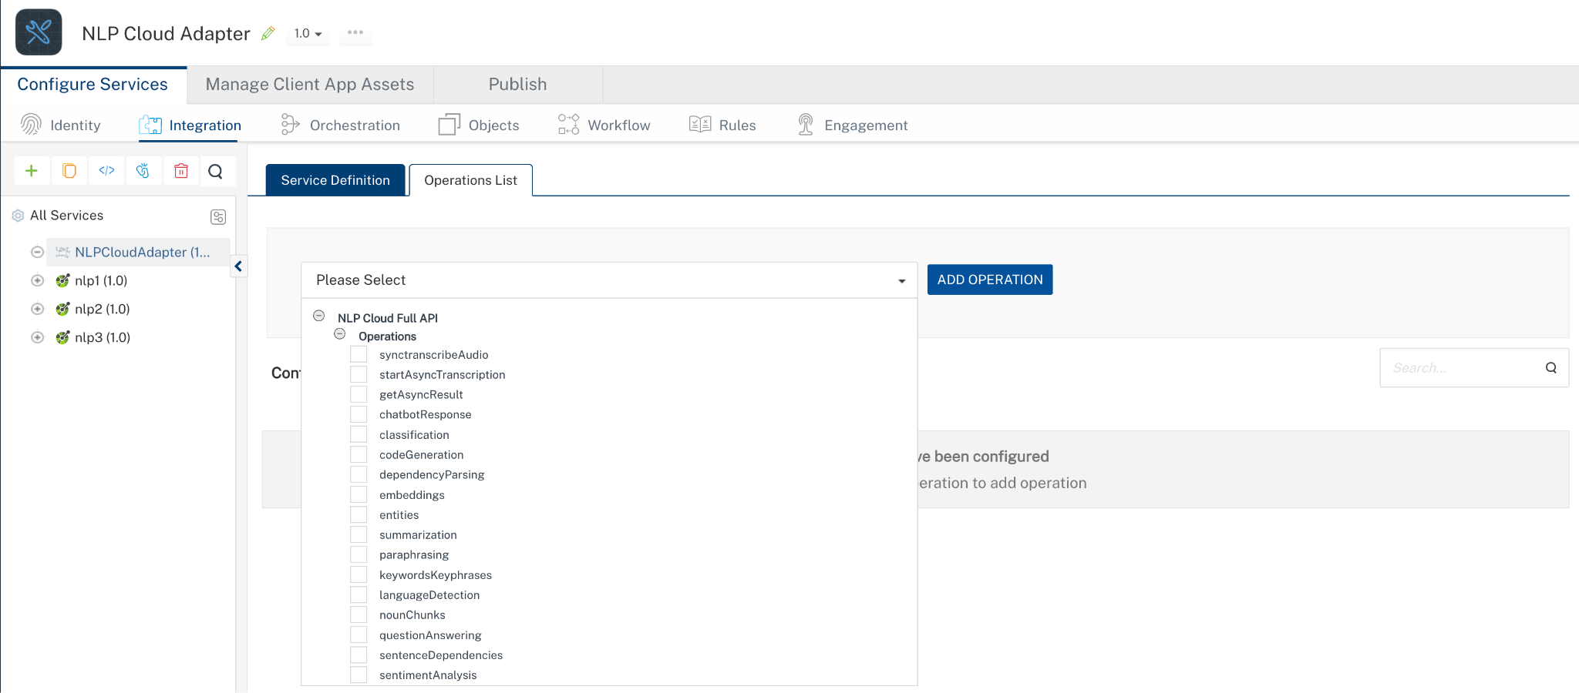

- Executing an operation

Under the Configured Operations section, click the operation. The Request Input sub-tab opened by default. Provide Body and Headers.

- Provide the required parameters of the endpoints(refer to this Document https://docs.nlpcloud.com/#endpoints).

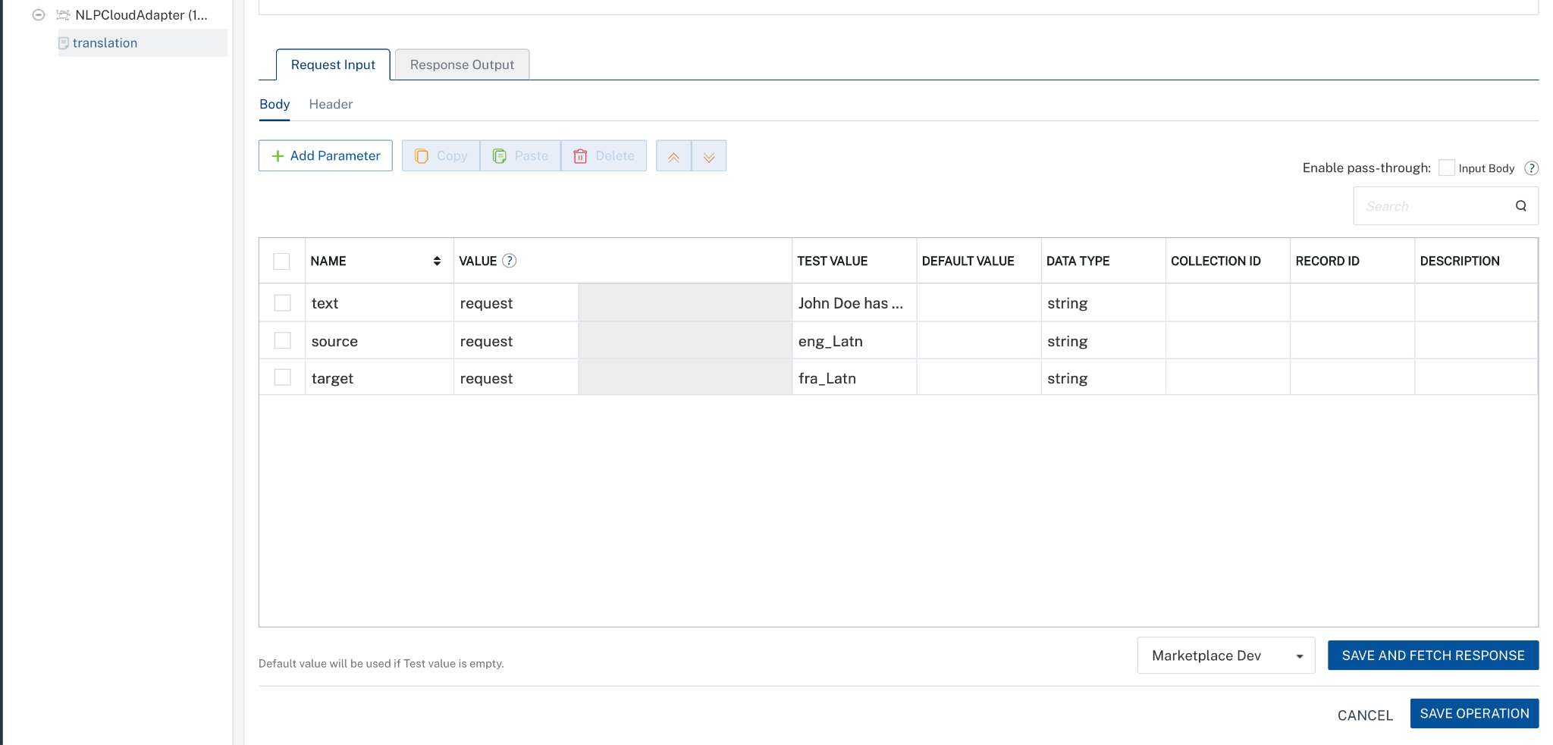

Enter the value of the API key as the default value created during the Creating an NLP Cloud Account and API Key.
NLP Cloud accepts the API key in the format: Token YOUR_API_KEY in the Headers.

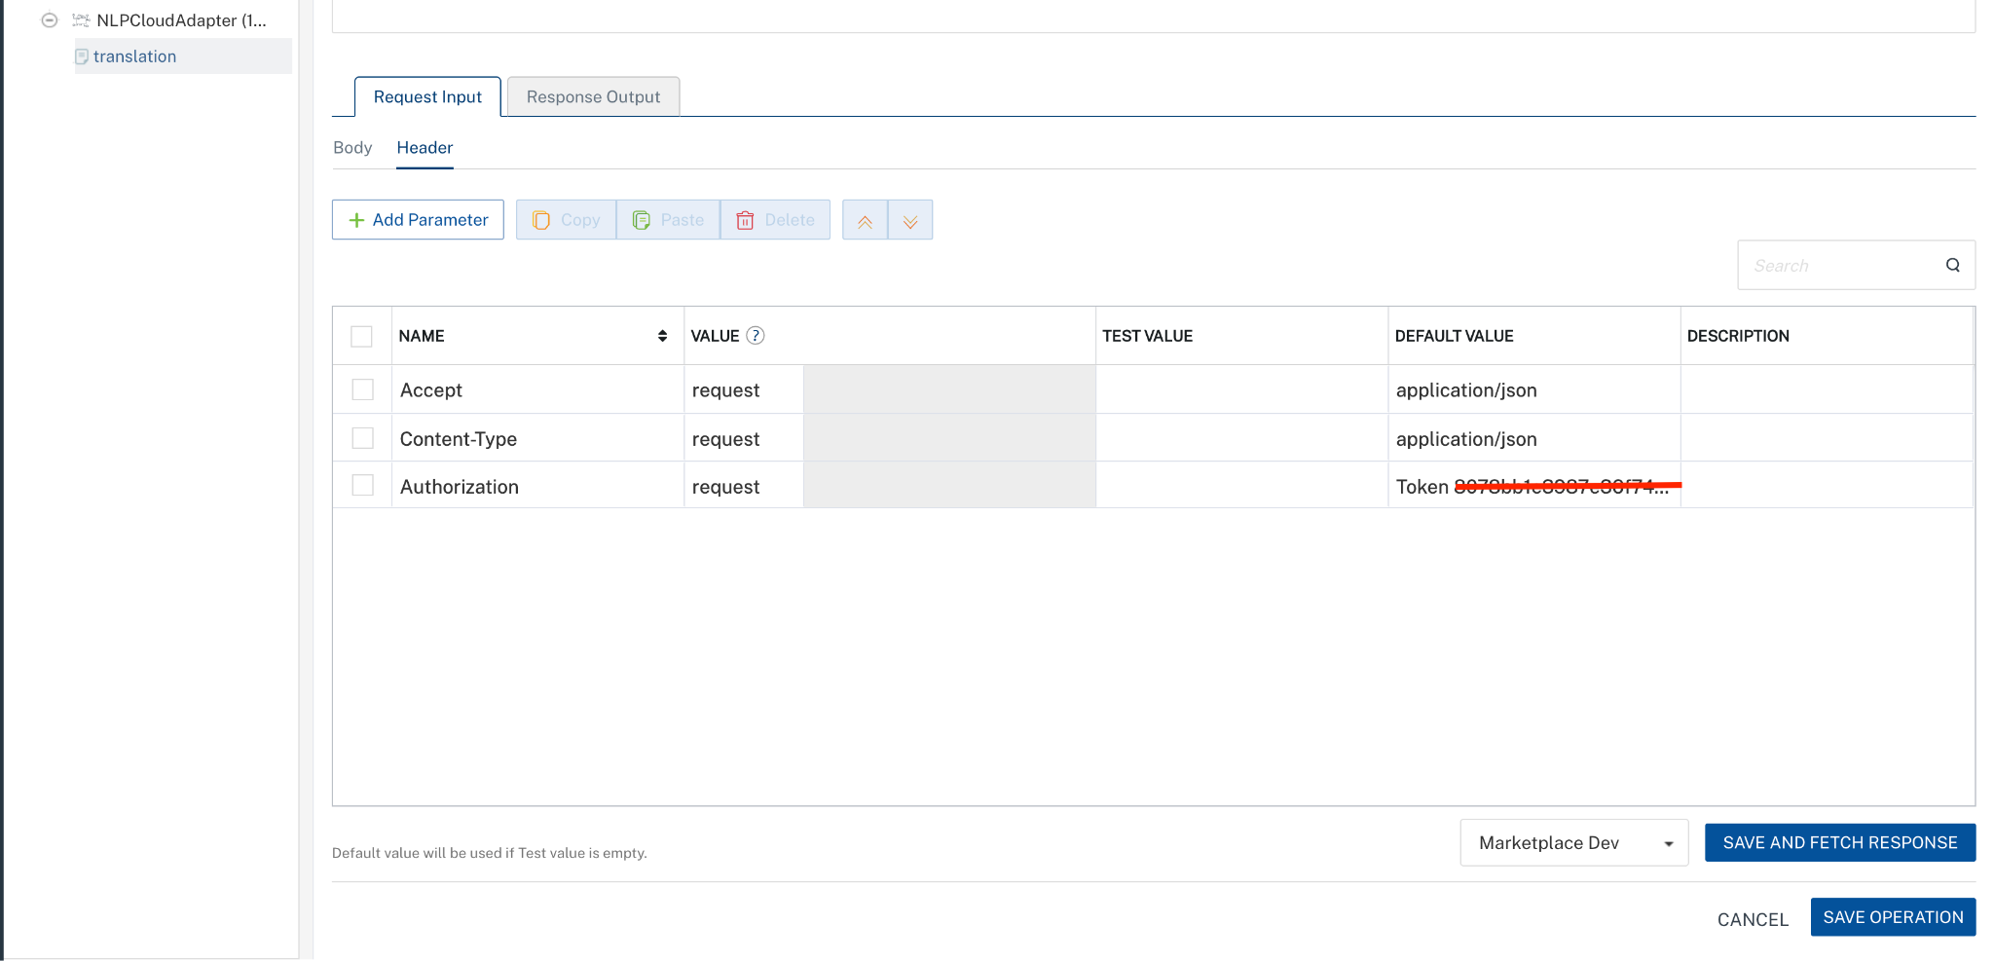

- Click SAVE AND FETCH RESPONSE. The Output Result dialog appears with the response. Otherwise, the Output Result shows an error.
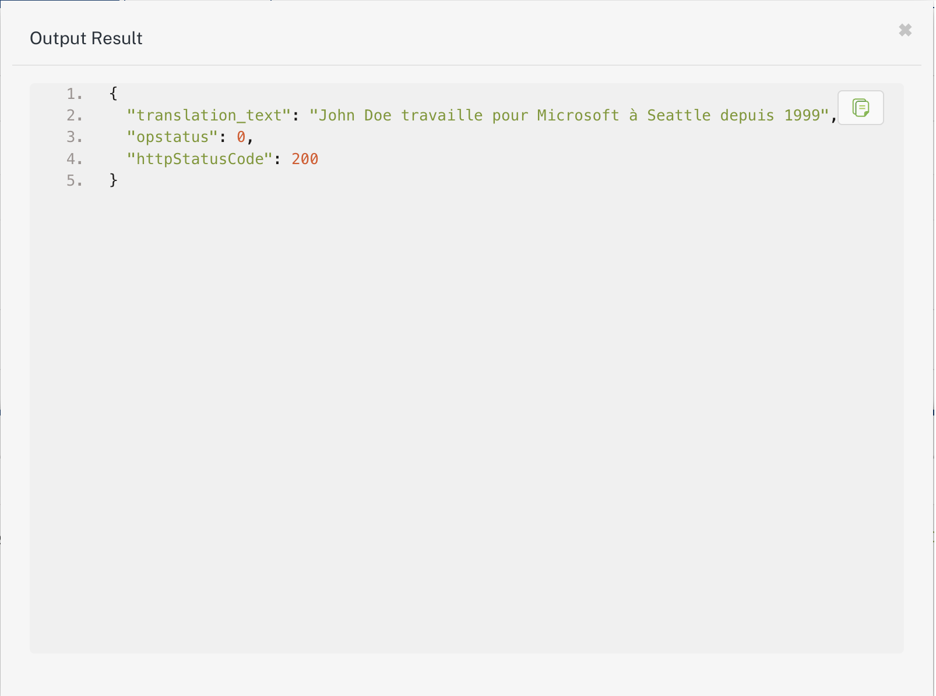

Publishing your application
If you want to use the services in client applications, you need to publish an app to a run-time environment. You can create the service (as described above) in an application or import the service into an application and publish the application.

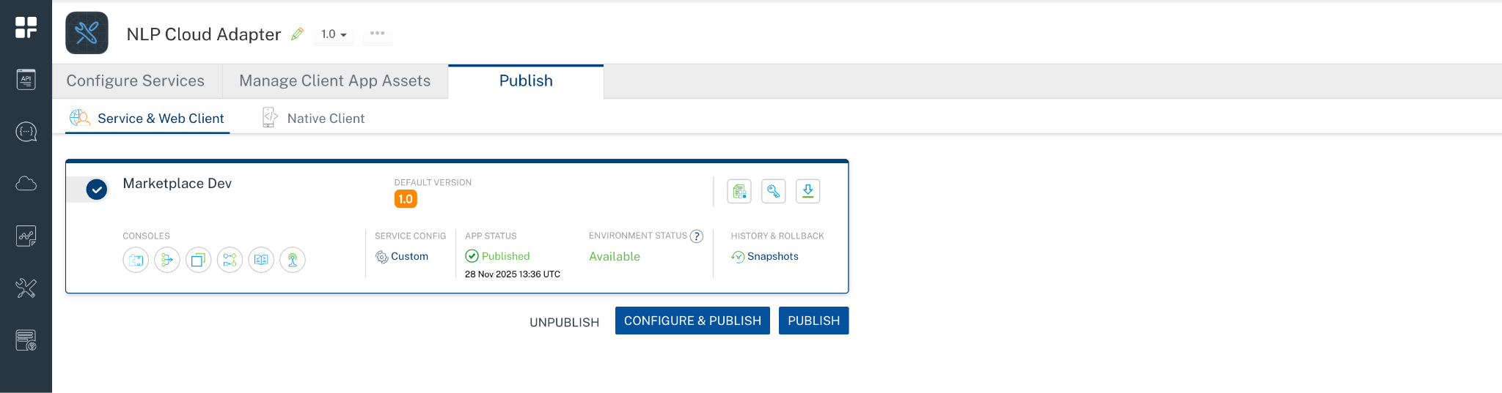

References

Endpoint Documentation
https://nlpcloud.com/pricing.html

https://docs.nlpcloud.com/#endpoints

Revision History
App version 1.0.0:

Known Issues
- No Known Issues

Limitations
- NA

