Date : 02-Jan-26

NLP CLOUD CODE GENERATION APPLICATION

VERSION: 1.0.0

Overview
The NLP Cloud Code Generation Application is an interactive AI-powered interface that helps users generate, complete, and explain code using natural-language instructions. Simply describe the functionality you need, and the system produces clean, efficient code snippets or full implementations in your chosen programming language. Powered by NLP Cloud’s advanced code-focused language models, it accelerates development by reducing manual coding effort and improving productivity across software projects.

Purpose
This Application enables users to:
- Generate source code from natural-language prompts or technical descriptions
- Support multiple programming languages and frameworks using state-of-the-art code generation models
- Refine and extend generated code through iterative, conversational prompts
- Accelerate prototyping, learning, and development workflows with AI-assisted coding
The NLP Cloud Code Generation API is a cloud-based REST service that leverages state-of-the-art large language models to automatically generate source code from natural language instructions. Developers can provide a detailed prompt describing the desired functionality, and optionally include additional context such as existing code snippets, constraints, or style guidelines to guide the generation process. The API supports multiple programming languages and is powered by advanced generative models (e.g., GPT-OSS 120B, LLaMA 3.1 405B, fine-tuned LLaMA 3.3 70B).
.
Requirements:

- HCL Foundry
- Volt MX Iris
- NLP Cloud API Key
Creating an NLP Cloud Account and API Key:

- Go to https://nlpcloud.com/ and create a free account.
- After signing up, go to the Dashboard.
- Navigate to API Key and Copy the generated API key and store it securely - you will need it while configuring the integration service in Foundry.

Devices:
- Mobile

Platforms:
- Android
- IOS

Features:
- Context-Aware Code Generation: Generates accurate and relevant code by leveraging provided context such as existing code snippets, project structure, or implementation constraints, ensuring the output aligns with your codebase.
- Multi-Language Programming Support: Supports generating code in multiple programming languages and frameworks, enabling developers to work across diverse technology stacks using a single API.
- Production-Ready API: A scalable and secure cloud-based REST API designed for low latency and easy integration into developer tools, IDEs, CI/CD pipelines, and applications to boost development productivity.

App Functionality:

Initial Launch Experience

On launch, users are presented with an empty chat screen.
The message input field is active by default, allowing immediate interaction.

Code Prompt Input & Submission

Users type requests such as “Write a C program for Fibonacci series” into the input field.

The keyboard appears while keeping the input visible.

Prompts can be submitted by:

Tapping the blue send button, or

Pressing Enter

After submission:

The input field clears instantly

The user’s prompt appears as a blue chat bubble on the right

The conversation auto-scrolls to the latest message

AI Code Generation & Response Handling

The app sends an HTTP POST request to the NLP Cloud backend service.

A temporary loading indicator (“…”) appears while the request is processed.

Once a response is received:

The loading indicator disappears

The AI-generated code appears in a left-aligned response bubble

The view automatically scrolls to the newest message

Error Handling

If an error occurs (e.g., invalid API key, network failure, or model issue):

An alert or bot error message is displayed

Users can immediately retry by submitting a new prompt

Importing the app:
To import the NLP Cloud Code Generation Application into your workspace, follow these steps:
- Open Volt MX Iris
- On the main menu select Forge → Browse.
- Search for the NLPCloudCodeGen Application, and then click Import to Workspace. The app is imported to your workspace. A dialog box appears, confirming that the app has been imported. Click OK.
- Switch to your project containing the NLPCloudCodeGen Application. To switch to your project, click File → Open → Reference Architecture → <project name>

Building the app:
After performing all the above steps, you can build your app and run it on your device. For more information, you can refer to the Building and Viewing an Application section of the Volt MX User Guide.
You can then run your app to see the NLP Cloud Code Generation Application work in real time.

Configure the UI and settings of the NLP Cloud Code Generation Application
The NLP Cloud Code Generation Application consists of the following component:
- The NLP Cloud Code Generation component is used to allow users to ask a question and interact with it using advanced Natural Language Processing (NLP) models to accurately extract or generate code to user instructions from text.
- Take one form and add the component. Add required widgets and code to create a chat like UI
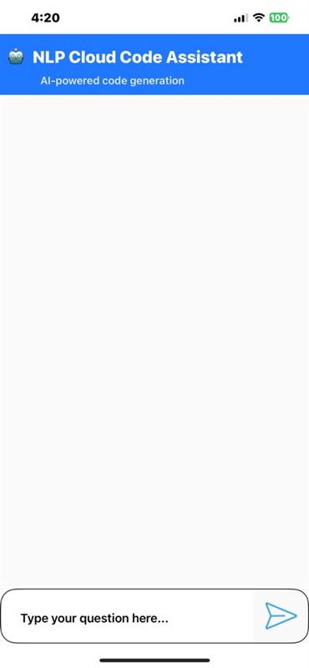
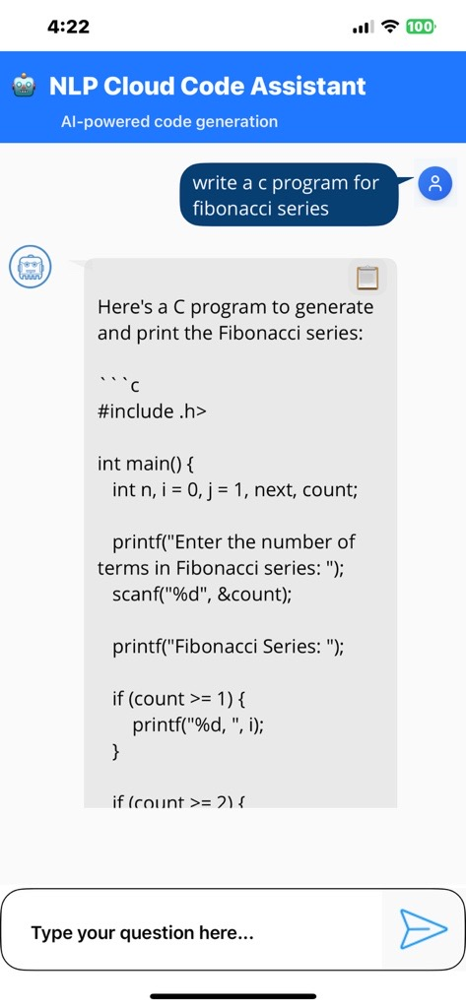

Foundry APP Setup

When you import the application into your Volt MX Iris, the HCL Volt MX Foundry services of the NLP Cloud Cloud Code Generation are added to the HCL Volt MX Foundry app, which is associated with the Volt MX Iris project. While importing the NLP Cloud Cloud Code Generation Application to your Volt MX Iris project, if there is no HCL Volt MX Foundry app associated with the existing Volt MX Iris project, a new HCL Volt MX Foundry app is automatically added to your HCL Volt MX Foundry environment and is associated with your Volt MX Iris.
To set the Foundry app, follow these steps:
- Click the HCL Volt MX Foundry app associated with your Volt MX Iris project from the Project Explorer. Click DATA & SERVICES
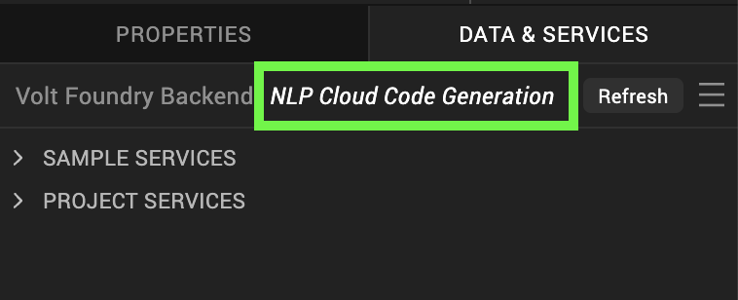
- Under the Configure Services tab, click Integration and can see the Google NLPCloudQA. Click on Integration service to add the keys.
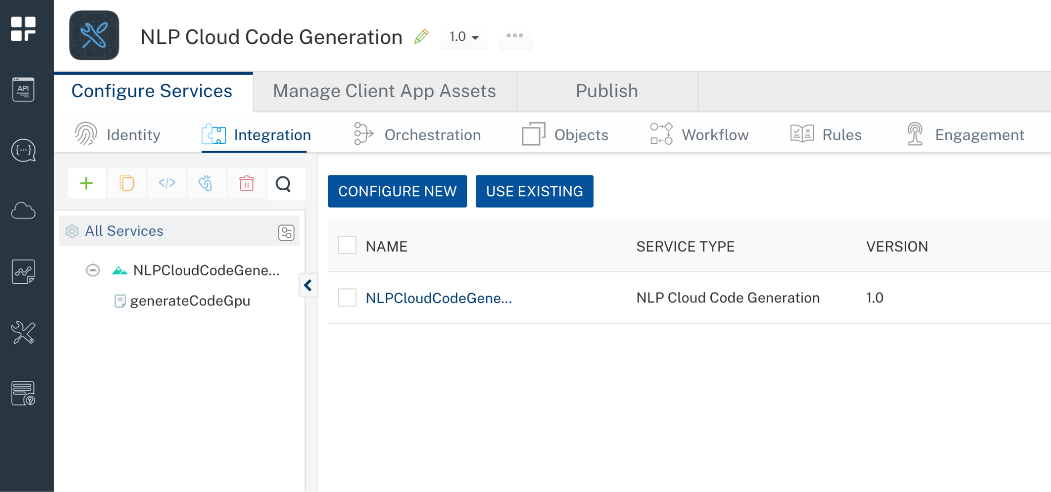
- Click the NLPCloudCodeGeneration Integration service. On the right pane, expand the NLPCloudCodeGeneration service and then select the generateCodeGpu operation.
- The generateCodeGpu tab opens with the Request Input sub-tab opened by default.
- On the Request Input tab, in the Body section, for the following parameters, specify the values in the respective boxes under the Test Value column.
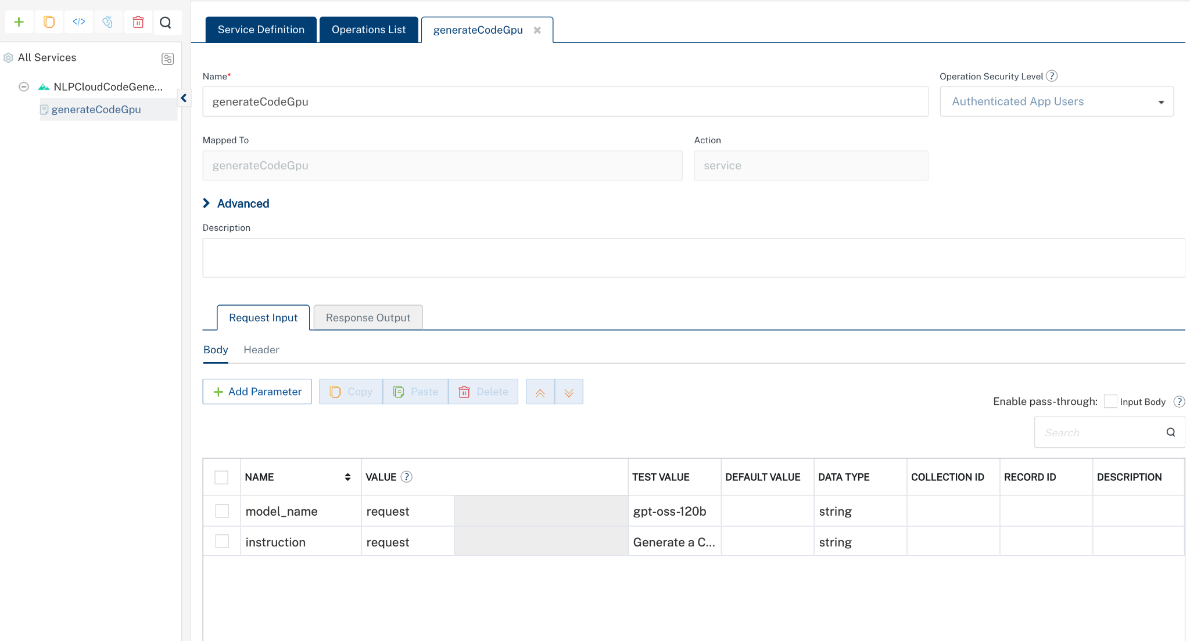
Parameter | Description | Syntax example
model_name (or similar) | Identifies which model to use for the QA endpoint (e.g., “gpt-oss-120b”). You can find the available models here https://docs.nlpcloud.com/#code-generation | "model_name": "gpt-oss-120b"
instruction | The description of what your program should do. | "instruction": "Generate a C++ program that sorts a list of integers in ascending order."
- Click Header sub-tab. The Header section opens.
- For Authorization, In the box under the DEFAULT VALUE column, type the API Key generated from https://nlpcloud.com/home/token.
Syntax: Token Your_API_KEY
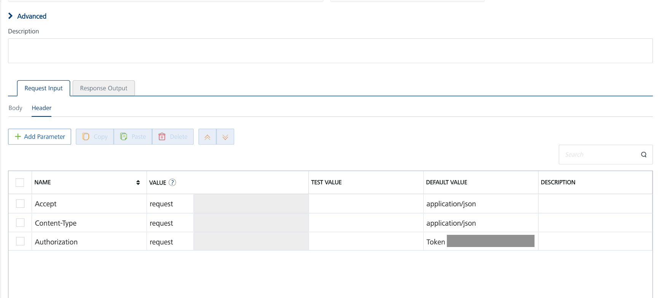
- Click SAVE AND FETCH RESPONSE. The Output Result dialog appears with the response. Otherwise, the Output Result shows an error.
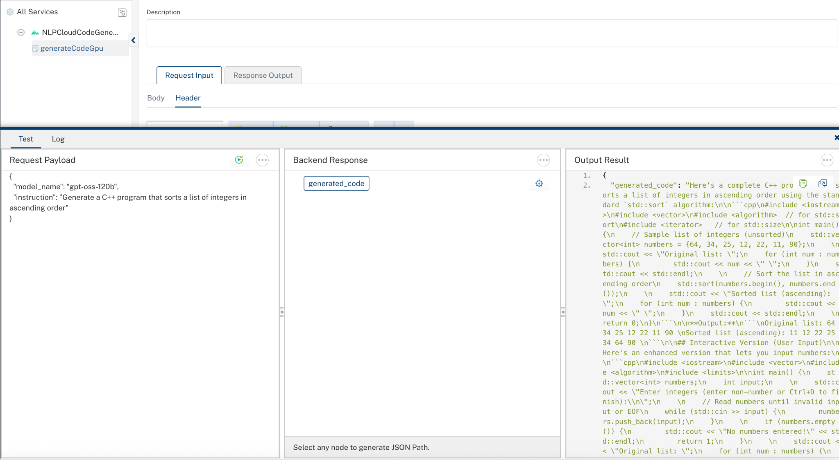
- Click the icon to go back to Volt MX Iris.

Publish the HCL Volt MX Foundry App
After you set the Operation Security Level, you must publish the HCL Volt MX Foundry app. To publish the HCL Volt MX Foundry, follow these steps:
In Volt MX Iris, click DATA & SERVICES, and then click Publish Project Services to Publish to your foundry app.
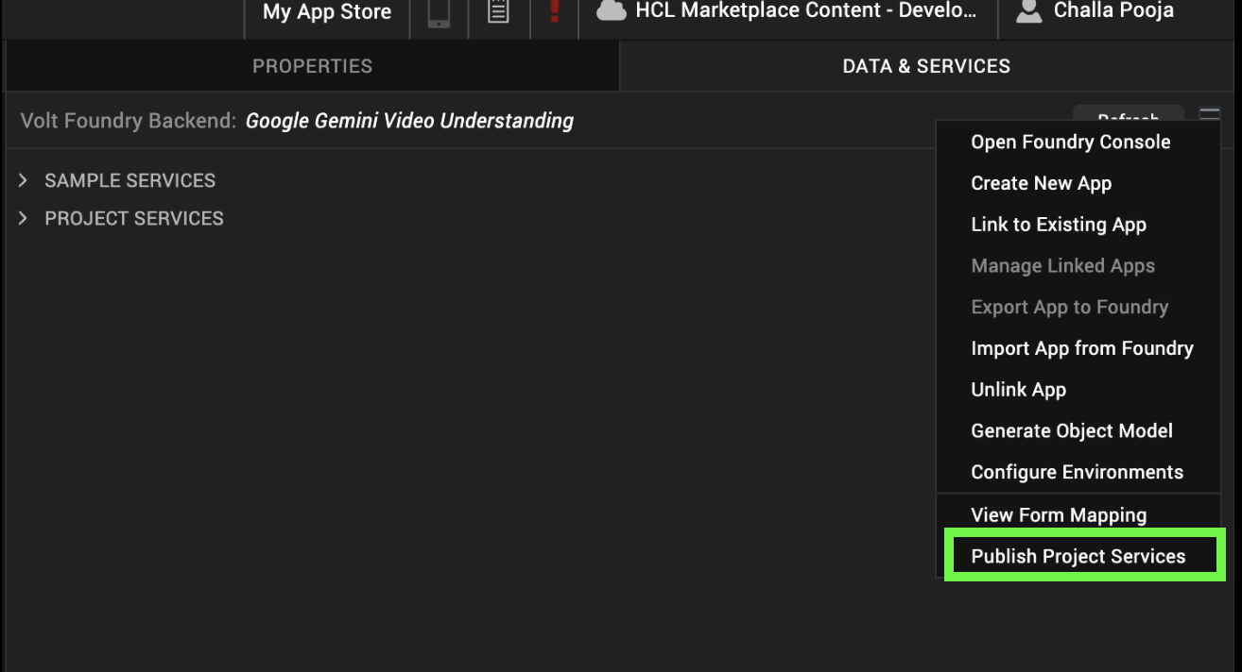
Select the environment to which you want to publish your app, and then click Publish.
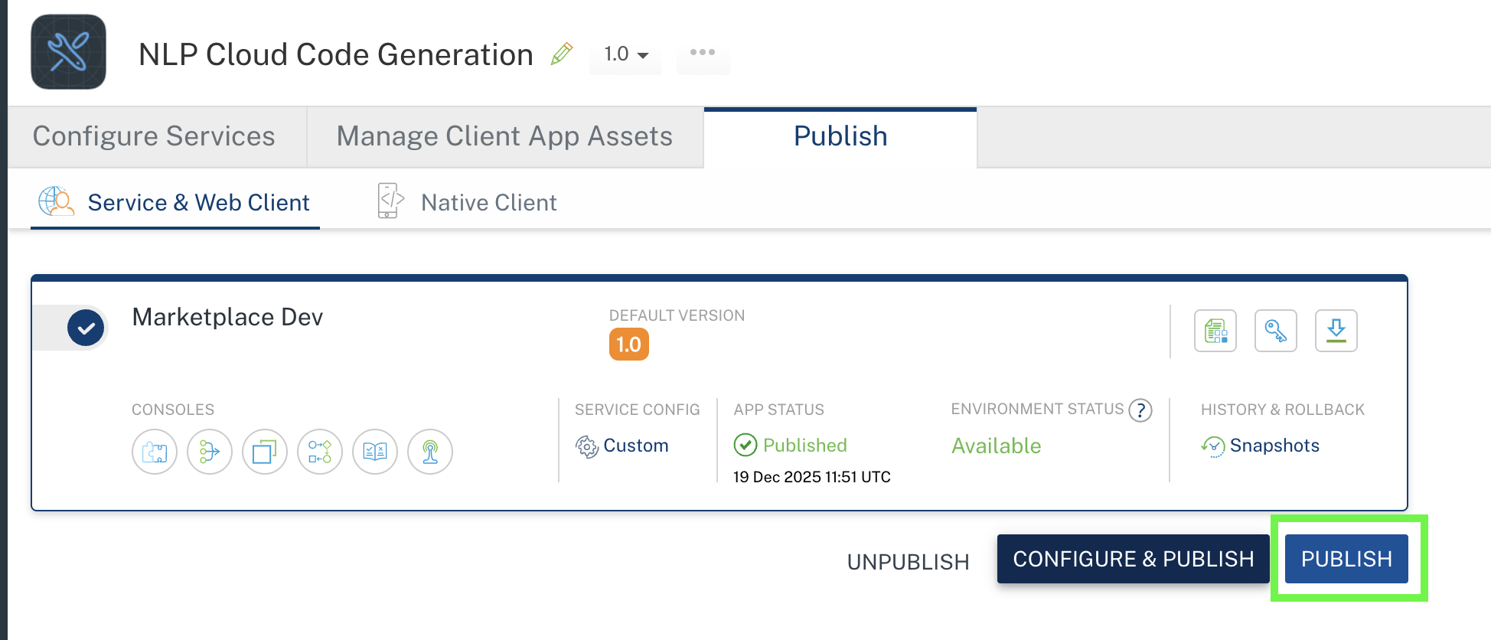
After the app is published to your environment, the following window appears confirming the publish.
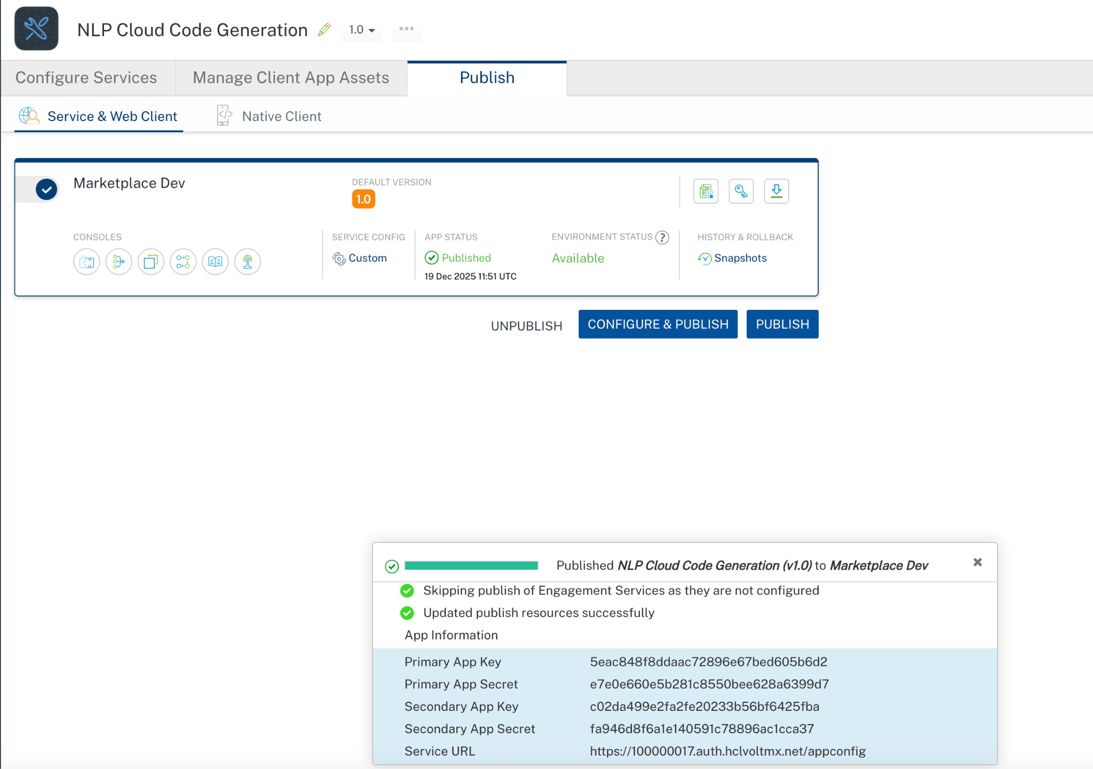

Building and previewing the app
After performing all the above steps, you can build your app and run it on your device. For more information, you can refer to the Building and Viewing an Application section of the Volt MX User Guide.
You can then run your app to see the NLP Cloud Code Generation Application work in real time.

NLP Cloud Code Generation Component Properties:

General Properties

- ModelName

Description: | Specifies which model to use (e.g., “gpt-oss-120b”).
Syntax: | ModelName
Type: | String
Read/Write: | Read + Write
Example: | this.view.NLPCloudCodeGeneration.ModelName = "gpt-oss-120b";
- Instruction

Description: | Specifies the Instruction you’re asking the model.
Syntax: | Instruction
Type: | String
Read/Write: | Read + Write
Example: | this.view.NLPCloudCodeGeneration.Instruction = "Generate a C++ program that sorts a list of integers in ascending order.";

APIs

No APIs

Events

getInputText

Description: | Invoked after the input/Instruction is entered. This getInput should be invoked in the onNavigate function.
Syntax: | getInputText
Parameters: | text: The given instruction or input text
Remarks: | Need to invoke this event to get the input text
Example: | onNavigate: function() {  this.view.NLPCloudCodeGeneration.getInputText = function(text){  try{  if(text){  alert("Instruction= "+text);  }  else{  alert("Input is empty");  }  }.bind(this);  }

getGeneratedCode

Description: | Invoked after the component generates the content. This getGeneratedCode should be invoked in the onNavigate function.
Syntax: | getGeneratedCode
Parameters: | response[JSON] : The generated JSON object from the NLP Cloud Code Generation
Remarks: | Need to invoke this event to get the generated content result.
Example: | onNavigate: function() {  this.view.NLPCloudCodeGeneration.getGeneratedCode = function(generatedCode){  try{  if(generatedCode){  alert("Generated code = "+JSON.stringify(generatedCode));  }  }  catch(err){  voltmx.ui.Alert({  message: "err in getGeneratedCode= "+err.message,  alertType: constants.ALERT_TYPE_INFO,  yesLabel: "OK"  }, {} );  }  }.bind(this);  }

onErrorCallback

Description : Invoked when error occurs.

Syntax : onErrorCallback

Parameters : args [Array of JSON] : Contains information about the error.

Example : this.view.NLPCloudCodeGeneration.onErrorCallback= function(args)
{
alert("Error: "+JSON.stringify(args));
}.bind(this);

Reference documentation link: https://docs.nlpcloud.com/#code-generation

REVISION HISTORY
Adapter version 1.0.0:

Known Issues
None

Limitations
None

