Date : 20-May-26

NLP CLOUD HEADLINE GENERATION APPLICATION

VERSION: 1.0.1

OVERVIEW
NLP Cloud is a cloud-based Natural Language Processing platform that provides pre-trained and custom AI models through REST APIs. The Headline Generation feature uses advanced transformer models to automatically generate short, meaningful headlines from longer text such as articles, news, or blog content.
This application demonstrates how to integrate NLP Cloud’s Headline Generation API into an HCL Volt MX application using Foundry Integration Services.

Requirements:
Before you start using the NLP Cloud Headline Generation Application, ensure you have the following:

- HCL Foundry
- Volt MX Iris
- NLP Cloud account
  - Sign up at https://nlpcloud.com to create an account.
  - After logging in, navigate to the dashboard and generate an API key. This key is required to authenticate all requests.
- NLP Cloud API Key
Once logged in, go to the Get Your Free API Key section in the NLP Cloud dashboard.Generate your API key and store it securely.This key is required for authenticating all API requests such as :
- Headline generation
- API Access
Ensure that you understand the required API endpoints based on your use case:
- Reference NLP Cloud Playground :https://nlpcloud.com/home/playground/headline-generation
- Project Setup
You can start with the free plan, which allows a limited number of API requests per minute.
Endpoint Type: REST
Method: POST
Use Case: Generate headline from long input text
Input: Article or paragraph text
Output: AI-generated headline
- Reference document:
  - NLP Cloud Playground
  - NLP Cloud API Reference (Note: t5-base-en-generate-headline for headline generation in English)

Devices:
- Mobile

Platforms:
- Android
- iOS

App Functionality – NLP Cloud Headline Generator Sample Application
When you build and run the NLP Cloud Headline Generator Sample Application, you can generate meaningful and concise headlines from long-form input text using NLP Cloud’s AI models.
The app allows users to:
- Enter long text such as articles, news content, or paragraphs
- Generate AI-powered headlines from the provided input
- View the generated headline instantly
- Regenerate headlines for different variations
- Handle slow responses or empty input with user-friendly messages

Home Screen (frmHeadline)
This is the primary and only screen of the Headline Generation application.
- The user enters or pastes long-form content (article, paragraph, or news text) into the input text area.
- A delete icon appears dynamically when text is present, allowing the user to clear the input quickly.
- On clicking Generate, the app validates the input and triggers a Foundry Integration Service call to the NLP Cloud Headline Generation API.
- A full-screen loader is displayed while the headline is being generated.
- Once the response is received, the generated headline is displayed in the output section on the same screen.
There is no navigation to another form; input and output are handled within frmHeadline.

Authentication
- The app uses an NLP Cloud API Key configured in Volt MX Foundry.
- The API key is securely stored within the Foundry Integration Service and is not exposed to the client app.
- Each request to NLP Cloud includes:
  - Authorization token
  - Content-Type header
  - Input text payload
Foundry acts as a secure middleware between the Volt MX app and NLP Cloud.

Process Flow
- The user enters or pastes article text in the input field.
- The user clicks the Generate button.
- Volt MX app sends the request to the Foundry Integration Service.
- Foundry invokes the NLP Cloud Headline Generation API.
- NLP Cloud processes the input text and returns a generated headline.
- The app receives the response and updates the UI with the generated headline

Result Retrieval & Display
- The generated headline is displayed immediately on the same screen.
- Copy and delete actions become visible once a headline is available.
- Alerts are shown when:
  - Input text is empty
  - API request fails
  - Headline generation is unsuccessful
Users can modify the input text and regenerate headlines without restarting the app.

Importing the app
To import the NLP Cloud Headline Generator Application into your workspace, follow these steps:
- Open Volt MX Iris
- On the main menu select Forge → Browse.
- Search for the NLP Cloud Headline Generator Application, and then click Import to Workspace. The app is imported to your workspace. A dialog box appears, confirming that the app has been imported. Click OK.
- Switch to your project containing the NLP Cloud Headline Generator Application. To switch to your project, click File → Open → Reference Architecture → <project name>

Building the app
After performing all the above steps, you can build your app and run it on your device. For more information, you can refer to the Building and Viewing an Application section of the Volt MX User Guide.
You can then run your app to see the NLP Cloud Headline Generator work in real time.

Configure the UI and settings of the NLP Cloud Headline Generator Application
The NLP Cloud Headline Generator application is structured into a single screen (form), responsible for accepting long-form text and generating AI-based headlines.
Below is the clear and structured version for the form — frmHeadline.

Form 1: frmHeadline (Home / Headline Generation Screen)

Purpose
This screen allows users to generate concise and meaningful headlines from long-form input text using NLP Cloud’s Headline Generation API.
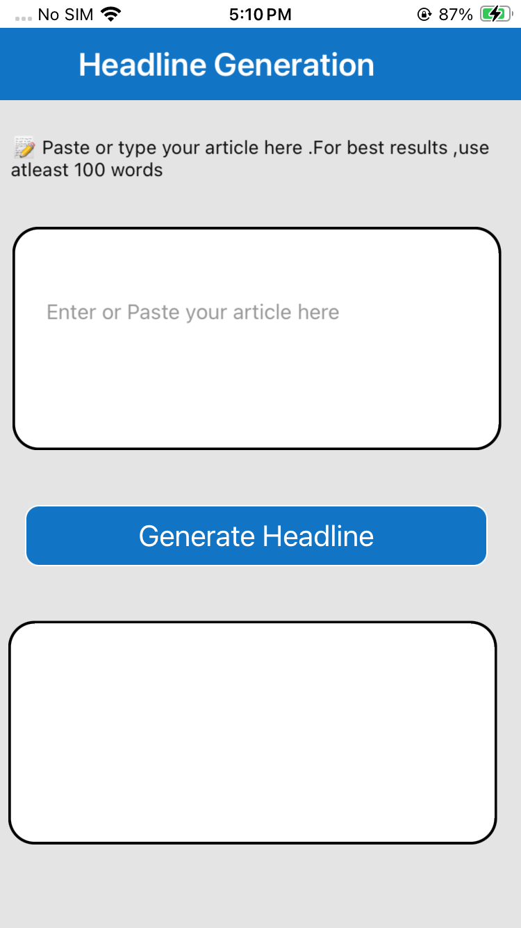

UI Configuration

Header Label
Displays the title:
“AI Headline Generator”

Input Text Area (txtArea)
- Placeholder: “Enter or paste your article here…”
- Accepts long text such as news articles, blogs, or paragraphs
- Supports multiline input

Generate Button (btnGenerate)
When clicked:
- Validates the input text
- Displays a full-screen loading indicator
- Calls Foundry → Integration Service → Headline_generation operation

Delete Input Icon (ImgDelete)
- Visible only when input text is present
- Clears the input text area on tap

Headline Output Label (lblHeadline)
- Displays the generated headline returned from the API
- Hidden initially
- Becomes visible after successful headline generation

Copy Headline Control (lblCopyHeadline / CopyToClipboard)
- Allows users to copy the generated headline to the clipboard
- Visible only after a headline is generated

Delete Headline Icon (ImgDeleteHeadline)
- Clears the generated headline
- Hides copy and delete controls

Visibility Handling
- Headline output and copy controls are hidden initially
- Input delete icon appears only when text is entered
- Loader is shown while the API request is in progress

Flow / Logic
- User enters or pastes long-form text into the input area
- User clicks Generate
- App validates the input text
- Loader is displayed while processing
- Foundry Integration Service calls the NLP Cloud Headline Generation API
- On success:
  - Generated headline is displayed
  - Copy and delete options are enabled
- On failure:
  - Loader is dismissed
  - User-friendly alert is shown

Final Summary – 3 Form App Flow
Form | Purpose | Key API | Navigation
frmHeadline | Enter text and generate headline | NLP Cloud Headline Generation | No navigation (single screen)

Foundry APP Setup
When you import the application to your Volt MX Iris project, the HCL Volt MX Foundry services of the NLP Cloud Headline Generation are added to the HCL Volt MX Foundry app, which is associated with the Volt MX Iris project. While importing the NLP Cloud Headline Generation to your Volt MX Iris project, if there is no HCL Volt MX Foundry app associated with the existing Volt MX Iris project, a new HCL Volt MX Foundry app is automatically added to your HCL Volt MX Foundry environment and is associated with your Volt MX Iris.
To set the Foundry app, follow these steps:
- Click the HCL Volt MX Foundry app associated with your Volt MX Iris project from the Project Explorer. Click DATA & SERVICES.
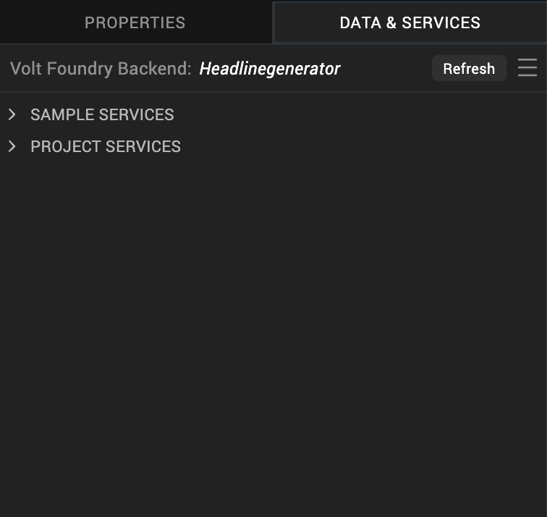

- Under the Configure Services tab, click Integration and can see theNLP Cloud Headline Generation. Click on the Integration service to add the keys.
For the Host URL,replace the value of the endpoint URL mentioned inM NLP Cloud Headline Generationoverview . Refer NLP Cloud Headline Generation Documentation.
- 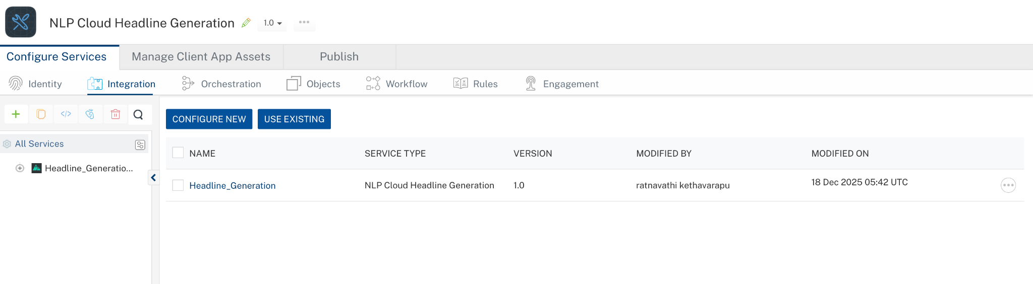
- Click on the Headline_Generation integration service to expand the operations.
- Select each operation, On the Request Input tab, in the Body section, specify the values in the respective boxes under the Test Value column.
- For Key, In the box under the TEST VALUE and DEFAULT VALUE columns, type the API Key generated from NLP Cloud Headline Generation Dashboard.
- Click SAVE OPERATION.
- Click SAVE AND FETCH RESPONSE. The Output Result dialog appears with the response. Otherwise, the Output Result shows an error.
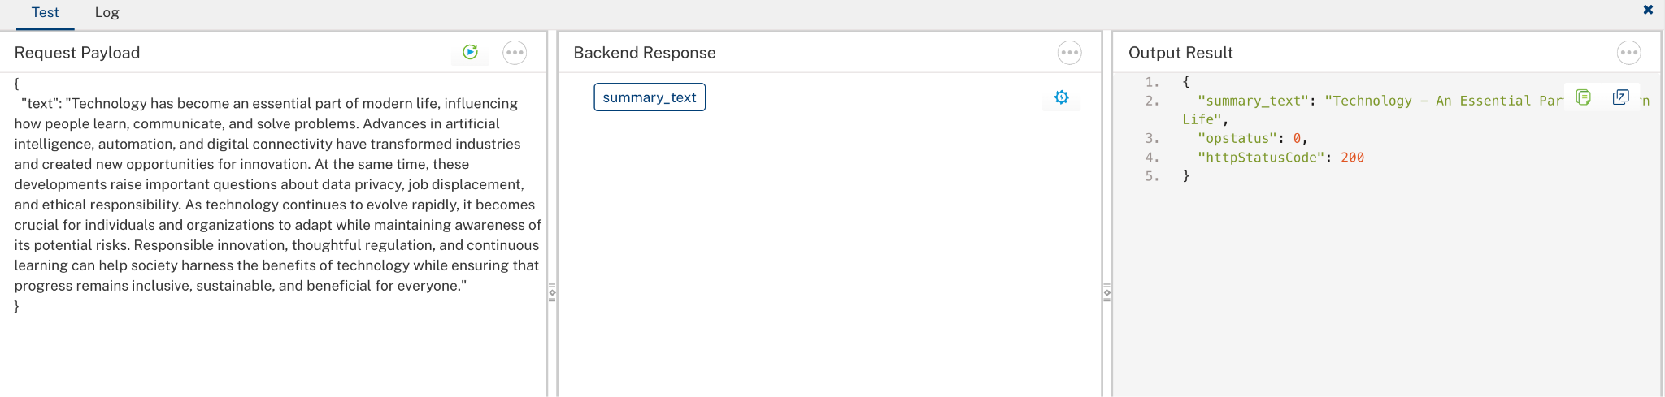

Publish the HCL Volt MX Foundry App
After you set the Operation Security Level, you must publish the HCL Volt MX Foundry app. To publish the HCL Volt MX Foundry, follow these steps:
In Volt MX Iris, click DATA & SERVICES, and then click Publish Project Services to Publish to your foundry app.
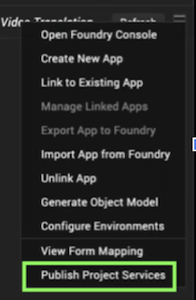
Select the environment to which you want to publish your app, and then click Publish.
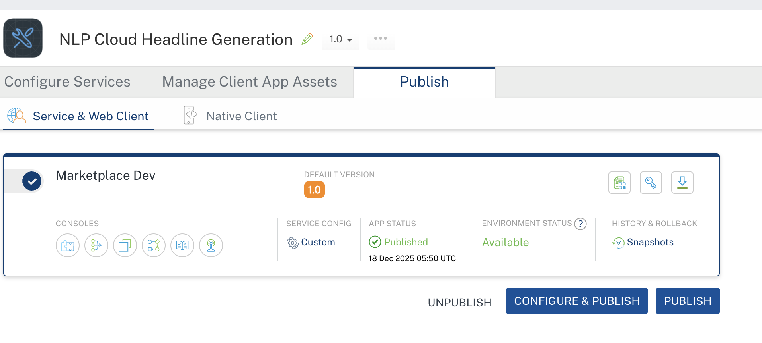

Building and previewing the app
After performing all the above steps, you can build your app and run it on your device. For more information, you can refer to the Building and Viewing an Application section of the Volt MX User Guide.
You can then run your app to see the NLP Cloud Headline Generation Application work in real time.

Reference Documents:
- NLP Cloud Headline Generation Overview
- NLP Cloud Headline Generation Reference

REVISION HISTORY
App version 1.0.1:

Known Issues
None

Limitations
      - API keys may need to be regenerated or replaced periodically due to expiration, security policies, or plan changes, requiring updates in the Foundry Integration Service configuration
      - The NLP Cloud API response time may vary depending on model load and request volume, which can occasionally result in slower headline generation.

