Date : 26-Nov-25

NLP CLOUD QUESTION ANSWERING APPLICATION

VERSION: 1.0.0

Overview
The NLP Cloud Question Answering Application is an interactive chat interface that uses AI to extract precise answers from any text context you provide. Simply paste your context (from articles, documents, or reports), then ask natural-language questions to receive instant, accurate answers. Powered by NLP Cloud’s state-of-the-art language models, it helps you quickly locate key information in long document text without reading everything.

Purpose
This application enables users to:
- Extract specific information from large text using natural-language questions
- Interact with AI-powered question-answering models in a simple, chat-based interface
- Automatically pass previous question-answer context into the next query for deeper continuous understanding
- Ask and receive answers in multiple languages, supported by multilingual NLP models
NLP Cloud Question Answering API is a cloud-based REST service that uses advanced Natural Language Processing (NLP) models to accurately extract or generate answers to user questions from text. You can optionally provide context (a block of text) for the model to use in answering the question. It supports multilingual input (via the multilingual add-on) and works with powerful generative models (e.g., GPT-OSS 120B, LLaMA 3.1 405B, fine-tuned LLaMA 3.3 70B).
Requirements:

- HCL Foundry
- Volt MX Iris
- NLP Cloud API Key
Creating an NLP Cloud Account and API Key:

- Go to https://nlpcloud.com/ and create a free account.
- After signing up, go to the Dashboard.
- Navigate to API Key and Copy the generated API key and store it securely - you will need it while configuring the integration service in Foundry.

Devices:
- Mobile

Platforms:
- Android
- IOS

Features:
- Context-Aware Answering: Provides accurate answers by using the supplied context text, ensuring responses are grounded in your documents.
- Multilingual Question Support: Allows questions and context in multiple languages through multilingual-enabled models.
- Works With or Without Context: Can answer general questions without context or deliver domain-specific answers when context is provided.
- Production-Ready API: Scalable cloud REST API with secure processing, low latency, and easy integration into applications or chatbots.

App Functionality:

Initial Launch Experience: When the app opens, users are greeted with a clean, empty chat screen. The header shows the application title along with a settings gear icon for configuration. A text input field is immediately active, allowing users to start typing their first question.

Settings Configuration Panel: Tapping the settings icon brings up a configuration modal where users can:
- Select the NLP Cloud model of their choice
- Configure the language field for multilingual usage
The modal can be closed using the “X” button. On closing, users are returned to the main chat interface.

Question Input & Submission: Users tap the text box to begin typing; the keyboard slides in while keeping the input field visible. Questions can be submitted by tapping the blue send button or pressing Enter. After submission, the text field clears instantly, and the user’s message appears on the right as a blue chat bubble. The conversation automatically scrolls to the latest message.

AI Response Handling: After a question is submitted, the system sends an HTTP POST request to the NLP Cloud backend integration service. A temporary loading indicator (“…”) shows a bot is processing the request.
Once the response arrives:
- The loading indicator disappears
- The AI’s answer appears as a bubble on the left
- The view auto-scrolls to the latest message
If an error occurs (e.g., API key issue or network failure), an alert or bot error message is shown, allowing users to retry by sending another question.

Multi-Question Conversational Flow: Users can ask questions continuously in a natural chat format. The first question is sent without any context (or from the initial text provided).
For every following question, the previous answer becomes the context for the next API call—creating a smooth, chained conversational flow.
Only the last answer is reused; the app does not accumulate the entire chat history.

Live Updates Through Settings: The settings modal can be opened at any point during the chat. Changing the model or language takes effect immediately for all future API calls.
No confirmation step is required—closing the modal finalizes the changes.

Importing the app:
To import the NLP Cloud Question Answering Application into your workspace, follow these steps:
- Open Volt MX Iris
- On the main menu select Forge → Browse.
- Search for the NLPCloudQA Application, and then click Import to Workspace. The app is imported to your workspace. A dialog box appears, confirming that the app has been imported. Click OK.
- Switch to your project containing the NLPCloudQA Application.. To switch to your project, click File → Open → Reference Architecture → <project name>

Building the app:
After performing all the above steps, you can build your app and run it on your device. For more information, you can refer to the Building and Viewing an Application section of the Volt MX User Guide.
You can then run your app to see the NLP Cloud Question Answering Application work in real time.

Configure the UI and settings of the NLP Cloud Question Answering Application
The NLP Cloud Question Answering Application consists of the following component:
- The NLP Cloud Question Answering component is used to allow users to ask a question and interact with it using advanced Natural Language Processing (NLP) models to accurately extract or generate answers to user questions from text.
- Take one form and add the component. Add required widgets and code to create a chat like UI
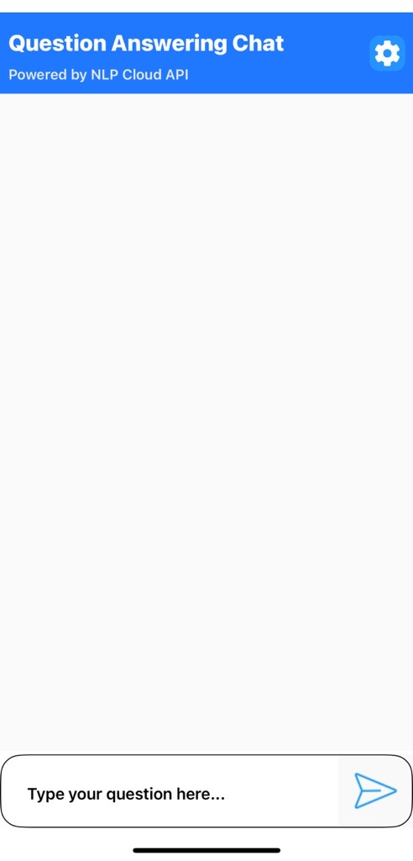
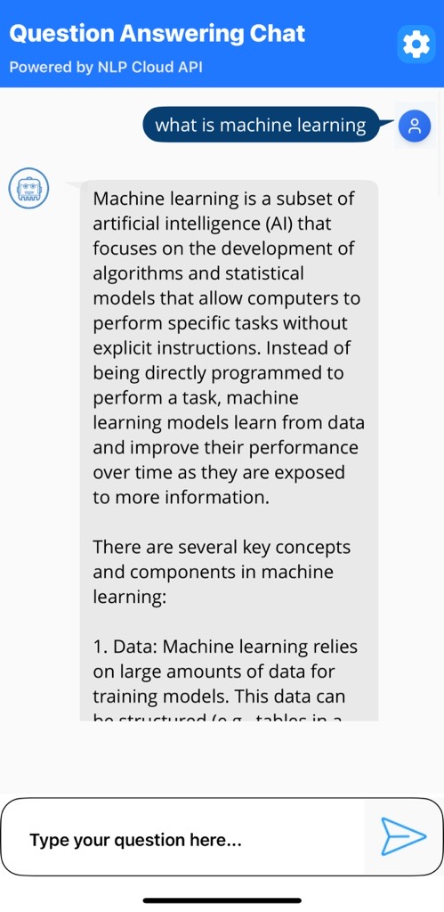

Foundry APP Setup

When you import the application into your Volt MX Iris, the HCL Volt MX Foundry services of the NLP Cloud Question Answering are added to the HCL Volt MX Foundry app, which is associated with the Volt MX Iris project. While importing the NLP Cloud Question Answering Application to your Volt MX Iris project, if there is no HCL Volt MX Foundry app associated with the existing Volt MX Iris project, a new HCL Volt MX Foundry app is automatically added to your HCL Volt MX Foundry environment and is associated with your Volt MX Iris.
To set the Foundry app, follow these steps:
- Click the HCL Volt MX Foundry app associated with your Volt MX Iris project from the Project Explorer. Click DATA & SERVICES
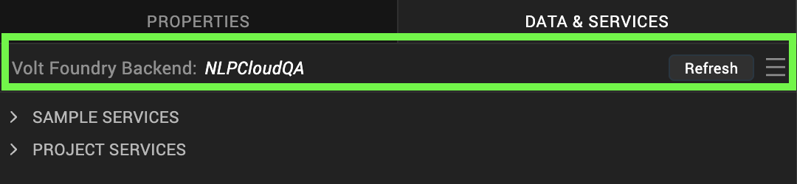
- Under the Configure Services tab, click Integration and can see the Google NLPCloudQA. Click on Integration service to add the keys.
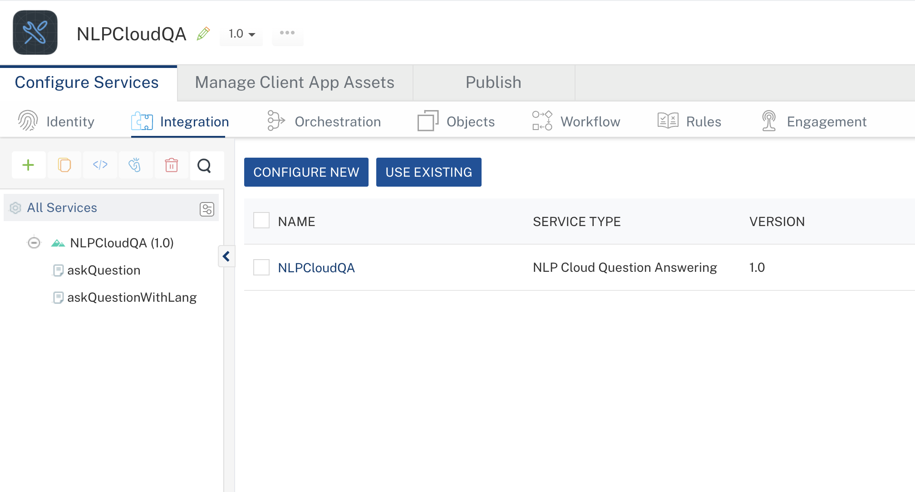
- Click the NLPCloudQA Integration service. On the right pane, expand the NLPCloudQA service and then select the askQuestion operation.
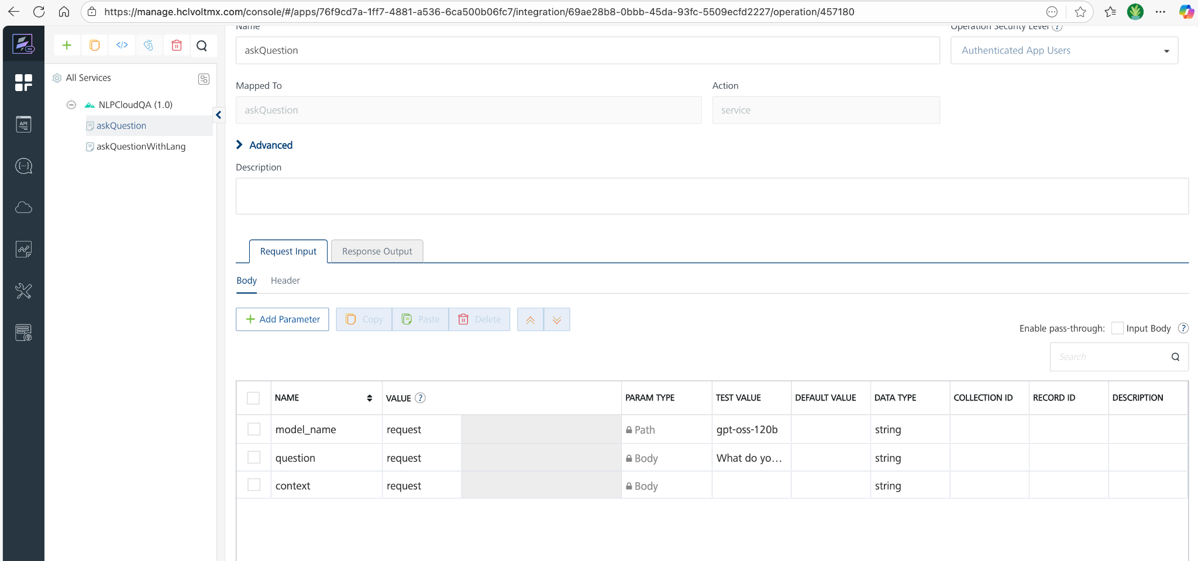
- The askQuestion tab opens with the Request Input sub-tab opened by default.
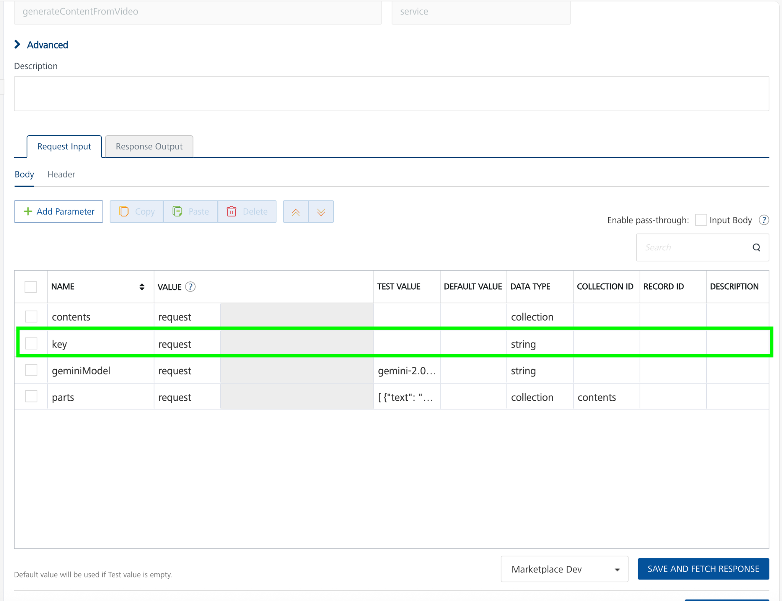
- On the Request Input tab, in the Body section, for the following parameters, specify the values in the respective boxes under the Test Value column.

Parameter | Description | Syntax example
model_name (or similar) | Identifies which model to use for the QA endpoint (e.g., “gpt-oss-120b”). You can find the available models here https://docs.nlpcloud.com/#question-answering | "model_name": "gpt-oss-120b"
question | The question you’re asking the model. | "question": "What is the warranty period on the HP LaserJet Pro?"
context | (Optional) A block of text/document the model may use to find the answer. | "context": "Every HP printer comes with at least a one-year HP commercial warranty..."
NOTE: For askQuestionWithLang operation the language_code parameter specifies the input language of your question and context when using the Multilingual Add-On.
This ensures NLP Cloud automatically translates the input to English, performs question answering, and then translates the answer back to the specified language.
E.g. "hin_Deva" for Hindi, "mar_Deva" for Marathi, "eng_Latn" for English — using codes from the language-list dropdown. You can find the full list of supported language codes in the NLP Cloud documentation: https://docs.nlpcloud.com/#multilingual-add-on
- Click Header sub-tab. The Header section opens.
- For Authorization, In the box under the DEFAULT VALUE column, type the API Key generated from https://nlpcloud.com/home/token.
Syntax: Token Your_API_KEY
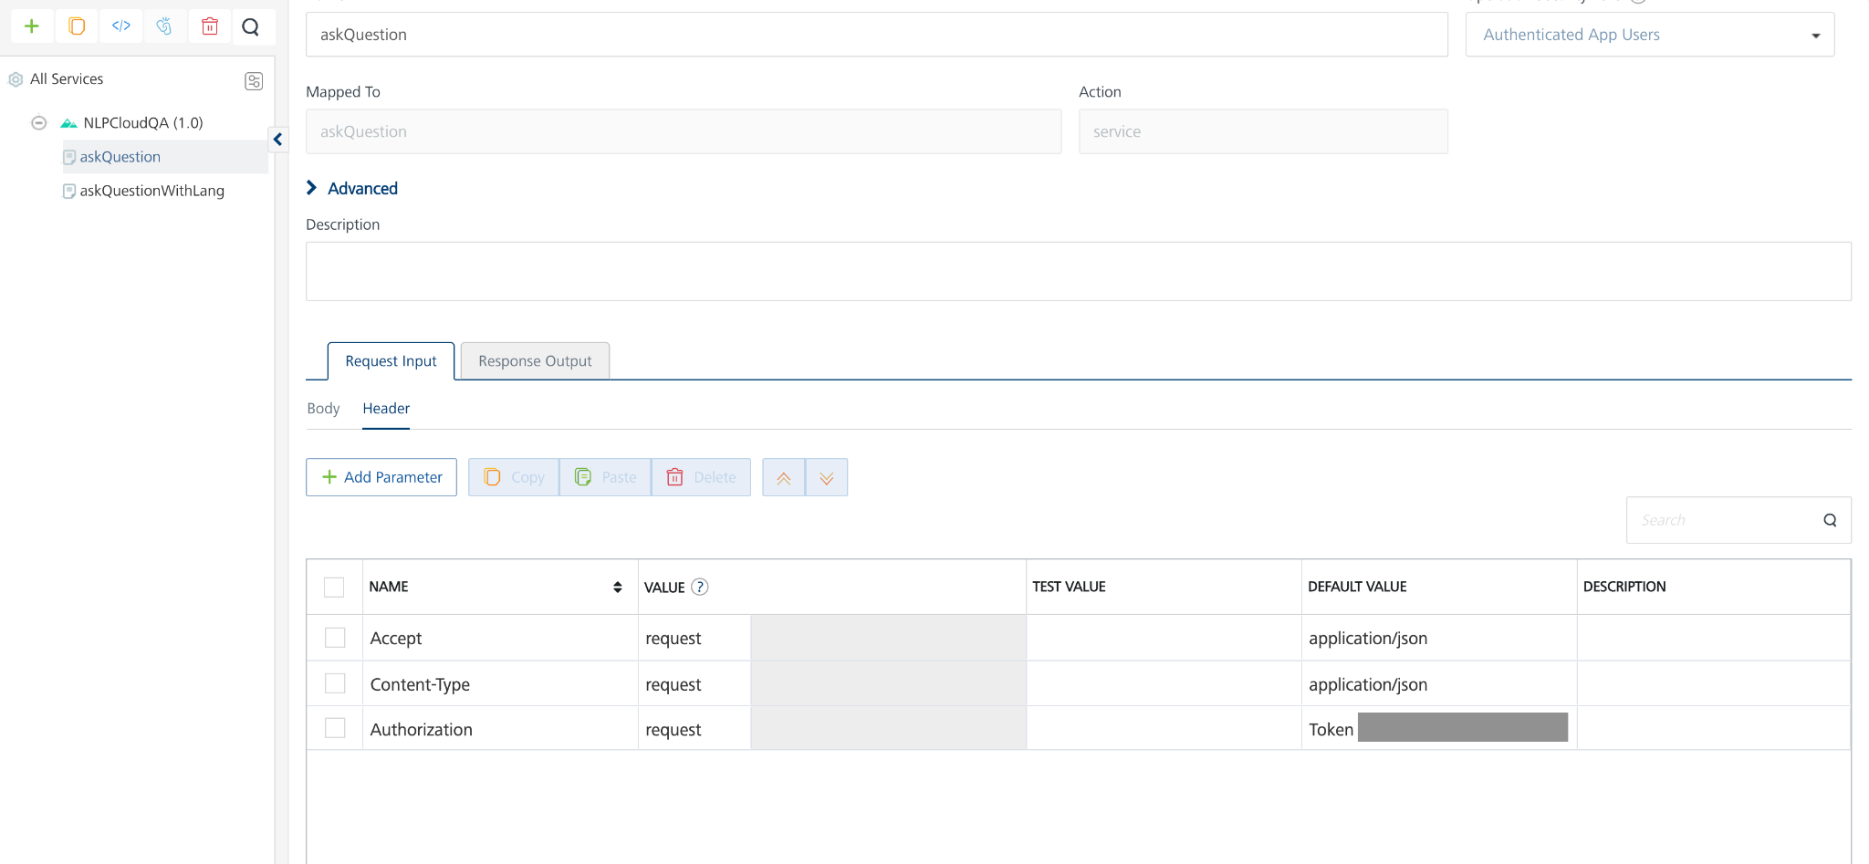
- Click SAVE AND FETCH RESPONSE. The Output Result dialog appears with the response. Otherwise, the Output Result shows an error. 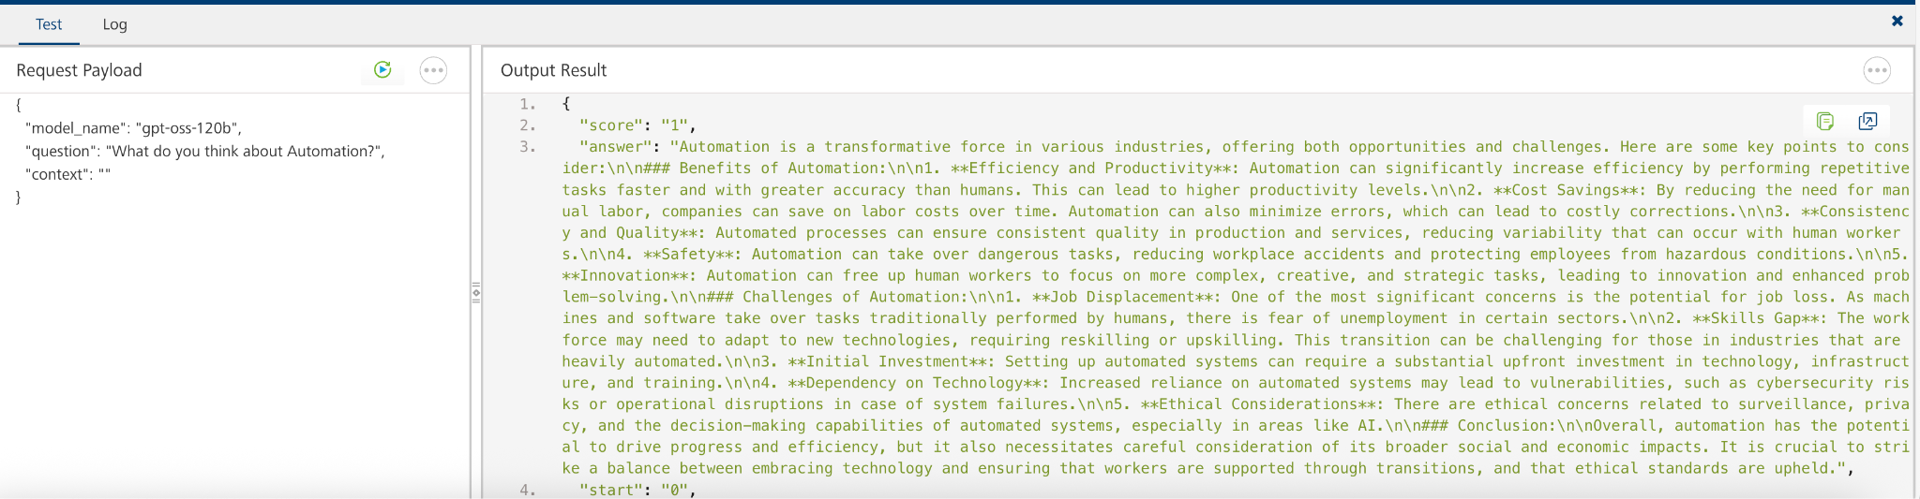
- Click the icon to go back to Volt MX Iris.

Publish the HCL Volt MX Foundry App
After you set the Operation Security Level, you must publish the HCL Volt MX Foundry app. To publish the HCL Volt MX Foundry, follow these steps:
In Volt MX Iris, click DATA & SERVICES, and then click Publish Project Services to Publish to your foundry app.
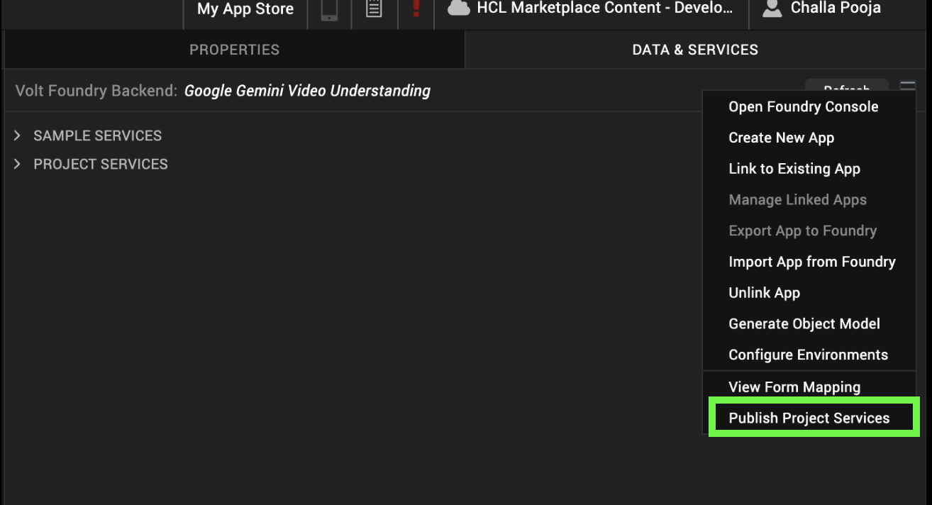
Select the environment to which you want to publish your app, and then click Publish.
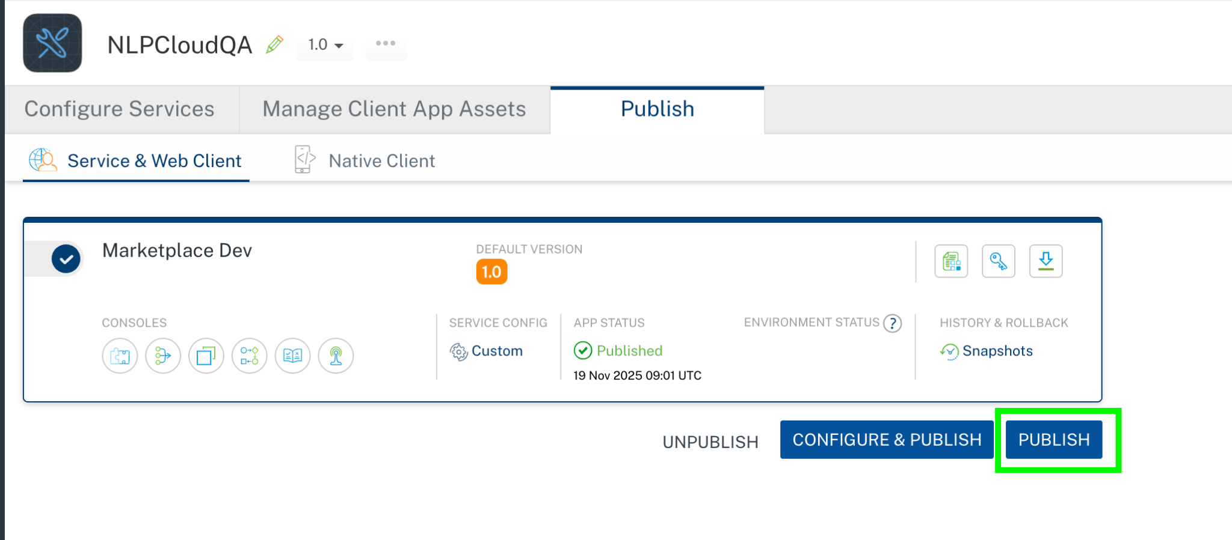
After the app is published to your environment, the following window appears confirming the publish.
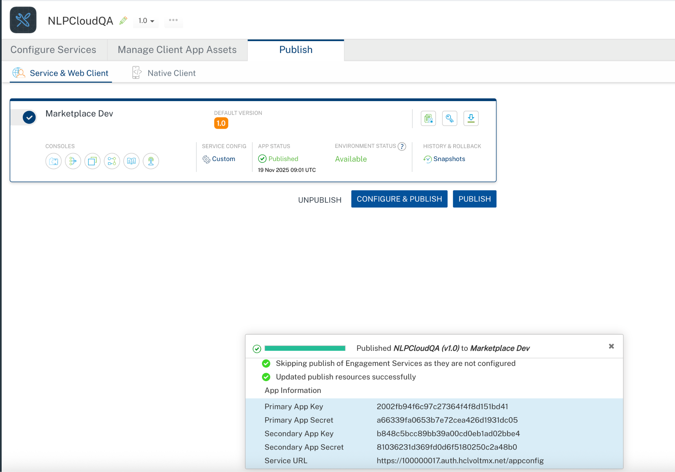

Building and previewing the app
After performing all the above steps, you can build your app and run it on your device. For more information, you can refer to the Building and Viewing an Application section of the Volt MX User Guide.
You can then run your app to see the NLP Cloud Question Answering Application work in real time.

NLP Cloud Question Answering Component Properties:

General Properties

- ModelName

Description: | Specifies which model to use (e.g., “gpt-oss-120b”).
Syntax: | ModelName
Type: | String
Read/Write: | Read + Write
Example: | this.view.NLPCloudQuestionAnswering.ModelName = "gpt-oss-120b";
- Question

Description: | Specifies the question you’re asking the model.
Syntax: | Question
Type: | Integer
Read/Write: | Read + Write
Example: | this.view.NLPCloudQuestionAnswering.Question = "Explain about data science?";

APIs

No APIs

Events

getInput

Description: | Invoked after the input/Question is entered. This getInput should be invoked in the onNavigate function.
Syntax: | getInput
Parameters: | text: The given question or input text
Remarks: | Need to invoke this event to get the input text
Example: | onNavigate: function() {  this.view.NLPCloudQuestionAnswering.getInputText = function(text){  try{  if(text){  alert("Question= "+text);  }  else{  alert("Input is empty");  }  }.bind(this);  }

getGeneratedContent

Description: | Invoked after the component generates the content. This getGeneratedContent should be invoked in the onNavigate function.
Syntax: | getGeneratedContent
Parameters: | response[JSON] : The generated JSON object from the NLP Cloud Question Answering
Remarks: | Need to invoke this event to get the generated content result.
Example: | onNavigate: function() {  this.view.NLPCloudQuestionAnswering.getGeneratedContent = function(generatedContent){  try{  if(generatedContent){  alert("Generated content= "+JSON.stringify(generatedContent));  }  }  catch(err){  voltmx.ui.Alert({  message: "err in getGeneratedContent= "+err.message,  alertType: constants.ALERT_TYPE_INFO,  yesLabel: "OK"  }, {} );  }  }.bind(this);  }

onErrorCallback

Description : Invoked when error occurs.

Syntax : onErrorCallback

Parameters : args [Array of JSON] : Contains information about the error.

Example : this.view.NLPCloudQuestionAnswering.onErrorCallback= function(args)
{
alert("Error: "+JSON.stringify(args));
}.bind(this);

Reference API documentation: https://docs.nlpcloud.com/#question-answering

REVISION HISTORY
Adapter version 1.0.0:

Known Issues
None

Limitations
None

