Date : 17-DEC-25

NLP CLOUD SPEECH SYNTHESIS

VERSION: 1.0.1

OVERVIEW
NLP Cloud Speech Synthesis is a Text-to-Speech (TTS) API that converts written text into natural-sounding human speech.
It uses Microsoft’s Speech T5 model to generate high-quality .wav audio files from text input.
The generated audio is securely hosted on a CloudFront CDN, and the API returns a URL that can be streamed, downloaded, or embedded in applications.
A) Use case:
- Customer Support Voice Bots / IVR
Auto-generate natural voice responses for call centers and automated systems.
- Accessibility Tools
Convert text to audio for visually impaired users or reading assistance tools.
- E-learning Narration
Auto-generate narration for lessons, summaries, and training modules.
- Content Creation & Media
Generate AI voiceovers for videos, podcasts, and news briefings.
- Mobile & Web Apps
Convert dynamic app text (messages, notifications, summaries) into voice output.
- Healthcare Applications
Audio summaries of medical reports for patients or elderly users.

B) Features:
1. Text-to-Speech Conversion: Converts plain English text into high-quality spoken audio using advanced neural speech synthesis models.
2. Natural-Sounding Voices: Powered by Microsoft Speech T5, the service produces human-like speech with clear pronunciation and natural pacing.
C) Percentage of Reuse:
- Approximately 90% reuse.

2. GETTING STARTED

Prerequisites
Before using the NLP Cloud Speech Synthesis Adapter, ensure you have the following:
- HCL Foundry
- Volt MX Iris
- NLP Cloud API Key

Creating an NLP Cloud Account and API Key:

- Go to https://nlpcloud.com/ and create a free account.
- After signing up, go to the Dashboard.
- Navigate to API Key and Copy the generated API key and store it securely - you will need it while configuring the integration service in Foundry.

B. Importing the data adapter

You can import NLP Cloud Speech Synthesis Data Adapter into HCL Foundry directly from the Volt MX Forge website or by importing the data adapter zip file.

To import Data Adapter to Volt Foundry, do the following:
- Sign in to the HCL Foundry.
- From the left navigation menu, select API Management.
- In API Management, select Custom Data Adapters.

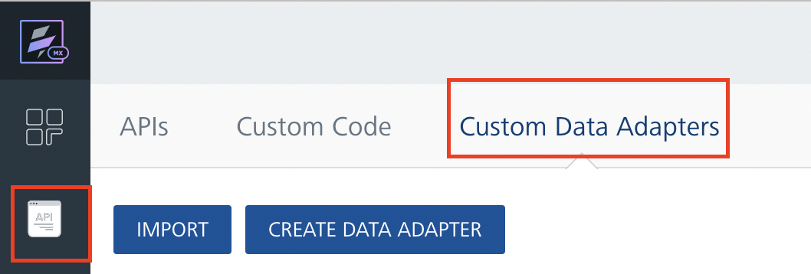
4. Click IMPORT to import a custom data adapter.
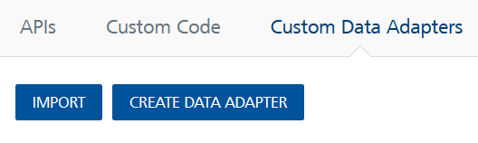
5. On the Import Data Adapter dialog box, click browser to import.

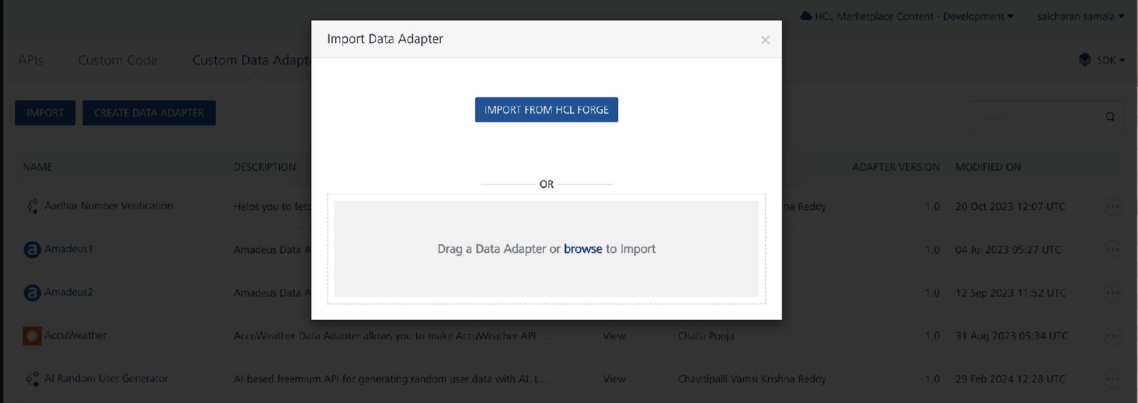

6. Click IMPORT FROM HCL FORGE. The Import Data Adapter from HCL Forge dialog appears with a list of available data adapters.
Click Import. NLP Speech Synthesis data adapter is listed on the Custom Data Adapters page.
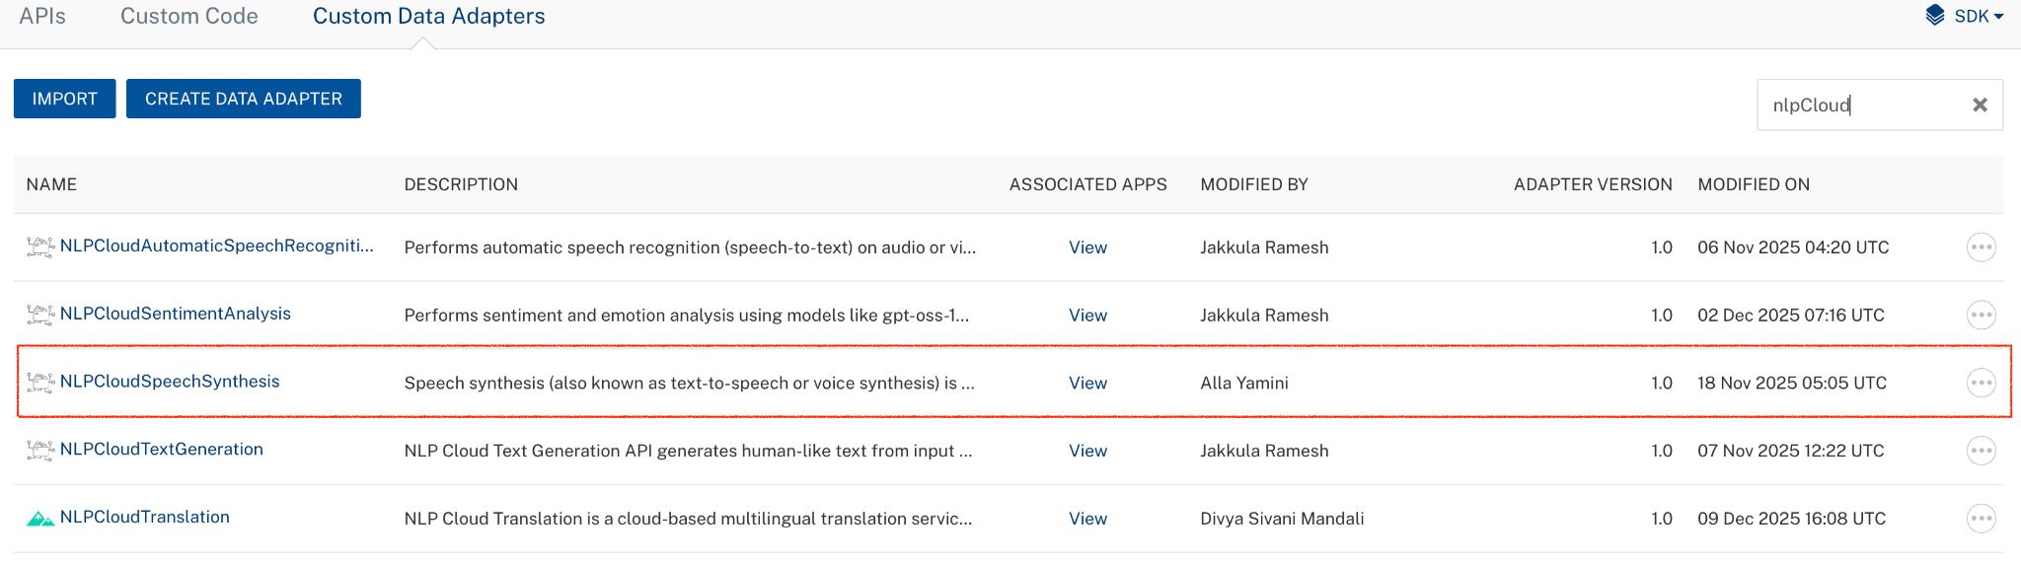
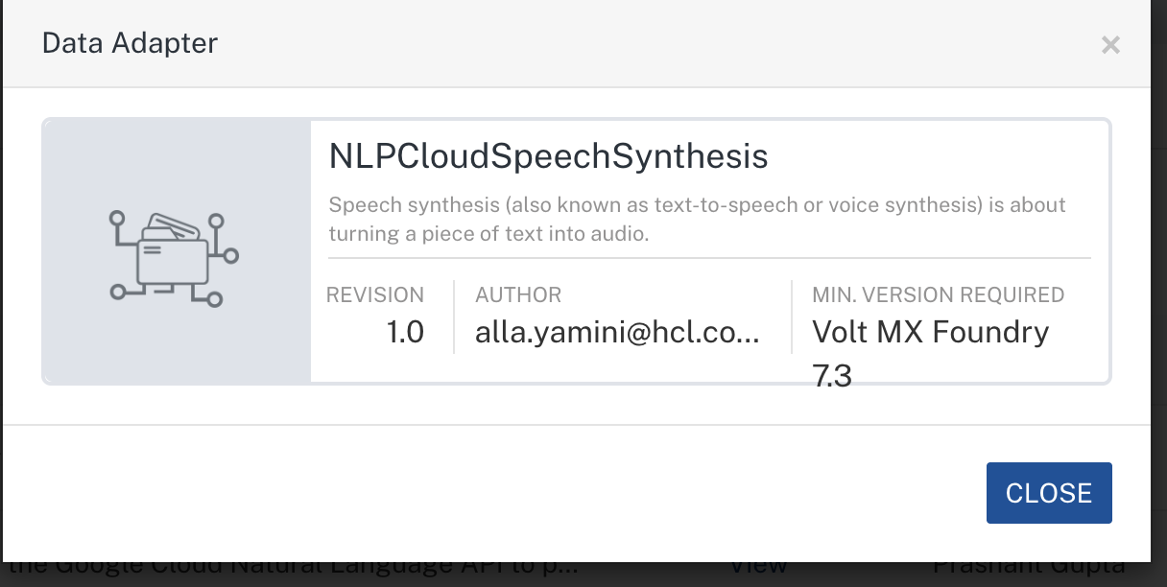
To import the data adapter zip file, do the following:
- Perform steps 1 to 4 in the above procedure
- Drag the data adapter zip file into the Drag a Data Adapter box.
Or
Click browse. The Open dialog appears.
Navigate to the location where you downloaded the data adapter (zip file) on your computer, select the data adapter, and click Open. The Import Data Adapter dialog shows the selected data adapter.
Note: Click Remove if the selected data adapter is not the one that you want to import.

C. Creating an Integration Service with NLP Cloud Speech Synthesis :
After you import the NLP Cloud Speech Synthesis Data Adapter into Foundry, you must create an integration service with a service type as NLPCloudSpeechSynthesis.
To create an integration service with NLP Cloud Speech Synthesis, do the following:
- Log on to your HCL Foundry. The Dashboard page appears by default.
- In the left pane, click the API Management menu. The APIs tab opens by default.
- Click the Integration tab. The Integration tab opens with a list of existing integration services.
- Click CONFIGURE NEW. The Service Definition tab opens.
- In the Name box, type a unique name for your service.
- From the Service Type list, select NLPCloudSpeechSynthesis
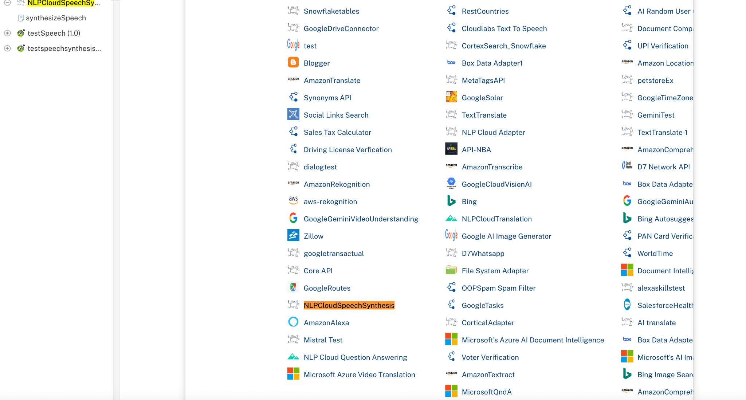
7. Click Save

D. Creating an Operation
To make any API call in the HCL Foundry console, you must create an operation for the respective API and then execute the operation. Executing an operation involves making the API call and displaying the response.
This section provides steps to create an operation for the NLP CloudSpeechSynthesis.
Steps to create an operation for the NLPCloudSpeechSynthesis:
- Log on to your HCL Foundry. The Dashboard page appears by default.
- In the left pane, click the API Management menu. The APIs tab opens by default.
- Click the Integration tab. The Integration page appears with a list of existing integration services.
- From the list of integration services, select the integration service that you have created with the service type as NLPCloudSpeechSynthesis. The Service Definition tab of the selected integration service opens by default.
- Click the Operations List tab. The Operations List tab opens.
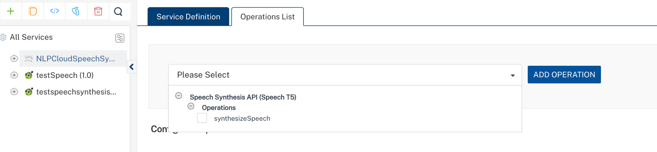
- Select synthesizeSpeech and Click Add Operation.
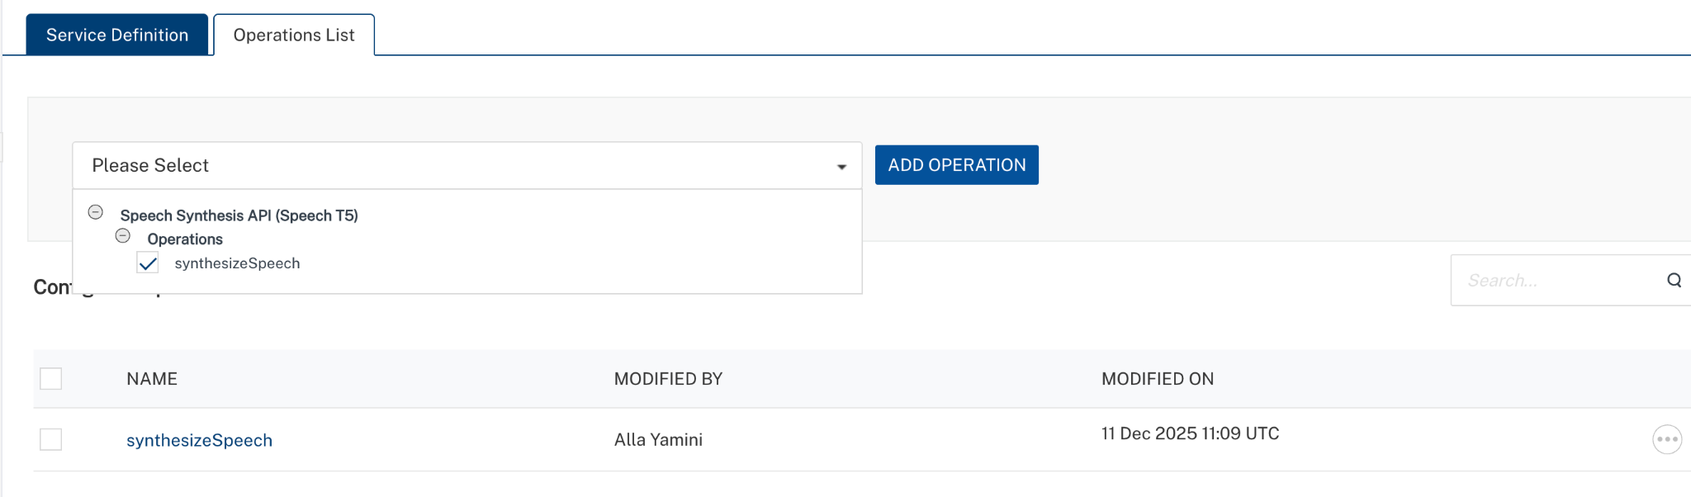

E. Executing Operation
Executing an operation involves making the API call by setting the necessary parameters and displaying the response. The procedure to execute any operation is the same, but the request parameters of the APIs vary. This section provides steps to execute the synthesizeSpeech (explained in Creating an Operation).
Steps to execute the synthesizeSpeech operation:
- Log on to your Hcl Foundry. The Dashboard page appears by default.
- In the left pane, click the API Management menu. The APIs tab opens by default.
- Click the Integration tab. The Integration tab opens with a list of existing integration services.
- From the list of integration services, select the integration service that you have created with service type as NLPCloudSpeechSynthesis. The Service Definition tab of the selected integration service opens by default.
- Click the Operations List tab.
- In the Name box, the name of the operation is displayed by default. If you want, you can change the name.
- On the Request Input tab, in the Body section, for the following parameters, specify the values in the respective boxes under the Test Value or Default Value column.
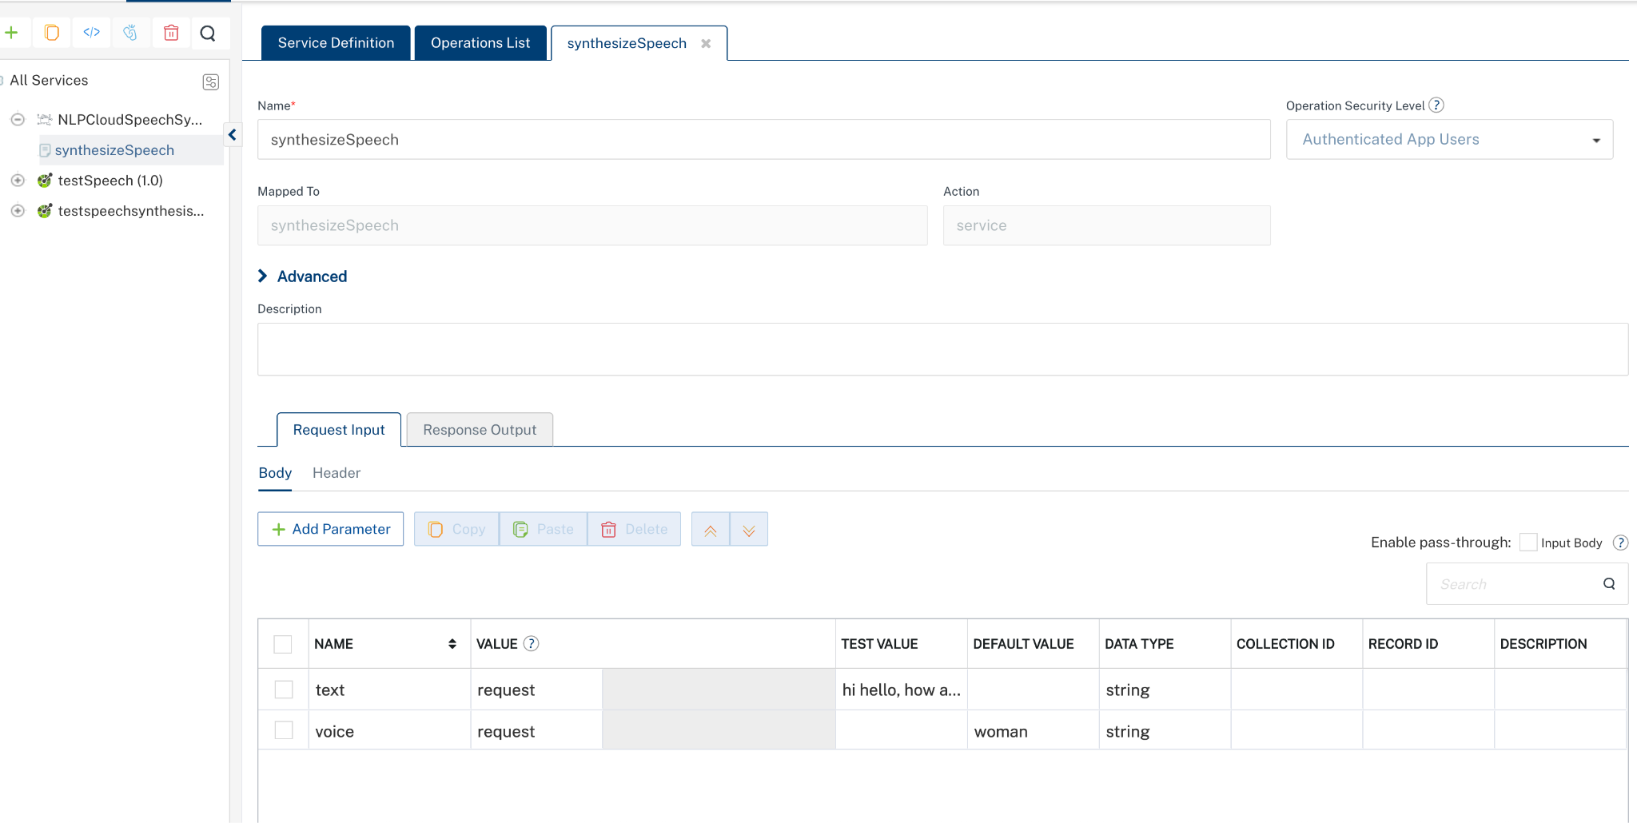
Enter the value of the API key as the default value created during the Creating an NLP Cloud Account and API Key.

NLP Cloud Speech Synthesis accepts the API key in the format: Token YOUR_API_KEY in the Headers.
In the Header section, for the following parameters, specify the values in the respective boxes under the Test Value or Default Value column.
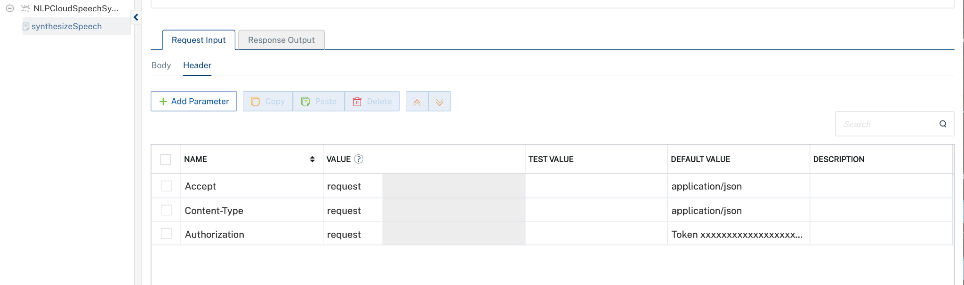

- Click SAVE AND FETCH RESPONSE. The Output Result dialog appears with the response. Otherwise, the Output Result shows an error.
. 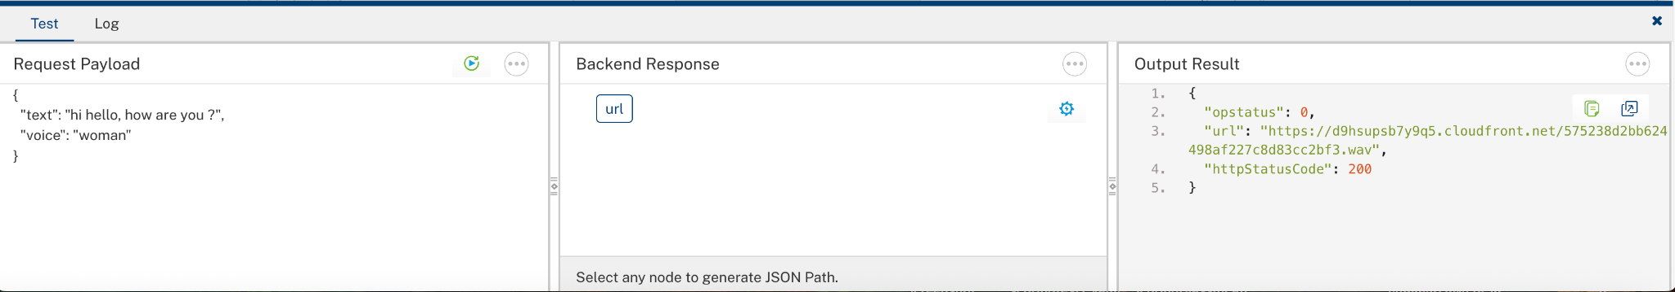

3. Publishing the App in VoltMX FOUNDRY:
After adding the NLP Cloud Speech Synthesis Data Adapter to your app and configuring the necessary configurations, you must publish the app to HCL Foundry. For more information, refer to Publish a foundry app.
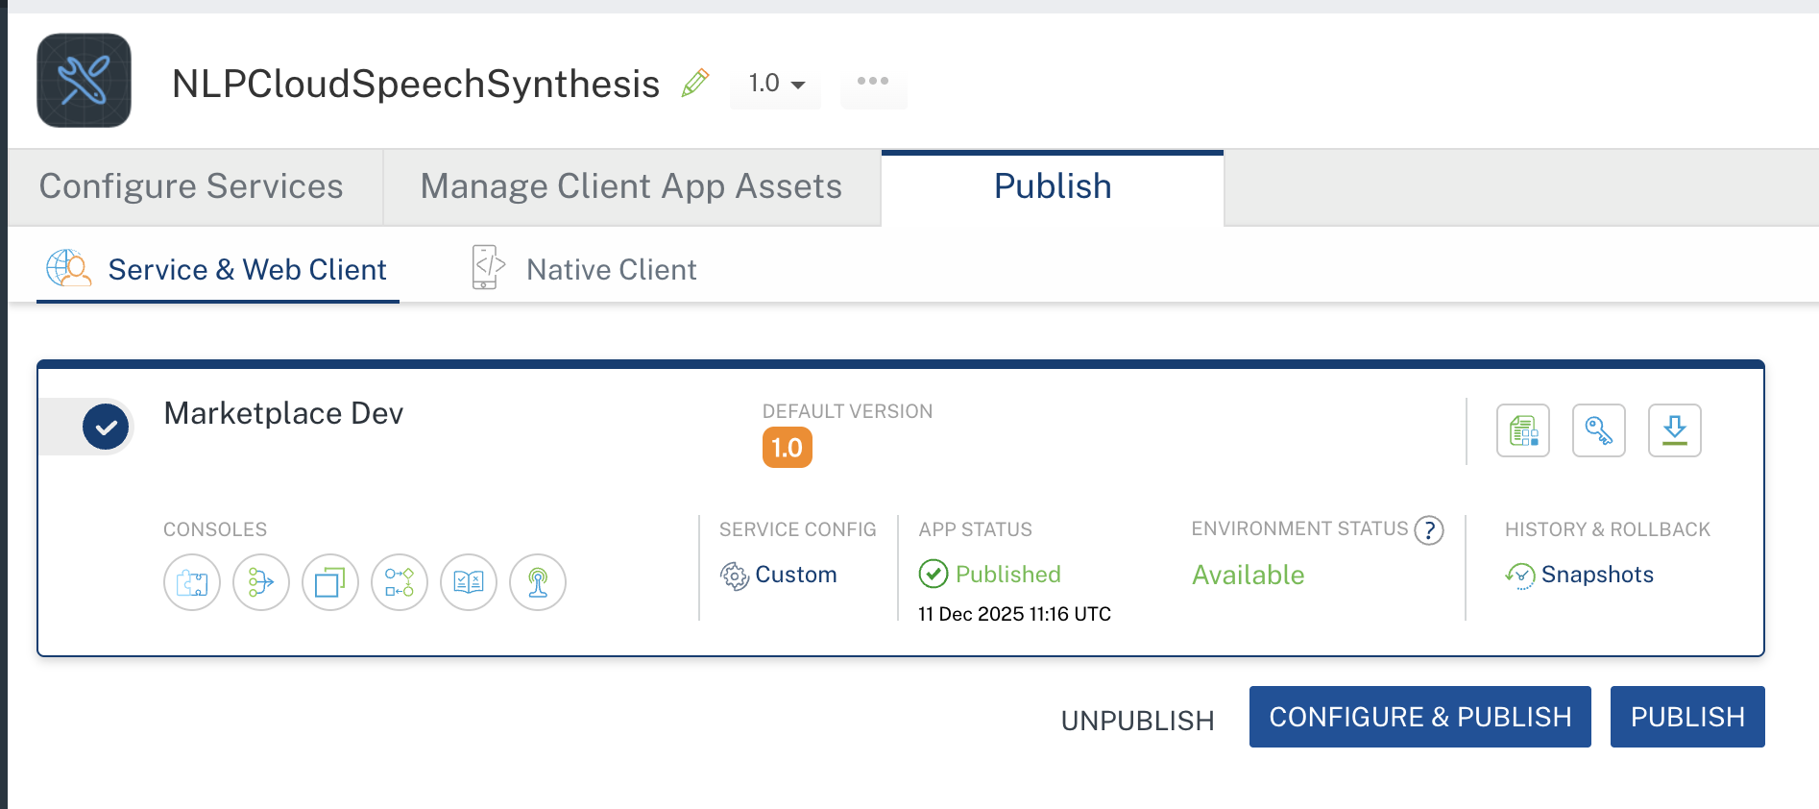
4. REFERENCES

Endpoint Documentation
https://nlpcloud.com/pricing.html

https://docs.nlpcloud.com/#speech-synthesis

5. REVISION HISTORY
Adapter version 1.0.0:

Known Issues
None

Limitations
- Language Restriction
The Speech Synthesis API supports English only. Non-English text is not supported and may result in errors or incorrect output.
- Input Size Limitation
The maximum supported input size is approximately 512 tokens (around 2000 characters). Text exceeding this limit will be rejected or return a payload-too-large error.

