Date : 17-DEC-25

NLP CLOUD SPEECH SYNTHESIS APPLICATION

VERSION: 1.0.1

OVERVIEW
NLP Cloud Speech Synthesis is a Text-to-Speech (TTS) API that converts written text into natural-sounding human speech.
It uses Microsoft’s Speech T5 model to generate high-quality .wav audio files from text input.
The generated audio is securely hosted on a CloudFront CDN, and the API returns a URL that can be streamed, downloaded, or embedded in applications.
A) Use case:
- Customer Support Voice Bots / IVR
Auto-generate natural voice responses for call centers and automated systems.
- Accessibility Tools
Convert text to audio for visually impaired users or reading assistance tools.
- E-learning Narration
Auto-generate narration for lessons, summaries, and training modules.
- Content Creation & Media
Generate AI voiceovers for videos, podcasts, and news briefings.
- Mobile & Web Apps
Convert dynamic app text (messages, notifications, summaries) into voice output.
- Healthcare Applications
Audio summaries of medical reports for patients or elderly users.
B) Features:
1. Text-to-Speech Conversion: Converts plain English text into high-quality spoken audio using advanced neural speech synthesis models.
2. Natural-Sounding Voices: Powered by Microsoft Speech T5, the service produces human-like speech with clear pronunciation and natural pacing.
C) Percentage of Reuse:
- Approximately 90% reuse.

2. GETTING STARTED

Prerequisites
Before using the NLP Cloud Speech Synthesis App, ensure you have the following:
- HCL Foundry
- Volt MX Iris
- NLP Cloud API Key

Creating an NLP Cloud Account and API Key:

- Go to https://nlpcloud.com/ and create a free account.
- After signing up, go to the Dashboard.
- Navigate to API Key and Copy the generated API key and store it securely - you will need it while configuring the integration service in Foundry.

B. Devices
- Mobile

C. Platforms Supported
- Android
- iOS

D. Importing the App
To import the NLP Cloud Speech Synthesis App to Volt MX Iris, do the following:
To import the NLP Cloud Speech Synthesis App, do the following:
- Launch Volt MX Iris.
- Click project, and then select Import. The Import dialog box appears.
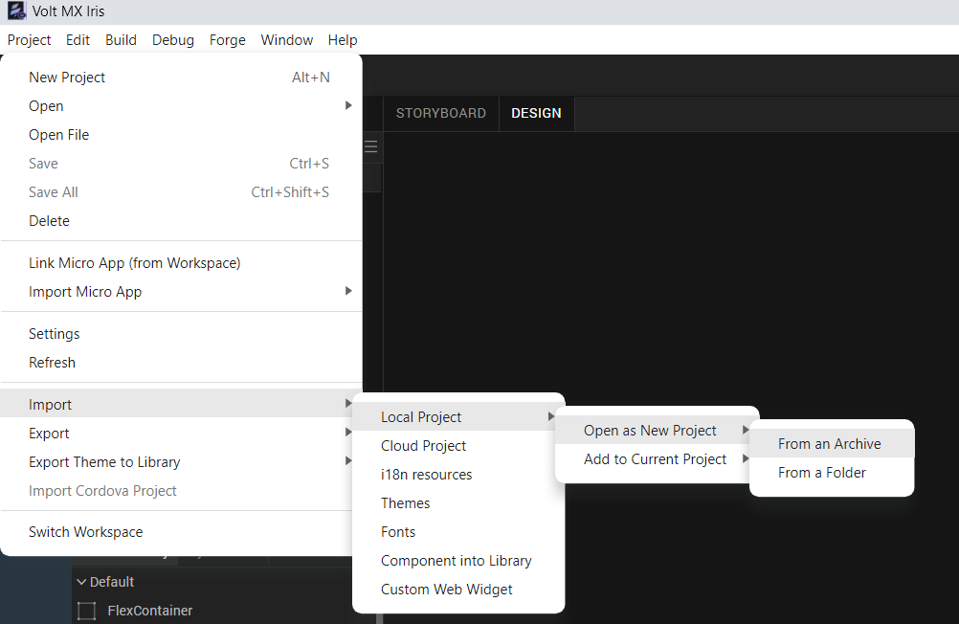
- Click From an Archive to navigate to the location of the project, select the files, and then click Import.
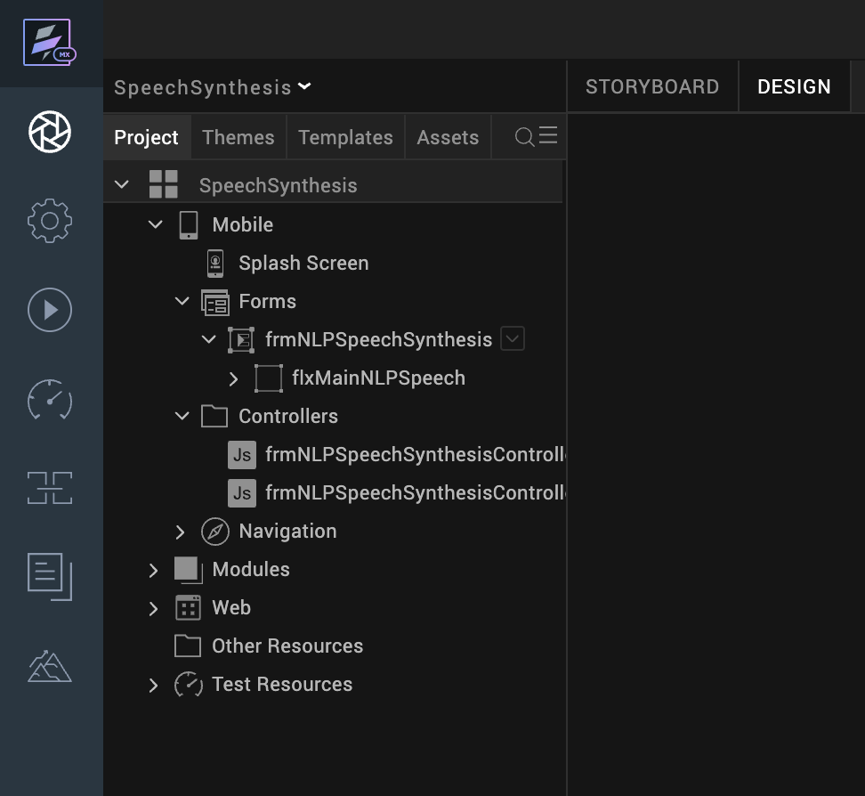
- After you import the application, you can view the associated Foundry app connected at the Data & Services section.
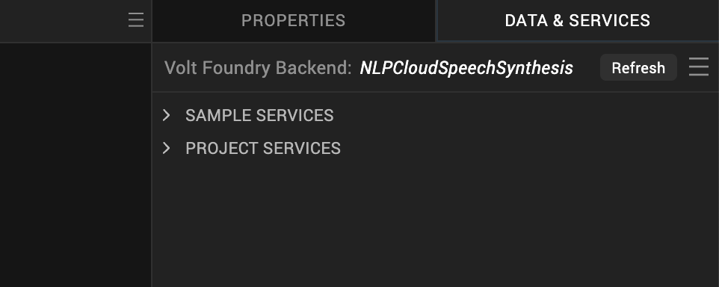

E. NLP Cloud Speech Synthesis Volt MX Foundry Services

When you import the application to your Volt MX Iris project, the HCL Volt MX Foundry services of the NLP Cloud Speech Synthesis are added to the HCL Volt MX Foundry app, which is associated with the Volt MX Iris project. While importing the NLP Cloud Speech Synthesis App to your Volt MX Iris project, if there is no HCL Volt MX Foundry app associated with the existing Volt MX Iris project, a new HCL Volt MX Foundry app is automatically added to your HCL Volt MX Foundry environment and is associated with your Volt MX Iris.
To set up the Foundry app, follow these steps:

Click the HCL Volt MX Foundry app associated with your Volt MX Iris project from the Project Explorer. Click on DATA & SERVICES.

2. Under the Configure Services tab, click Integration and can see the NLPCloudSpeechSynthesis Integration service. Click on that Integration service to add the keys.

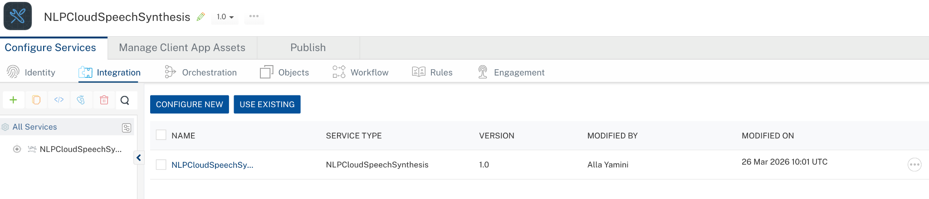

3. Click the Operations List tab. The Operations List tab opens with the list of operations available.
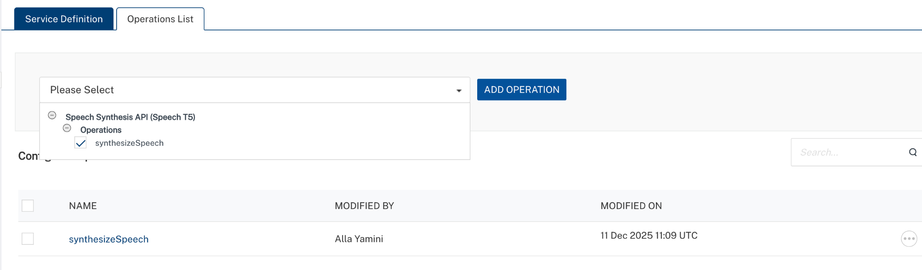

4. Executing Operation
Executing an operation involves making the API call by setting the necessary parameters and displaying the response. The procedure to execute any operation is the same, but the request parameters of the APIs vary. This section provides steps to execute the synthesizeSpeech (explained in Creating an Operation).
Steps to execute the synthesizeSpeech operation:
- Log on to your Hcl Foundry. The Dashboard page appears by default.
- In the left pane, click the API Management menu. The APIs tab opens by default.
- Click the Integration tab. The Integration tab opens with a list of existing integration services.
- From the list of integration services, select the integration service that you have created with service type as NLPCloudSpeechSynthesis. The Service Definition tab of the selected integration service opens by default.
- Click the Operations List tab.
- In the Name box, the name of the operation is displayed by default. If you want, you can change the name.
- On the Request Input tab, in the Body section, for the following parameters, specify the values in the respective boxes under the Test Value or Default Value column.
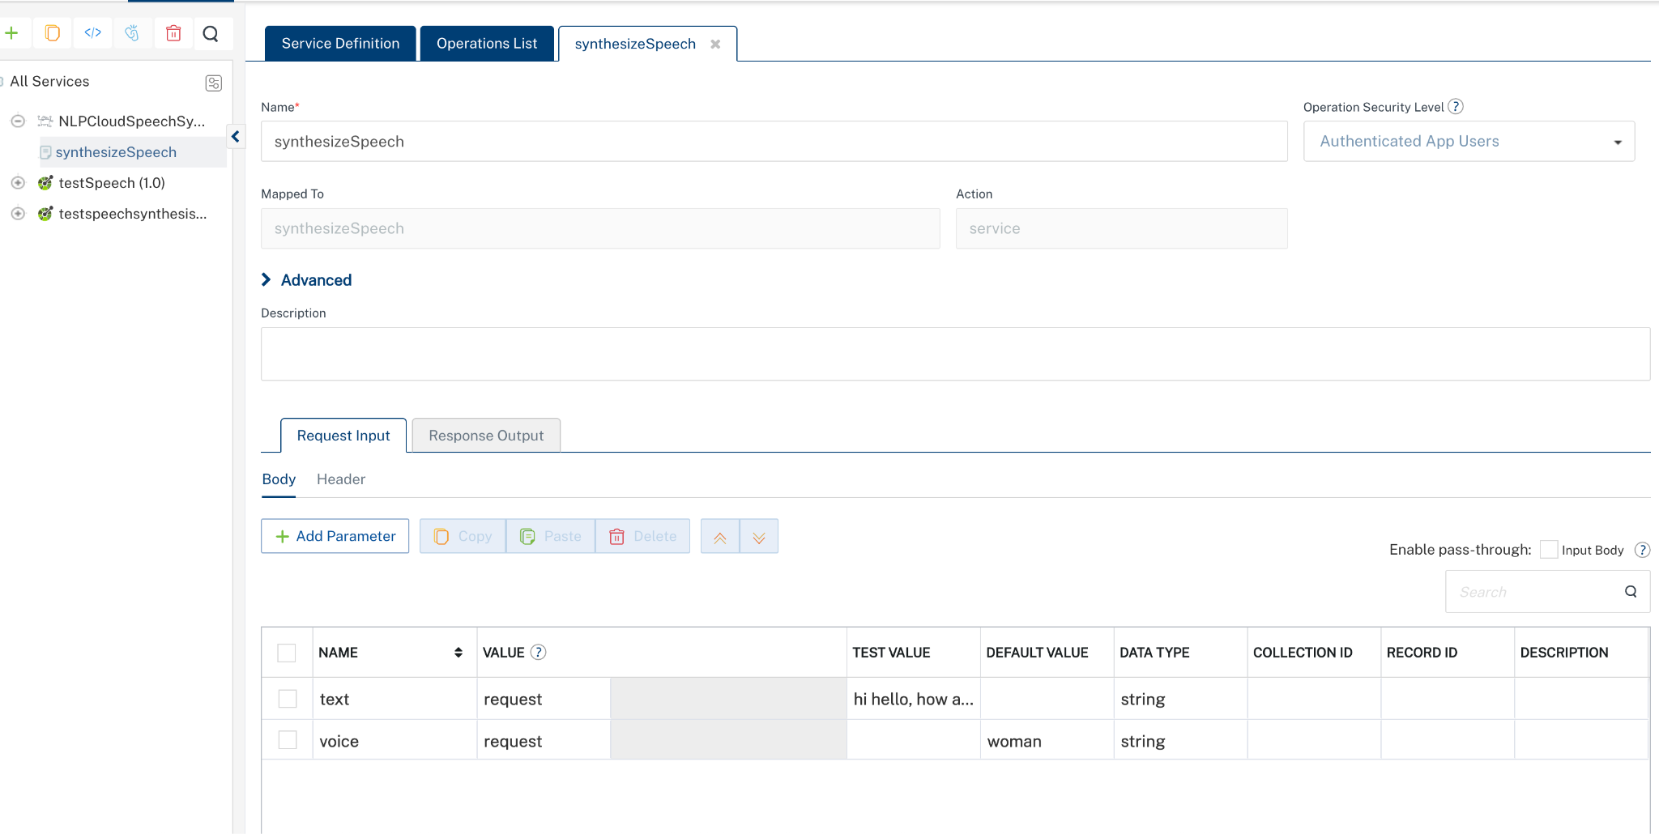
Enter the value of the API key as the default value created during the Creating an NLP Cloud Account and API Key.

NLP Cloud Speech Synthesis accepts the API key in the format: Token YOUR_API_KEY in the Headers.
In the Header section, for the following parameters, specify the values in the respective boxes under the Test Value or Default Value column.
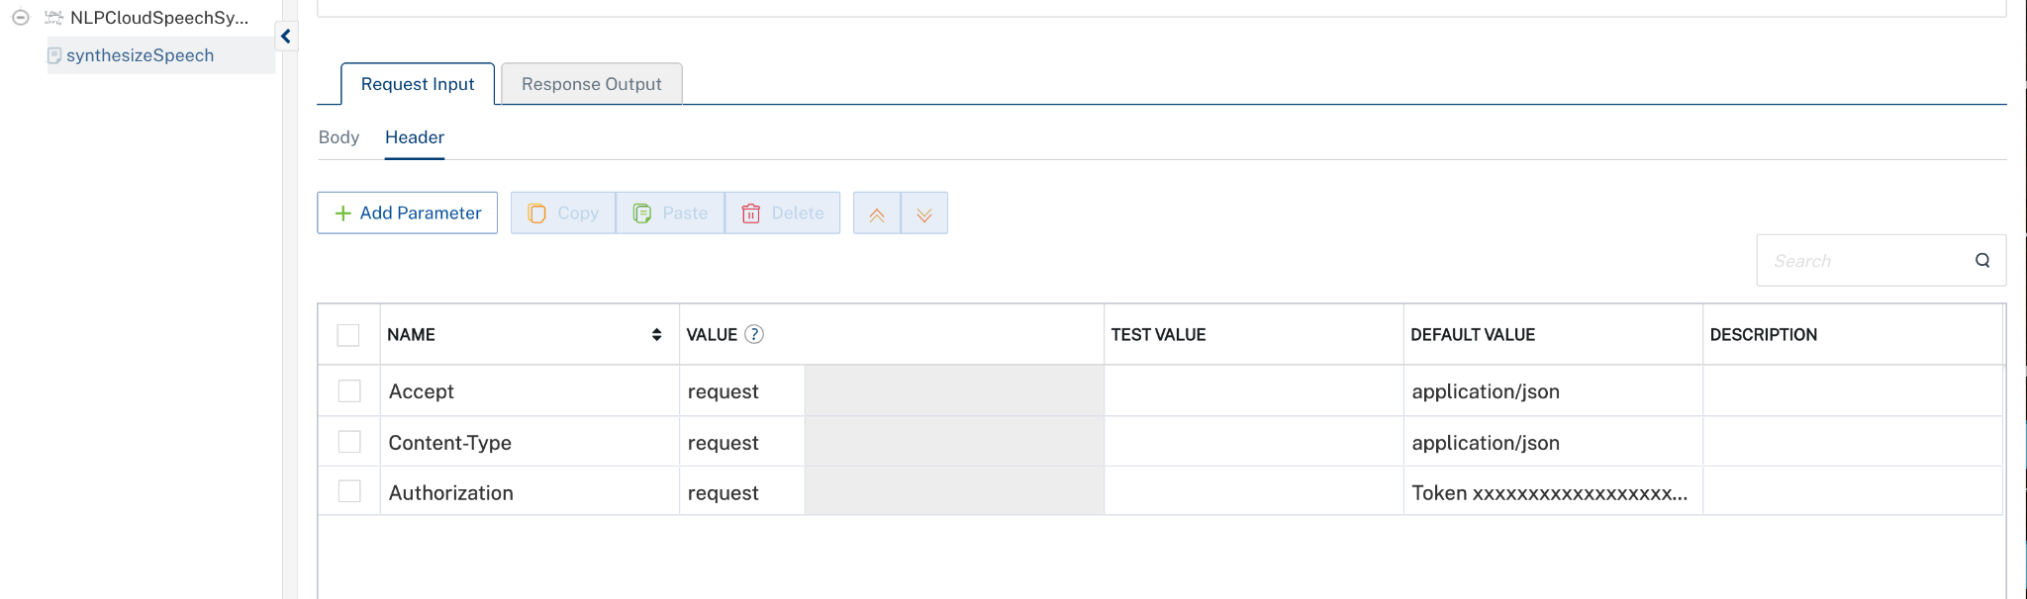
8. Click SAVE AND FETCH RESPONSE. The Output Result dialog appears with the response. Otherwise, the Output Result shows an error.
. 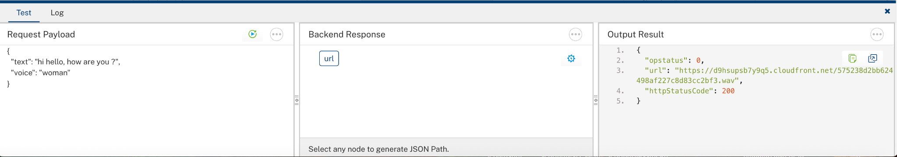

5. Publishing your application
After you set the Operation Security Level, you must publish the HCL Volt MX Foundry app. To publish the HCL Volt MX Foundry, follow these steps:

In Volt MX Iris, click DATA & SERVICES, and then click Publish Project Services to Publish to your foundry app.
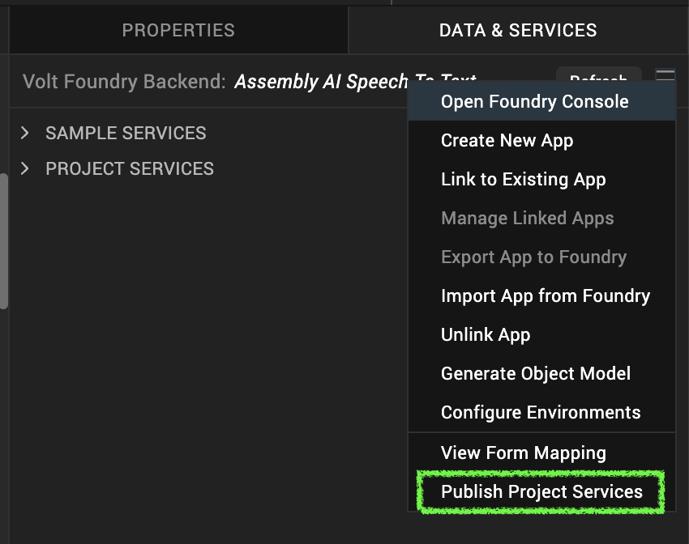
Select the environment to which you want to publish your app, and then click Publish. After the app is published to your environment, the following window appears confirming the publish.
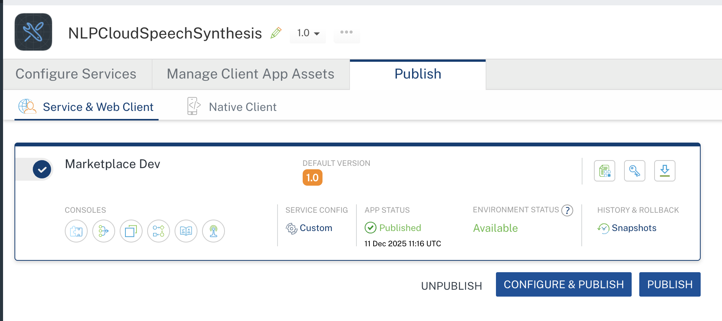

F. Building the app
From the menu bar, go to Build and then select Build Native Local.

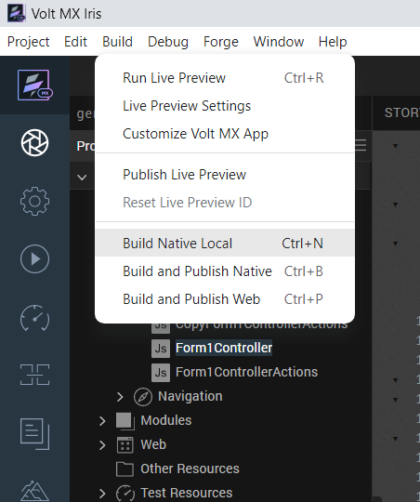

For Mobile, select Android and iOS. Click Build.

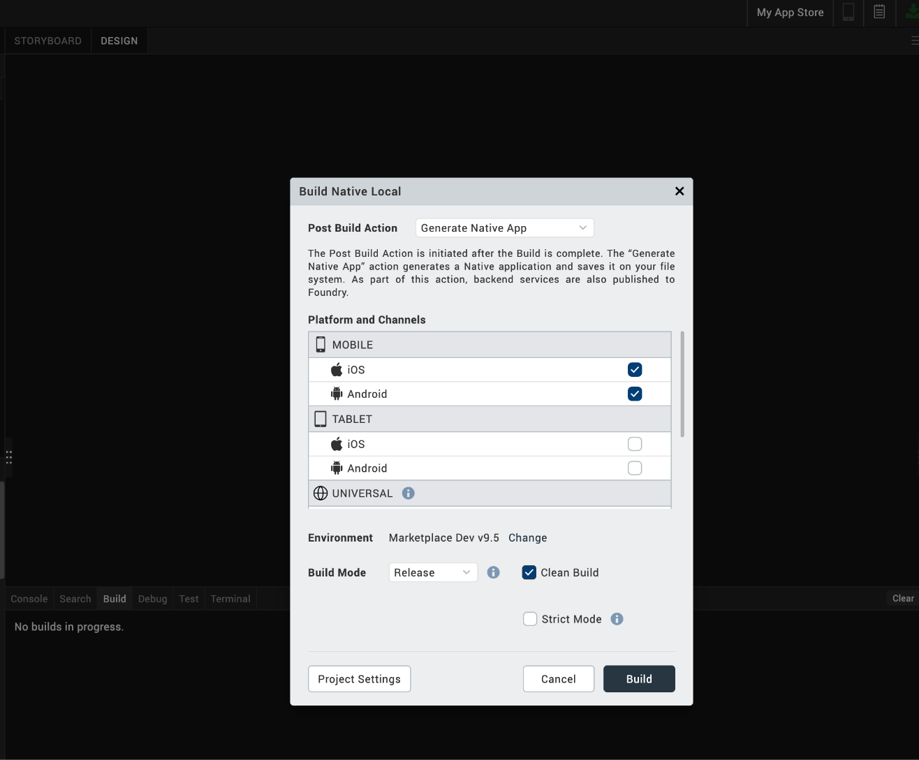

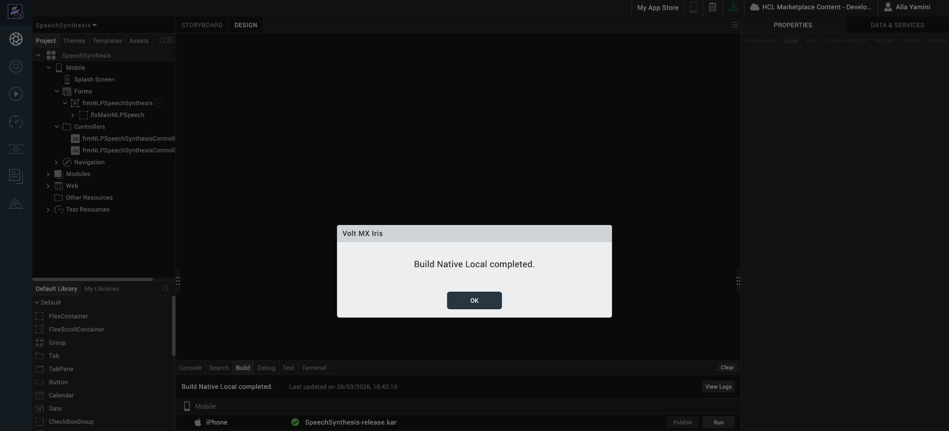

After the build is successful, run the app on your mobile device.

G. Application Flow

The landing page for the app is as follows:

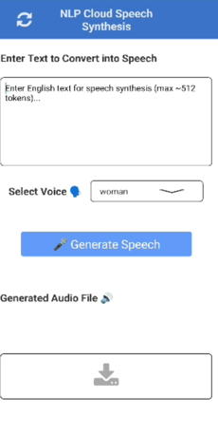
Enter your input text in the input textarea field and select the voice. The API analyzes the text and returns the generated audio .wav file and if we click on the download button it gets downloaded to the device.

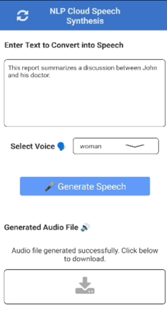
Downloaded file looks like:

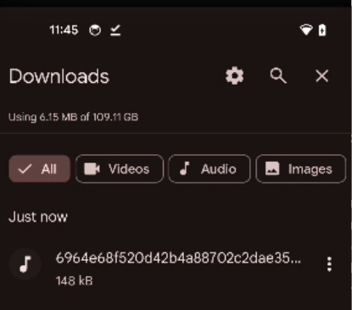

Note: NLP Cloud Speech Synthesis Adapter is present in the Marketplace page.
Marketplace link:

3. REFERENCES

Endpoint Documentation
https://nlpcloud.com/pricing.html

https://docs.nlpcloud.com/#speech-synthesis

4. REVISION HISTORY
Adapter version 1.0.0:

Known Issues
None

Limitations
- Language Restriction
The Speech Synthesis API supports English only. Non-English text is not supported and may result in errors or incorrect output.
- Input Size Limitation
The maximum supported input size is approximately 512 tokens (around 2000 characters). Text exceeding this limit will be rejected or return a payload-too-large error.

