Date : 15-May-26

NVIDIA NIM APPLICATION

VERSION: 1.0.0

OVERVIEW
The NVIDIA NIM sample application provides a clean, chat-focused mobile interface to interact with NVIDIA-hosted LLM inference endpoints through VoltMX Foundry. Built on the NIM API, it demonstrates how enterprise apps can integrate conversational AI using a single, standardized backend service.
The app abstracts the complexity of model selection and API handling, letting users focus on natural conversation through a minimal chat UI — a text input, send button, and scrollable message area. It connects to NVIDIA's endpoint via Foundry, returning structured JSON responses rendered directly in the chat view.

Use case:
- Conversational AI – Multi-turn chat interactions powered by NVIDIA-hosted LLMs such as Mistral and Nemotron.
- Enterprise Chatbot – A reusable chat template for embedding AI assistants into VoltMX mobile apps.
- Model Testing – Quickly test and compare responses across free-tier NIM models by swapping the model parameter.
- Foundry Integration Demo – Validates end-to-end connectivity between a VoltMX app and the NIM API via Foundry backend services.

Features:
- Chat Interface – Clean mobile UI with a scrollable conversation view, text input (txtInput), and Send button (btnSend).
- LLM-Powered Responses – Connects to chat completion for real-time, context-aware AI replies.
- Foundry Backend Integration – All API calls are routed securely through VoltMX Foundry — no direct client-side API exposure.
- Structured Response Handling – JSON responses are parsed and rendered consistently within the chat widget.
- Modular UI Layout – Flex-based component structure for easy customization and extension.
- Lightweight & Focused – Scoped to chat completion only, keeping the implementation simple, readable, and production-adaptable.

Percentage of re-use:
80%

GETTING STARTED

Prerequisites
Before you start using the Nvidia NIM App, ensure you have the following:
- HCL Foundry
- Volt MX Iris
- https://docs.api.nvidia.com/
- API key - https://build.nvidia.com/settings/api-keys

Devices
- Mobile

Platforms
- Android
- IOS

Importing the App
To import the Nvidia NIM App to Volt MX Iris, do the following:

To import the Nvidia NIM App, do the following:
- Launch Volt MX Iris.
- Click project, and then select Import. The Import dialog box appears.
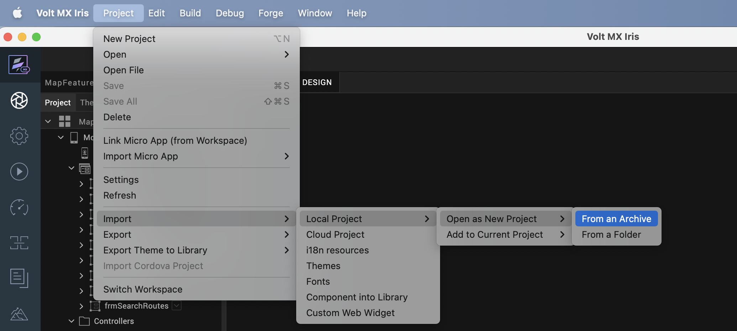

- Click From an Archive to navigate to the location of the project, select the files, and then click Import.
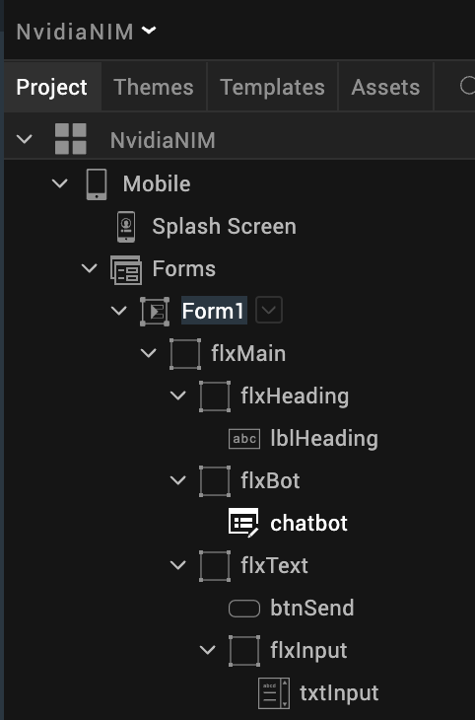
After you import the application, you can view the associated Foundry app connected at the in Data & Services section.
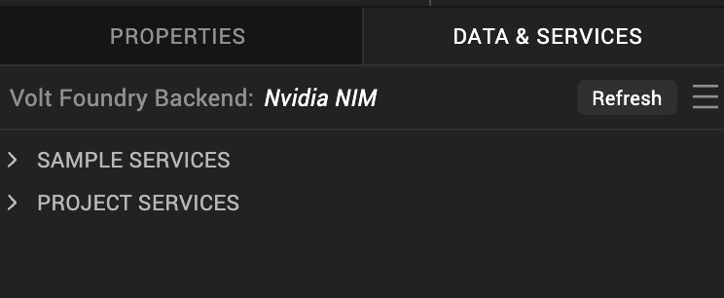

Nvidia NIM Volt MX Foundry Services:
The Nvidia NIM app contains an Integration Service:
Nvidia NIM : NVIDIA NIM provides a Foundry-safe inference integration service to access NVIDIA-hosted AI models for chat, text completion, and embedding capabilities through a single OpenAI-compatible REST interface. It enables seamless interaction with models from Mistral, Meta Llama, NVIDIA Nemotron, and others via standardized JSON endpoints — requiring no binary uploads or streaming payloads, making it fully compatible with VoltMX Foundry adapters.

Operations

1. createChatCompletion
Description: Invokes NVIDIA-hosted LLMs to generate AI responses for conversational and multi-turn text generation tasks.
Endpoint: POST /v1/chat/completions
Inputs:
- model – NVIDIA-hosted model (e.g., mistralai/mistral-7b-instruct, nvidia/nemotron)
- messages – Conversation history with user / assistant roles
- temperature – Controls response randomness
- top_p – Nucleus sampling control
- max_tokens – Maximum output token limit
- stream – Must be set to false for Foundry compatibility
Output: Structured JSON with the generated assistant message.

2. createCompletion
Description: Invokes NVIDIA-hosted LLMs for single-turn, prompt-based text completion — suited for content generation, summarization, and structured output tasks.
Endpoint: POST /v1/completions
Inputs:
- model – Selected free-tier NIM model
- prompt – Input text or instruction
- temperature – Randomness control
- top_p – Sampling control
- max_tokens – Output length limit
- stream – Must be set to false for Foundry compatibility
Output: Structured JSON with the completed text response.

3. createEmbeddings
Description: Generates high-dimensional vector embeddings for input text, enabling semantic search, similarity ranking, and RAG (Retrieval-Augmented Generation) pipelines.
Endpoint: POST /v1/embeddings
Inputs:
- model – Embedding model (e.g., nvidia/llama-nemotron-embed-1b-v2)
- input – Text string or array of strings to embed
- input_type – query or passage (required for asymmetric retrieval models)
Output: JSON array of numeric embedding vectors.

4. listModels
Description: Retrieves the list of currently available NVIDIA-hosted models accessible through the NIM inference API — useful for dynamic model selection at runtime.
Endpoint: GET /v1/models
Inputs: None
Output: JSON list of available model IDs with metadata, filterable to free-tier endpoints from the NVIDIA Model Catalog.

F. Building the app
From the menu bar, go to Build and then select Build Native Local.
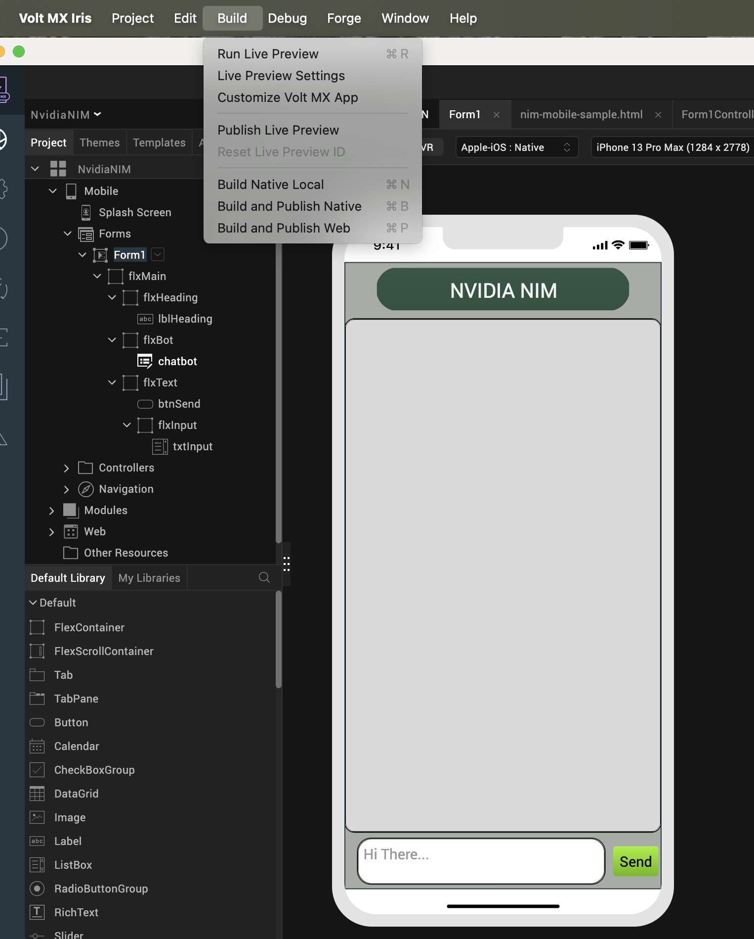

For Mobile, select Android and iOS. Click Build.
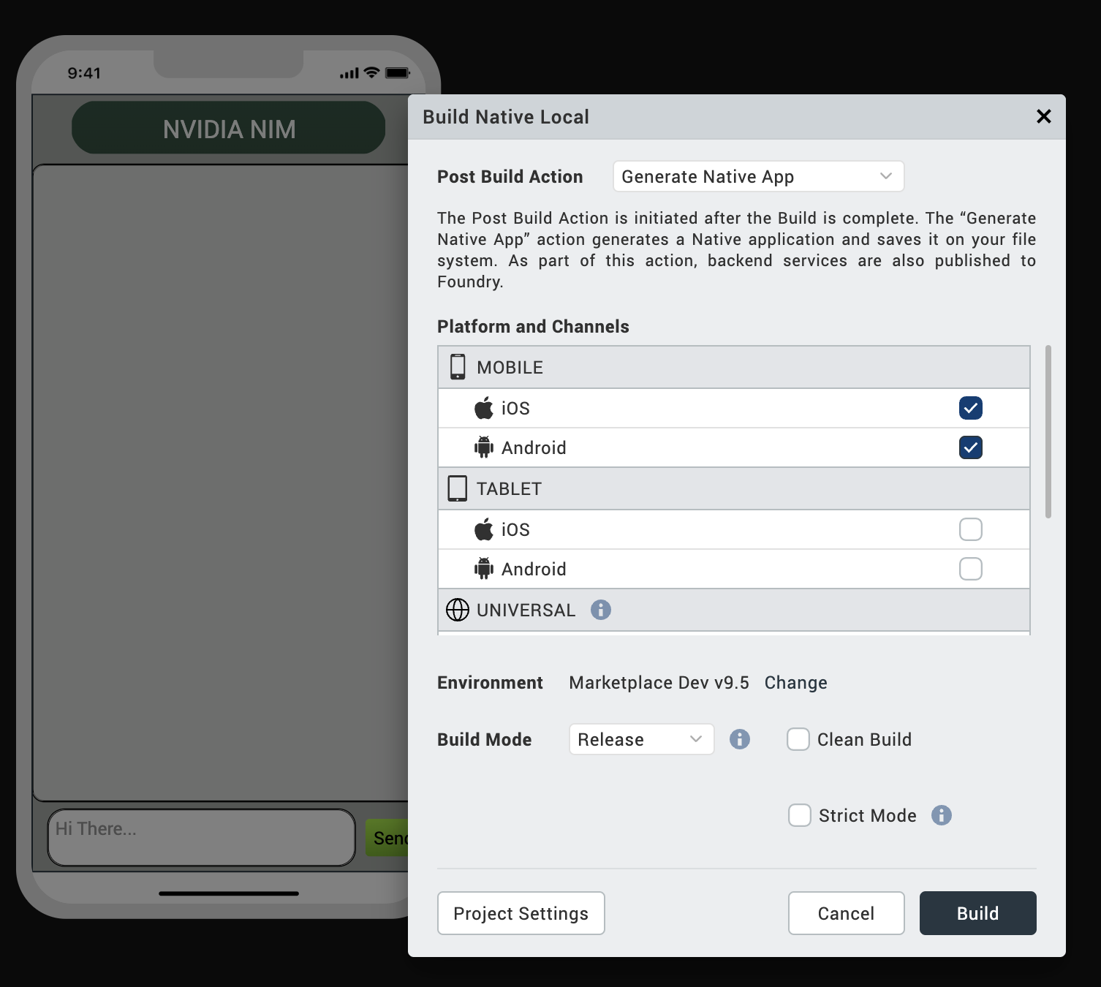

After the build is successful, run the app on your mobile device.

G. Application Flow
1. Landing Page of the application where we can switch between chat and image generation.
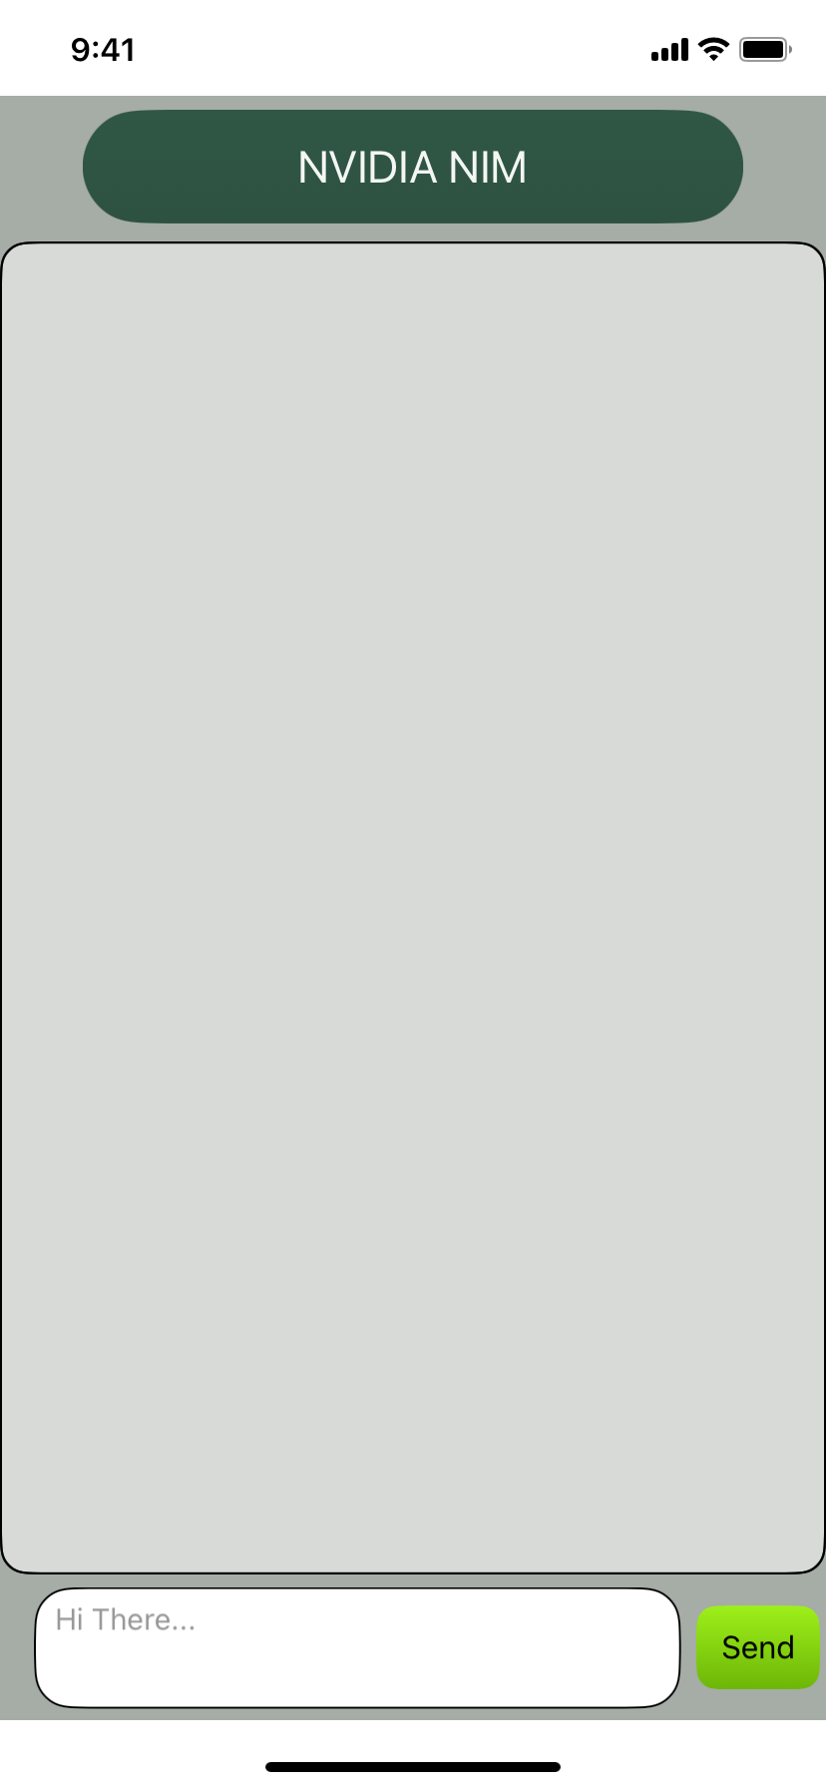

2. Chat using interactive UI with provided model system.

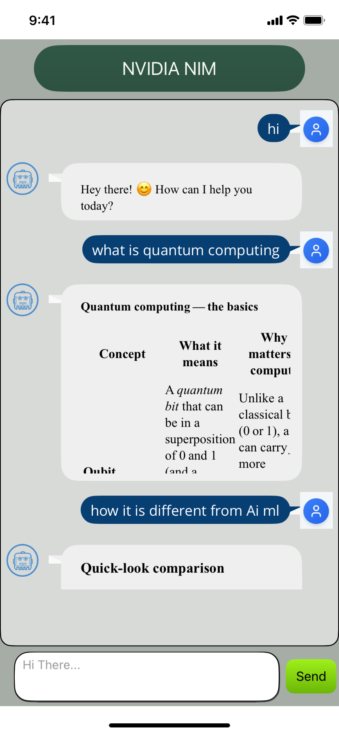

REVISION HISTORY
App version 1.0.0:

A. Limitations
1. Do not have support for Landscape mode.

B. Known Issue
- NA

