Date : 24-Mar-26

OLLAMA APPLICATION

VERSION: 1.0.0

OVERVIEW
Ollama is a lightweight AI model runtime platform that allows developers to run large language models locally or via cloud using simple REST APIs. It enables applications to generate text, process conversations, and create embeddings without relying on external services, ensuring better privacy and control.
It offers multiple endpoints such as Generate, Chat, and Embeddings, making it suitable for building chatbots, AI assistants, content generation tools, semantic search systems, and intelligent automation applications.

Requirements:
Before you start using the Ollama Application, ensure you have the following:

- HCL Foundry
- Volt MX Iris

Authentication
    - Cloud Usage (Ollama.com):
    - Run: ollama signin
    - Required for:
      - Accessing cloud-hosted models
      - Downloading private models
      - Publishing models

- Ollama API Key
Once logged in, go to the Get Your Free API Key section in the Ollama dashboard.
Generate your API key and store it securely.
- API Access
Ensure you understand the required API endpoints based on your use case:

Generate API:/api/generate
→ Generate text responses using a model

Chat API:/api/chat
→ Multi-turn conversation (chat-based interaction)

Embeddings API: /api/embeddings
→ Convert text into vector embeddings (used for search, RAG, etc.)

Tags API: /api/tags
→ List available models

Pull API: /api/pull
→ Download models programmatically
You can explore all available endpoints under the Ollama API Documentation

- Reference documents:
  - Ollama Overview
  - Ollama API Reference

Devices
- Mobile

Platforms
- Android
- iOS

Features

Text Generation API

Generates responses based on prompts using selected models.
Used for chatbots, summarization, and Q&A.

Chat API
Supports multi-turn conversations with context retention.
Used for assistant-like applications.

Embeddings API
Converts text into vector format.
Used for:
- Semantic search
- Recommendation systems
- Retrieval-Augmented Generation (RAG)

Model Management
  - Pull, delete, and manage models locally
  - Switch between models dynamically

Streaming Support
  - Real-time response generation
  - Improves user experience in chat applications

App Functionality- Ollama Chat Description

Overview
The Ollama App is an AI-powered chat application that allows users to interact with a local language model using text and image inputs.

Features
- Chat with AI using natural language
- Upload images and get AI-generated responses
- Real-time response generation
- Simple and intuitive chat interface

UI Flow (Based on Your Screen)

🔹 Header
- Displays app title “Ollama”
- Settings icon for configuration

🔹 Chat Area
- Displays conversation between user and AI
- Supports both text and image-based responses

🔹 Input Section
- Upload icon → Select and upload image
- Text field → “Ask Anything” input
- Send button → Submit request to AI

Work Flow
- User enters text or uploads an image
- On clicking Send:
  - Text → sent to Ollama /api/chat
  - Image → sent to Ollama /api/generate (multimodal model like qwen3-vl:235b-instruct)
- Ollama processes the request
- AI response is returned
- Response is displayed in chat UI

API Integration

Text Chat : POST /api/chat

Image + Prompt : POST /api/generate

Models Used
- gpt-oss:120b→ for text conversations
- qwen3-vl:235b-instruct→ for image understanding

Error Handling
Show message if:
  - No response from model
  - Invalid input
  - Image processing fails

User Actions
- Continue chatting
- Upload multiple images
- Clear or restart conversation
Result Retrieval & Display
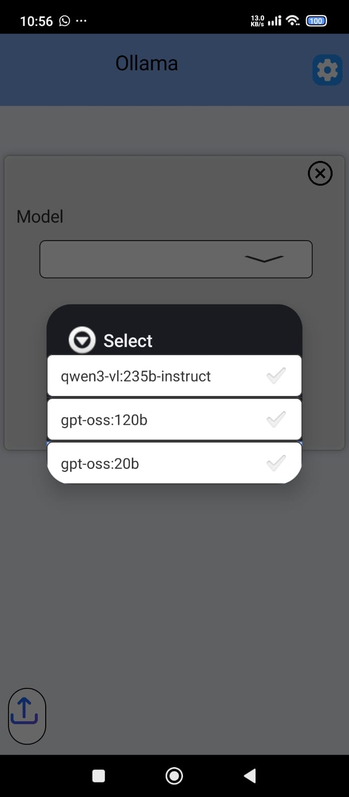
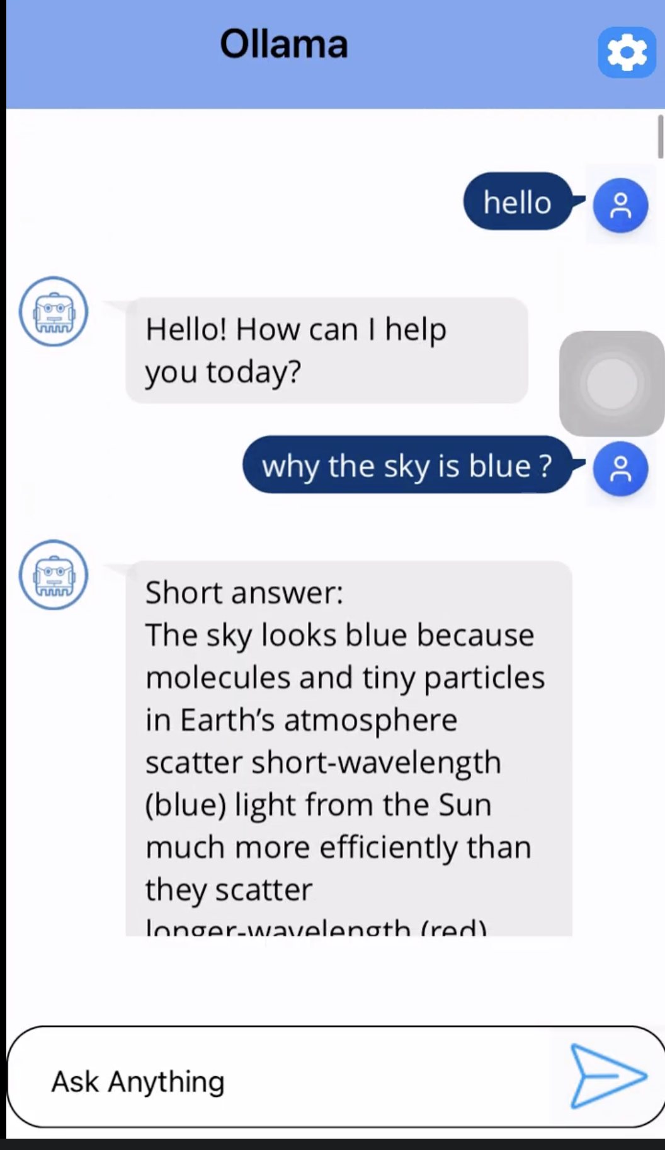

Importing the app
To import the Ollama Application into your workspace, follow these steps:
- Open Volt MX Iris
- On the main menu select Forge → Browse.
- Search for the Ollama Application, and then click Import to Workspace. The app is imported to your workspace. A dialog box appears, confirming that the app has been imported. Click OK.
- Switch to your project containing the Ollama Application. To switch to your project, click File → Open → Reference Architecture → <project name>

Building the app
After performing all the above steps, you can build your app and run it on your device. For more information, you can refer to the Building and Viewing an Application section of the Volt MX User Guide.
You can then run your app to see the Ollama work in real time.

Foundry APP Setup
When you import the application to your Volt MX Iris project, the HCL Volt MX Foundry services of the Ollama are added to the HCL Volt MX Foundry app, which is associated with the Volt MX Iris project. While importing the Ollama Application to your Volt MX Iris project, if there is no HCL Volt MX Foundry app associated with the existing Volt MX Iris project, a new HCL Volt MX Foundry app is automatically added to your HCL Volt MX Foundry environment and is associated with your Volt MX Iris.
To set the Foundry app, follow these steps:
- Click the HCL Volt MX Foundry app associated with your Volt MX Iris project from the Project Explorer. Click DATA & SERVICES.
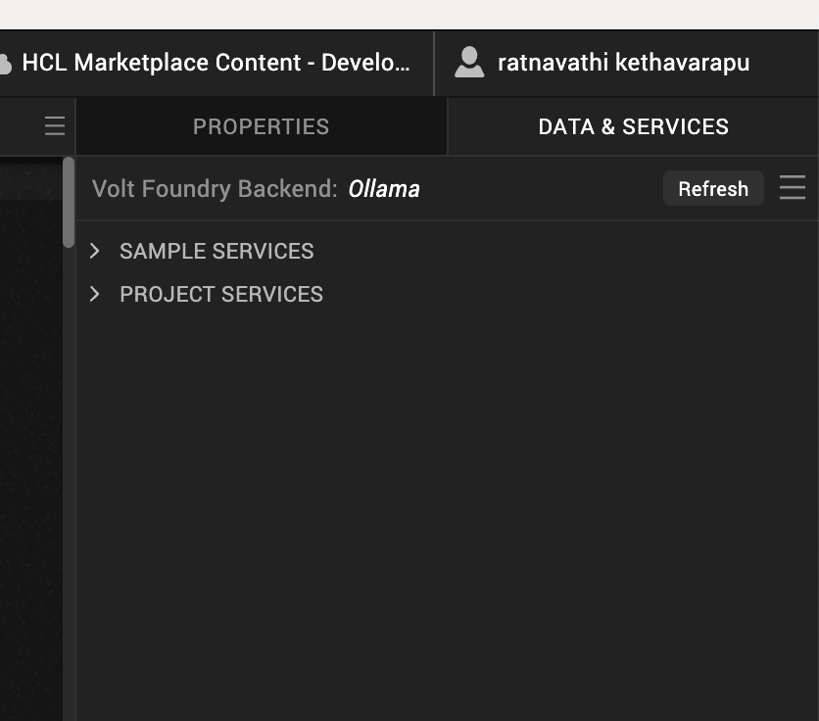

- Under the Configure Services tab, click Integration and can see the Ollama. Click on the Integration service to add the keys.
For the Host URL,replace the value of the endpoint URL mentioned in Ollama overview Refer Ollama Documentation.

- Click on the Ollama integration service to expand the operations.
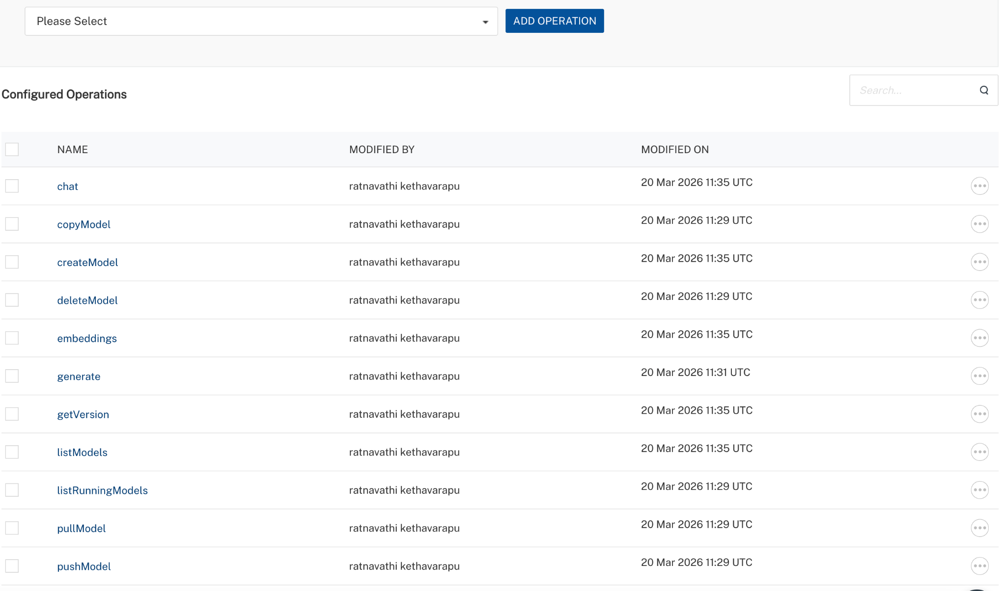
- Select each operation, On the Request Input tab, in the Body section, specify the values in the respective boxes under the Test Value column.
- For Key, In the box under the TEST VALUE and DEFAULT VALUE columns, type the API Key generated from Ollama Dashboard.
- Click SAVE OPERATION.
- Click SAVE AND FETCH RESPONSE. The Output Result dialog appears with the response. Otherwise, the Output Result shows an error.
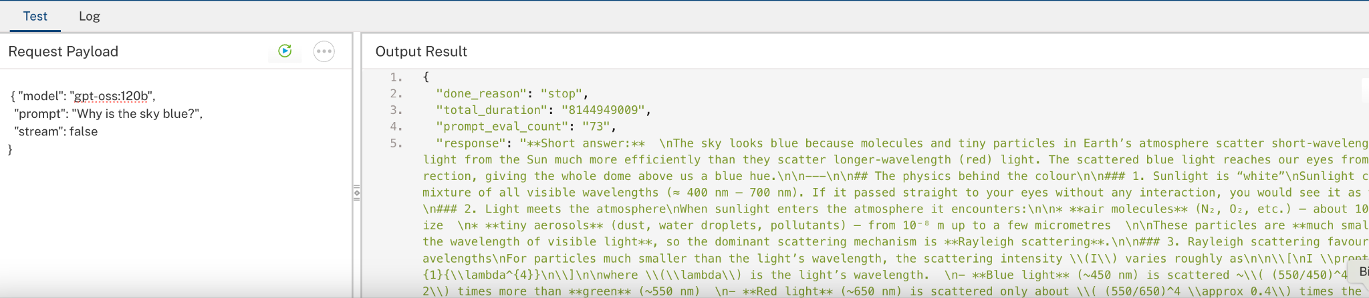

Publish the HCL Volt MX Foundry App
After you set the Operation Security Level, you must publish the HCL Volt MX Foundry app. To publish the HCL Volt MX Foundry, follow these steps:
  - Select the environment to which you want to publish your app, and then click Publish.
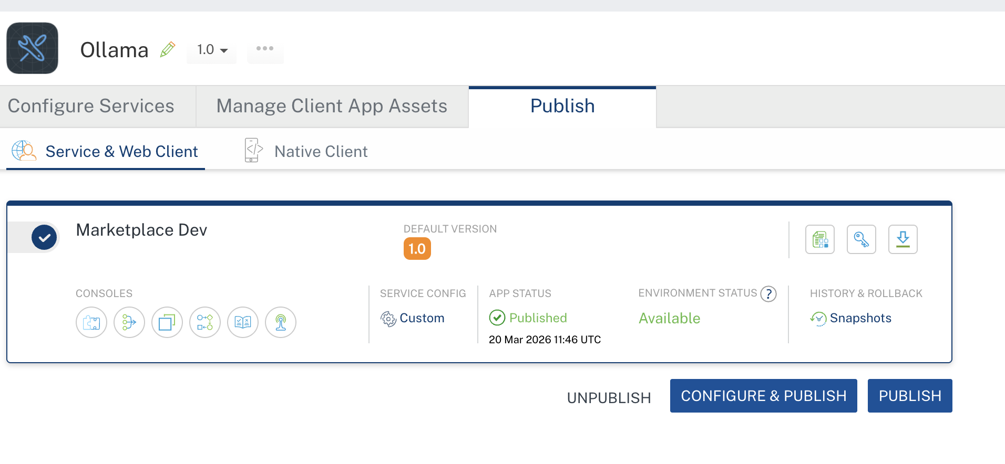

- Building and previewing the app
After performing all the above steps, you can build your app and run it on your device. For more information, you can refer to the Building and Viewing an Application section of the Volt MX User Guide.
You can then run your app to see the Ollama work in real time.

Reference Documents:
- Ollama Overview
- Ollama API Reference

REVISION HISTORY
App version 1.0.0:

Known Issues
None

Limitations
1. Hardware Dependency (Biggest Limitation)

Runs locally → depends on your system RAM/CPU/GPU

On ~8GB RAM:

Only small models work (like Mistral 7B, Phi, TinyLlama)

Large models → ❌ slow / crash

