Date : 10-Apr-26

ORACLE GENERATIVE AND LANGUAGE APPLICATION

VERSION: 1.0.0

Overview
The Oracle Generative and Language Application is an intelligent AI-powered enterprise application that combines Oracle Cloud Infrastructure (OCI) Generative AI and OCI Language AI capabilities into a unified, user-friendly experience.
It provides users with both conversational AI chat experiences and advanced natural language processing capabilities such as sentiment analysis, entity recognition, language detection, translation, and text classification.
The application offers an intuitive interface where users can:
- interact with OCI Generative AI chat models
- analyze text using Language AI capabilities
- translate content between multiple languages
- gain actionable insights from unstructured text
- experience AI-driven workflows through dedicated UI screens
Powered by Oracle OCI Generative AI and OCI Language services, the application demonstrates how enterprises can rapidly build intelligent workflows for communication, analytics, support, and multilingual operations.

Purpose
This application enables users to:
- Interact with OCI Generative AI chat models using a conversational chat interface
- Perform Language AI operations such as:
  - Detect Language
  - Sentiment Analysis
  - Entity Recognition
  - Translation
  - Text Classification
- Translate text between supported OCI languages using dynamic source and target language selection
- Generate contextual AI responses using enterprise-grade foundation models
- Analyze customer feedback, support tickets, documents, and business text
- Demonstrate real-time OCI AI integrations for enterprise application use cases

Requirements:

- HCL Foundry
- An Oracle Cloud Infrastructure Account with active subscription
- Create a free account at https://signup.oraclecloud.com/?
- OCI API Key / Signature credentials
- Access to OCI AI services in your selected region
- Refer this section to get the credentials
Reference document:
OCI Generative AI: Generative AI Documentation
OCI Language API: https://docs.oracle.com/en-us/iaas/api/#/en/language/20221001/
OCI API Request Signing: https://docs.oracle.com/en-us/iaas/Content/API/Concepts/signingrequests.htm

Devices:
- Mobile

Platforms:
- Android
- IOS

Features:
- Conversational AI Chat: Enables interactive, context-driven conversations using OCI Generative AI models for enterprise question answering and assistance.
- Language Detection: Automatically identifies the language of the input text and displays the detected language in a simple readable format.
- Sentiment Analysis: Analyzes text sentiment at aspect level to uncover positive, negative, neutral, or mixed opinions from user feedback and documents.
- Entity Recognition: Extracts important entities such as names, organizations, dates, and locations from unstructured text for better business insights.
- Text Translation: Supports multilingual text translation with dynamic source and target language selection using OCI-supported translation languages.
- Text Classification: Categorizes input text into meaningful labels or tags for routing, analytics, and document processing workflows.

App Functionality:
- Initial Launch Experience
When the app opens, users are presented with a modern home dashboard that highlights both Generative AI Chat and Language AI capabilities. The bottom navigation provides quick access to Home, Chat, Language, and Profile sections. By default, opening the Language tab automatically selects the “Detect Language” capability, making the form immediately functional with a text area and action button.
- Generative AI Chat Flow
In the Chat section, users are greeted with a clean conversational interface containing:
- application header
- settings icon
- message input field
- send button
- chatbot conversation area
Users can type their question in the text box and submit it by tapping the send icon. The user message is instantly shown as a chat bubble, and the conversation auto-scrolls to the latest message.
The system then sends the request to the OCI Generative AI backend integration service using the configured:
- compartmentId
- modelId
A temporary loading indicator is displayed while the AI processes the request. Once the response arrives:
- the loader disappears
- the assistant response is parsed
- the reply is displayed in the chatbot component
- the chat scrolls automatically
The Settings panel (flxSettings) allows runtime updates of compartmentId and modelId, which immediately affect all future chat requests.
- Language Capability Selection
From the Home dashboard, users can select any of the available Language AI capabilities:
- Detect Language
- Sentiment Analysis
- Entity Recognition
- Translation
- Text Classification
Clicking a capability navigates to frmLanguageInsights, where the selected capability is automatically set and the action button text updates dynamically to match the chosen operation.
- Detect Language
Users enter text in the input area and tap Detect Language. The application sends the request to OCI Language AI and displays the detected language in a simple result format such as:
Detected Language: English
This is also the default capability when the Language tab is opened directly.
- Sentiment Analysis
For sentiment analysis, users provide review or feedback text and tap the action button. The application processes the text and displays aspect-level sentiment results, showing:
- aspect text
- sentiment label
- confidence scores
The results are rendered in a readable list/card style for easy interpretation.
- Entity Recognition
Users can input business text, emails, or documents, and the app extracts meaningful entities such as:
- people
- organizations
- dates
- locations
- products
The extracted entities are displayed in a structured output section.
- Translation Workflow
When the selected capability is Translation, the UI automatically switches to the dedicated flxTranslation layout, which includes:
- source language dropdown
- target language dropdown
- source text area
- translated output area
- translate button
- swap button
Users select the source and target languages, enter the source text, and tap Translate. The translated response is displayed in the output area, while the swap button exchanges both language selections and text flow.
- Text Classification
For text classification, users provide input text and tap the action button. The app sends the request to OCI Language AI and displays the classification categories or tags in a clean visual format, suitable for:
- ticket routing
- document tagging
- feedback categorization

Importing the app:
To import the Oracle Generative and Language Application into your workspace, follow these steps:
- Open Volt MX Iris
- On the main menu select Forge → Browse.
- Search for the OracleAI Application, and then click Import to Workspace. The app is imported to your workspace. A dialog box appears, confirming that the app has been imported. Click OK.
- Switch to your project containing the OracleAI Application.. To switch to your project, click File → Open → Reference Architecture → <project name>

Building the app:
After performing all the above steps, you can build your app and run it on your device. For more information, you can refer to the Building and Viewing an Application section of the Volt MX User Guide.
You can then run your app to see the OracleAI Application work in real time.

Configure the UI and settings of the Oracle Generative and Language Application
The Oracle Generative and Language Application consists of the following reusable components:
- tabsicontext component → used for bottom tab navigation
- chatbot component → used to provide a chat-style conversational interface
- Language capability UI containers → used for text analytics and translation workflows
The application combines OCI Generative AI chat with OCI Language AI capabilities in a single multi-form experience.
Bottom Navigation Setup
The tabsicontext component is used to provide smooth navigation between the primary application forms:
- Home (frmHome / frm1)
- Chat (frmChat)
- Language (frmLanguageInsights)
- Profile (frmProfile)
The component uses the onTabChange event to detect the selected tab and navigate to the corresponding form.
When the Language tab is selected, the application automatically opens frmLanguageInsights with Detect Language set as the default capability.
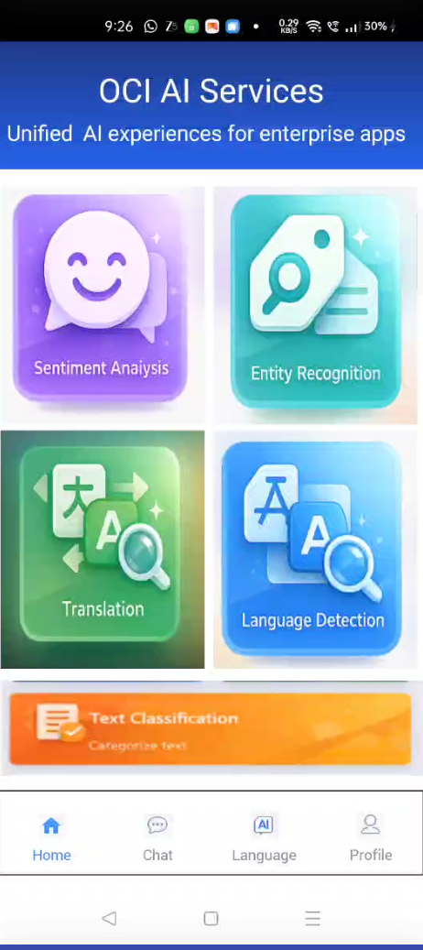
Chat UI Setup
The chatbot component is used in frmChat to create a modern chat-like UI for OCI Generative AI interactions.
The chat screen includes:
- chat header
- message container
- text input field
- send icon
- loading indicator
- assistant response bubbles
- runtime settings section
Users can type questions and send them using the send icon, while responses are displayed through the reusable ChatBot component.
Dynamic Chat Settings
To avoid hardcoding values, the settings section (flxSettings) is used in frmChat.
This allows users to dynamically configure:
- Compartment ID
- Model ID
These values are then used while building the OCI Generative AI request payload.
This makes the chat flow:
- configurable
- reusable
- environment independent
- marketplace ready
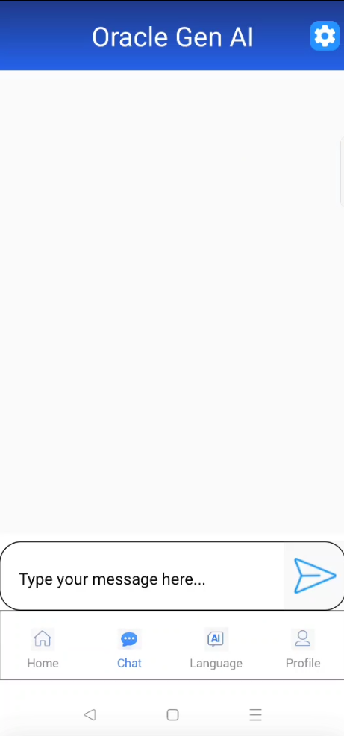

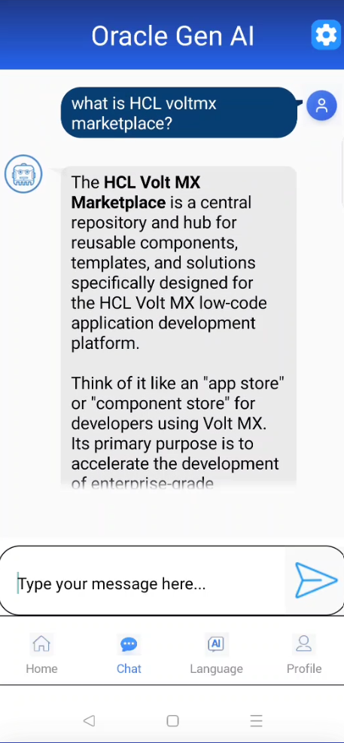
Language Capability UI Setup
The Language Insights form (frmLanguageInsights) provides a dynamic UI that changes based on the selected capability.
Default / Standard Layout
For capabilities such as:
- Detect Language
- Sentiment Analysis
- Entity Recognition
- Text Classification
the app uses:
flxMain
which contains:
- input text area
- output container
- analyse button
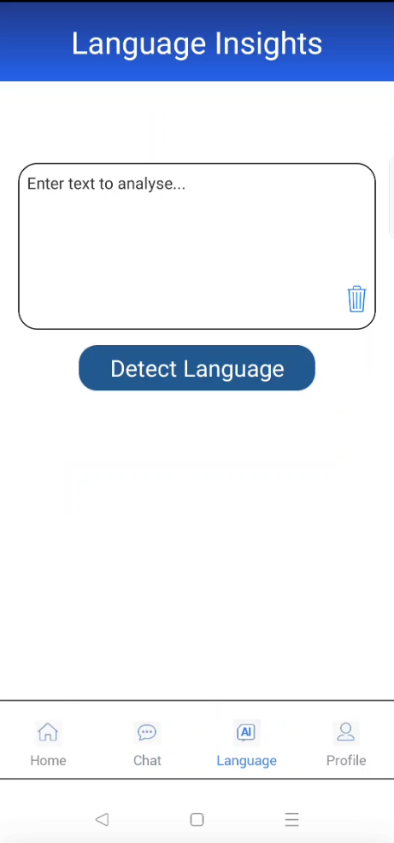
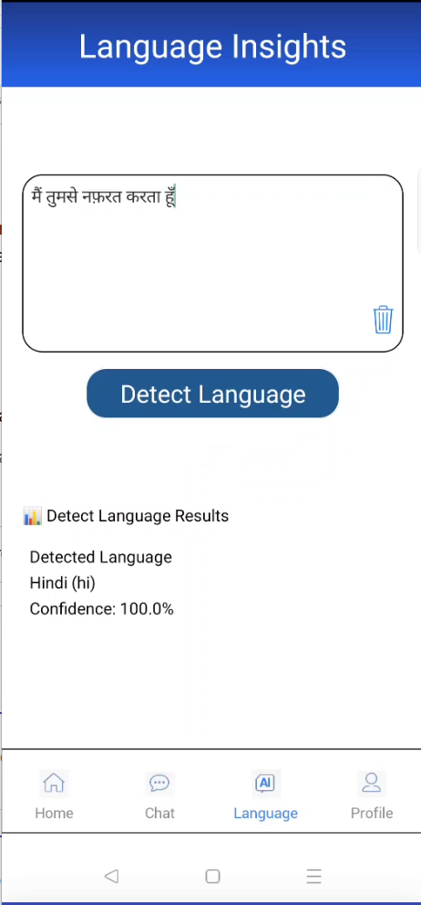
Translation Layout
For the Translation capability, the app uses a dedicated container:
flxTranslation
This includes:
- source language listbox
- target language listbox
- source text area
- translated output text area
- translate button
- swap button
The visibility of flxTranslation and flxMain is controlled dynamically based on the selected capability.
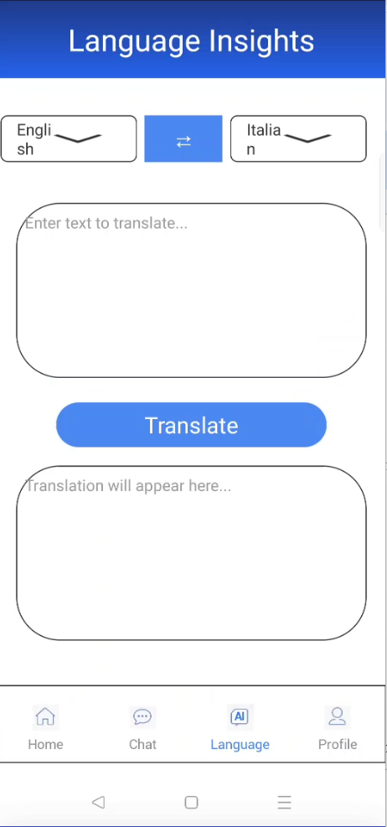

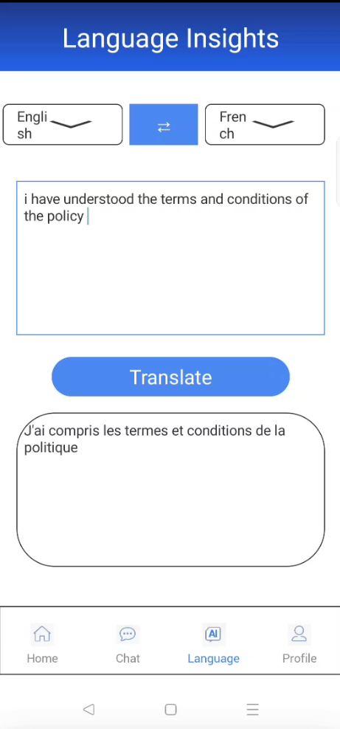
Form Setup
To configure the application UI:
- Create the required forms:
  - frmHome
  - frmChat
  - frmLanguageInsights
  - frmProfile
- Add the tabsicontext component to each form for bottom navigation.
- Add the chatbot component to frmChat for chat-style AI interaction.
- Add capability cards in frmHome for:
  - Detect Language
  - Sentiment Analysis
  - Entity Recognition
  - Translation
  - Text Classification
- Add dynamic capability UI containers in frmLanguageInsights.

Foundry APP Setup

When you import the application into your Volt MX Iris, the HCL Volt MX Foundry services of the Oracle Generative and Language services are added to the HCL Volt MX Foundry app, which is associated with the Volt MX Iris project. While importing the Oracle Generative and Language Application to your Volt MX Iris project, if there is no HCL Volt MX Foundry app associated with the existing Volt MX Iris project, a new HCL Volt MX Foundry app is automatically added to your HCL Volt MX Foundry environment and is associated with your Volt MX Iris.
To set the Foundry app, follow these steps:
- Click the HCL Volt MX Foundry app associated with your Volt MX Iris project from the Project Explorer. Click DATA & SERVICES
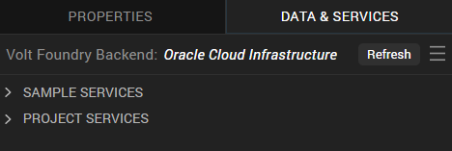
- Under the Configure Services tab, click Integration and can see the Oracle Cloud Infrastructure . Click on Integration service to add the keys.
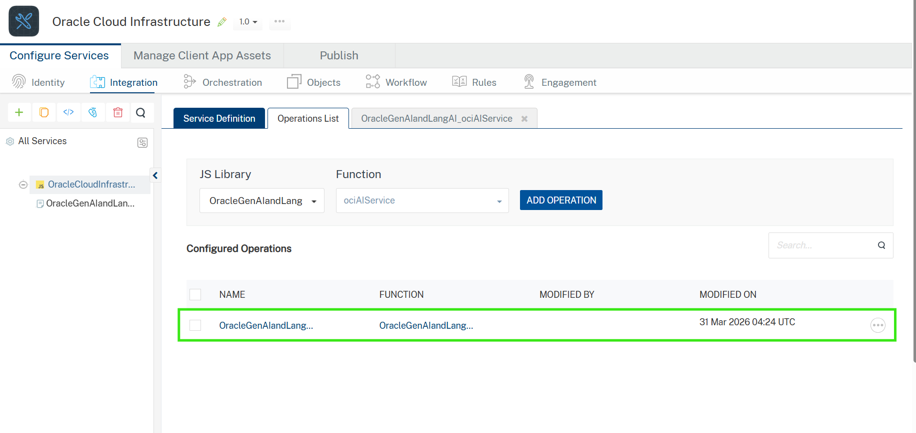
- Click the Oracle Cloud Infrastructure Integration service. On the right pane, expand the Oracle Cloud Infrastructure service and then select the OracleGenAIandLangAI_ociAIService operation.
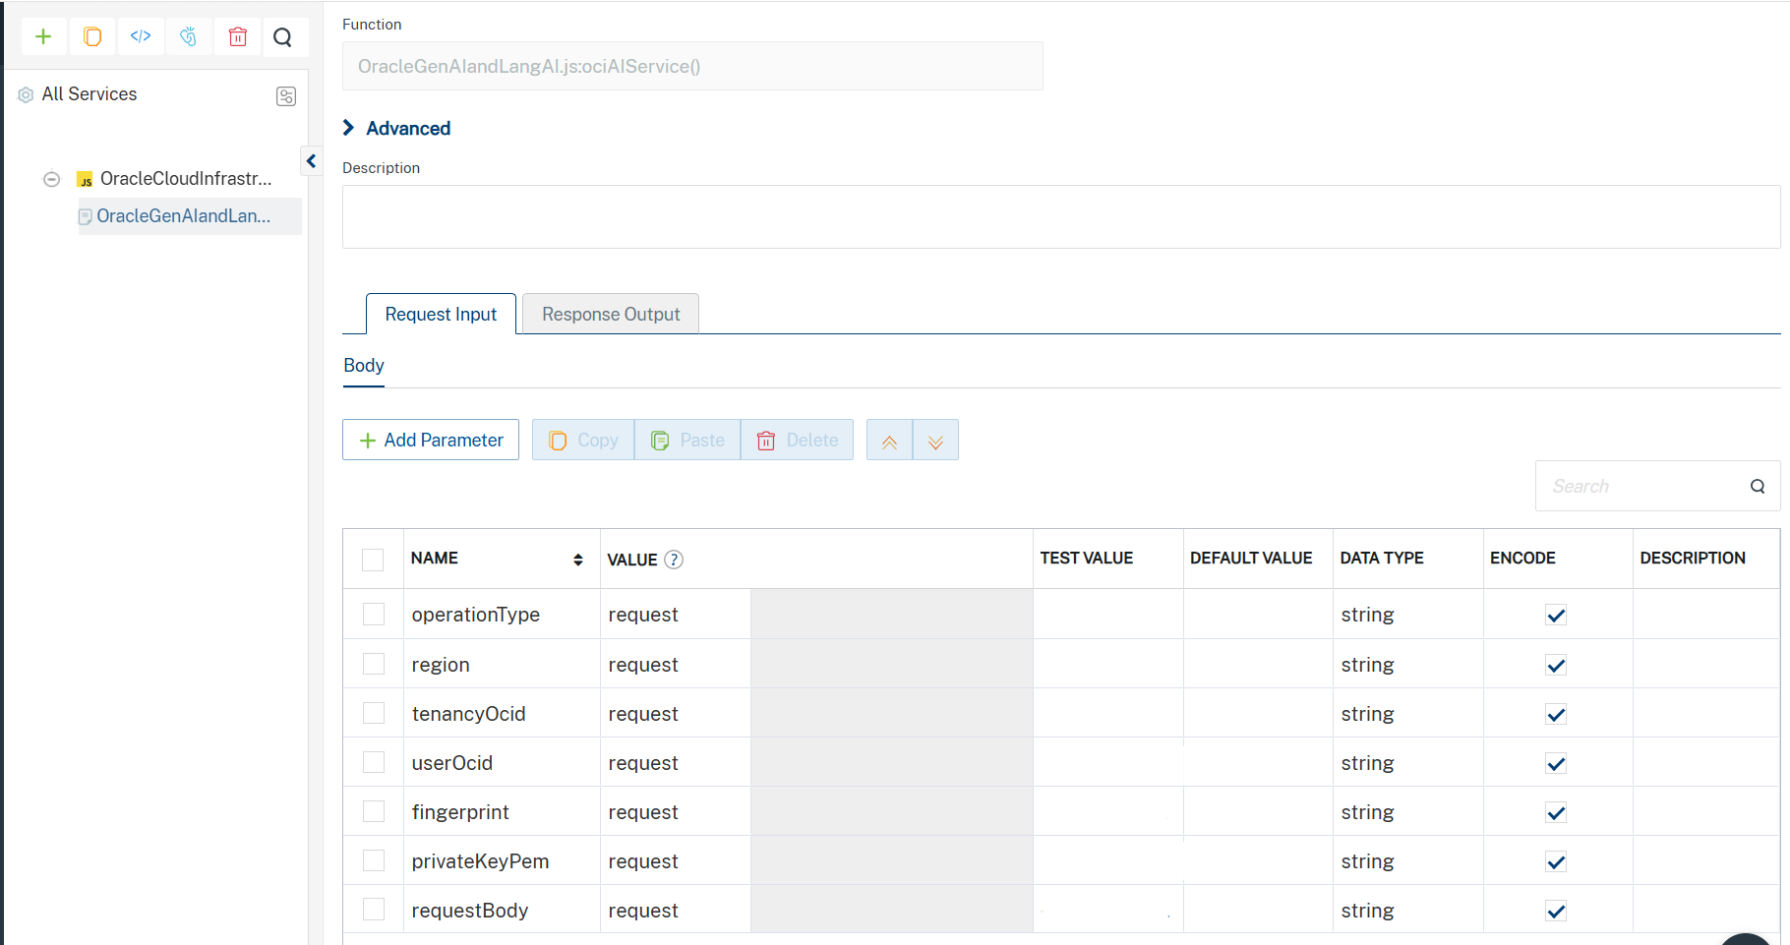
- The OracleGenAIandLangAI_ociAIService tab opens with the Request Input sub-tab opened by default.
- On the Request Input tab, in the Body section, for the following parameters, specify the values in the respective boxes under the Test Value column.
Mandatory Parameters
For Generative AI Operations
Supported operations:
- chat
- embedText
Parameters
- tenancyOcid: The OCI tenancy OCID used for request signature authentication.
- userOcid: The OCI user OCID associated with the uploaded API key.
- fingerprint: The fingerprint of the OCI API signing key.
- privateKeyPem: The private key in PEM format used to generate OCI request signatures.
- region: The OCI region where the Generative AI service is deployed (for example, us-chicago-1).
- requestBody: The request payload containing the prompt, messages, or embedding text based on the selected operation.
- operationType: The type of Generative AI operation to perform (chat, embedText).
For OCI Language API Operations
Supported operations:
- batchDetectDominantLanguage
- batchDetectLanguageEntities
- batchDetectLanguageKeyPhrases
- batchDetectLanguagePiiEntities
- batchDetectLanguageSentiments
- batchDetectLanguageTextClassification
- batchLanguageTranslation
Parameters
- tenancyOcid: The OCI tenancy OCID used for request signature authentication.
- userOcid: The OCI user OCID associated with the uploaded API key.
- fingerprint: The fingerprint of the OCI API signing key.
- privateKeyPem: The private key in PEM format used to generate OCI request signatures.
- region: The OCI region where the Language service is deployed (for example, ap-hyderabad-1).
- requestBody: The input request payload for the selected Language API operation. The request structure varies depending on the operation (documents, text, translation details, classification details, etc.).
- operationType: The type of Language API operation to perform.
Important Note
The requestBody format differs for each supported operation.
Examples:
- For chat → prompt/messages payload
- For embedText → text input payload
- For batchDetectDominantLanguage → compartmentId + documents
- For batchLanguageTranslation → translation request schema
- Click SAVE AND FETCH RESPONSE. The Output Result dialog appears with the response. Otherwise, the Output Result shows an error.
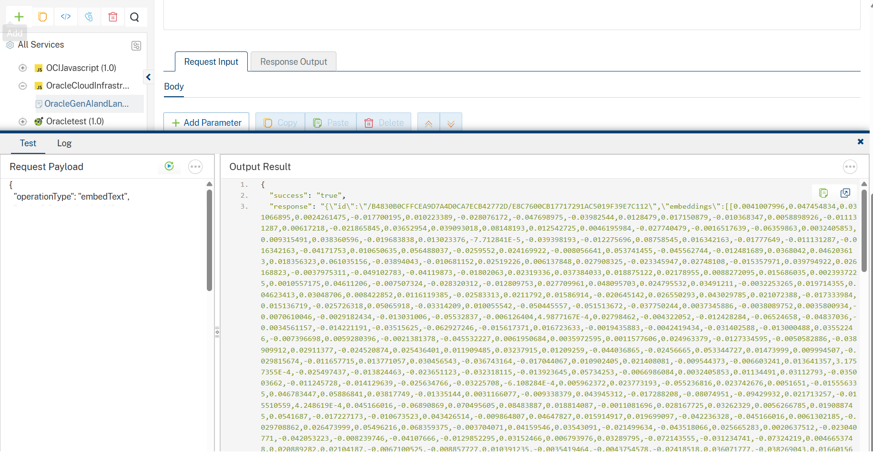
- Click the icon to go back to Volt MX Iris.

Get OCI Credentials
Navigate to the Oracle Cloud Infrastructure Console:
https://cloud.oracle.com
This section explains how to obtain the required OCI credentials:
- tenancyOcid
- userOcid
- fingerprint
- privateKeyPem
1. Get Tenancy OCID
- Log in to the OCI Console
- Click the Profile icon in the top-right corner
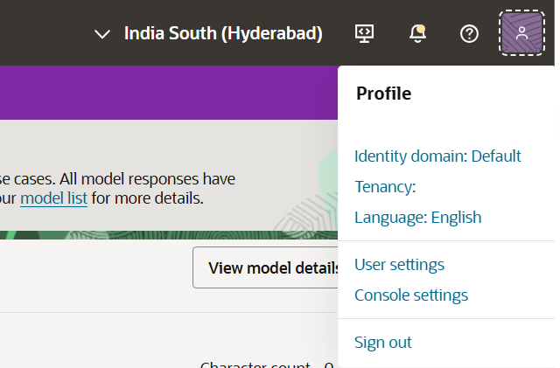
- Select:Tenancy: <Your Tenancy Name>
- In the Tenancy Information page, locate:OCID
- Click Copy
tenancyOcid
Example : ocid1.tenancy.oc1..aaaaaaaaxxxxxxxxxxxxxxxxxxxxxxxxxxxxxxxxxxxxxxxxxxxxx
2. Get User OCID
Navigate to User Profile
- In OCI Console, click the Profile icon
- Select:User settings -> My Profile
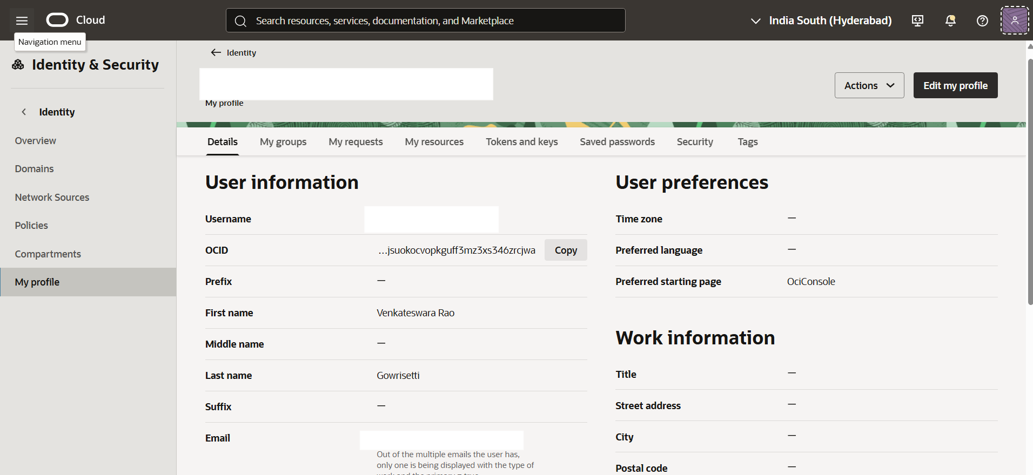
- In the User Information section, locate:OCID
- Click Copy
Example : ocid1.user.oc1..aaaaaaaaxxxxxxxxxxxxxxxxxxxxxxxxxxxxxxxxxxxxxxxxxxxxx
3. Generate API Key and Get Fingerprint
Navigate to API Keys
- In My Profile, Go to:Tokens and Keys
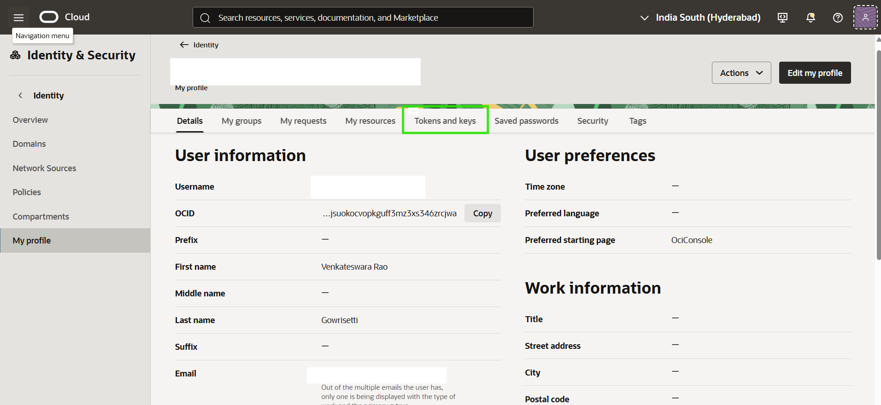
- Click:Add API Key
- Choose:Generate API Key Pair
- Click:Download Private Key.Save the file securely as:oci_api_key.pem
- Click:Add
- After creation, OCI displays the:Fingerprint
- Copy and save
Example : 12:34:56:78:90:ab:cd:ef:11:22:33:44:55:66:77:88
4. Get Private Key PEM
The downloaded file from Step 3 is your private key PEM.
How to use
- Open the downloaded .pem file in:
  - VS Code
  - Notepad++
  - Text Editor
- Copy the entire contents, including:
-----BEGIN PRIVATE KEY-----...
-----END PRIVATE KEY-----
- Save this as:privateKeyPem
Example
-----BEGIN PRIVATE KEY-----MIIEvQIBADANBgkqhkiG9w0BAQEFAASC......-----END PRIVATE KEY-----
5. Required IAM Policy Access
Ensure your OCI user has access to:
- Generative AI
- Language API
Recommended Policy
Go to:User Settings ->Identity & Security → Policies
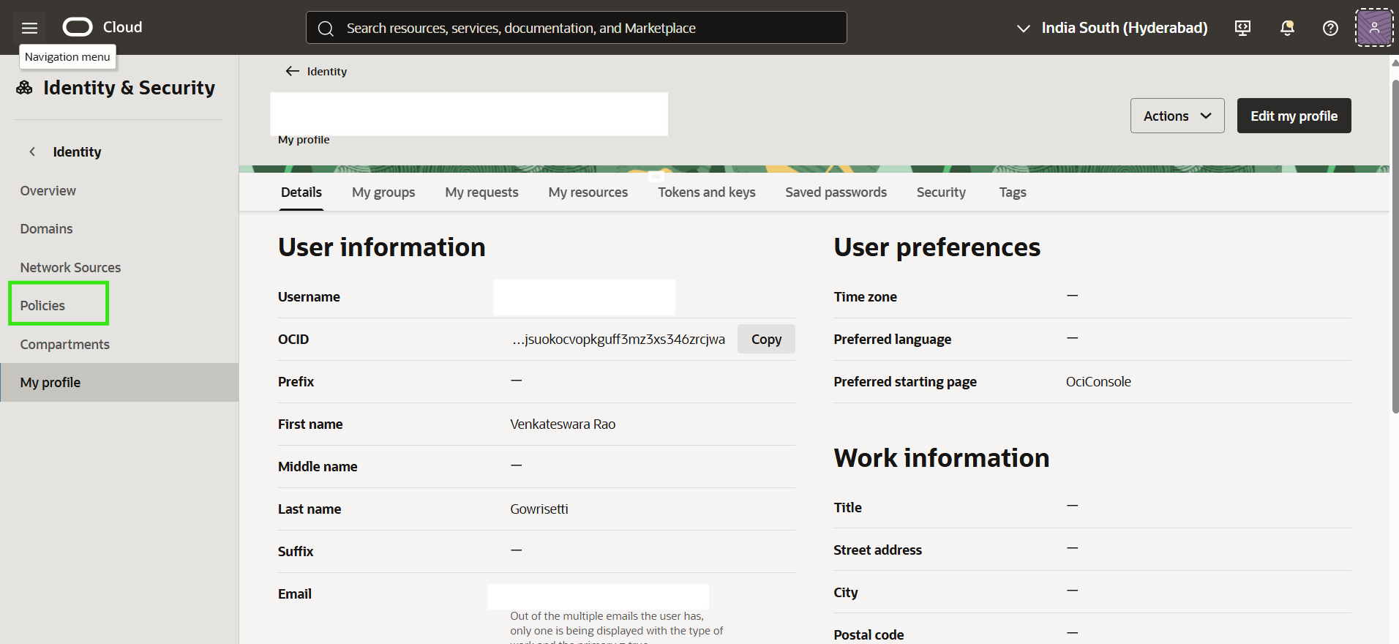
Create Policy:
Give proper name,description and click on show manual editor and add the below policy
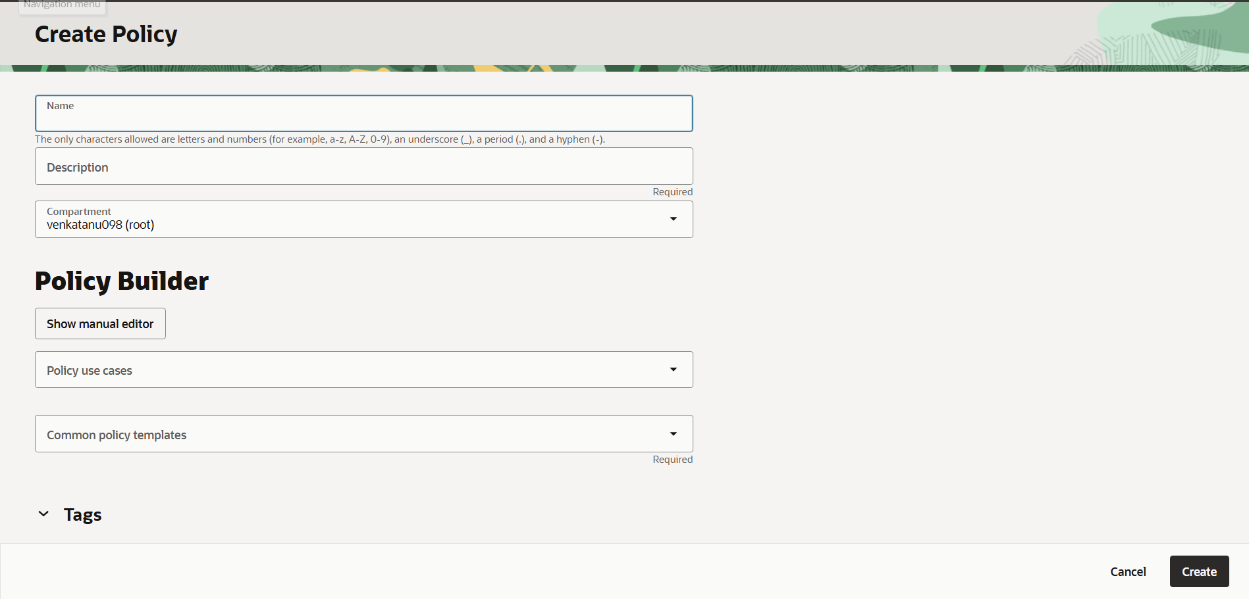
For Generative AI
- Allow any-user to use generative-ai-family in tenancy where request.principal.type = 'generativeaiapikey'
For Language AI create the another policy with proper name,description and click on show manual editor and add the below policy
- Allow group Administrators to use ai-service-language-family in tenancy
This is required for the adapter to invoke OCI AI services.

Publish the HCL Volt MX Foundry App
After you set the Operation Security Level, you must publish the HCL Volt MX Foundry app. To publish the HCL Volt MX Foundry, follow these steps:
In Volt MX Iris, click DATA & SERVICES, and then click Publish Project Services to Publish to your foundry app.
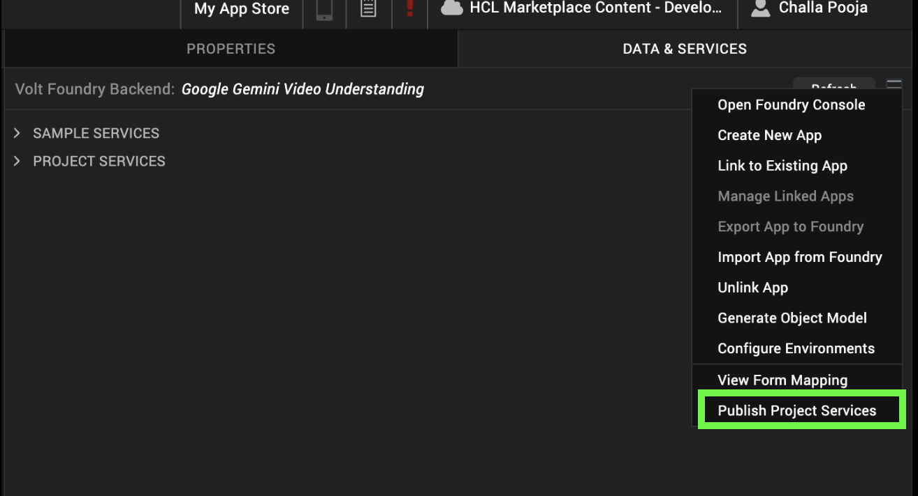
Select the environment to which you want to publish your app, and then click Publish.
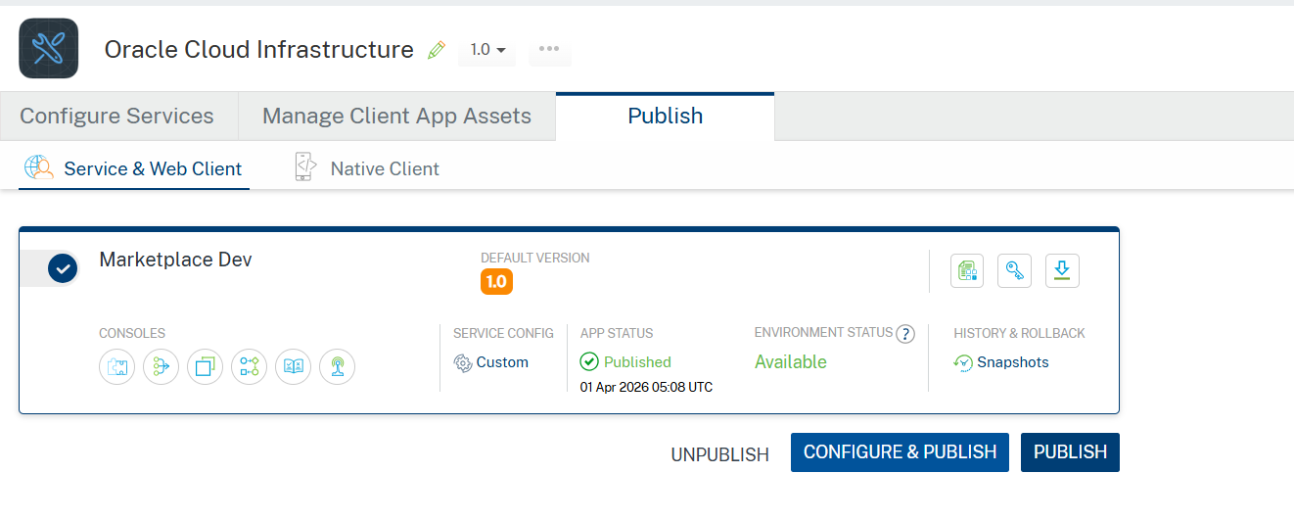
After the app is published to your environment, the following window appears confirming the publish.

Building and previewing the app
After performing all the above steps, you can build your app and run it on your device. For more information, you can refer to the Building and Viewing an Application section of the Volt MX User Guide.
You can then run your app to see the Oracle Generative and Language Application work in real time.

APIs

No APIs

Events

No Events

Reference API documentation:
- OCI Documentation: OCI Documentation
- OCI Language API Guide: OCI Language API Guide
- OCI Generative AI Guide: OCI Generative AI Guide
- OCI API Signing Guide: OCI API Signing Guide

REVISION HISTORY
App version 1.0.0:

Known Issues
- None

Limitations
- OCI Generative AI integrations are dependent on the availability of specific models such as cohere.command-a-03-2025 and google.gemini-2.5-flash. If a selected model is deprecated or no longer supported by OCI, the API requests may fail or not return a response.

