Date: 07 May 2025

PDFVIEWER Sample Application

VERSION: 1.0.0

**Overview:**

The PDF Viewer sample application is for viewing the PDFs within the app, it supports all types of PDF’s like base64, remote and local PDF picking and rendering. This sample has the PDF viewer component, which renders the PDFs with the help of local html files.

**Requirements:**

* Volt MX Iris

**Devices:**

* Mobile
* Tablet

**Platforms:**

* Android
* iOS

**Features:**

1. This sample app has the PDF viewer component which renders the PDF within the component.

2. It supports all types of rendering like base64, local and remote PDFs.

**A. App Functionality:**

1. When you build and run the app, you will see the form with the PDF rendered from the different sources.

**B. Importing the app:**  
  
To import the PDFViewer sample application into your workspace, follow these steps:

1. Open Volt MX Iris
2. On the main menu select Forge/Browse.
3. Search for the PDFViewer sample application, and then click Import to Workspace. The app is imported to your workspace. A dialog box appears, confirming that the app has been imported. Click OK.

4. Switch to your project containing the PDFViewer sample application. To switch to your project, click File/Open/Reference Architecture/<project name>

**C. Building the app:**

After performing all the above steps, you can build your app and run it on your device. For more information, you can refer to the Building and Viewing an Application section of the Volt MX User Guide.

You can then run your app to see the PDF Viewer work in real time.

**D. Configure the UI and settings of the PDFViewer sample application**

The PDFViewer sample application looks like the below attached screenshots.

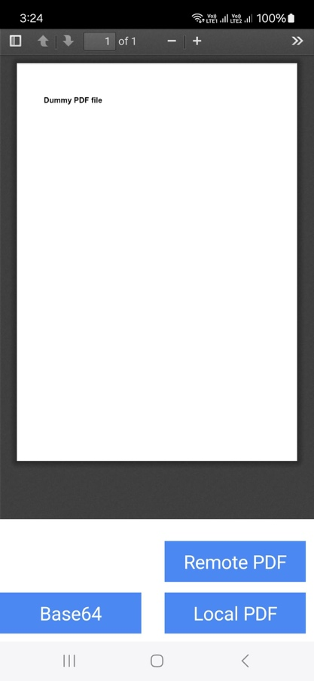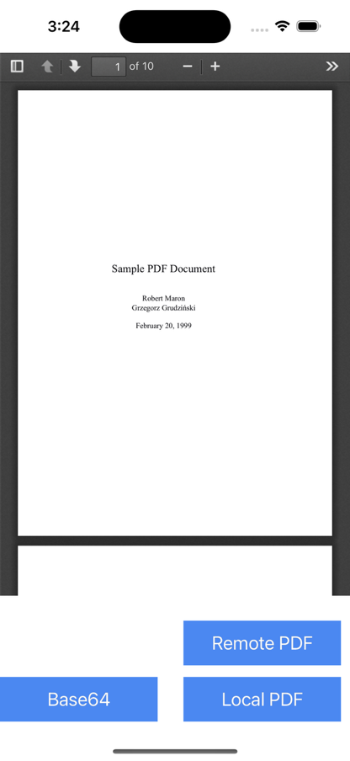

**Configuring Settings:**  
Follow the steps below to import and use PDFViewer component from PDFViewer sample application to your project

1. Copy Pdfjs-1 folder from **PDFViewer** **sample app/Modules/Web/Localfiles** to same location of your project.  
     
   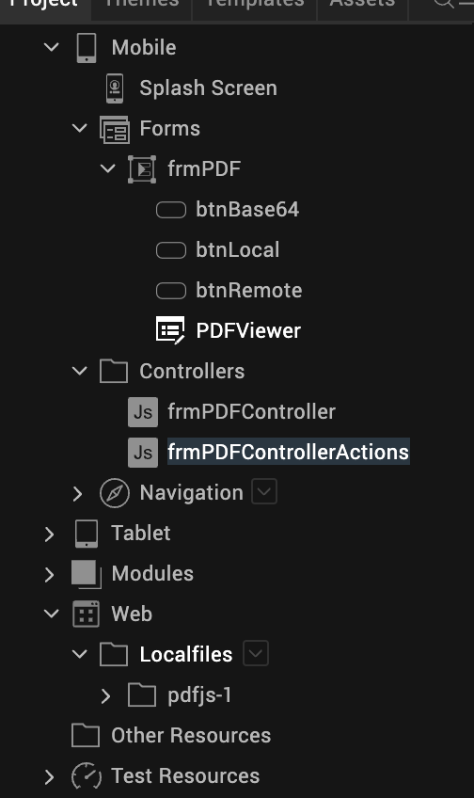
2. Export PDFViewer component from this sample at **Templates/Components/com.hcl.technohub.PDFViewer/** right click and Export.

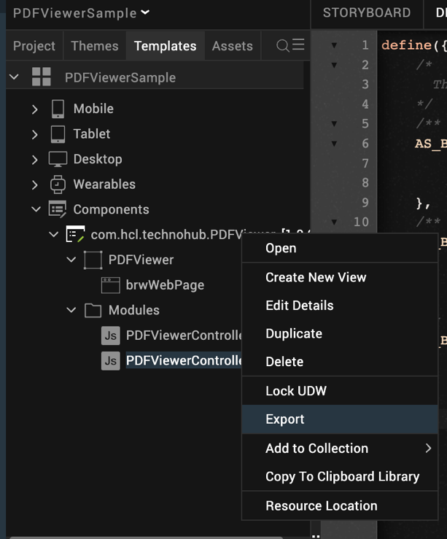

1. Import exported component into your project at **Iris/Project/Import/Component into the Library/**choose the above exported zip file.

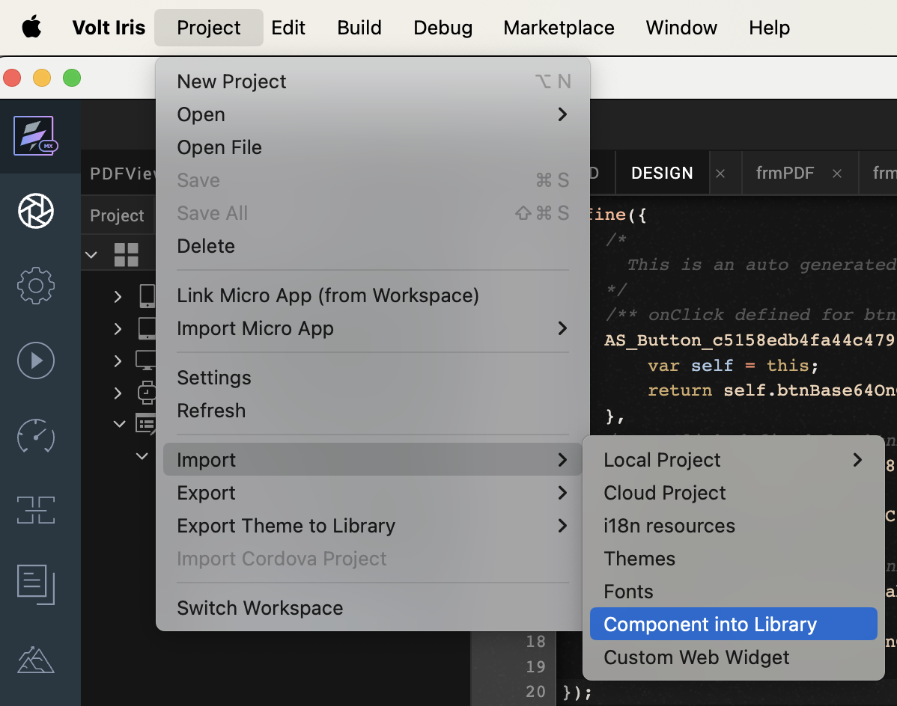

1. After importing the Component just ensure **Iris/Edit/Manage native Function API(s)Android/PdfNfi** and **Iris/Edit/Mange Native Function API(s)/iOS/PdfNfi** zips are updated into your project. If not, import them manually.

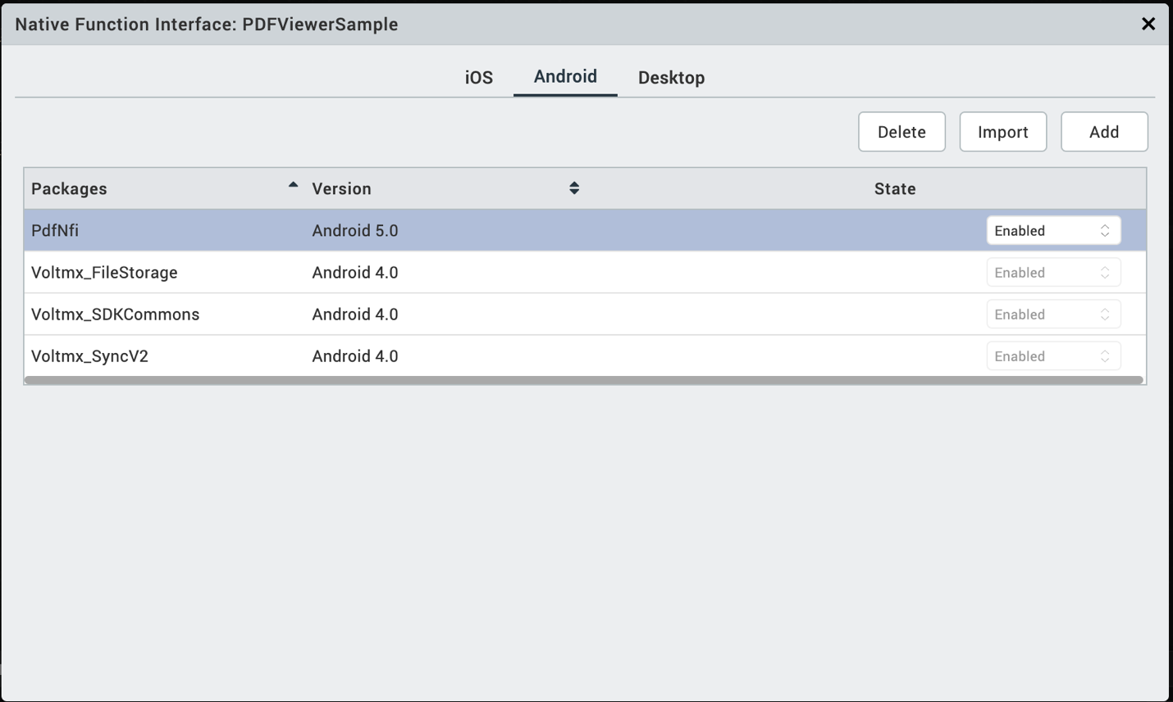

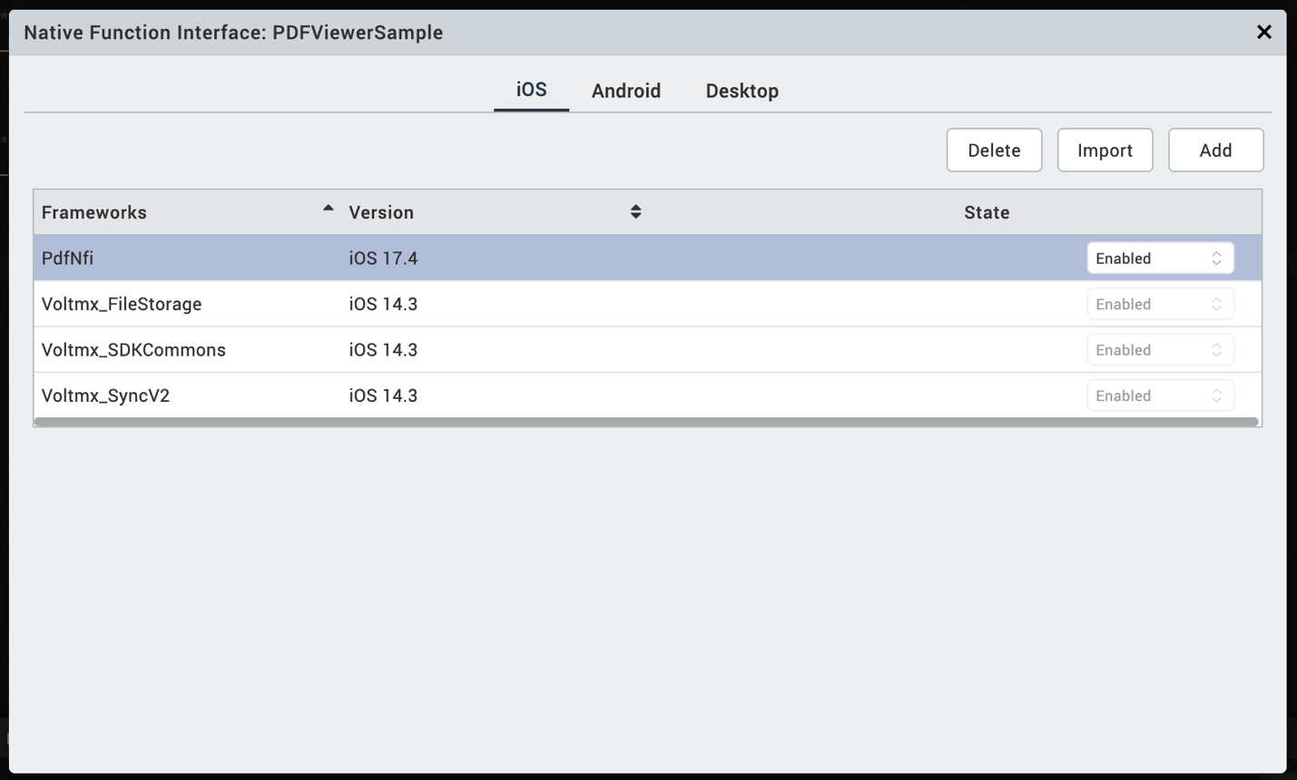

# **APIs**

### loadBase64

|  |  |
| --- | --- |
| **Description:** | Renders the PDF from the base64 string. |
| **Syntax:** | loadBase64(<String>) |
| **Parameters:** | String, base64 value of the PDF |
| **Return Value:** | None |
| **Remarks:** | NA |
| **Example:** | this.view.PDFViewer.loadBase64(this.base64); |

### loadUrl

|  |  |
| --- | --- |
| **Description:** | Renders the PDF from the remote URL. |
| **Syntax:** | loadUrl(<String>) |
| **Parameters:** | String, remote URL of the PDF |
| **Return Value:** | None |
| **Remarks:** | NA |
| **Example:** | this.view.PDFViewer.loadUrl(this.url); |

### pickAndLoadLocalPdf

|  |  |
| --- | --- |
| **Description:** | Picks the device stored PDF and renders the PDF |
| **Syntax:** | pickAndLoadLocalPdf () |
| **Parameters:** | NA |
| **Return Value:** | None |
| **Remarks:** | NA |
| **Example:** | this.view.PDFViewer.pickAndLoadLocalPdf(); |

**Limitations:**

1. This component supports only 64-bit devices

**Known issues:**

-N.A.-