Date : 30-Oct-25
RANGE SLIDER
VERSION: 4.1.0

OVERVIEW
The Range Slider component consists of a slider with a minimum value, maximum value, and intervals. A user can move the handles of the slider to select a range between the minimum and maximum values.

Use case:
- If you want to show flights between $250 and $275 specifically when the cost of flights ranging from $150 to $500, then, this component will fit in and serve your use case seamlessly.

Features:
- Facility to customize the UI as you require.
- Slider with a double handle to select a specific range from a given range.
- Easy to achieve the single slider feature without developing it from scratch.
- Ability to define intervals on the slider.

Percentage of re-use:
80-90% (Data can be customizable and skins are not customized but can be changed manually)

GETTING STARTED

Prerequisites
Before you start using the Range Slider component, ensure you have the following:
- HCL Foundry
- Volt MX Iris

Platforms Supported
    - Mobile
      - iOS
      - Android
    - Tablets
    - PWA & Responsive Web.

Importing the Component
You can import the Forge components only into the apps that are of the Reference Architecture type.

To import the Range Slider component, do the following:
- Open your app project in Volt MX Iris.
- In the Project Explorer, click the Templates tab.

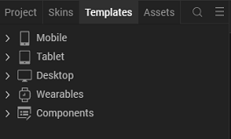

3. Right-click Components, and then select Import Component. The Import Component dialog box appears.

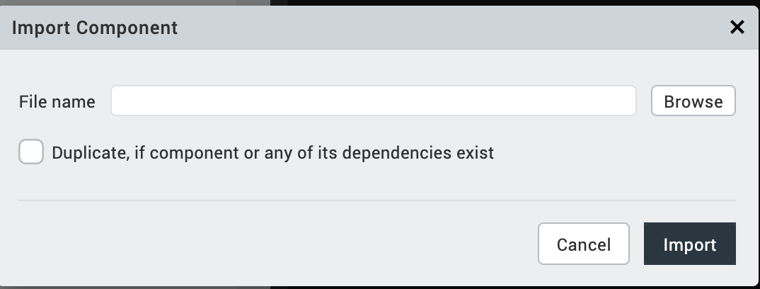

4. Click Browse to navigate to the location of the component, select the component, and then click Import. The component and its associated widgets and modules are added to your project.
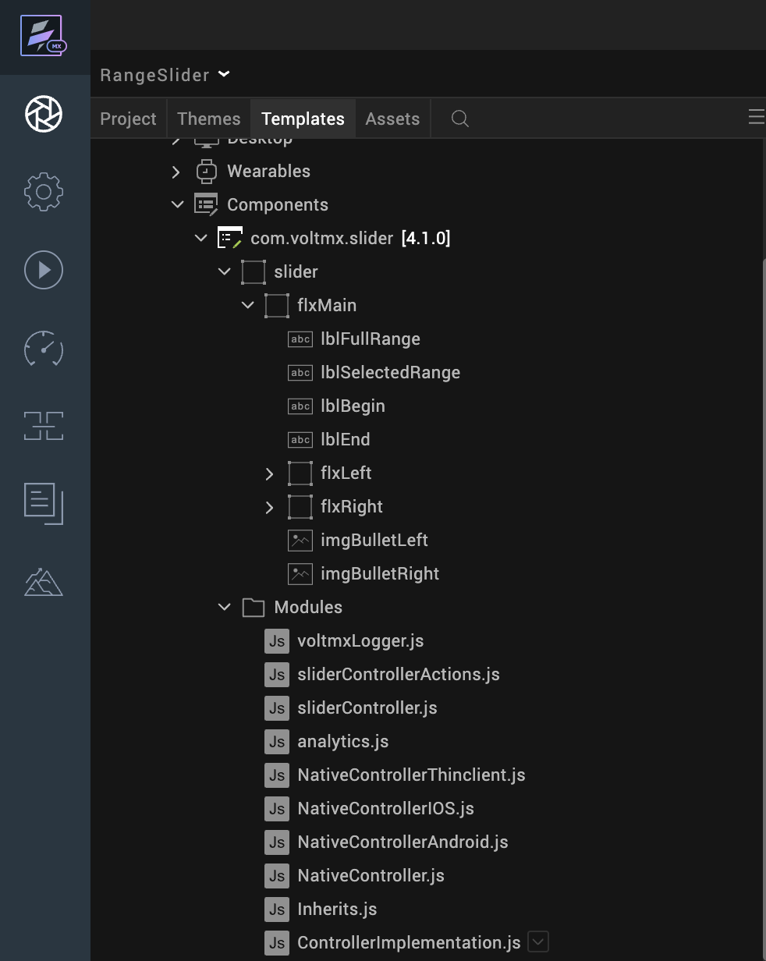

5. Once you have imported a component to your project, you can easily add the component to a form. For more information, refer Add a Component to a Form.

Building and previewing the app
After performing all the above steps, you can build your app and run it on your device. For more information, you can refer to the Building and Viewing an Application section of the Volt MX Iris User Guide.
You can then run your app to see the RangeSlider work in real time.

Configuring settings for Responsive Web
Before you can use this component in a web context, we need to set some flags within the project settings. This will ensure that the drag function of the component will work on web pages.
Go to Project Settings -> Responsive Web and select the Enable JS Library mode (Legacy)
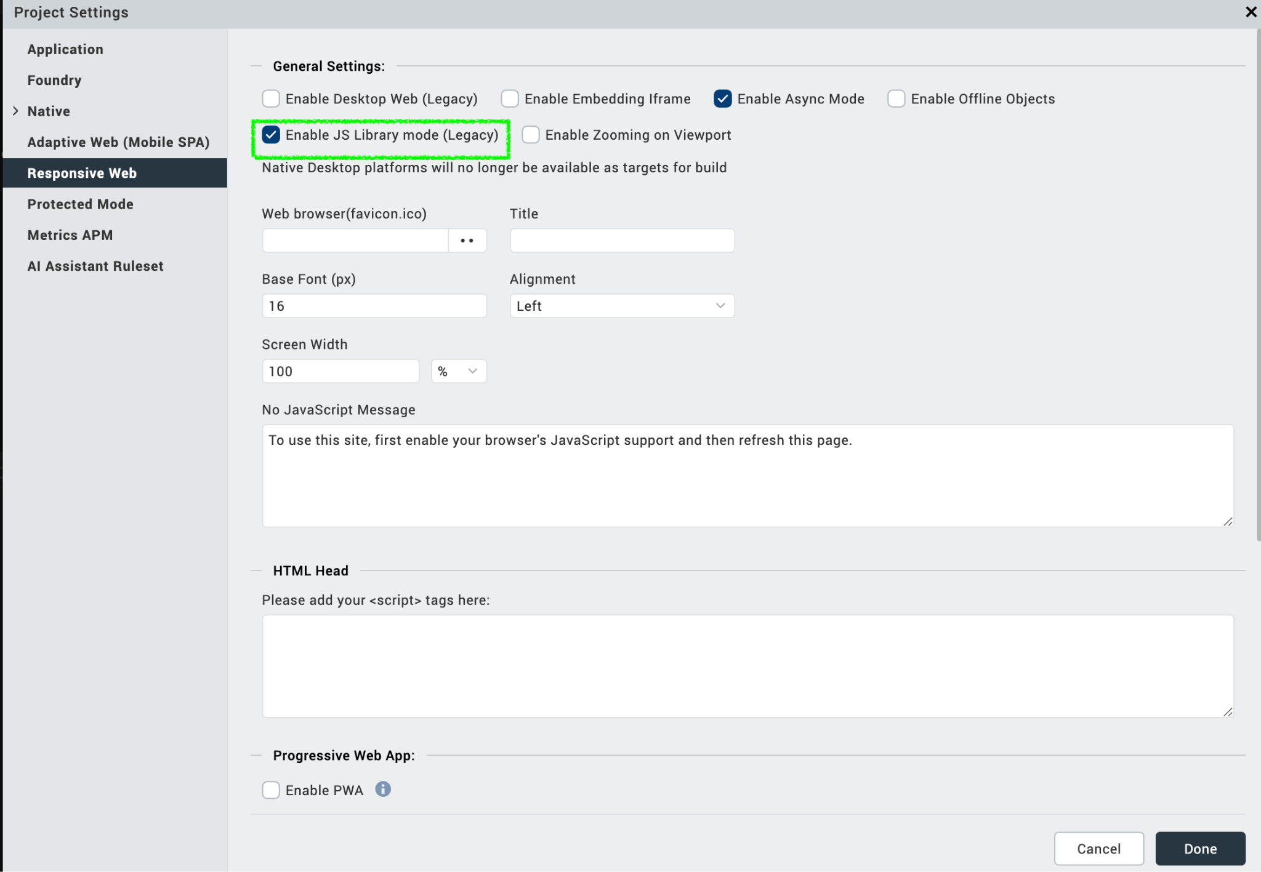

REFERENCES

Dynamic Usage
You can also add Range Slider component dynamically.
To do so:
- In the Project Explorer, on the Projects tab, click Controllers section to access the respective Form Controller. Create a method and implement the code snippet similar to the sample code mentioned below.
In the code snippet, you can edit the properties of the component as per your requirement. For more information, see Setting Properties.

/* Creating a component's Object */
var Slider = new com.voltmx.slider (
{
"autogrowMode": voltmx.flex.AUTOGROW_NONE,
"clipBounds": true,
"height": "20%",
"id": "Slider",
"isVisible": true,
"layoutType": voltmx.flex.FREE_FORM,
"left": "0dp",
"top": "0%",
"width": "80%"
}, {}, {});

/* Setting the component's properties */
Slider.minValue = 110;
Slider.maxValue = 200;
Slider.minimumIncrementValue = 10;
Slider.fullRangeEndpointIcon = "Slider.png";
Slider.selectedRangeEndpointIcon = "Slider_android.png";

/* Adding the component to the form */
this.view.add(Slider);
/* Initializing the component */
this.view.Slider.initialize();
}
Save the file.

Properties
The properties provided on the Component tab allow you to customize the UI elements in the Range Slider component. You can set the properties directly on the Component tab or by writing a JavaScript.

- Minimum Value
Category: Pass Through
Description: Specifies the minimum value that you want to set on the slider.
Syntax: minValue
Type: Number
Read/Write: Read + Write
Example: this.view.componentID.minValue = 10;
- Maximum Value
Category: Pass Through
Description: Specifies the maximum value that you want to set on the slider
Syntax: maxValue
Type: Number
Read/Write: Read + Write
Example: this.view.componentID.maxValue= 100;

- Minimum Increment Value
Category: Pass Through
Description: Specifies the maximum value that you want to set on the slider
Syntax: minimumIncrementValue
Type: Number
Read/Write: Read + Write
Example: this.view.componentID.minimumIncrementValue= 10;
- Background Skin
Category: Pass Through
Description: This skin links to the background of the component.
Syntax: sknBackground
Widget Type: FlexContainer
Read/Write: Read + Write
Example: this.view.componentID.sknBackground = "BackgroundSkin";

- Selected Index Skin
Description: This skin links to the index numbers that are in the selected range.
Syntax: sknSelectedIndex
Example: this.view.componentID.sknSelectedIndex = "SelectedIndexSkin";
Widget Type: Label

- Unselected Index Skin
Description: This skin links to the index numbers that are not in the selected range.
Syntax: sknUnselectedIndex
Example: this.view.componentID.sknUnselectedIndex = "UnselectedIndexSkin";
Widget Type: Label

- Selected Range Skin
Description: This skin links to the line that indicates the selected range.
Syntax: sknSelectedRange
Example: this.view.componentID.sknSelectedRange = "SelectedRangeSkin";
Widget Type: Label

Events
You can define events to be executed when an action is performed. You can configure the events directly on the Actions tab or by writing a JavaScript. To configure the events on the Actions tab, click Edit against each event. For more information, refer to Add Actions.
This section provides details about each event that help you define the actions by writing a JavaScript.

- OpenonRangeChangeEnd
Description: Invoked when the user releases the handles of the slider.
Syntax: onRangeChangeEnd(values)
Parameters: values [Array]Contains the minimum and maximum values of the selected range.
Example: this.view.componentID.onRangeChangeEnd = function(values)
{
alert("Minimum Value: "+values[0]+"; Maximum Value: "+values[1]);
}.bind(this);

- OpenonRangeChange
Description: Invoked when the user moves the handles of the slider. This event gets invoked even if the handle is moving, that is, even if the user does not release the handle.
Syntax: onRangeChange(values)
Parameters: values [Array]Contains the minimum and maximum values
of the selected range.
Example: this.view.componentID.onRangeChange = function(values)
{
alert("Minimum Value: "+values[0]+"; Maximum Value: "+values[1]);
}.bind(this);

- OpenonErrorCallback
Description: Invoked when an error occurs in the component.
Syntax: onErrorCallback(error)
Parameters: error [JSON]Contains information about the error such as the error code and error message.
Remarks: If you do not define this event, the component displays an alert when an error occurs.
Example: this.view.componentID.onErrorCallback = function(error)
{
alert("Error Occured: "+JSON.stringify(error));
}.bind(this);

APIs

The following APIs pertain to the Range Slider component

- OpengetSelectedValues
Description: | Fetches the minimum and maximum values of the current selected range, that is, the values that are indicated by the left handle and the right handle.
Syntax: | getSelectedValues()
Parameters: | None
Return Value: | SelectedValues [Array]:Contains the minimum and maximum values of the selected range.
Example: | var selectedValues= this.view.componentID.getSelectedValues();  var min = selectedValues[0];  //Minimum value of the selected range (left handle)  var max = selectedValues[1];  //Maximum value of the selected range (right handle)

- OpenresetRangeSlider
Description: | Resets the range slider.
Syntax: | resetRangeSlider()
Parameters: | None
Return Value: | None
Remarks: | Use this API to reset the slider in the following scenarios:  After you add the component to a form dynamically.  After you change the width of the component at run time.  After a breakpoint change, to enable responsive behavior.
Example: | this.view.componentID.resetRangeSlider();

- Openinitialize
Description: | Initializes the component.
Syntax: | initialize()
Parameters: | None
Return Value: | None
Remarks: | Use this API to initialize the component after you create a component dynamically.
Example: | this.view.componentID.initialize();

REVISION HISTORY
App version 4.1.0

Limitations
- The component does not support floating point values.
- To avoid UI distortion, the Minimum Value and Maximum Value properties should not contain more than four digits.
- If browser height is minimized then the UI might get distorted.

Miscellaneous
- Make sure that you use the initialize API to initialize the component after you create a component dynamically.
- Make sure that you call the resetRangeSlider API in the following scenarios.
  - After you add the component to a form dynamically.
  - After you change the width of the component at run time.
  - After a breakpoint change, to enable responsive behaviour.
- If the component contains a lot of divisions, it can cause the labels of the slider to overlap when the slider handles are close to each other.
  - Make sure that you set the Minimum Increment Value such that the component does not contain a lot of divisions.
- By default, the component displays an alert when an error occurs. If you want to add custom actions, you can define the onErrorCallback event.

