Date : 03-Feb-26

REMOVEBG ADAPTER

VERSION: 1.0.0

OVERVIEW
The remove.bg API is a cloud-based AI service that automatically removes backgrounds from images and can also enhance image quality. It’s commonly used in e-commerce, profile photos, marketing creatives, and mobile apps. It supports common image formats and returns a transparent image or a custom background.
This document focuses on JSON-based (application/json) integrations, suitable for:
- Backend services
- API gateways
- Volt MX Foundry integrations
- Server-to-server communication
A) Use case:
- E-Commerce Product Catalog Automation
- User Profile & ID Photo Processing
- Marketing & Creative Automation

Mobile Camera & Photo Editing Apps

Real Estate Listings
- Automotive Industry
- HR, Recruitment & Employee Systems
- Document Digitization & OCR Pipelines
B) Features:
- Auto background removal: Saves manual editing time
- Consistent outputs: Strong brand identity
- Image enhancement: Better user perception
- Scalable API: Supports growth
- Mobile support: Wider reach

C) Percentage of Reuse:
- Approximately 80–90% reuse.

2. GETTING STARTED

Prerequisites
Before using the Removebg Adapter, ensure you have the following:
- HCL Foundry
- Volt MX Iris
- Removebg Key
Creating an Removebg Kaleido Account and API Key:
- Go to https://www.remove.bg/ and create a free account.
- After signing up, go to the Dashboard.
- Navigate to https://www.remove.bg/dashboard#api-key API Key and Copy the generated API key and store it securely - you will need it while configuring the integration service in Foundry.

B. Importing the data adapter

You can import Removebg Data Adapter into HCL Foundry directly from the Volt MX Forge website or by importing the data adapter zip file.

To import Data Adapter to Volt Foundry, do the following:
- Sign in to the HCL Foundry.
- From the left navigation menu, select API Management.
- In API Management, select Custom Data Adapters.
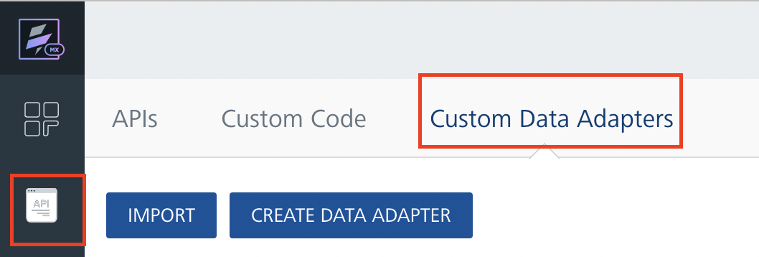
4. Click IMPORT to import a custom data adapter.
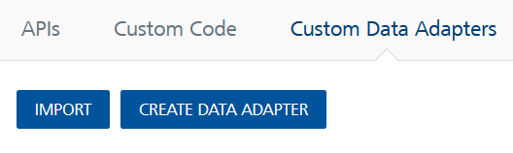
5. On the Import Data Adapter dialog box, click browser to import.

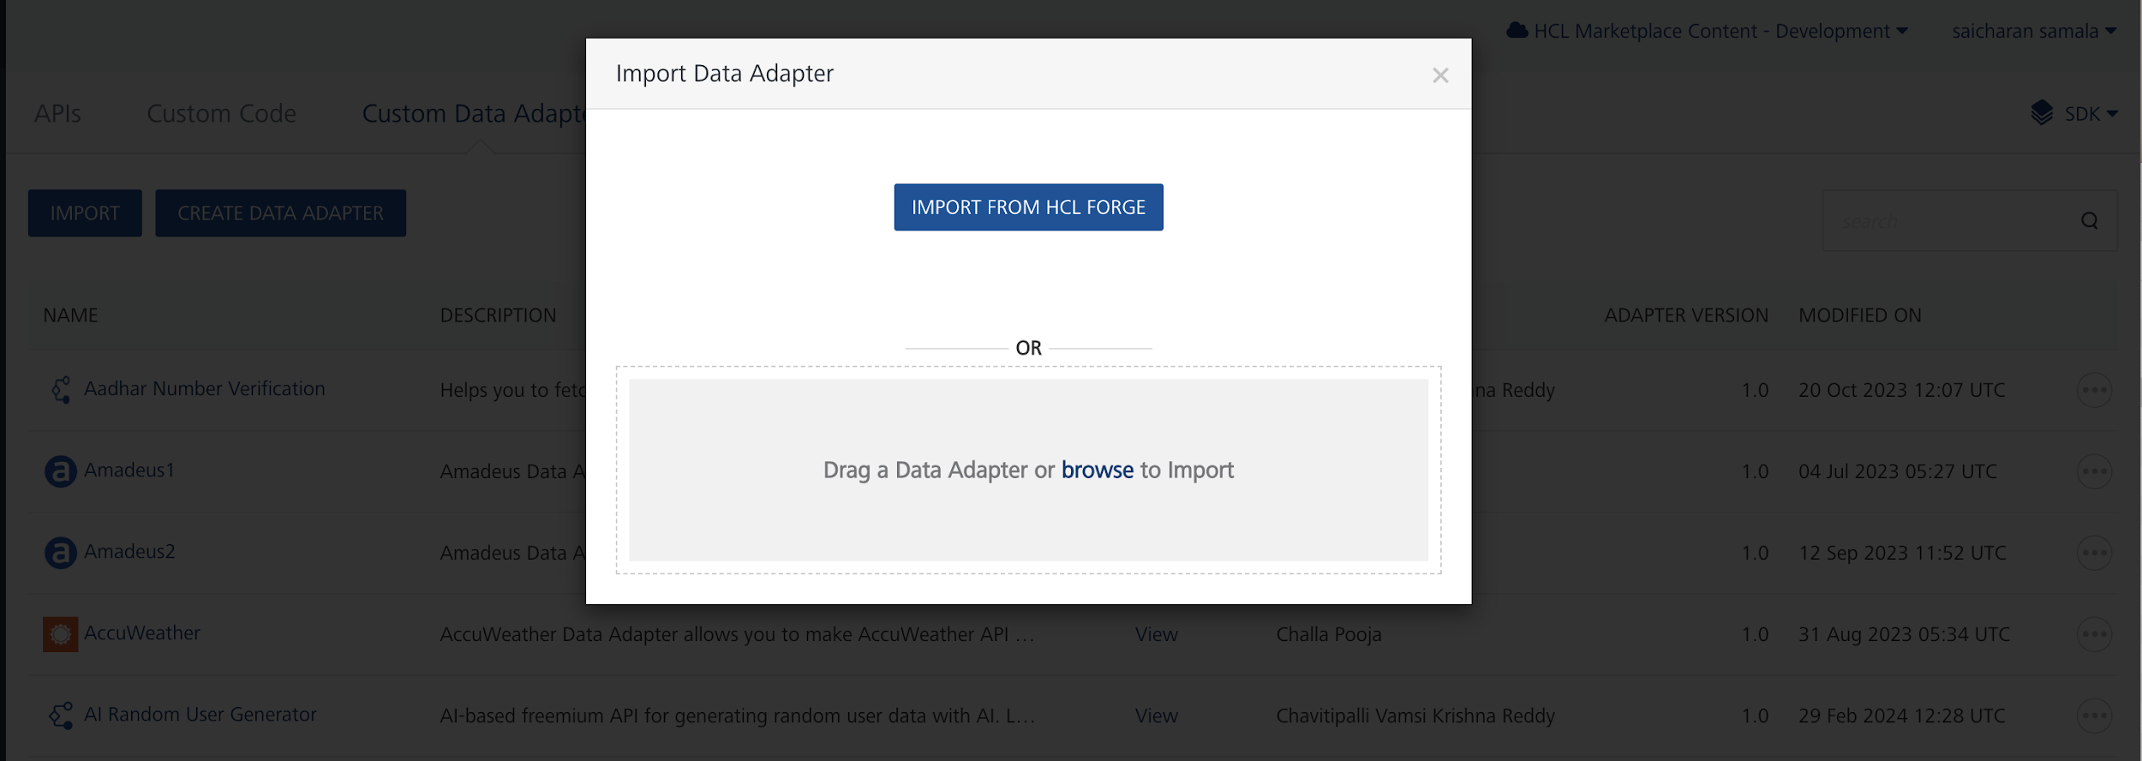

6. Click IMPORT FROM HCL FORGE. The Import Data Adapter from HCL Forge dialog appears with a list of available data adapters.
Click Import. Removebg data adapter is listed on the Custom Data Adapters page.
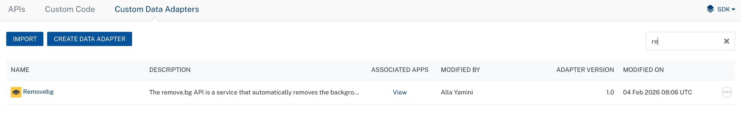
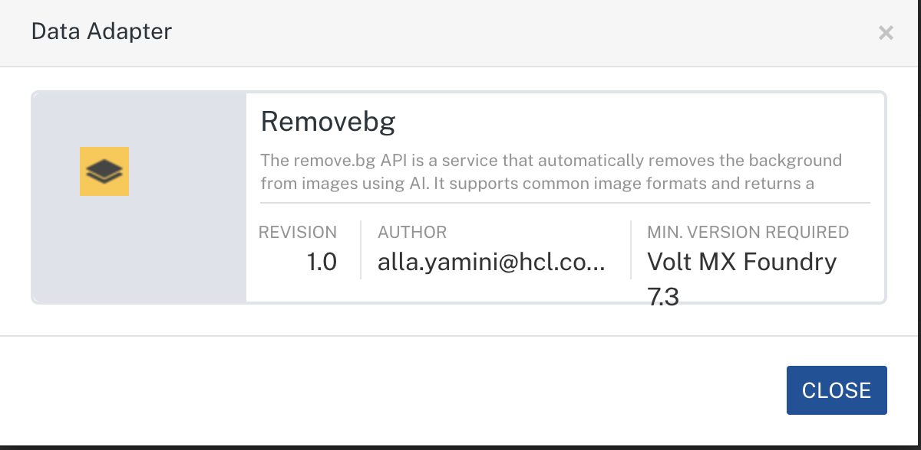
To import the data adapter zip file, do the following:
- Perform steps 1 to 4 in the above procedure
- Drag the data adapter zip file into the Drag a Data Adapter box.
Or
Click browse. The Open dialog appears.
Navigate to the location where you downloaded the data adapter (zip file) on your computer, select the data adapter, and click Open. The Import Data Adapter dialog shows the selected data adapter.
Note: Click Remove if the selected data adapter is not the one that you want to import.

C. Creating an Integration Service with Removebg :
After you import the Removebg Data Adapter into Foundry, you must create an integration service with a service type as Removebg.
To create an integration service with Removebg, do the following:
- Log on to your HCL Foundry. The Dashboard page appears by default.
- In the left pane, click the API Management menu. The APIs tab opens by default.
- Click the Integration tab. The Integration tab opens with a list of existing integration services.
- Click CONFIGURE NEW. The Service Definition tab opens.
- In the Name box, type a unique name for your service.
- From the Service Type list, select Removebg
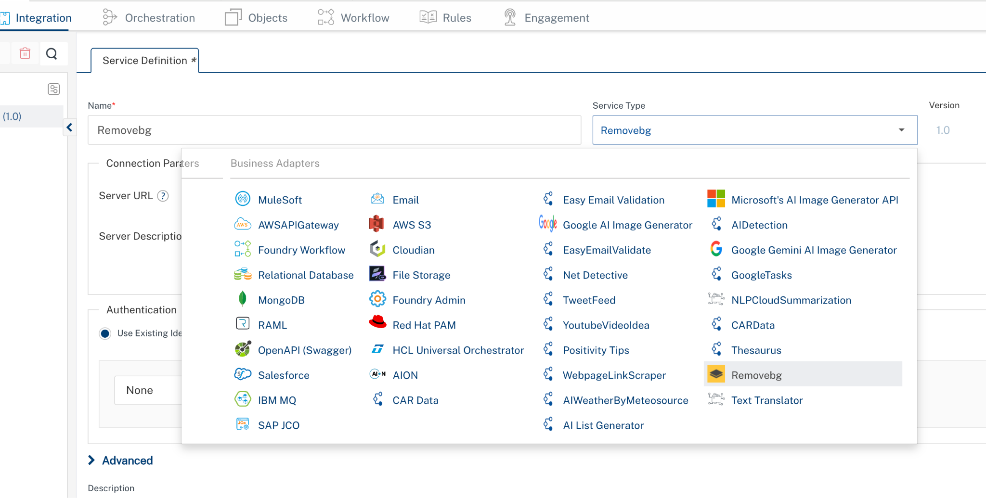

7. Click Save

D. Creating an Operation
To make any API call in the HCL Foundry console, you must create an operation for the respective API and then execute the operation. Executing an operation involves making the API call and displaying the response.
This section provides steps to create an operation for the Removebg.
Steps to create an operation for the Removebg:
- Log on to your HCL Foundry. The Dashboard page appears by default.
- In the left pane, click the API Management menu. The APIs tab opens by default.
- Click the Integration tab. The Integration page appears with a list of existing integration services.
- From the list of integration services, select the integration service that you have created with the service type as Removebg. The Service Definition tab of the selected integration service opens by default.
- Click the Operations List tab. The Operations List tab opens.
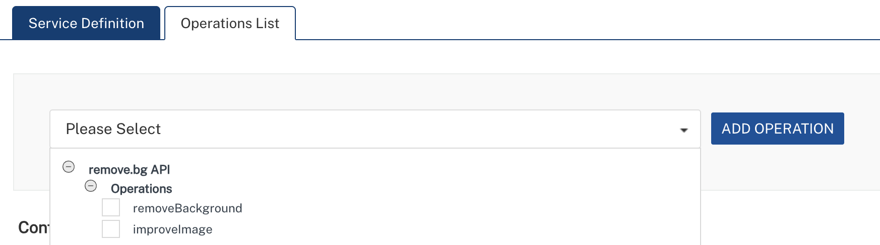
- Select improveImage and Click Add Operation.
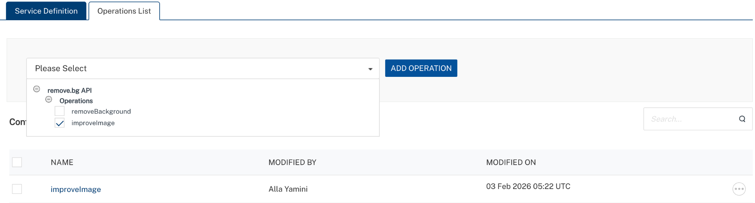

E. Executing Operation
Executing an operation involves making the API call by setting the necessary parameters and displaying the response. The procedure to execute any operation is the same, but the request parameters of the APIs vary. This section provides steps to execute the improveImage (explained in Creating an Operation).
Steps to execute the improveImage operation:
- Log on to your Hcl Foundry. The Dashboard page appears by default.
- In the left pane, click the API Management menu. The APIs tab opens by default.
- Click the Integration tab. The Integration tab opens with a list of existing integration services.
- From the list of integration services, select the integration service that you have created with service type as Removebg. The Service Definition tab of the selected integration service opens by default.
- Click the Operations List tab.
- In the Name box, the name of the operation is displayed by default. If you want, you can change the name.
- On the Request Input tab, in the Body section, for the following parameters, specify the values in the respective boxes under the Test Value or Default Value column.
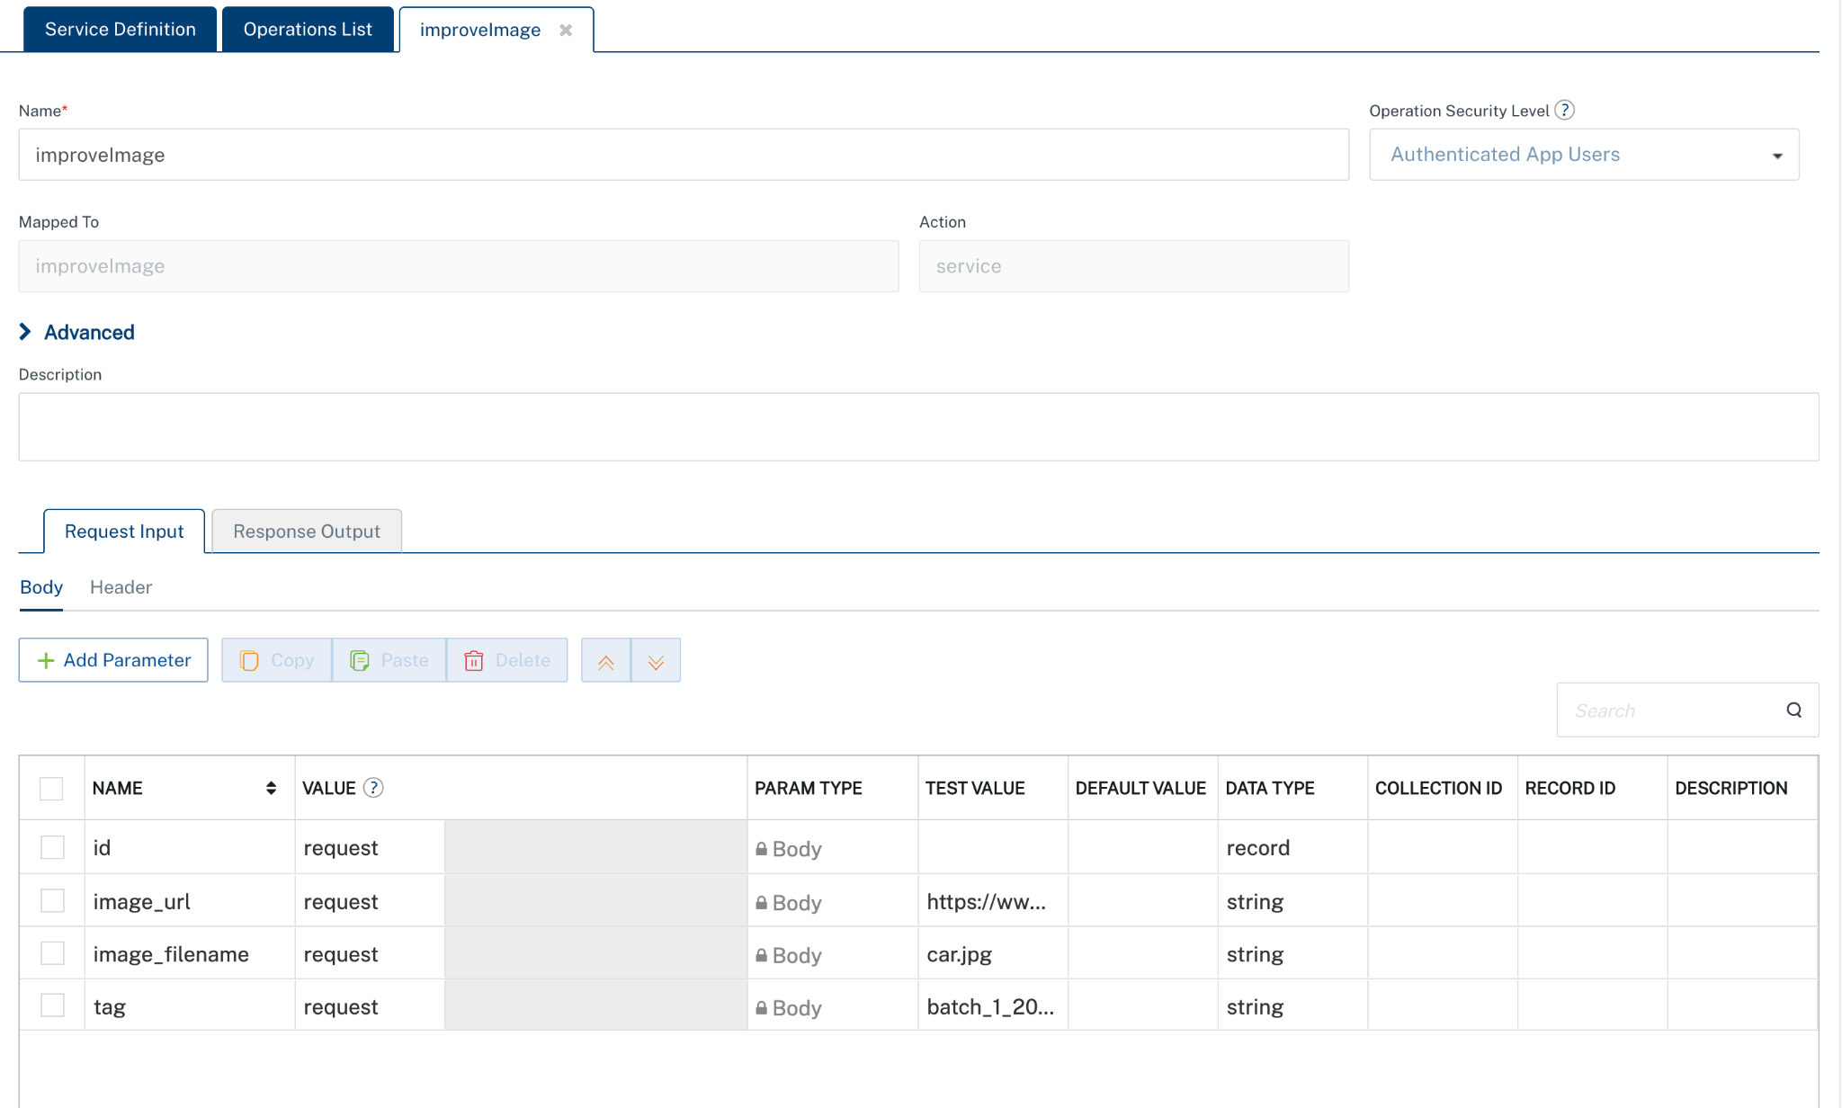
In the Header section, for the following parameters, specify the values in the respective boxes under the Test Value or Default Value column.
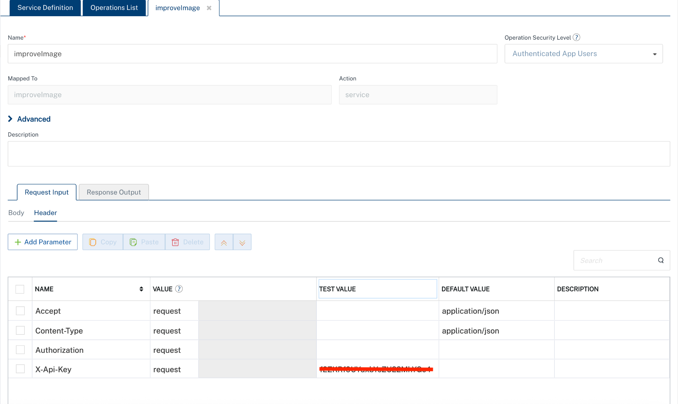
- Click SAVE AND FETCH RESPONSE. The Output Result dialog appears with the response. Otherwise, the Output Result shows an error.
. 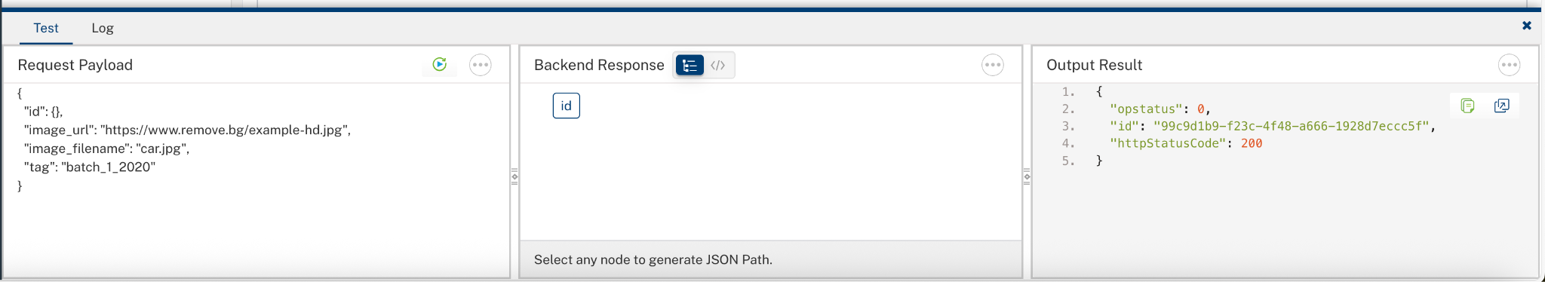

3. Publishing the App in VoltMX FOUNDRY:
After adding the Removebg Data Adapter to your app and configuring the necessary configurations, you must publish the app to HCL Foundry. For more information, refer to Publish a foundry app.
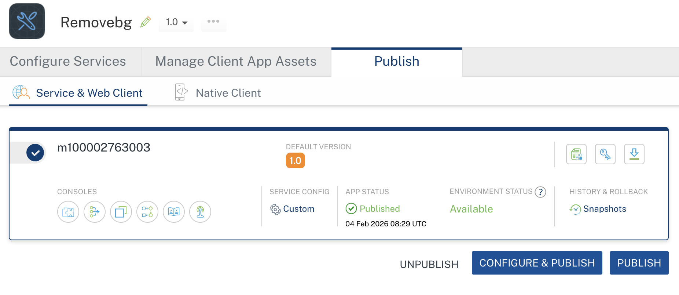
4. REFERENCES

Properties
- None of the properties are exposed.

Events
- None of the events are exposed.

API’s
- None of the APIs are exposed.

5. REVISION HISTORY
Adapter version 1.0.0:

Known Issues
None

Limitations
None

