Date : 21-jan-26

REPLICATE

VERSION: 1.0.0

1.OVERVIEW
The Replicate AI Platform is a powerful inference-focused ecosystem that enables developers to run state-of-the-art machine learning models through simple, consistent APIs. Replicate hosts a wide range of community and partner models across image generation, video creation, audio processing, and multimodal AI, allowing teams to integrate advanced AI capabilities without managing infrastructure.
Replicate abstracts away model hosting, GPU provisioning, scaling, and optimization, so developers can focus entirely on inputs and outputs. With a unified REST API, users can execute models on demand, stream results in real time, and handle long-running jobs asynchronously using webhooks. Replicate supports popular open-source and proprietary models such as FLUX, Stable Diffusion, Ideogram, Imagen, and video generation systems, making experimentation and production usage fast and reliable.

A. Use case:

1. Image Generation & Creative AI
Generate high-quality images from text prompts using state-of-the-art diffusion models. Supports photorealistic images, illustrations, posters, product visuals, and artistic styles for creative and marketing workflows.

2. Video Generation & Enhancement
Create short videos from text or images, reframe and resize existing videos, and enhance low-resolution footage using AI-powered video generation and upscaling models.

3. Image Understanding & Transformation
Apply image-to-image transformations such as style transfer, restoration, background modification, face enhancement, and super-resolution using specialized vision models.

4. Audio, Speech & Multimodal AI
Run models for speech synthesis, audio processing, music generation, and multimodal workflows where text, images, and audio are combined as inputs or outputs.

5. Unified AI Inference for Applications
Execute any supported model through a single REST API without managing GPUs, containers, or infrastructure. Ideal for integrating AI features directly into web, mobile, and enterprise applications.

6. Real-Time & Asynchronous AI Processing
Support both synchronous inference (wait for results) and asynchronous workflows using polling, streaming (SSE), or webhooks for long-running jobs and real-time output.

7. Model Experimentation & Rapid Prototyping
Quickly test, compare, and switch between multiple community and partner models using consistent APIs—enabling fast experimentation before production rollout.

B. Percentage of re-use:
Approximately 80% of reuse
C. Features:

1. Model Marketplace
A curated catalog of community and partner AI models across image, video, audio, and multimodal domains. Each model includes versioning, documentation, example inputs, and usage metadata.

2. Prediction API (Core Feature)
Run AI models on demand using a single REST endpoint. Handles provisioning, scaling, execution, and cleanup automatically—no server or GPU management required.

3. Streaming & Webhooks
Receive real-time outputs via server-sent events (SSE) or asynchronous callbacks via webhooks, enabling responsive UI updates and background processing.

4. Cost-Controlled Execution
Pay-per-prediction pricing with execution limits, cancellation controls, and timeouts to prevent runaway costs and manage production usage safely.

5. Model Versioning & Reproducibility
Pin exact model versions for deterministic results, rollback safety, and reproducible AI workflows across environments.

6. Model Publishing & Monetization
Creators can upload, version, and publish their own models to Replicate, making them available for private use or public monetization through the platform.

2. GETTING STARTED
  - Prerequisites
Before you start using the Replicate API data adapter, ensure you have the following:

- HCL Foundry
- Volt MX Iris

PLATFORMS SUPPORTED

Foundry

Importing the adapter
To import the Data Adapter to Volt Foundry, do the following:
- Sign in to the HCL Foundry.
- From the left navigation menu, select API Management.
- In API Management, select Custom Data Adapters.
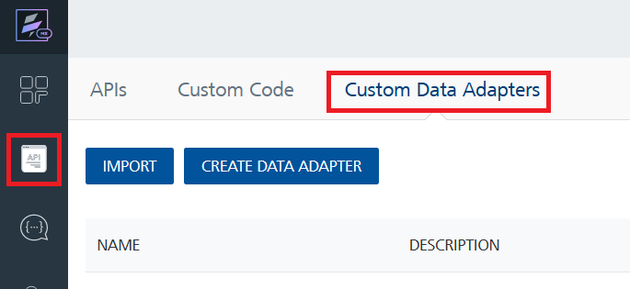
- Click IMPORT to import a custom data adapter.
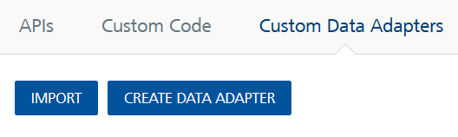
- On the Import Data Adapter dialog box, click browser to import.
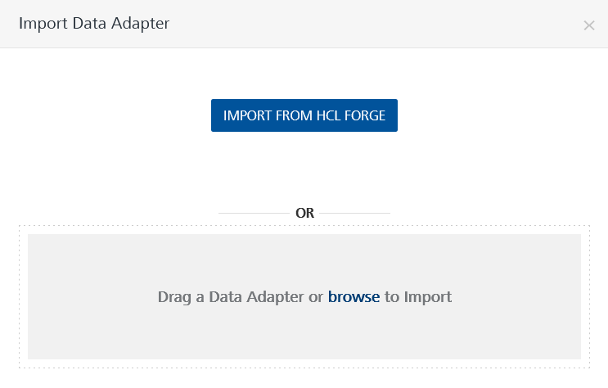
- Select Replicate API data adapter zip file and click IMPORT.
After importing the data adapter, Volt Foundry opens a window that shows the metadata of the data adapter.
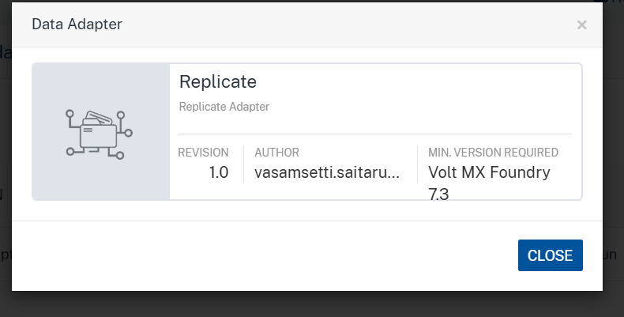
After you import the data adapter, you can view it on the Custom Data Adapters page and use it to create services on Volt Foundry.
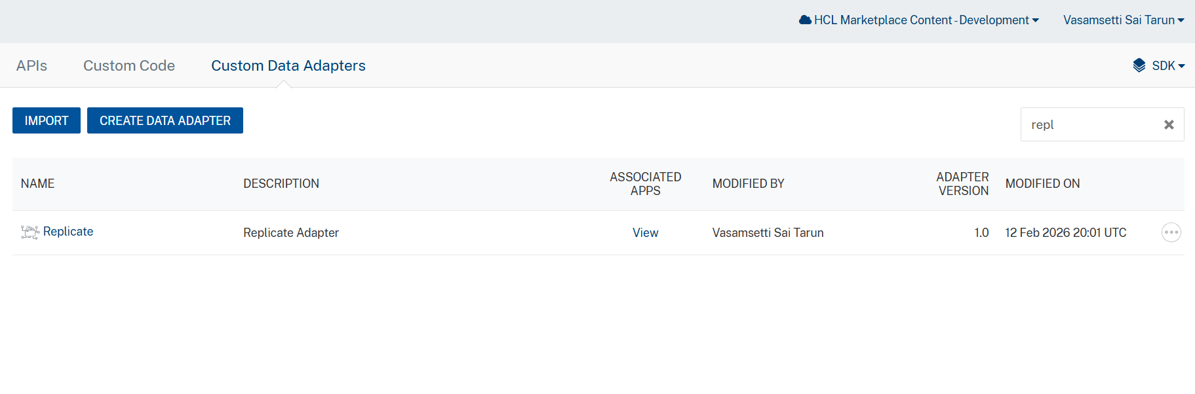
After you add the data adapter to your Volt Foundry app. You can refer to the section below for more information.

Creating an Integration service
Follow the steps given to create an Integration service using the Replicate API Data Adapter.
- Sign in to the HCL Foundry.
- From the left navigation menu, select API Management.
- In API Management, select Integration.
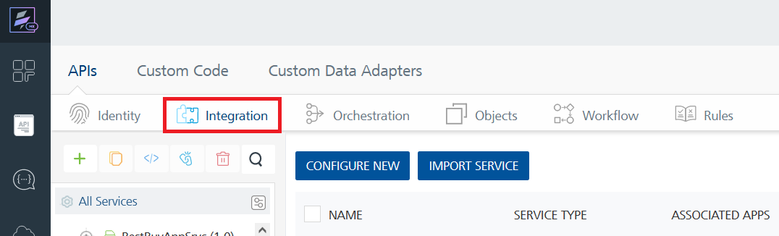
- To create a new service, click the + button or the CONFIGURE NEW button.
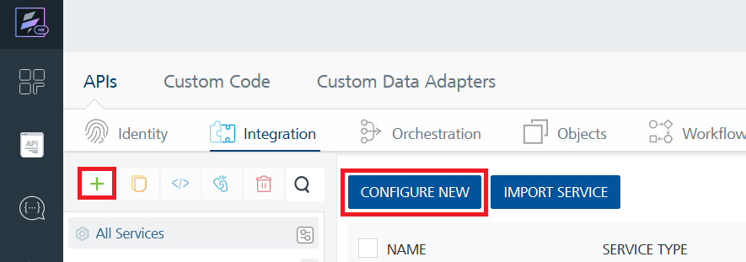
- On the Service Definition tab, select the service type as Replicate API, and click SAVE.
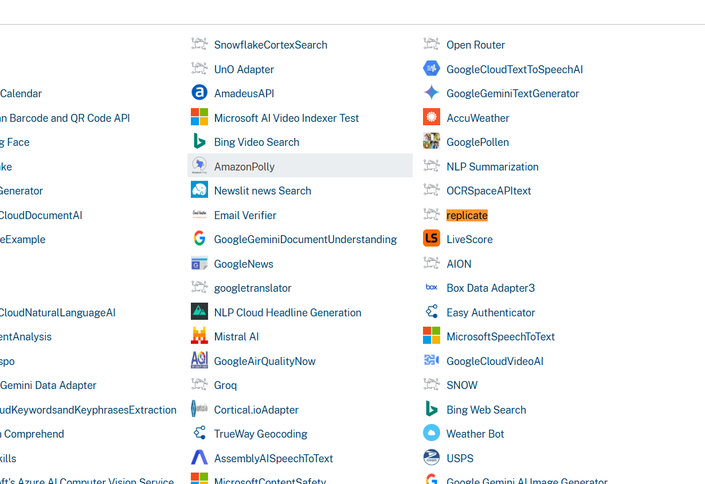
Creating and Executing operations
After you create an integration service, you can create and execute operations using the service.

Creating an operation
- In the API Management/Foundry app you created, in the Integration section, select the service that you created.
- After you select the service, navigate to the Operation List tab.
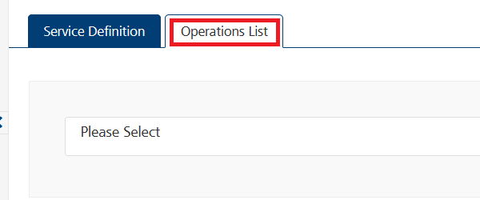
- From the drop-down list, select an operation that you want to execute, and click ADD OPERATION.
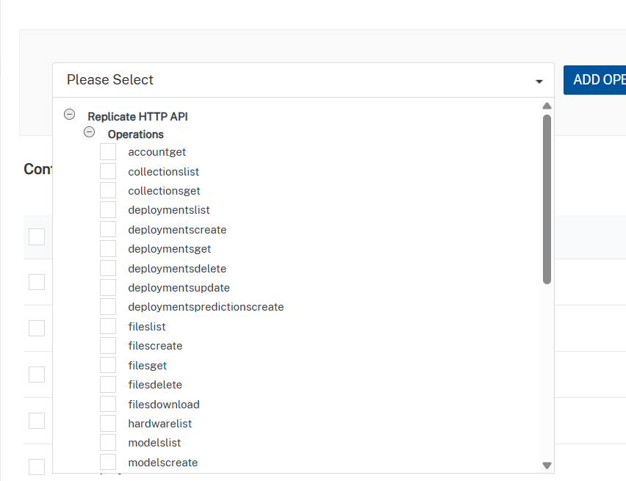

Executing an Operation

- From the Operations List tab, in the Configured Operations section, select the operation you want to execute.
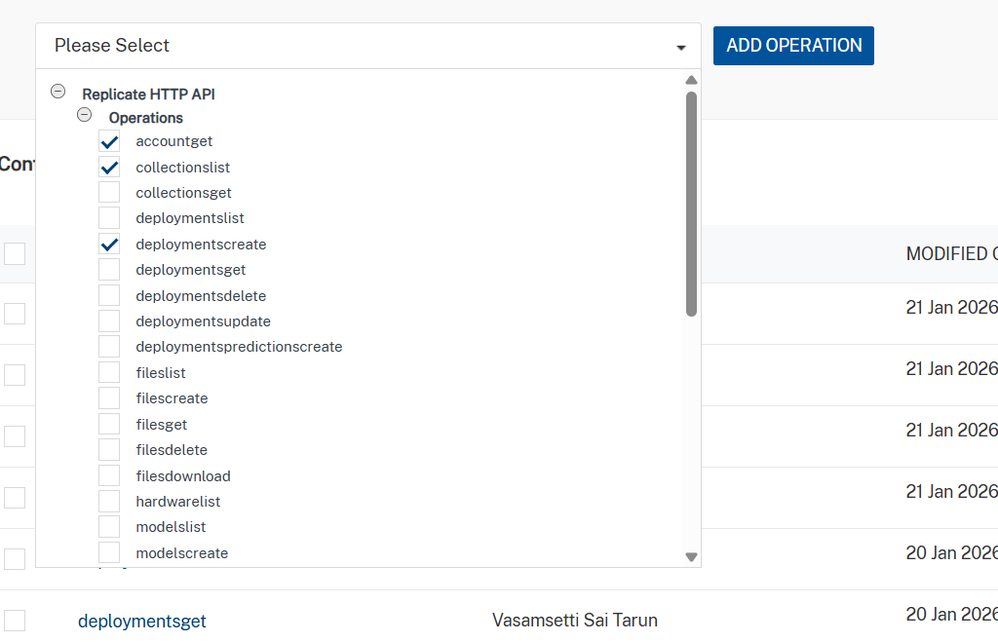
- On the Operation Page, in the Request Input tab, enter a TEST VALUE for all the fields.
Sample Test case.

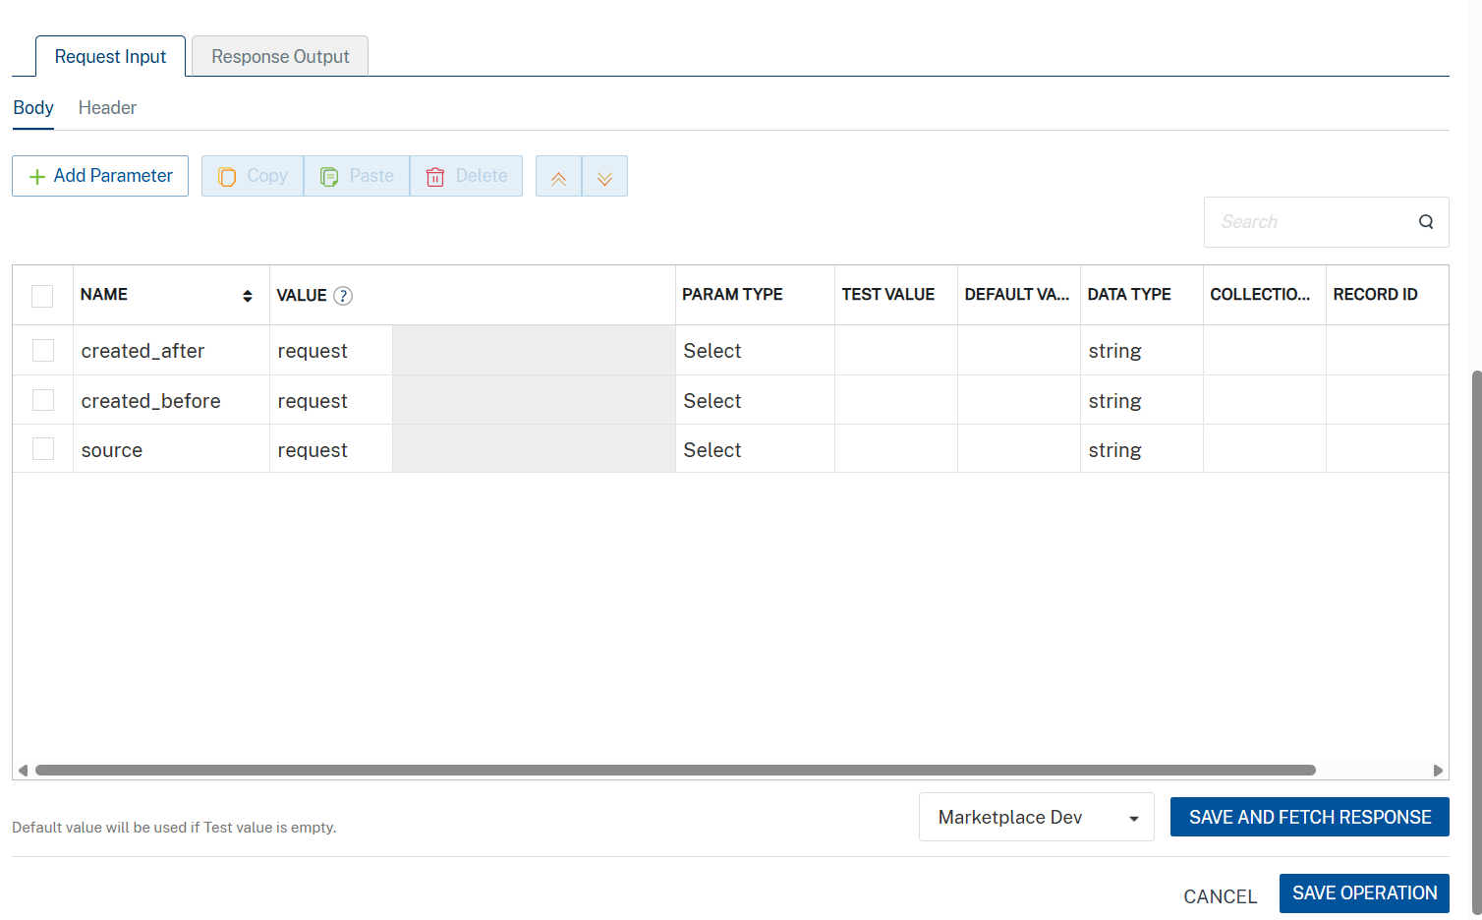

- Select a run-time environment and click Save and Fetch Response to get a response based on your inputs.
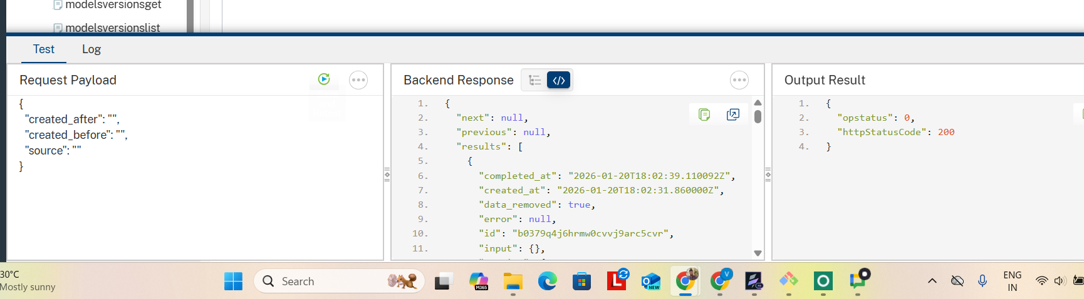

3. Publishing your application
If you want to use the services in client applications, you need to publish an app to a run-time environment. You can create the service (as described above) in an application or import the service into an application and publish the application.

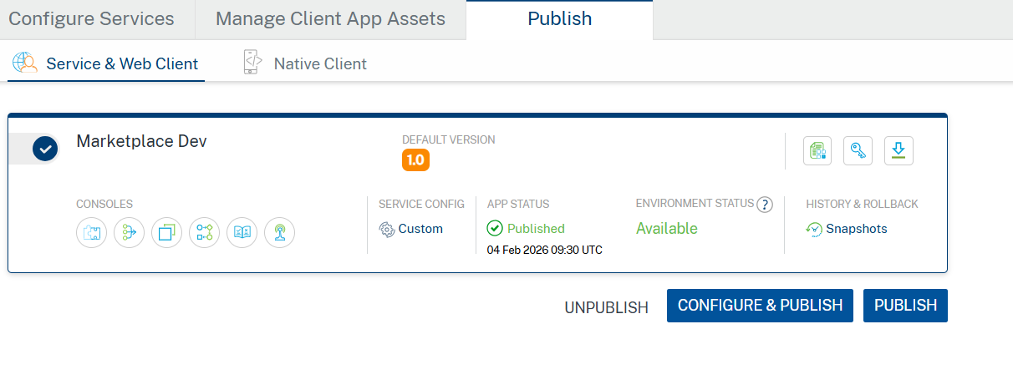

4. REVISION HISTORY

App version 1.0.0:

A. Limitations
- Some endpoints are not supported due to Volt MX Foundry’s current limitation with handling multipart/form-data requests.

B. Known Issue

- NA

