Date : 2-MAR-26

SAMBANOVA APPLICATION

VERSION: 1.0.0

OVERVIEW
The SambaNova AI Platform provides high-performance AI inference and model execution through scalable cloud infrastructure optimized for large language models and advanced AI workloads. It enables developers to integrate powerful generative AI capabilities such as text generation, conversational agents, summarization, and reasoning directly into their applications using simple APIs.
SambaNova focuses on delivering enterprise-grade AI performance by leveraging its specialized AI hardware and optimized runtime stack. This architecture allows organizations to run complex models efficiently while maintaining high throughput and low latency.

Use case:
- Content Creation & Writing Assistance: Generate high-quality text for articles, blogs, or creative writing with controlled style and tone.
- Conversational AI & Chatbots: Provide contextually accurate, human-like responses for virtual assistants or customer support.
- Summarization & Knowledge Extraction: Condense long documents or extract key insights efficiently.
- Education & E-Learning: Produce clear explanations, tutorials, or interactive learning content.
- Marketing & Media Production: Create engaging copy for ads, social media, or scripts with consistent quality

Features:
- Controllable Text Generation: Adjust style, tone, creativity, and structure using natural language prompts.
- Context-Aware Responses: Maintain coherence and relevance across multi-turn interactions.
- High-Quality, Natural Text: Delivers accurate, human-like writing output.
- Fine-Grained Output Control: Ideal for structured scenarios like storytelling, summarization, or guided dialogues.
- Seamless API Integration: Easily integrates with applications for automated text generation.

Percentage of re-use:
80%

GETTING STARTED

Prerequisites
Before you start using the sambanovaApp, ensure you have the following:
- HCL Foundry
- Volt MX Iris
- To use the SambaNova API, you need an API key. You can generate an API key from the SambaNova Cloud dashboard. Visit https://cloud.sambanova.ai/, sign in to your account, navigate to the API Keys section, and create a new key to authenticate API requests.

Devices
- Mobile

Platforms
- Android
- IOS

Importing the App
To import the sambanova App to Volt MX Iris, do the following:

To import the sambanova App, do the following:
- Launch Volt MX Iris.
- Click project, and then select Import. The Import dialog box appears.
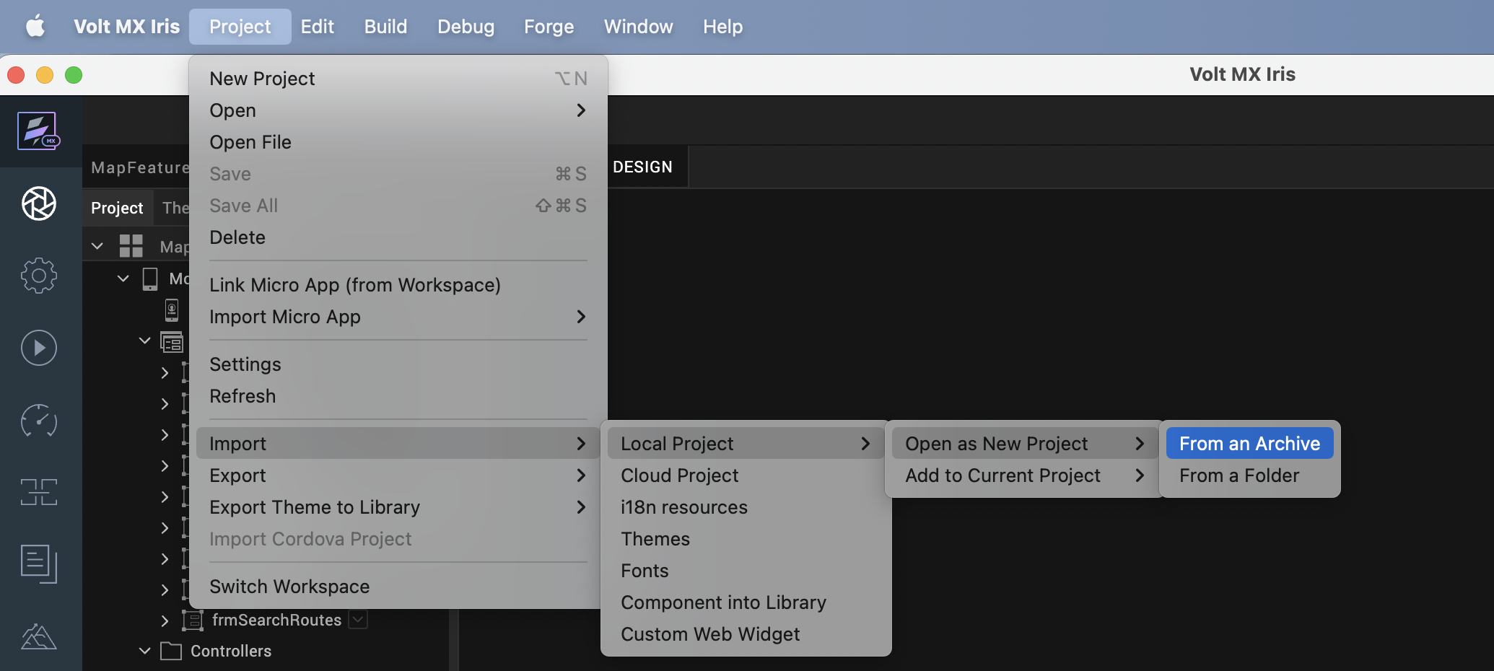

- Click From an Archive to navigate to the location of the project, select the files, and then click Import.
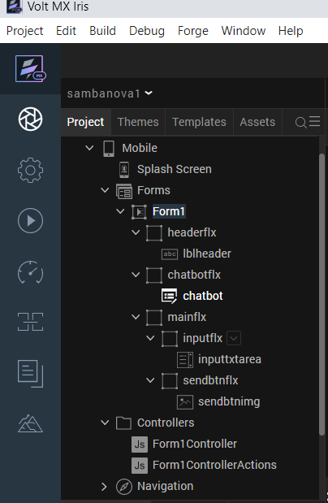
After you import the application, you can view the associated Foundry app connected at the in Data & Services section.
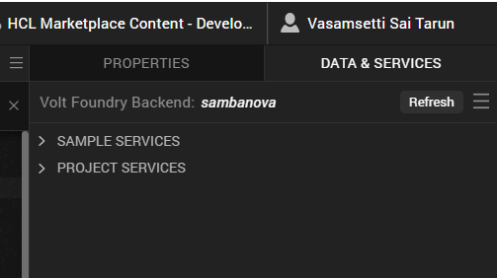

sambanova Volt MX Foundry Services:
The sambanova app contains an Integration Service:
sambanova: The sambanovaAPI offers advanced text generation and completion capabilities, producing high-quality, contextually accurate text. It allows fine-grained control over style, tone, creativity, and structure using natural language instructions. Sambanova is optimized for interactive text generation—ideal for applications like content creation, chatbots, summarization, and educational materials.
To set the Foundry app, follow these steps:
- Click the HCL Volt MX Foundry app associated with your Volt MX Iris project from the Project Explorer.
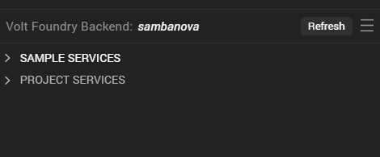

- Under the Configure Services tab, click Integration and can see the Sambanova. Click on Integration service to add the parameters.
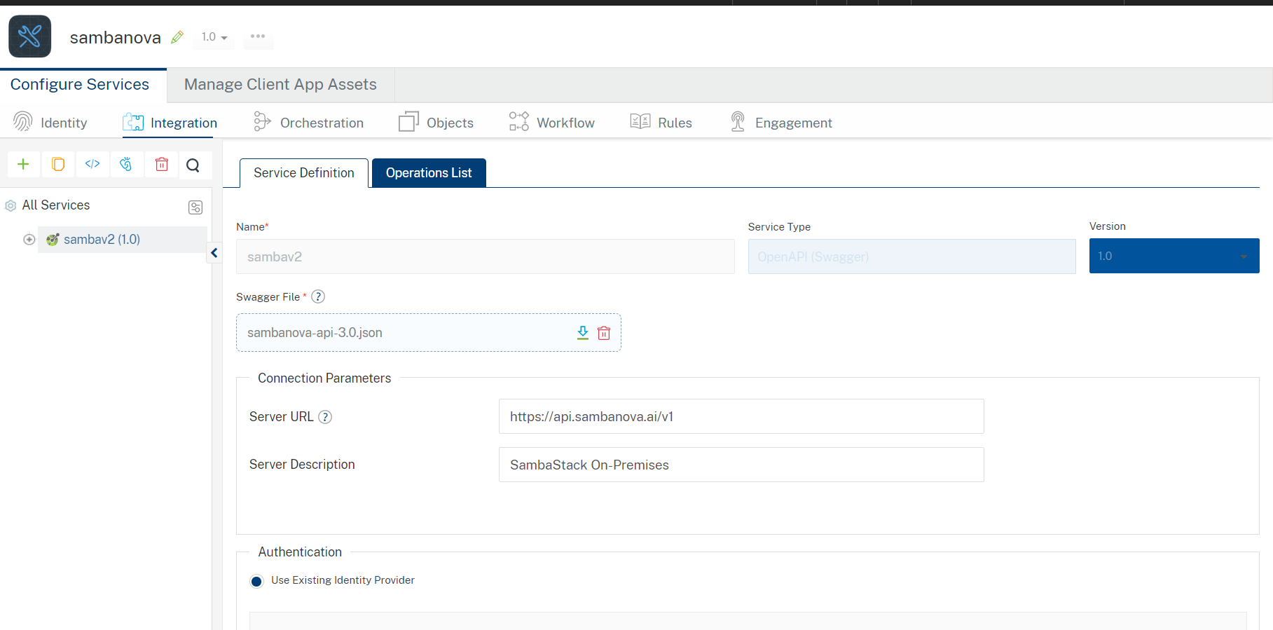
In the API Management/Foundry app you created, in the Integration section, select the service that you created.
- After you select the service, navigate to the Operation List tab.
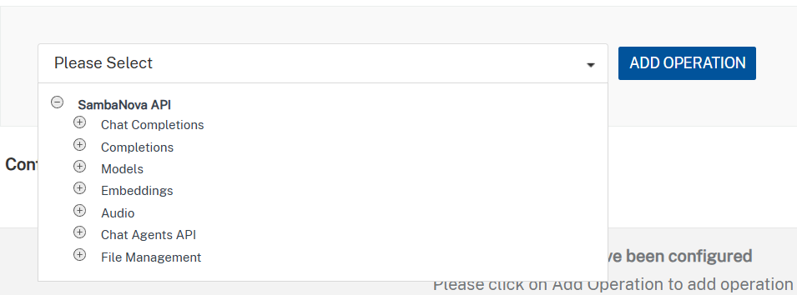
- From the drop-down list, select createChatCompletion click ADD OPERATION.
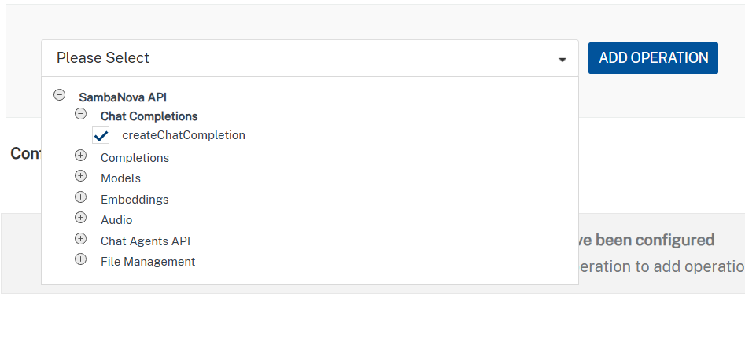
createChatCompletion
This operation invokes foundation models hosted on sambanovaInference to generate AI responses for tasks such as text generation, summarization, and conversational AI.
Inputs include:
- prompt / messages – User input or conversation history
- model – Selected sambanova-supported model
- temperature – Controls randomness of the output
- top_p – Controls nucleus sampling
- max_tokens – Maximum number of tokens to generate
- stop sequences (optional) – Tokens that stop generation
The operation processes the input using the selected sambanova model and returns a generated response optimized for speed and scalability.
- On the Operation Page, in the Request Input tab, enter a TEST VALUE for all the fields.
Sample Test case.
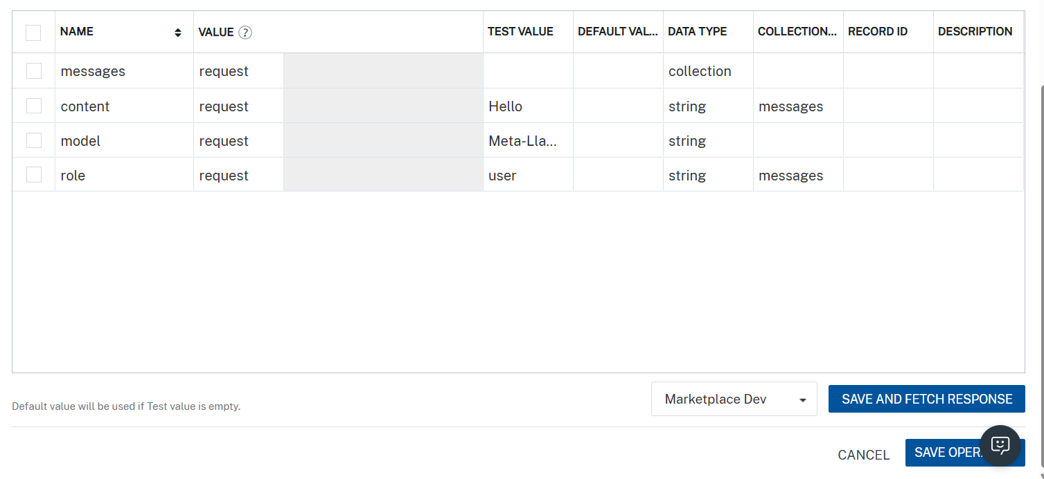
Click Header sub-tab. The Header section opens.
For Authorization, In the box under the Test VALUE column, type the API key obtained from sambanova
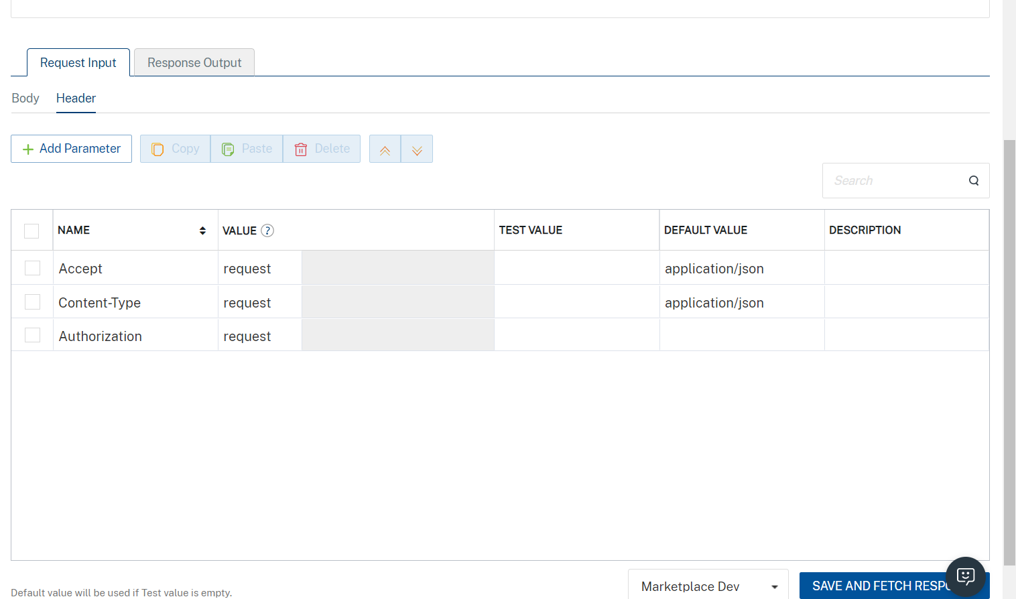
- Select a run-time environment and click Save and Fetch Response to get a response based on your inputs.
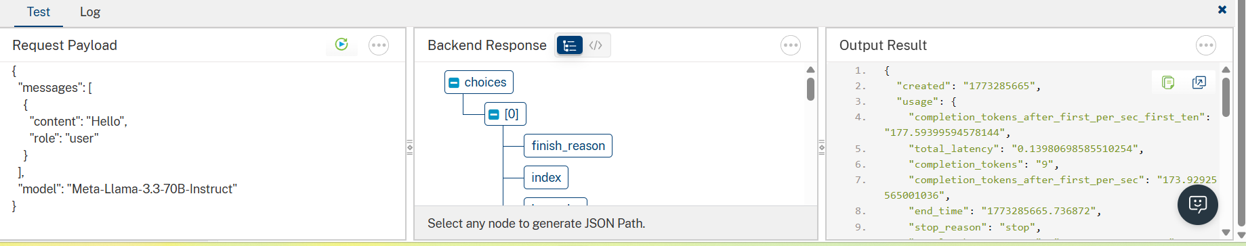

Building the app
From the menu bar, go to Build and then select Build Native Local.
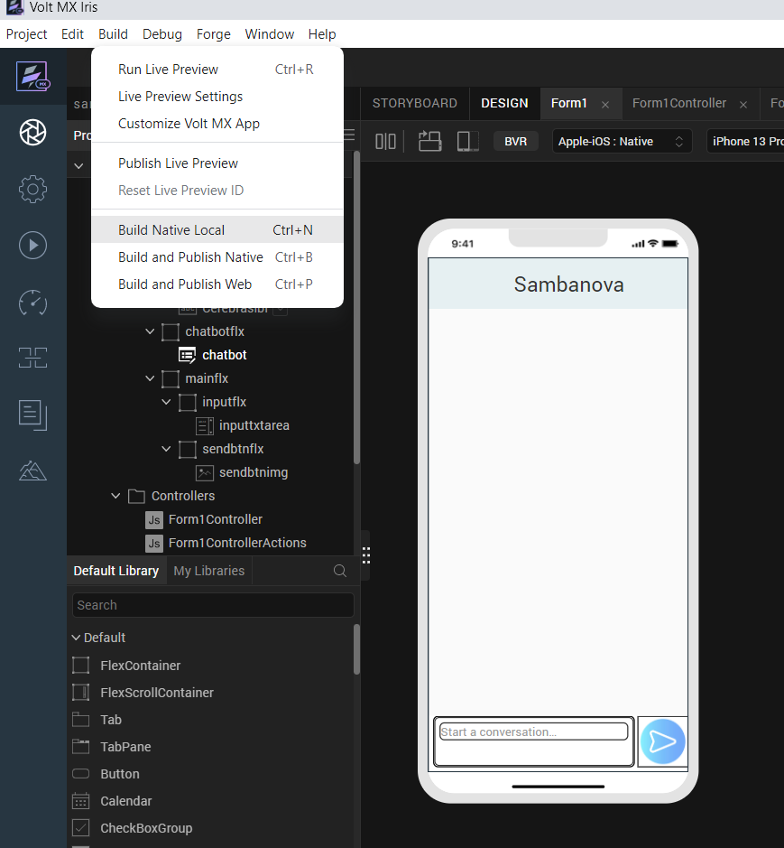

For Mobile, select Android and iOS. Click Build.
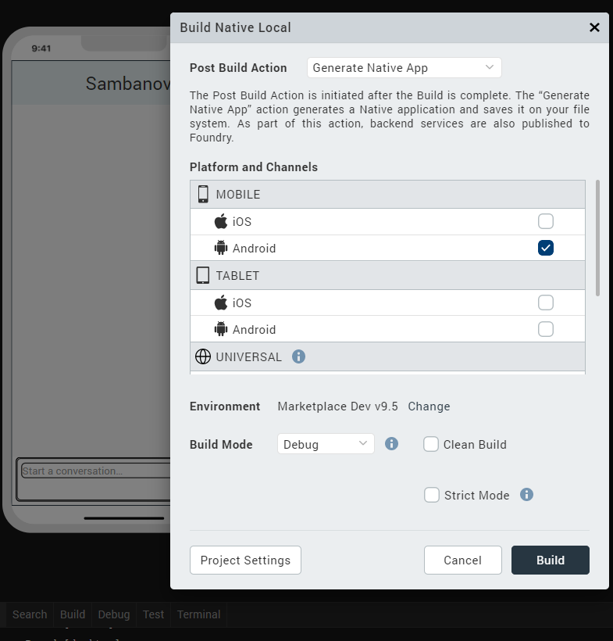

After the build is successful, run the app on your mobile device.

G. Application Flow
The landing page for the app is as follows:

Enter text to generate text generation and summarization questions.
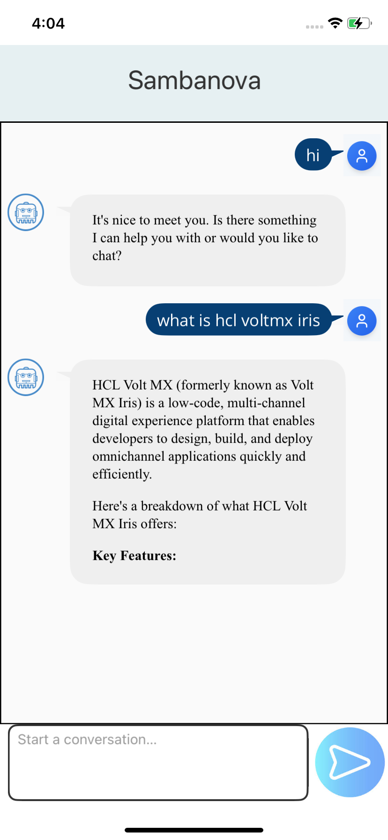

REVISION HISTORY
App version 1.0.0:

A. Limitations
1. Do not have support for Landscape mode.

B. Known Issue
- NA

