Date : 06-OCT-25

SAPLING REPHRASE ADAPTER

VERSION: 1.0.0

OVERVIEW
A Rephrase API is a service that rephrases or rewrites text while preserving its original meaning. This can be particularly useful for:
- Avoiding plagiarism
- Generating multiple versions of content
- Enhancing SEO by diversifying keywords and phrases
- Improving readability and clarity
A) Use case:
- Content Rewriting: Rewrite text while preserving meaning.
- Tone Adaptation: Change tone (friendly, formal, confident).
- Copy Generation: Generate creative text variations.
- Learning Tools: Help users write better.
- NLP Preprocessing: Simplify data for ML models.
- Translation Aid: Clarify text before translating.

B) Features:
- Context-Aware Rephrasing: Uses advanced NLP models to rewrite sentences while preserving original meaning. Ensures fluent, natural, and human-like phrasing.

Multiple Rewriting Styles (Mappings): Supports several mapping options to match different writing needs:
- paraphrase: General rewording for clarity or variation
- shorten: Makes text concise while keeping meaning
- expand: Adds detail or elaboration
- informal-to-formal: Converts casual text into professional tone
- sentence-split: Breaks long sentences into shorter ones
- passive-to-active: Changes passive voice into active

High-Performance Cloud Service
- Language & Tone Adaptability

2. GETTING STARTED

Prerequisites
Before you start using the Sapling Rephrase Data Adapter, ensure you have the following:

- HCL Foundry
- Volt MX Iris
- Get the API Key from sapling.ai
Reference document: https://sapling.ai/docs/api/rephrase

B. Importing the data adapter

You can import Sapling Rephrase Data Adapter into HCL Foundry directly from the Volt MX Forge website or by importing the data adapter zip file.

To import the data adapter zip file, do the following:
- Log on to your HCL Foundry. The Dashboard page appears by default.
- In the left pane, click the API Management menu. The APIs tab opens by default.
- Click the Custom Data Adapters tab. The Custom Data Adapter page appears.
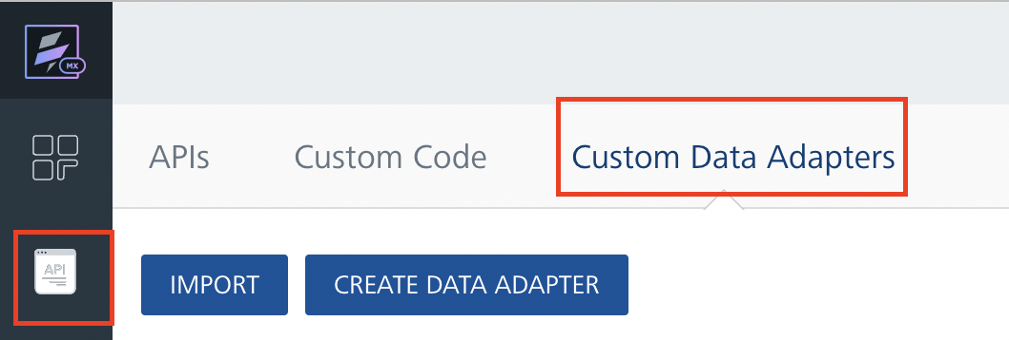
- Click Import. The Import Data Adapter dialog appears.

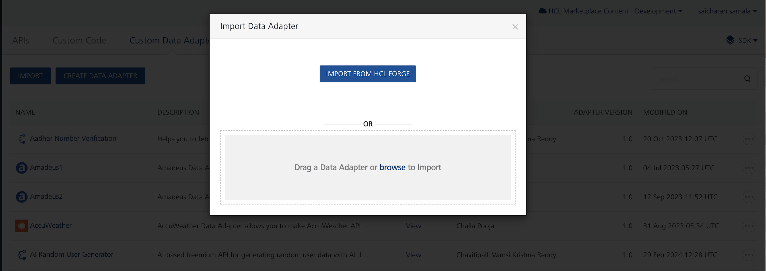

- Click IMPORT FROM HCL FORGE. The Import Data Adapter from HCL Forge dialog appears with a list of available data adapters.
- Click Import. Rephrasetext data adapter is listed on the Custom Data Adapters page.
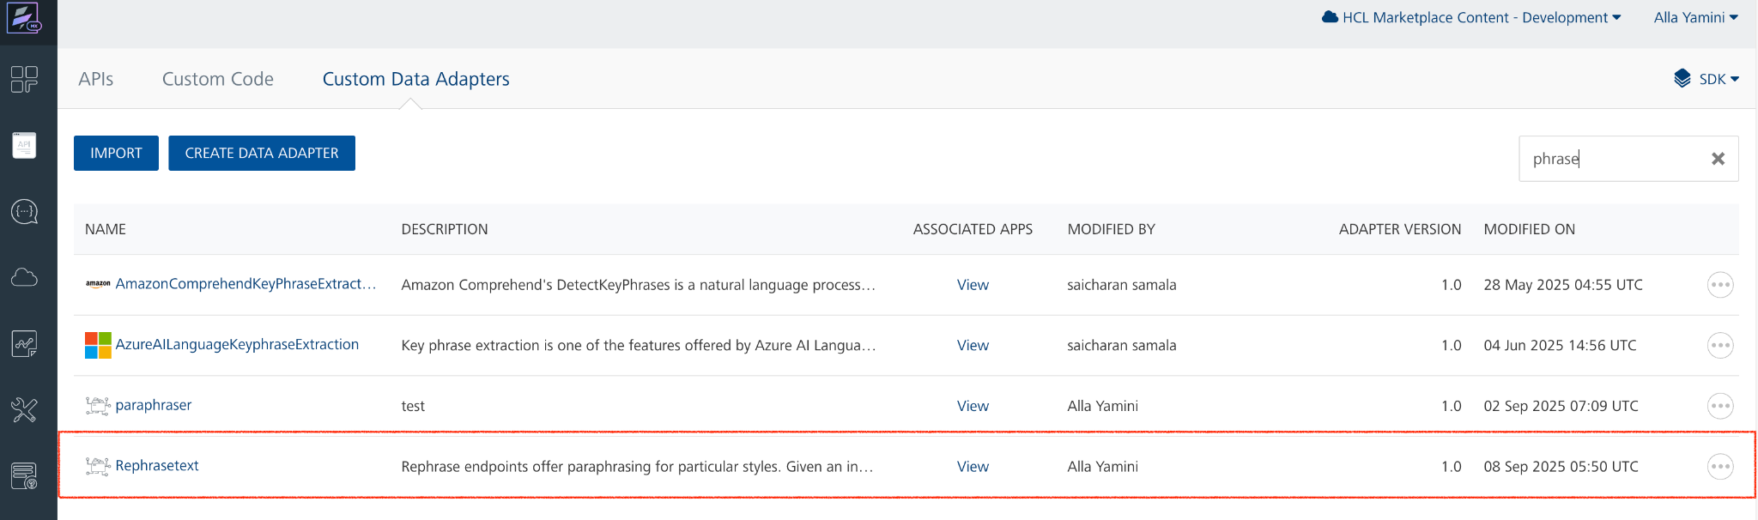

To import the data adapter zip file, do the following:
- Perform steps 1 to 4 in the above procedure
- Drag the data adapter zip file into the Drag a Data Adapter box.
Or
Click browse. The Open dialog appears.
Navigate to the location where you downloaded the data adapter (zip file) on your computer, select the data adapter, and click Open. The Import Data Adapter dialog shows the selected data adapter.

C. Creating an Integration Service with Sapling Rephrase :
After you import Sapling Rephrase Data Adapter into Foundry, you must create an integration service with service type as Rephrasetext .
To create an integration service with Rephrase, do the following:
- Log on to your HCL Foundry. The Dashboard page appears by default.
- In the left pane, click the API Management menu. The APIs tab opens by default.
- Click the Integration tab. The Integration tab opens with a list of existing integration services.
- Click CONFIGURE NEW. The Service Definition tab opens.
- In the Name box, type a unique name for your service.
- From the Service Type list, select Rephrasetext.
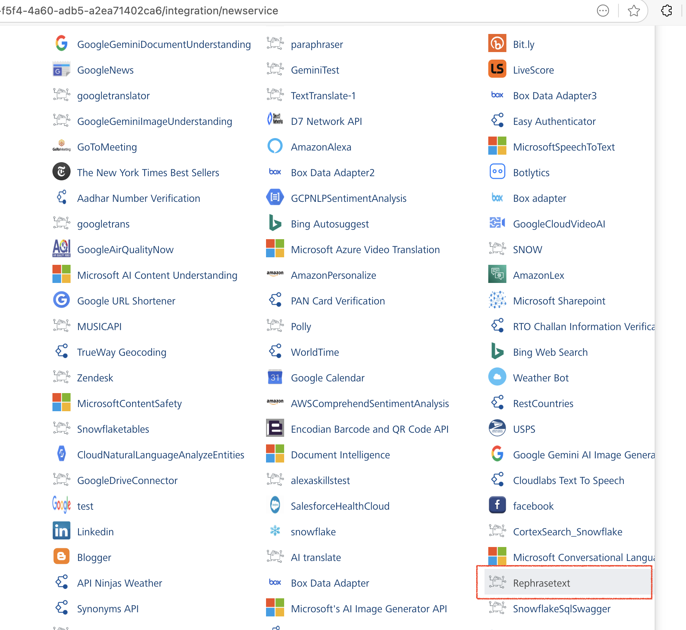
- Click Save

D. Creating an Operation
To make any API call in the HCL Foundry console, you must create an operation for the respective API and then execute the operation. Executing an operation involves making the API call and displaying the response.
This section provides steps to create an operation for the Rephrase.
Steps to create an operation for the Rephrase:
- Log on to your HCL Foundry. The Dashboard page appears by default.
- In the left pane, click the API Management menu. The APIs tab opens by default.
- Click the Integration tab. The Integration page appears with a list of existing integration services.
- From the list of integration services, select the integration service that you have created with service type as Rephrase. The Service Definition tab of the selected integration service opens by default.
- Click the Operations List tab. The Operations List tab opens.
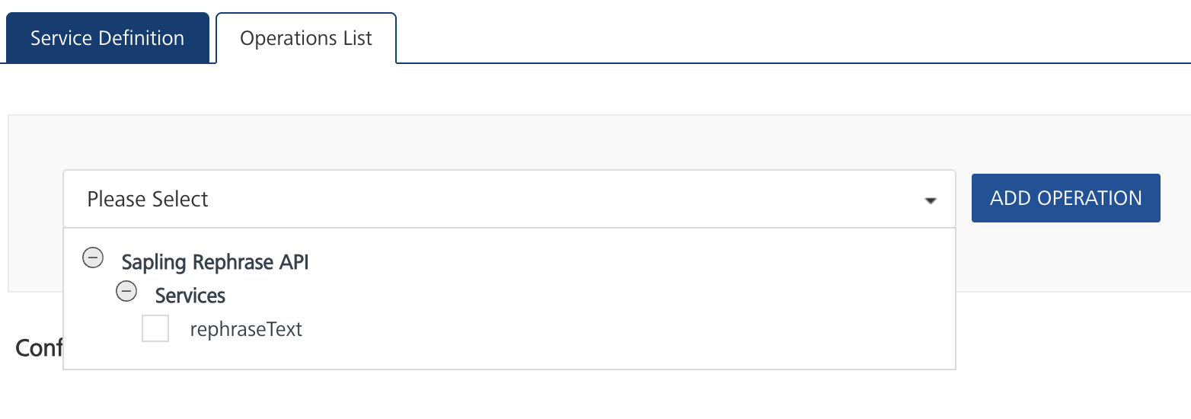
- Select rephraseText and Click Add Operation.
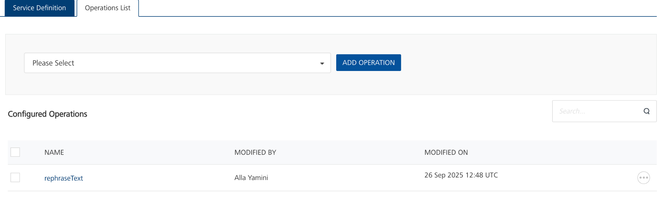

E. Executing Operation
Executing an operation involves making the API call by setting the necessary parameters and displaying the response. The procedure to execute any operation is the same, but the request parameters of the APIs vary. This section provides steps to execute the Rephrase (explained in Creating an Operation).
Steps to execute the rephraseText operation:
- Log on to your Hcl Foundry. The Dashboard page appears by default.
- In the left pane, click the API Management menu. The APIs tab opens by default.
- Click the Integration tab. The Integration tab opens with a list of existing integration services.
- From the list of integration services, select the integration service that you have created with service type as Rephrase. The Service Definition tab of the selected integration service opens by default.
- Click the Operations List tab.
- In the Name box, the name of the operation is displayed by default. If you want, you can change the name.
- On the Request Input tab, in the Body section, for the following parameters, specify the values in the respective boxes under the Test Value column.
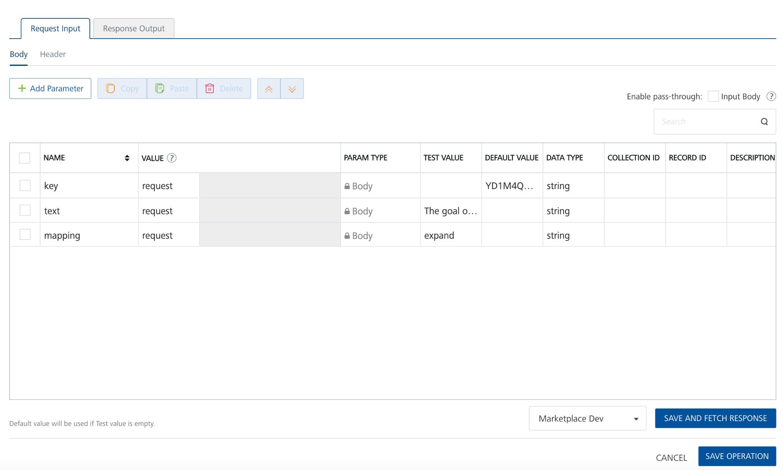
- Click SAVE AND FETCH RESPONSE. The Output Result dialog appears with the response. Otherwise, the Output Result shows an error.
. 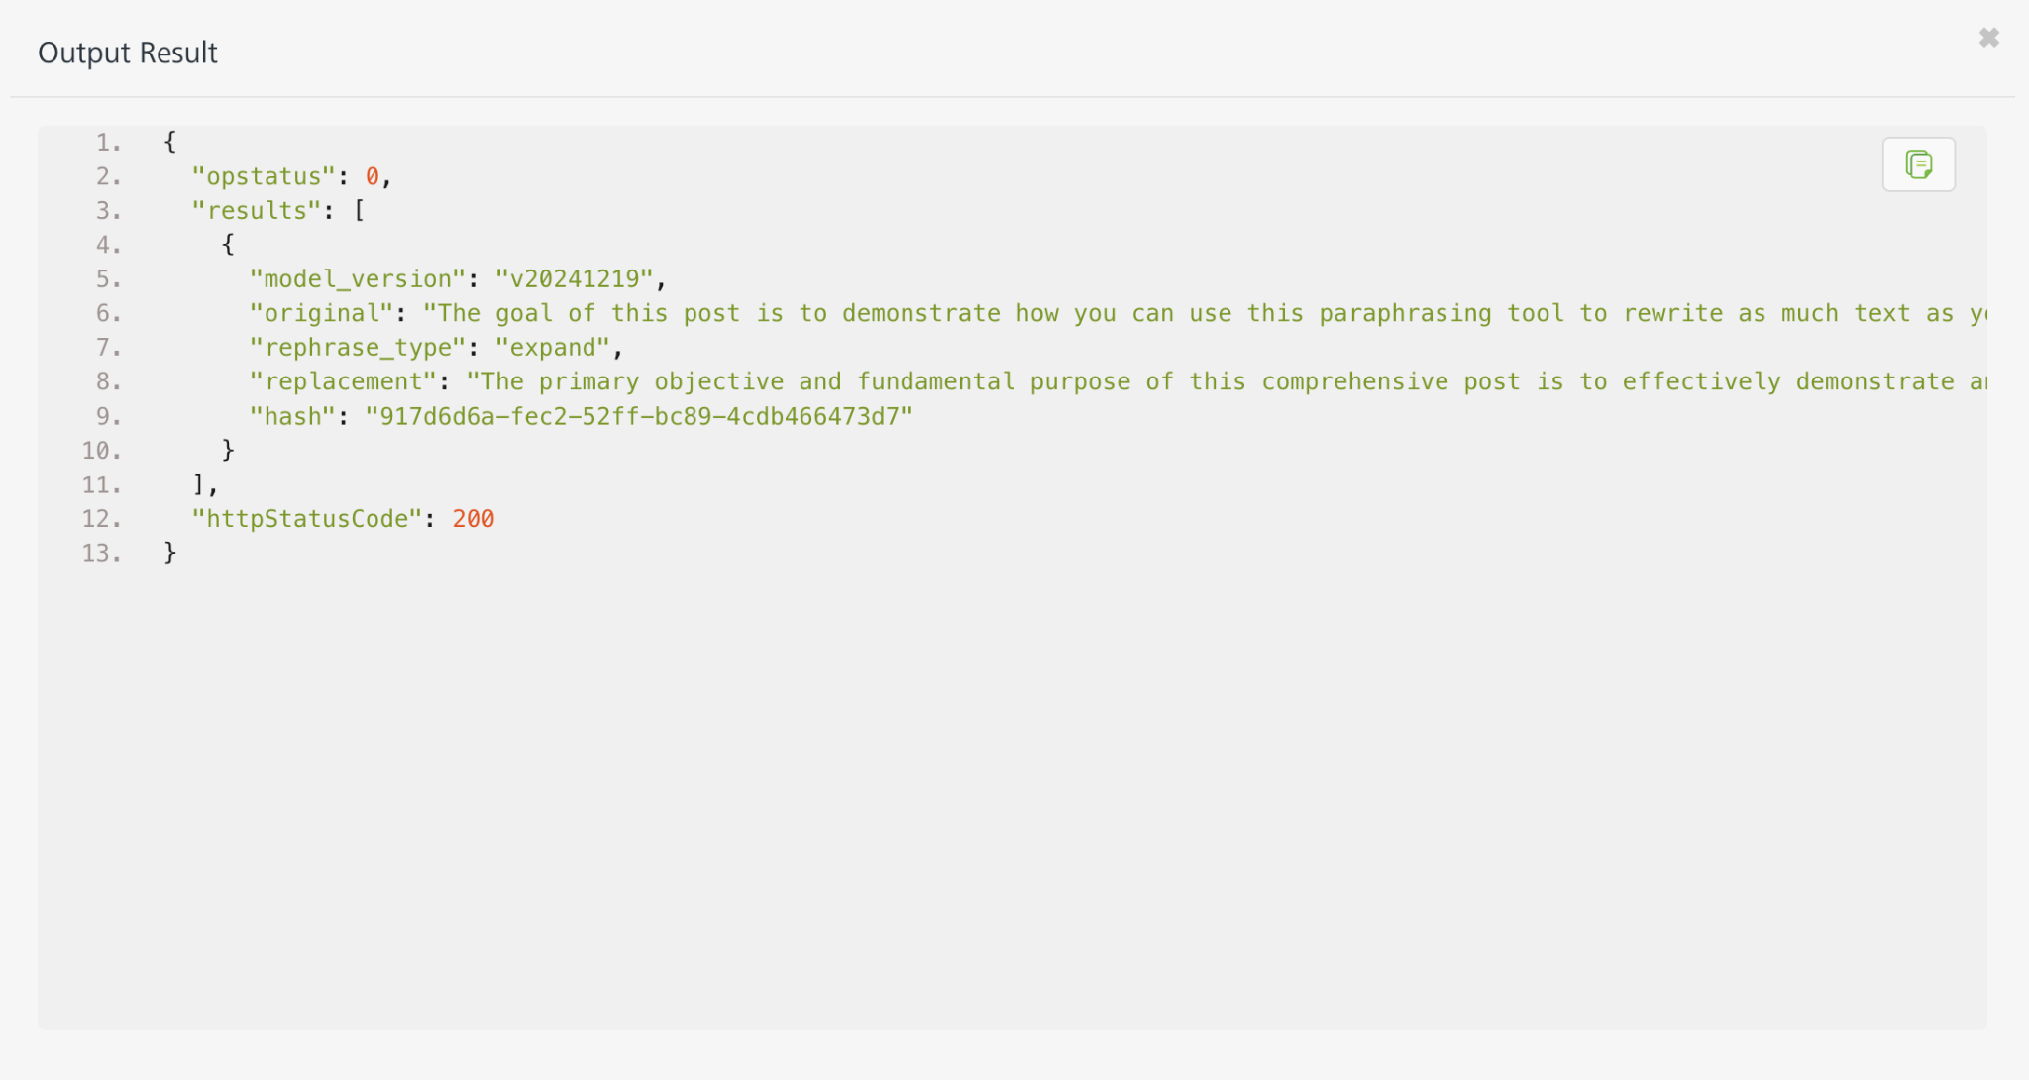

3. Publishing the App in VoltMX FOUNDRY:
After adding the Sapling Rephrase Data Adapter to your app and configuring the necessary configurations, you must publish the app to HCL Foundry. For more information, refer to Publish a foundry app.
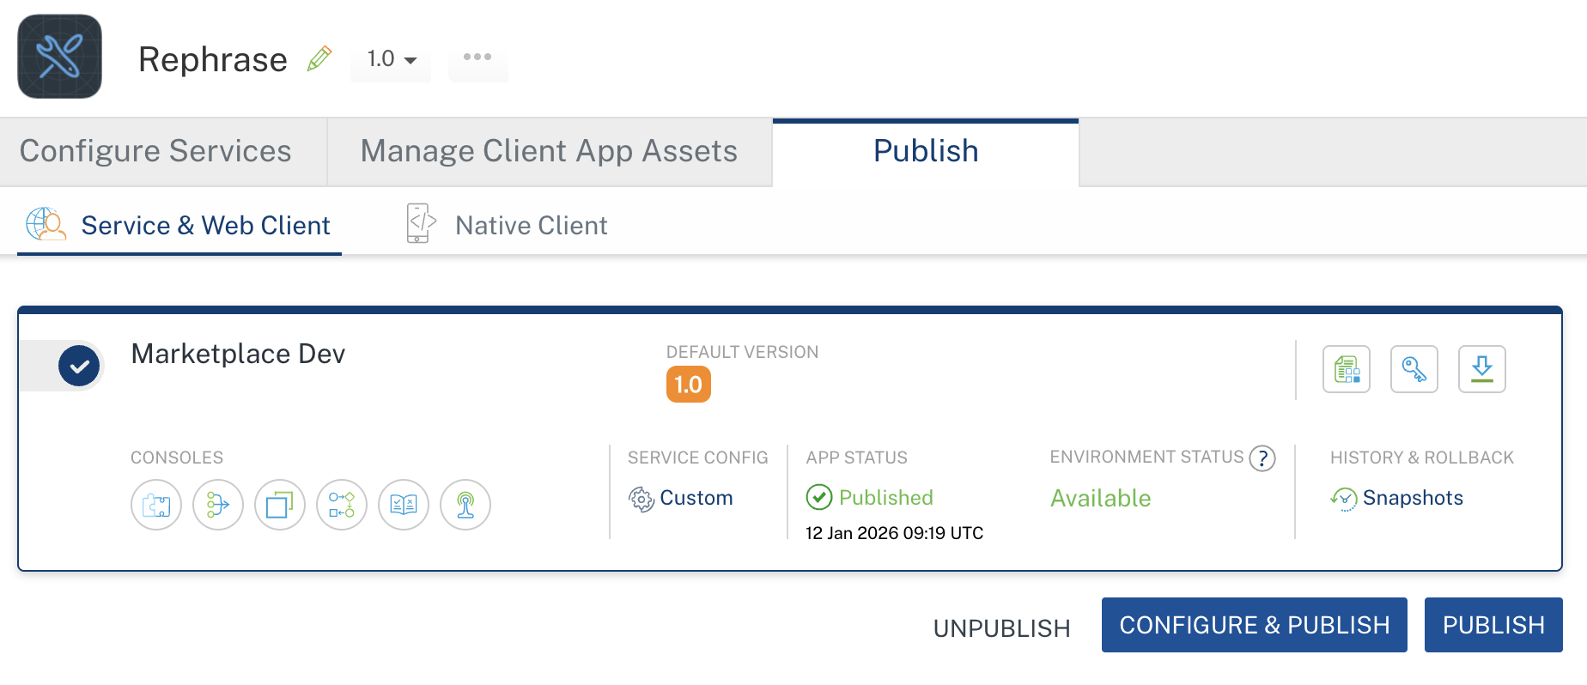

4. REFERENCES

Properties
- None of the properties are exposed.

Events
- None of the events are exposed.

API’s
- None of the APIs are exposed.

5. REVISION HISTORY
Adapter version 1.0.0:

Known Issues
None

Limitations
None

