Date : 20-JAN-26

SAPLING SCORING AND CLASSIFICATION APPLICATION

VERSION: 1.0.1

OVERVIEW
This AI asset provides advanced text understanding capabilities to analyze, score, and classify textual content. It helps enterprises automatically evaluate text quality, sentiment, tone, profanity, and statistical characteristics to drive automation, moderation, analytics, and decision-making.

A) Use case:
- Customer Support Automation: Analyze incoming tickets for sentiment, tone, and quality to prioritize and route issues.
- Content Moderation: Detects profanity and low-quality content before publishing.
- Customer Feedback Analysis: Measure sentiment and tone in reviews, surveys, and social feedback.
- Agent Quality Assurance: Score chat/email responses for clarity and professionalism.
- Compliance & Governance: Monitor internal and external communications for inappropriate language.
B) Features:
- Statistics: Provides word count, character count, readability metrics
- Sentiment Analysis: Detects Positive / Neutral / Negative sentiment
- Tone Detection: Identifies emotional tone (angry, polite, confident, etc.)
- Profanity Filter: Detects abusive or unsafe language
- Quality Score: Scores grammar, clarity, and readability (0–100)

C) Percentage of Reuse:
- Approximately 80–90% reuse.

GETTING STARTED

Prerequisites
Before using the Sapling Scoring and Classification App, ensure you have the following:
- HCL Foundry
- Volt MX Iris
- Get the API Key from sapling.ai
Reference document: https://sapling.ai/docs/api/

Creating an Sapling.ai Account and API Key:

- Go to https://sapling.ai/ and create a free account.
- After signing up, go to the Dashboard.
- Navigate to API Key and Copy the generated API key and store it securely - you will need it while configuring the integration service in Foundry.

Devices
- Mobile

Platforms Supported
- Android
- iOS

Importing the App

You can import Sapling Scoring and Classification App to Volt MX Iris, do the following:
To import the Sapling Scoring and Classification App, do the following:
- Launch Volt MX Iris.
- Click project, and then select Import. The Import dialog box appears.
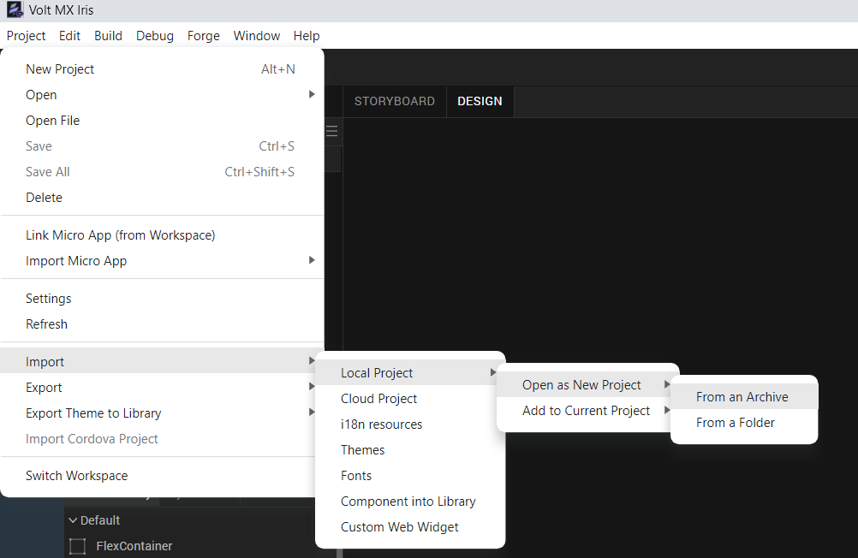
- Click From an Archive to navigate to the location of the project, select the files, and then click Import.
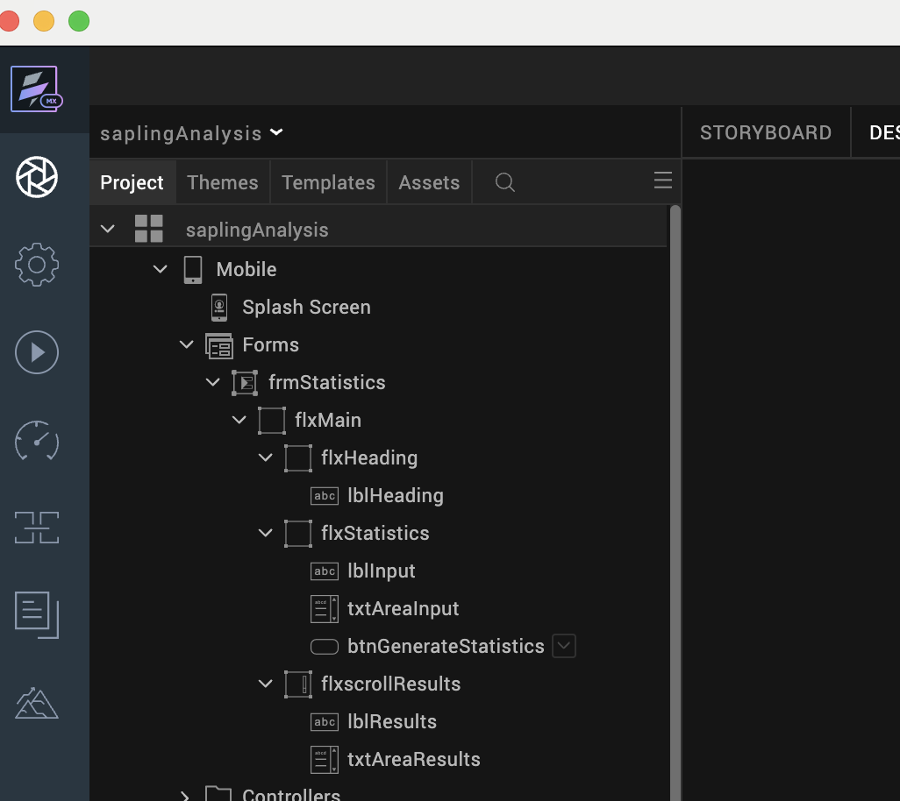

4. After you import the application, you can view the associated Foundry app connected at the Data & Services section.

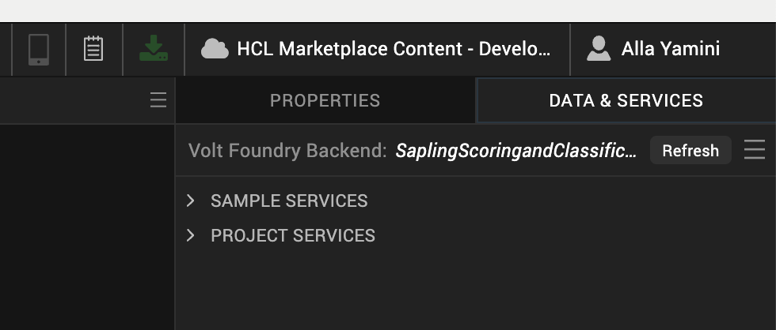

5. From the menu bar, go to Build and then select Build Native Local.

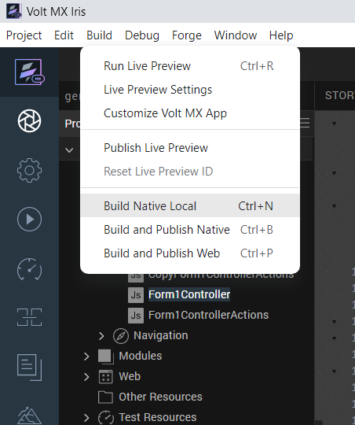

For Mobile, select Android and iOS. Click Build.

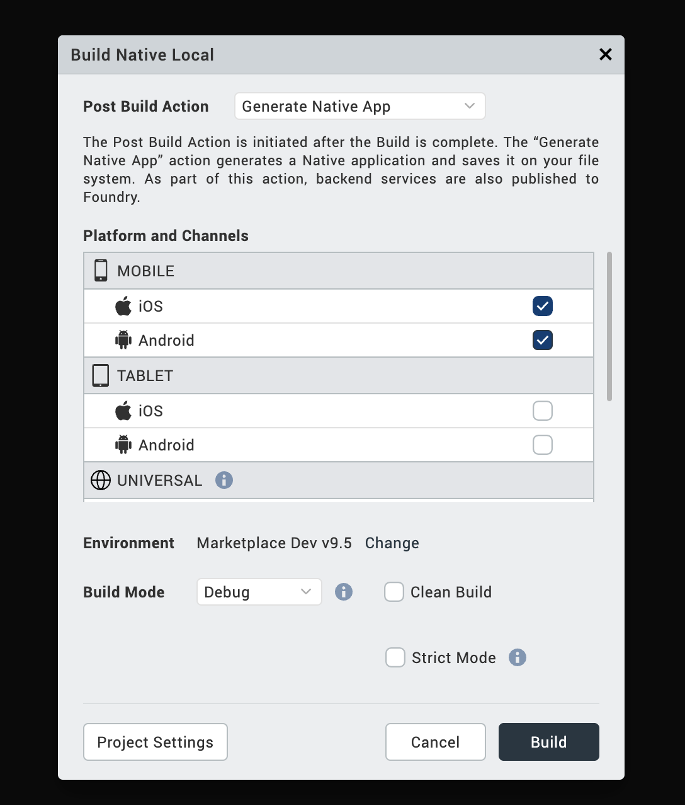

After the build is successful, run the app on your mobile device.

Foundry App Setup
When you import the component to your Volt MX Iris project, the HCL Volt MX Foundry services of the Sapling scoring and classification are added to the HCL Volt MX Foundry app, which is associated with the Volt MX Iris project. While importing the Sapling scoring and classification Application to your Volt MX Iris project, if there is no HCL Volt MX Foundry app associated with the existing Volt MX Iris project, a new HCL Volt MX Foundry app is automatically added to your HCL Volt MX Foundry environment and is associated with your Volt MX Iris.
To set the Foundry app, follow these steps:
- Click the HCL Volt MX Foundry app associated with your Volt MX Iris project from the Project Explorer. Click DATA & SERVICES.

- Under the Configure Services tab, click Integration and can see the Sapling Scoring and Classification Integration service. Click on that Integration service to add the keys.
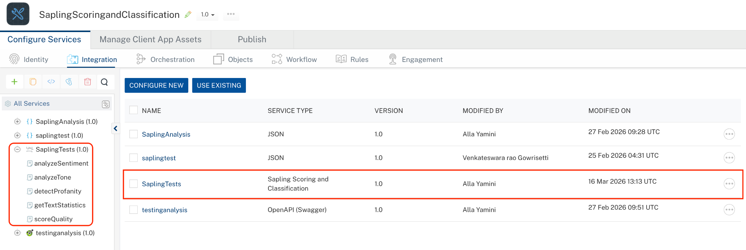
- Click the Operations List tab. The Operations List tab opens with the list of operations available.
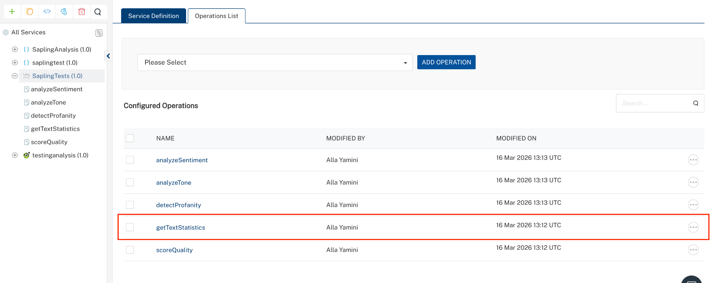

Executing an operation:
Executing an operation involves making the API call by setting the necessary parameters and displaying the response. The procedure to execute any operation is the same, but the request parameters of the APIs vary. This section provides steps to execute the getTextStatistics (explained in Creating an Operation).
Steps to execute the getTextStatistics operation:
- Log on to your Hcl Foundry. The Dashboard page appears by default.
- In the left pane, click the API Management menu. The APIs tab opens by default.
- Click the Integration tab. The Integration tab opens with a list of existing integration services.
- From the list of integration services, select the integration service that you have created with service type as Sapling Scoring and Classification. The Service Definition tab of the selected integration service opens by default.
- Click the Operations List tab.
- In the Name box, the name of the operation is displayed by default. If you want, you can change the name.
- On the Request Input tab, in the Body section, for the following parameters, specify the values in the respective boxes under the Test Value or Default Value column.
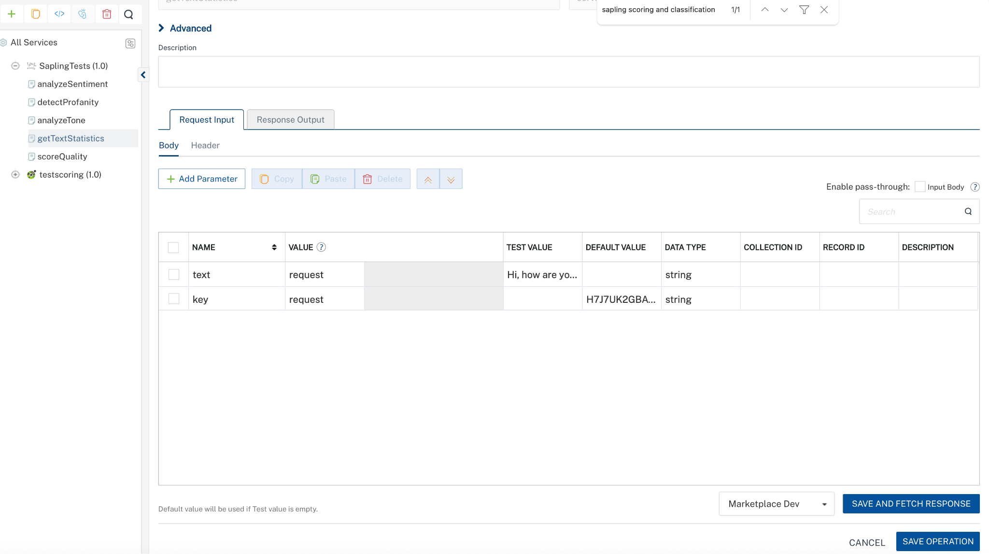
- Click SAVE AND FETCH RESPONSE. The Output Result dialog appears with the response. Otherwise, the Output Result shows an error.
. 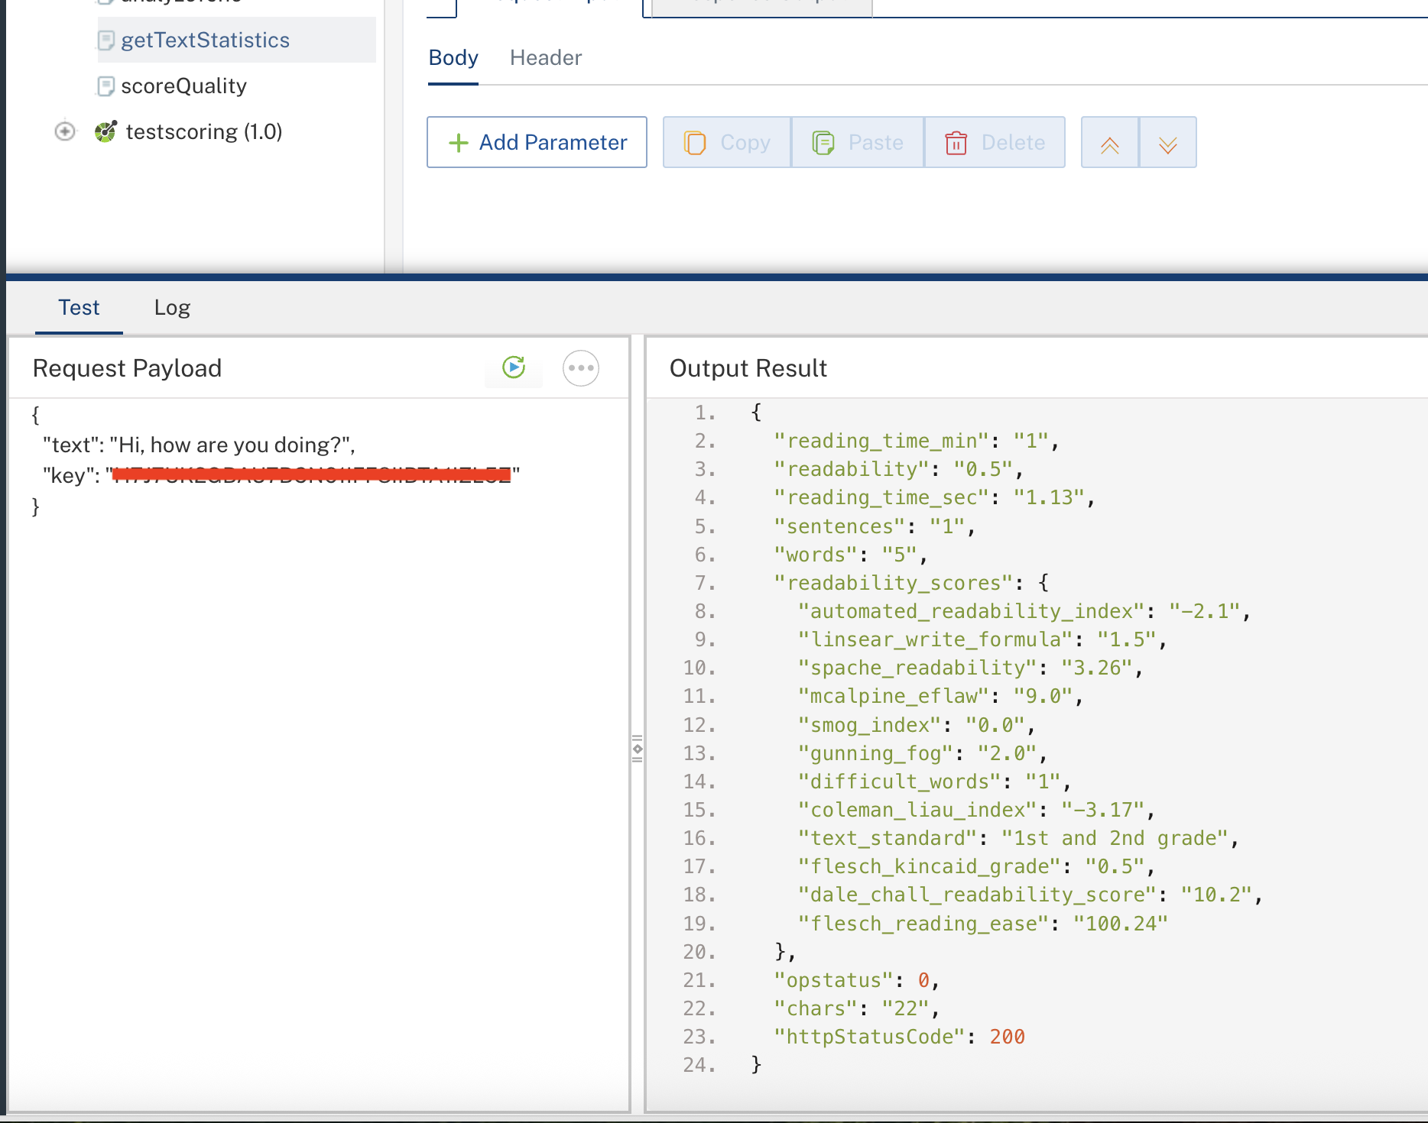

Publishing the App in VoltMX FOUNDRY:
After you set the Operation Security Level, you must publish the HCL Volt MX Foundry app. To publish the HCL Volt MX Foundry, follow these steps:
In Volt MX Iris, click DATA & SERVICES, and then click Publish Project Services to Publish to your foundry app.
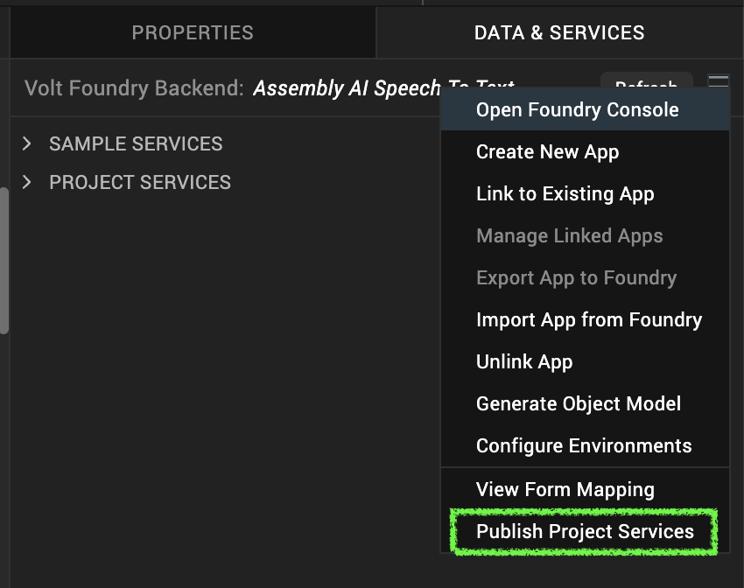
Select the environment to which you want to publish your app, and then click Publish. After the app is published to your environment, the following window appears confirming the publish.
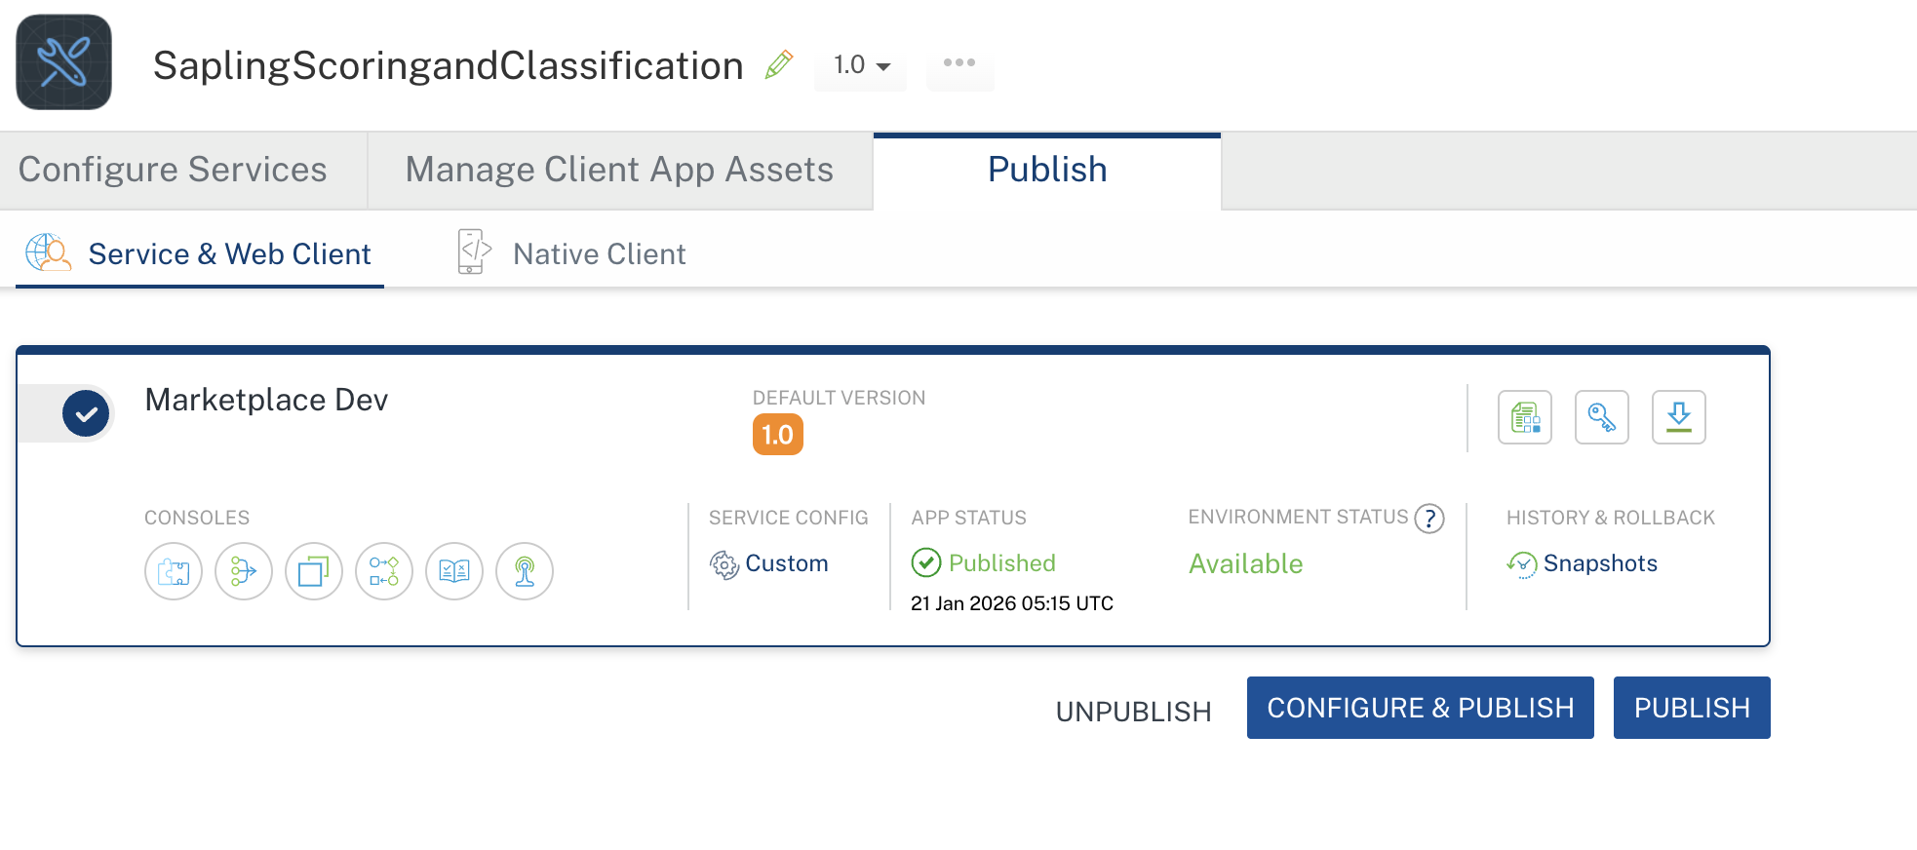

Building and previewing the app
After performing all the above steps, you can build your app and run it on your device. For more information, you can refer to the Building and Viewing an Application section of the Volt MX User Guide.
You can then run your app to see the Sapling Scoring and Classification Application work in real time.

Application Flow
The landing page for the app is as follows:
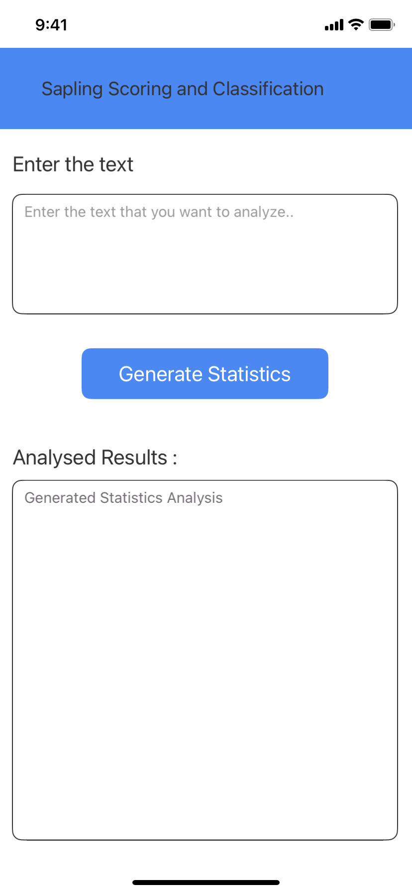

Enter your input text in the input textarea field. The API analyzes the text and returns the generated statistics analysis.

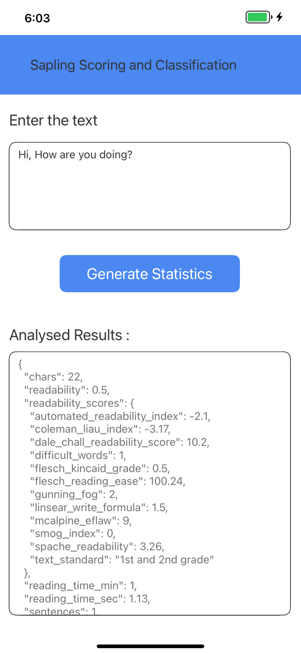

REFERENCE:

Endpoint Documentation
- Official API Docs: https://sapling.ai/docs/api/
- Pricing: https://sapling.ai/docs/api/pricing/
- Login / API Key: https://sapling.ai/api_settings

REVISION HISTORY:
App version 1.0.0:

A. Known Issue
- The /analyzeTone and /analyzeSentiment endpoints are not working in Foundry due to the response containing an array of arrays(nested arrays).

B. Limitations
- NA

