Date : 30-Mar-26

SCALEWAY GENERATIVE AI DATA ADAPTER

VERSION: 1.0.0

OVERVIEW
The Scaleway Generative AI Data Adapter is an intelligent middleware solution that bridges the gap between diverse data sources and generative AI models. It provides seamless data ingestion, transformation, and optimization capabilities to power AI-driven applications with clean, structured, and context-rich data.
The Scaleway Generative AI Data Adapter is designed to:
- Connect: various data sources to generative AI models and applications
- Transform: unstructured and semi-structured data into AI-ready formats
- Optimize: data delivery for improved model performance and response times
- Standardize: data pipelines across different generative AI use cases
- Use case:
- AI Chatbots & Assistants: Build conversational AI for customer support or internal tools
- Content Generation: Generate blogs, marketing copy, and product descriptions
- Code Assistance: Auto-generate or complete code snippets
- Image Generation: Create AI-generated visuals from text prompts
- Semantic Search & Embeddings: Improve search relevance using vector embeddings
- Automation Pipelines: Integrate AI into workflows for summarization, classification, and insights
- Features:
- Intelligent Data Transformation: Automatically detect schemas, clean, and preprocess data with built-in format conversion and normalization. Enrich datasets with metadata to ensure AI models receive optimally structured, context-rich information.
- Performance Optimization: Leverage smart caching, parallel processing, and intelligent data chunking to handle large documents efficiently. Token optimization features reduce LLM costs while maintaining response quality and speed.
- Security & Compliance: Enterprise-grade encryption for data in transit and at rest, with comprehensive access control and authentication mechanisms. Full GDPR compliance with audit logging and monitoring for regulatory requirements.
- Scalability: Auto-scaling architecture adapts to workload demands with distributed processing and load balancing capabilities. High availability design ensures reliable performance across varying data volumes and user demands.
- Percentage of Reuse:
- Approximately 80–90% reuse.

GETTING STARTED

Prerequisites
Before using the Scaleway Generative AI Data Adapter, ensure you have the following:
- HCL Foundry
- Volt MX Iris
- Account at Scaleway and get API Key
Steps to create API key:
- A Scaleway account logged into the console
- Click IAM & API keys on the top-right drop-down menu of the Scaleway console. You are taken to your Identity and Access Management dashboard.
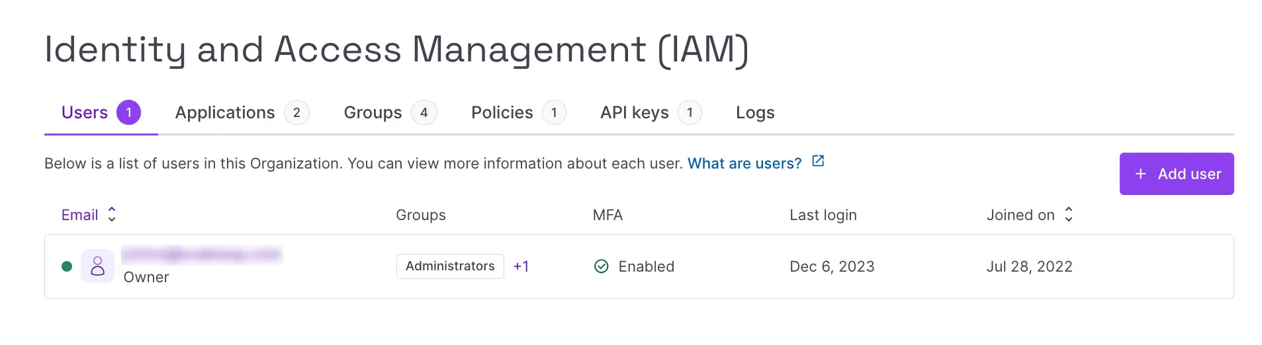
- Click the API keys tab.
- Click + Generate API key. The following screen pops up:
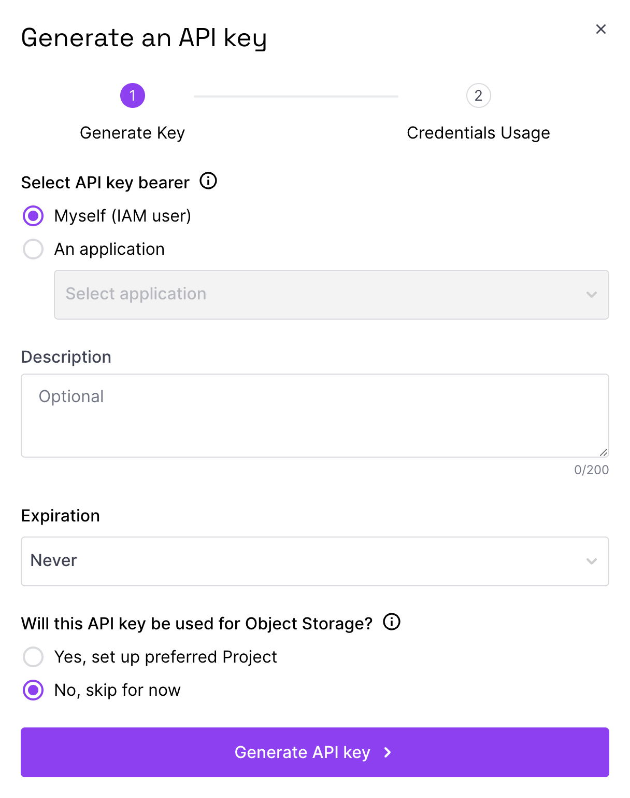
- Select the bearer of the API key. Choose between yourself (as an IAM user), or an IAM application associated with the Organization.
- Enter an optional description for the API key.
- Enter the desired expiration. Choose from:
  - Never: the API key will never expire,
  - 1 hour / week / month / year: the API key will expire at the end of the selected period,
  - Custom: you are prompted to enter a date on which the API key will expire.
- Select whether the API key will be used for Object Storage. Choose from:
  - Yes, set up preferred Project: you are prompted to select a Project that the API key will always use for Object Storage operations.
  - No, skip for now: the Project that you are currently navigating in the console (i.e. the one that is selected in your Project dashboard) will be automatically selected as the preferred Project for Object Storage.
- Click the Generate API key. A screen displays showing the access key and secret key for your new API key and reminding you that this is your only chance to securely save the secret key:
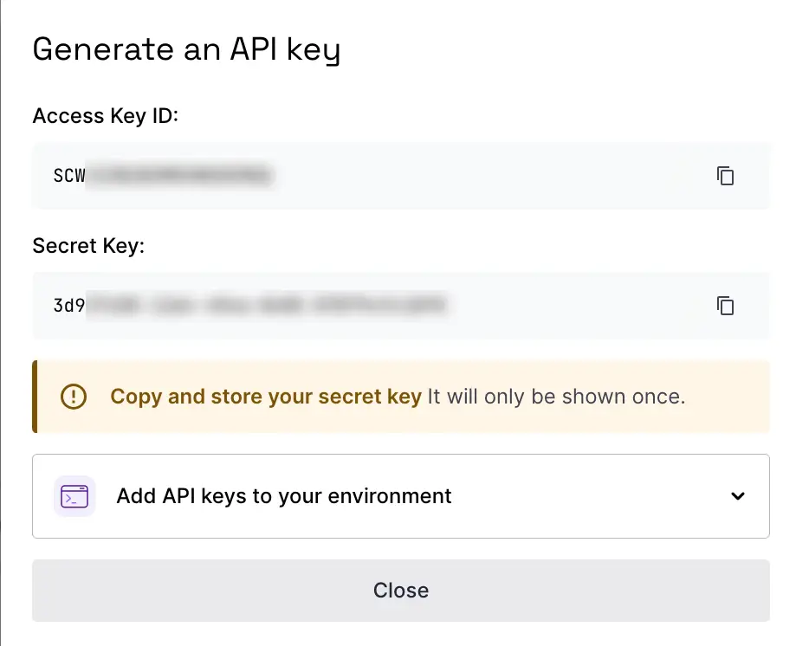
- Ensure you have securely saved the secret key, then close the window. You are returned to the API keys tab, where your new API key now appears in the list.
Reference doc: How to create API keys | Scaleway Documentation

Importing the data adapter

You can import Scaleway Generative AI Data Adapter into HCL Foundry directly from the Volt MX Forge website or by importing the data adapter zip file.

To import Data Adapter to Volt Foundry, do the following:
- Sign in to the HCL Foundry.
- From the left navigation menu, select API Management.
- In API Management, select Custom Data Adapters.

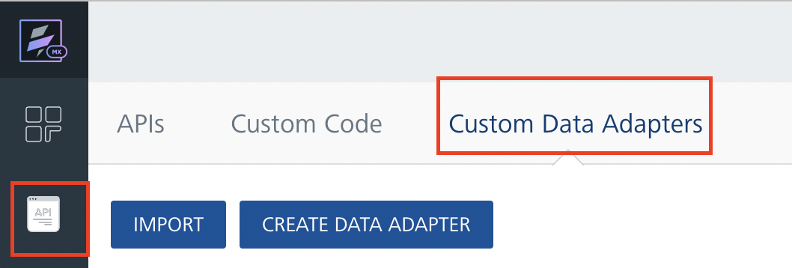
4. Click IMPORT to import a custom data adapter.
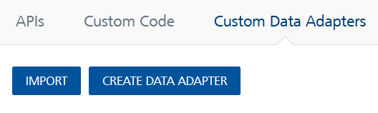
5. On the Import Data Adapter dialog box, click browser to import.

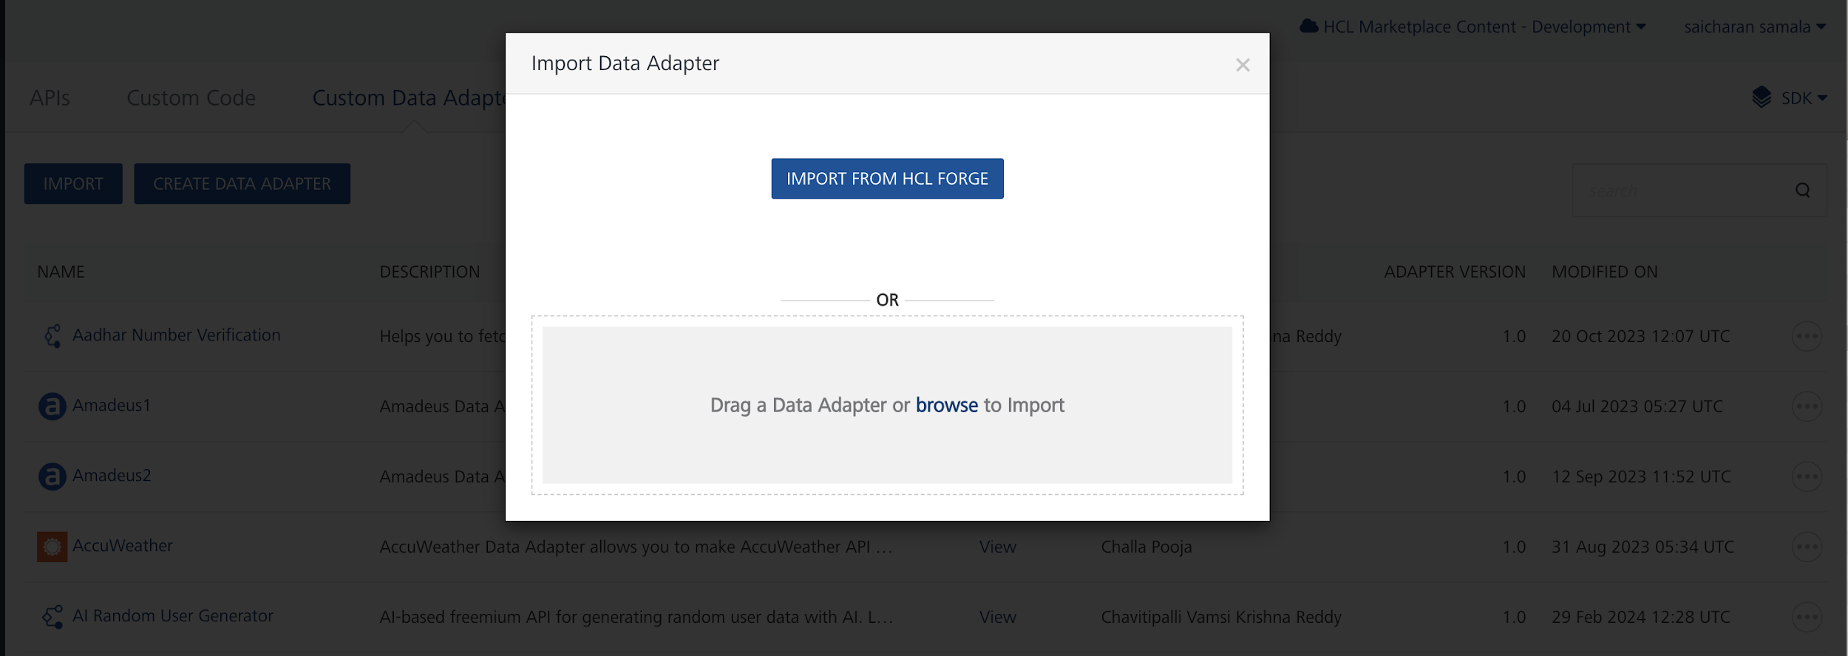

6. Click IMPORT FROM HCL FORGE. The Import Data Adapter from HCL Forge dialog appears with a list of available data adapters.
Click Import. Scaleway Generative AI data adapter is listed on the Custom Data Adapters page.
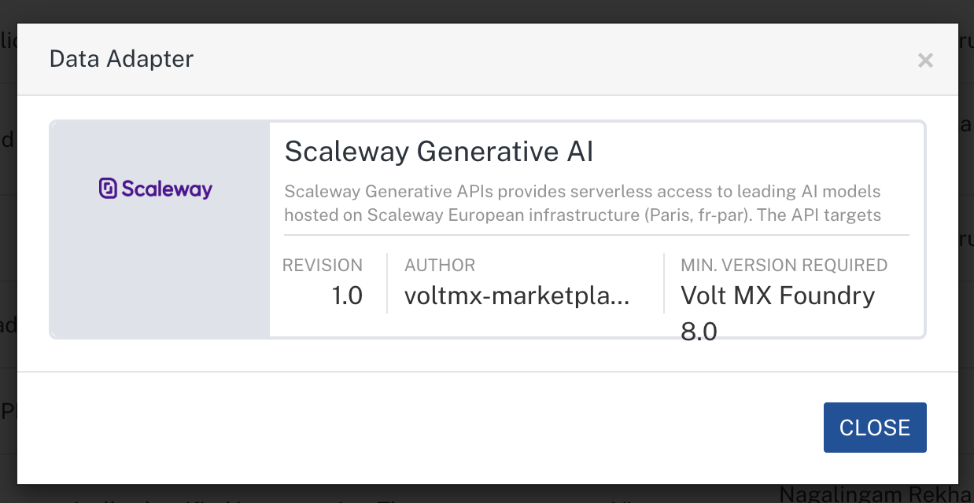
To import the data adapter zip file, do the following:
- Perform steps 1 to 4 in the above procedure
- Drag the data adapter zip file into the Drag a Data Adapter box.
Or
Click browse. The Open dialog appears.
Navigate to the location where you downloaded the data adapter (zip file) on your computer, select the data adapter, and click Open. The Import Data Adapter dialog shows the selected data adapter.
Note: Click Remove if the selected data adapter is not the one that you want to import.

Creating an Integration Service with Scaleway Generative AI :
After you import Scaleway Generative AI Data Adapter into Foundry, you must create an integration service with service type as Scaleway Generative AI.
To create an integration service with Scaleway Generative AI, do the following:
- Log on to your HCL Foundry. The Dashboard page appears by default.
- In the left pane, click the API Management menu. The APIs tab opens by default.
- Click the Integration tab. The Integration tab opens with a list of existing integration services.
- Click CONFIGURE NEW. The Service Definition tab opens.
- In the Name box, type a unique name for your service.
- From the Service Type list, select Scaleway Generative AI.
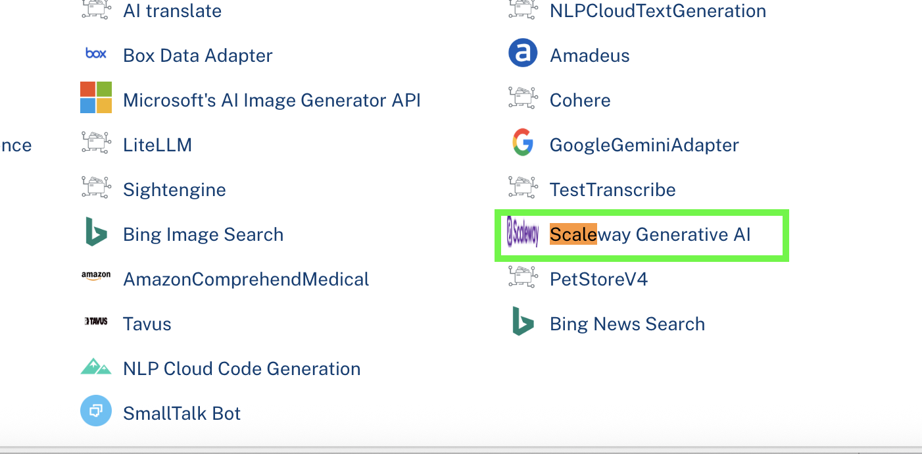
- Click Save

Creating an Operation
To make any API call in the HCL Foundry console, you must create an operation for the respective API and then execute the operation. Executing an operation involves making the API call and displaying the response.
This section provides steps to create an operation for the Scaleway Generative AI.
Steps to create an operation for the Scaleway Generative AI:
- Log on to your HCL Foundry. The Dashboard page appears by default.
- In the left pane, click the API Management menu. The APIs tab opens by default.
- Click the Integration tab. The Integration page appears with a list of existing integration services.
- From the list of integration services, select the integration service that you have created with the service type as Scaleway Generative AI. The Service Definition tab of the selected integration service opens by default.
- Click the Operations List tab. The Operations List tab opens.
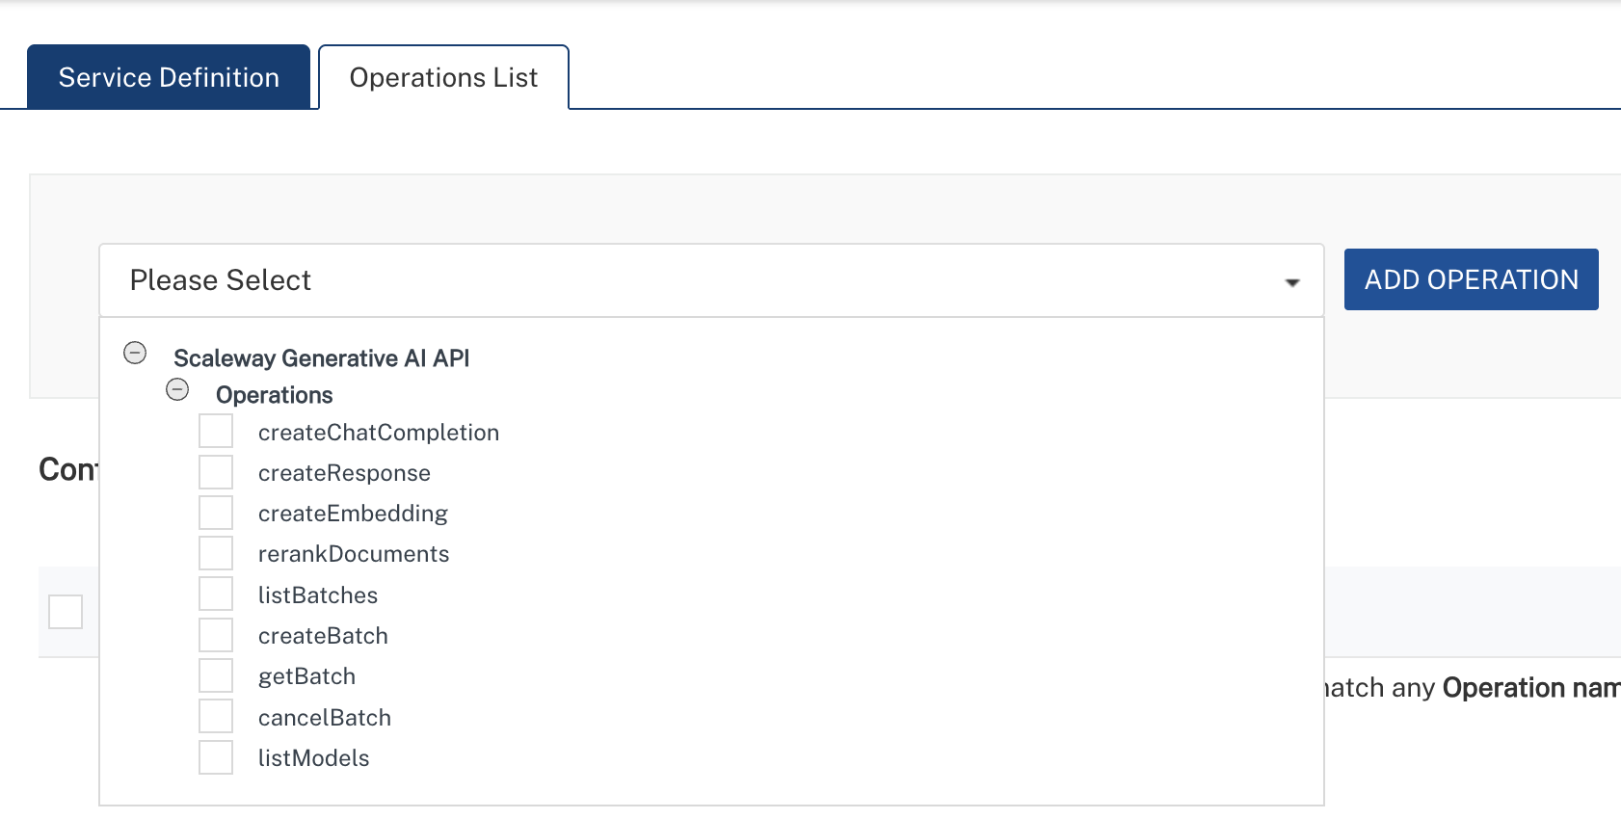
- Select createChatCompletion and Click Add Operation.
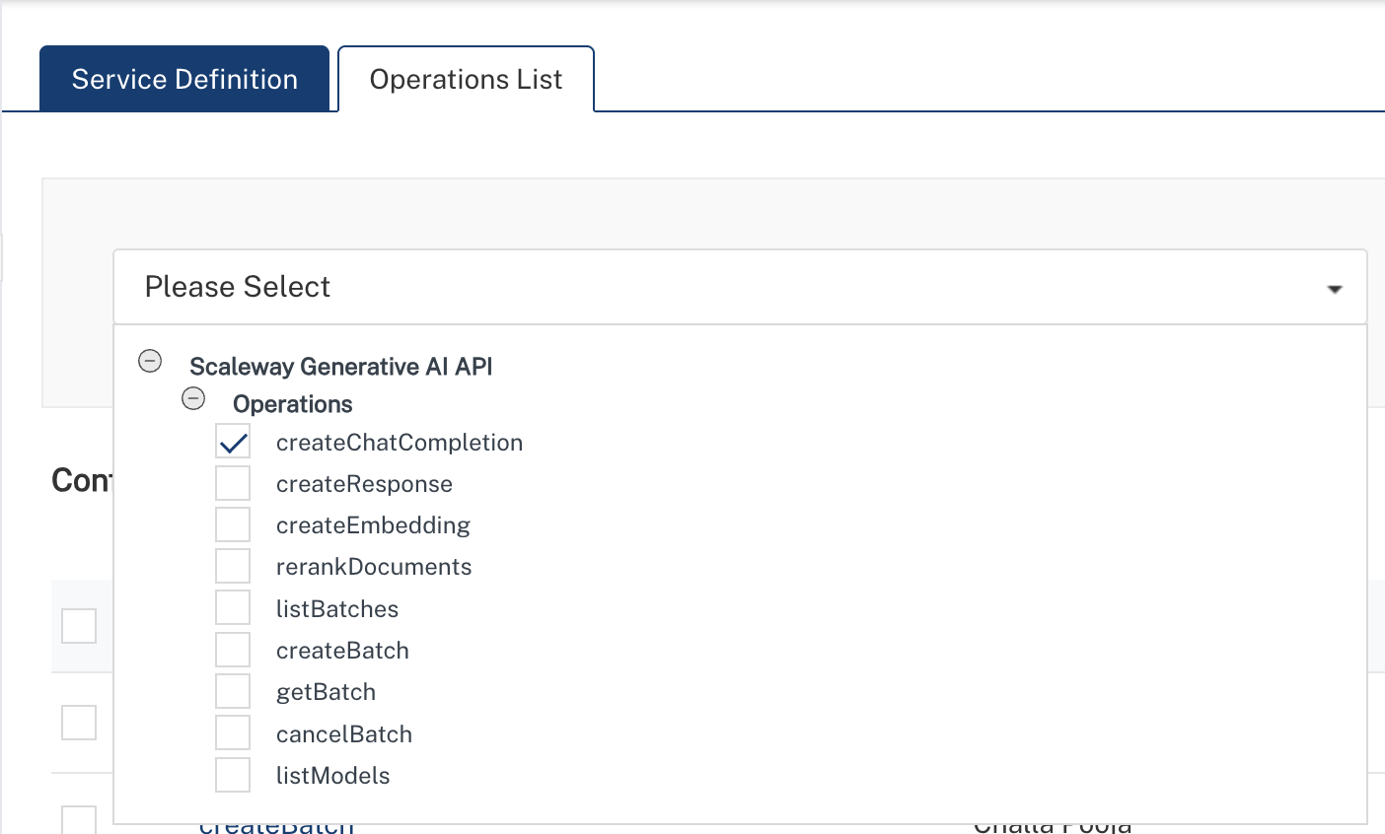

Executing Operation
Executing an operation involves making the API call by setting the necessary parameters and displaying the response. The procedure to execute any operation is the same, but the request parameters of the APIs vary. This section provides steps to execute the post_chat_completions (explained in Creating an Operation).
Steps to execute the createChatCompletion operation:
- Log on to your Hcl Foundry. The Dashboard page appears by default.
- In the left pane, click the API Management menu. The APIs tab opens by default.
- Click the Integration tab. The Integration tab opens with a list of existing integration services.
- From the list of integration services, select the integration service that you have created with service type as createChatCompletion. The Service Definition tab of the selected integration service opens by default.
- Click the Operations List tab.
- In the Name box, the name of the operation is displayed by default. If you want, you can change the name.
- On the Request Input tab, in the Body section, for the following parameters, specify the values in the respective boxes under the Test Value column.
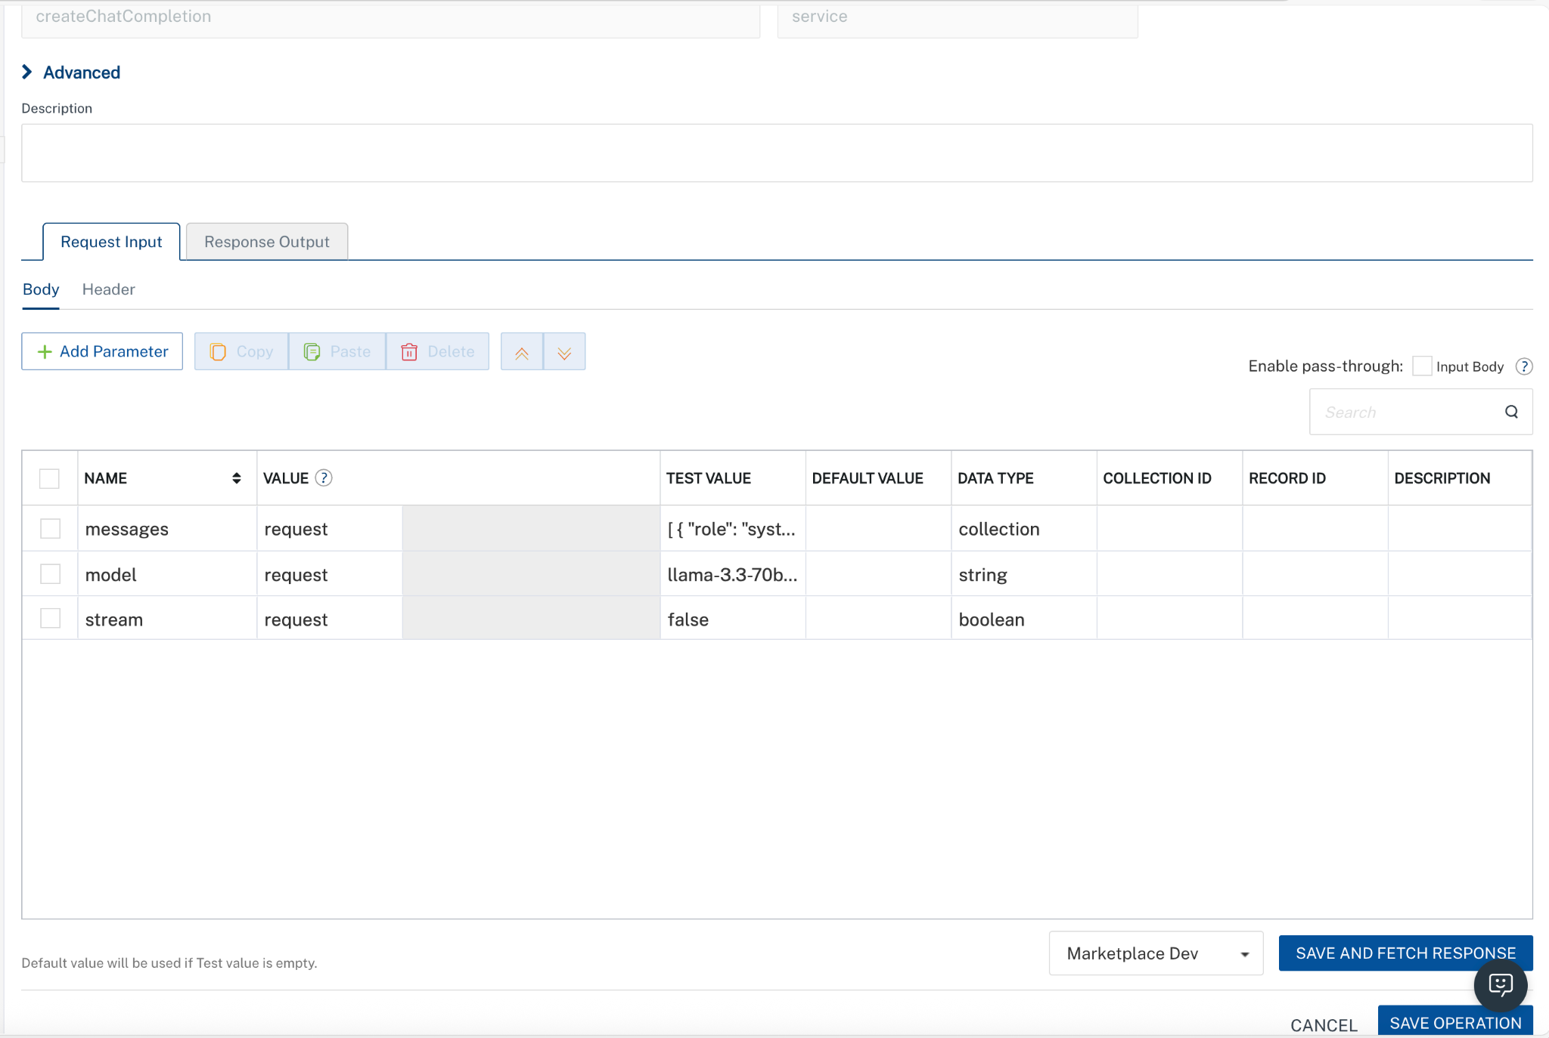
Parameter | Description | Syntax Example
model (Required) | Specifies which AI model to use for the request. Available models depend on your Scaleway configuration. | "model": "openai/gpt-oss-120b"
messages (Required) | Array of conversation messages. Each message must include a role (system, user, or assistant) and content. | "messages": [{"role": "user", "content": "Generate a Java program to reverse a string"}]
temperature (Optional) | Controls randomness of output. Lower values produce deterministic responses; higher values increase creativity. | "temperature": 0.7
max_tokens (Optional) | Maximum number of tokens the model can generate in the response. | "max_tokens": 4096
top_p (Optional) | Nucleus sampling parameter that controls diversity by limiting token selection to a probability mass. | "top_p": 1
stream (Optional) | Enables real-time streaming response when set to true. | "stream": true
stop (Optional) | Specifies sequences where the API will stop generating further tokens. | "stop": ["\n", "###"]
presence_penalty (Optional) | Penalizes new tokens based on whether they appear in the text so far, encouraging new topics. | "presence_penalty": 0.6
frequency_penalty (Optional) | Penalizes repeated tokens based on their frequency in the text so far. | "frequency_penalty": 0.5
Note: In VoltMX Foundry, always provide values for required parameters. Optional parameters should only be included when you have valid values. Avoid sending empty strings, empty objects, or empty arrays for optional fields, as this may lead to validation errors. The request example includes all available parameters only for reference.
Additionally, the messages parameter (array of objects) must be passed completely within the messages value as a properly structured JSON array.
- Click Header sub-tab. The Header section opens.
- For Authorization, In the box under the DEFAULT VALUE column, type the API Key generated from Scaleway
Syntax: Authorization: Bearer <YOUR_API_KEY>
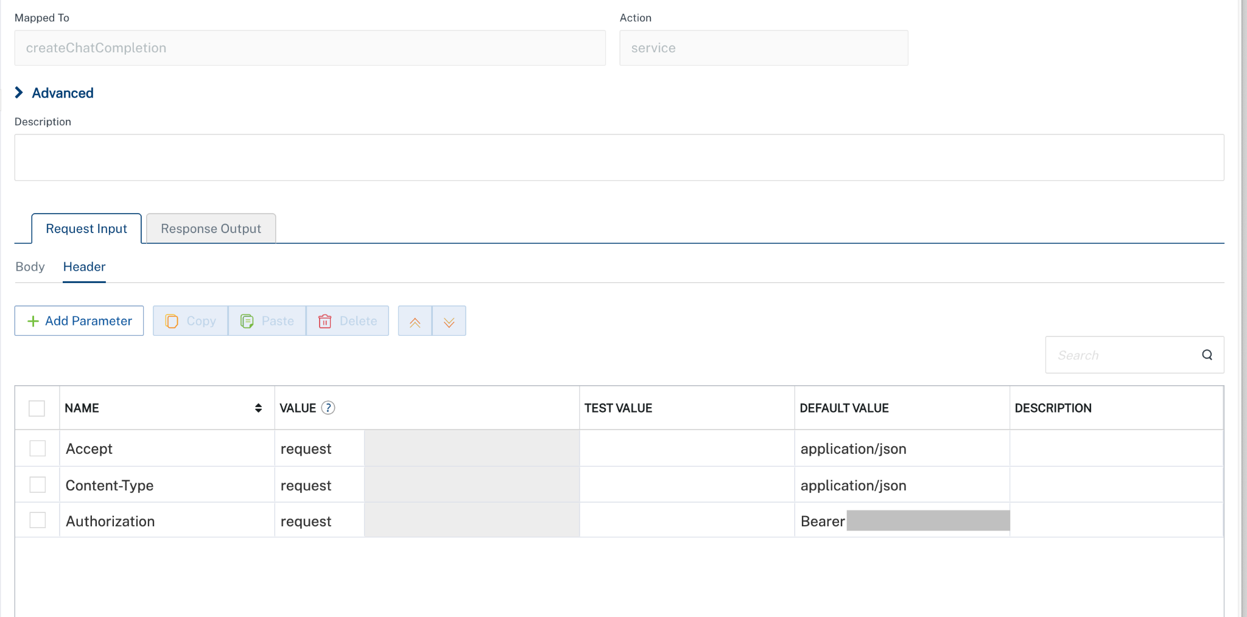
- Click SAVE AND FETCH RESPONSE. The Output Result dialog appears with the response. Otherwise, the Output Result shows an error. 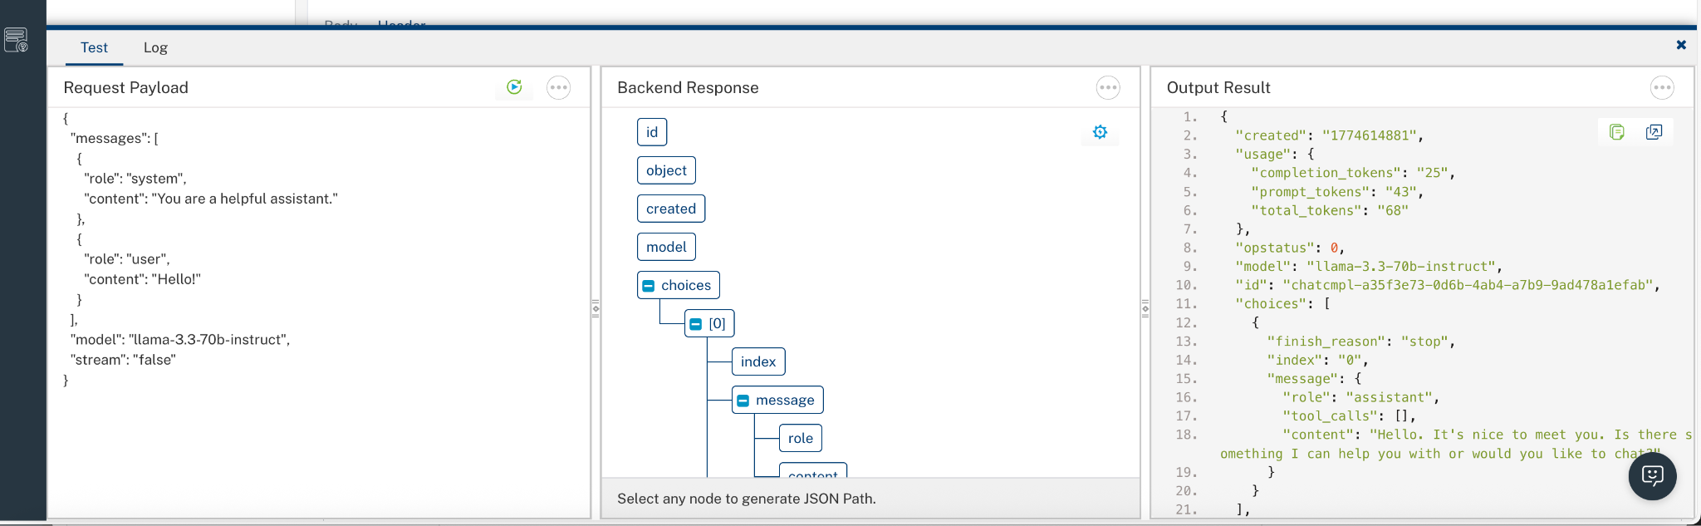

PUBLISHING THE APP IN VOLTMX FOUNDRY:
After adding the Scaleway Generative AI Data Adapter to your app and configuring the necessary configurations, you must publish the app to HCL Foundry. For more information, refer to Publish a foundry app.
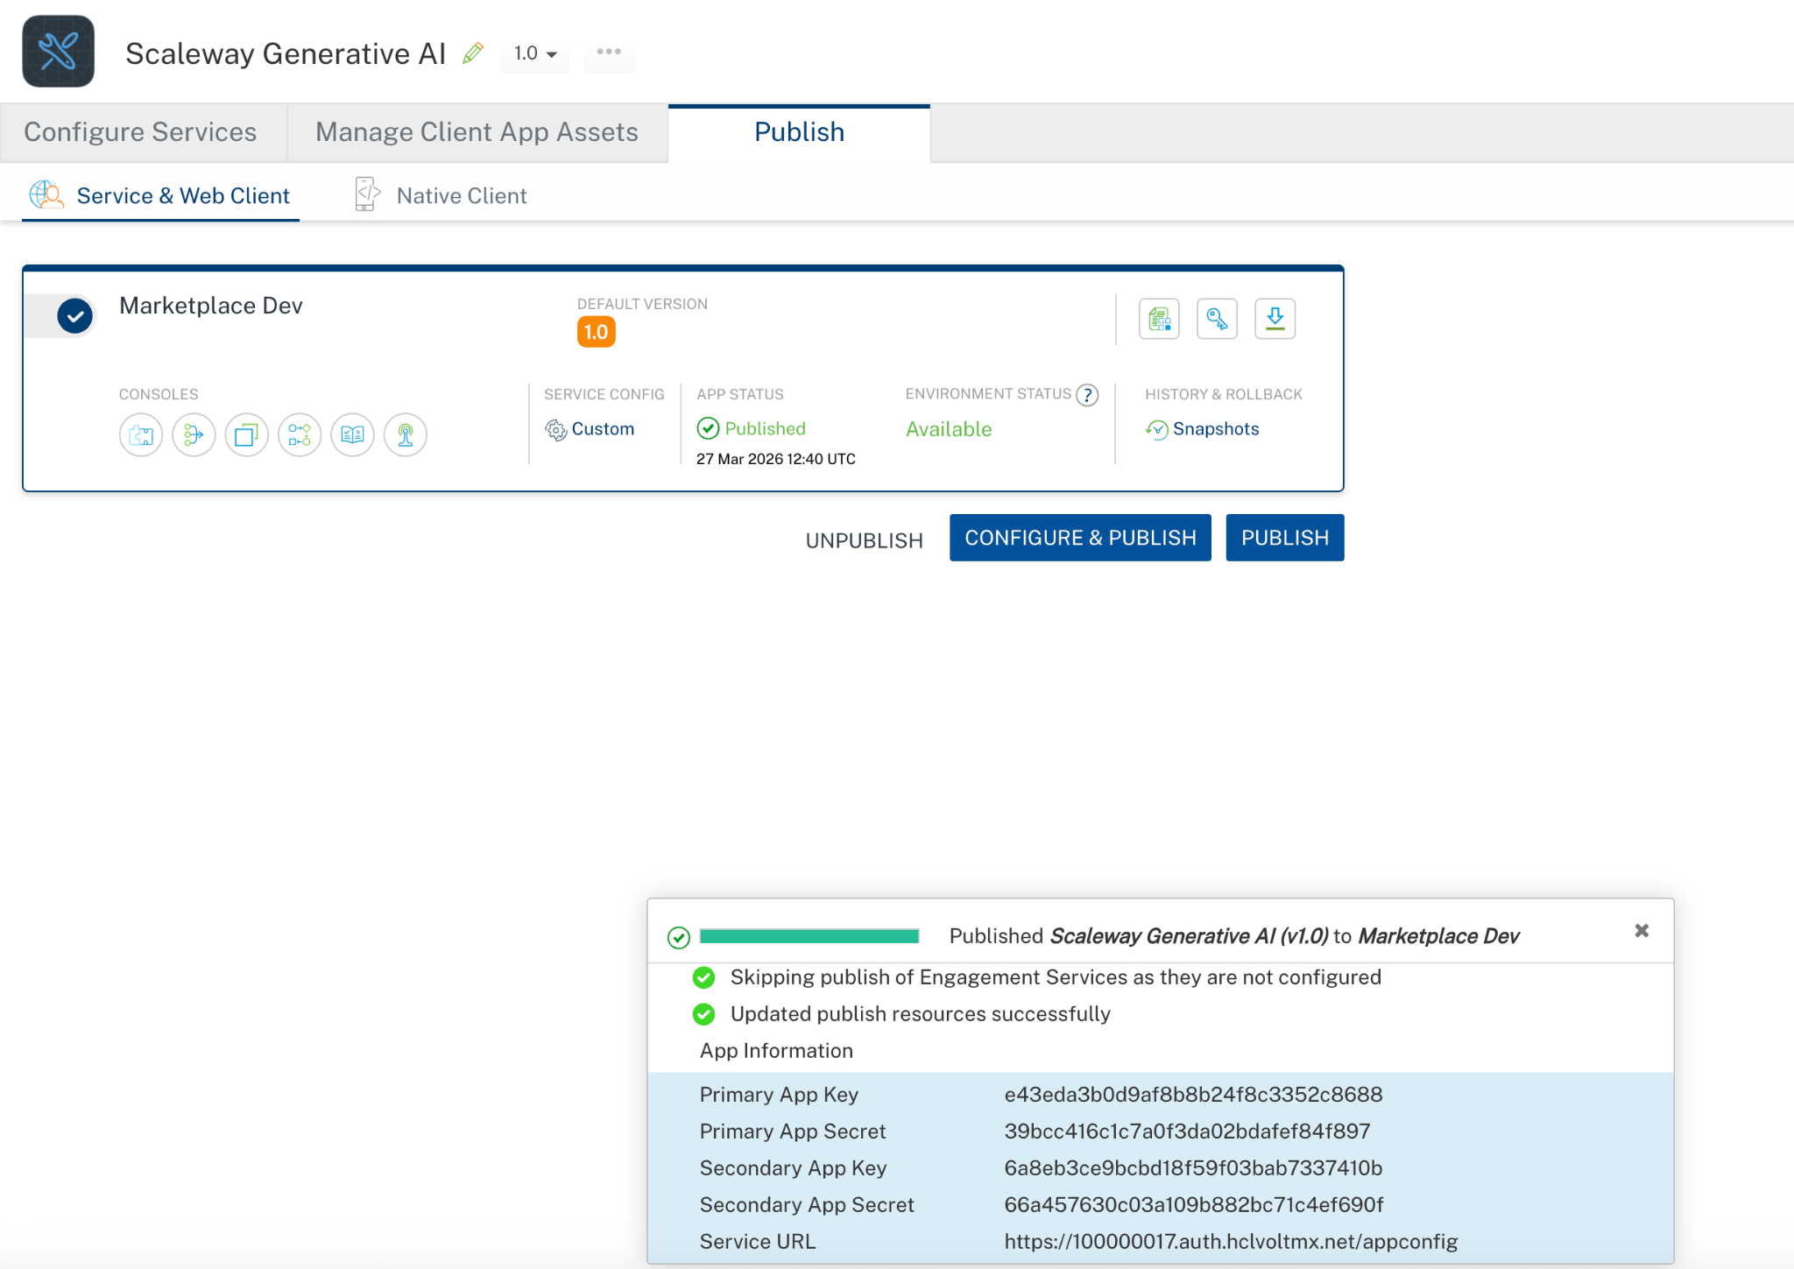
Reference documentation link:
- Generative APIs
- Generative APIs Documentation | Scaleway Documentation
- Supported models | Scaleway Documentation
- Generative APIs FAQ | Scaleway Documentation
- What are Rate limits with Scaleway Generative APIs | Scaleway Documentation
- Model-as-a-service Solutions Pricing

REVISION HISTORY
Adapter version 1.0.0:

Known Issues
None

Limitations
- For the createEmbedding operation, the input parameter is implemented using a default collection (array of strings). This can be changed to a single string input, or a single string can be passed within the collection (e.g., ["Here is a text to embed as a vector"]). As per Scaleway API support, both formats are supported, and the data type can be adjusted based on the use case without impacting functionality.
- In VoltMX Foundry, always provide values for required parameters. Optional parameters should only be included when you have valid values. Avoid sending empty strings, empty objects, or empty arrays for optional fields, as this may lead to validation errors. The request example includes all available parameters only for reference. Additionally, the messages parameter (array of objects) must be passed completely within the messages value as a properly structured JSON array.

