05 June 2023

Select File and Display(1.0.1)

Overview
Use this component within a web application to drag and drop or select a file from the local file system and then display the file selected within the browser.

Use case

To Select a file and then display it

Percentage of re-use:
Approximately 90% reusable.

Features.
- Drag and drop files
- Select files
- Display the selected files

Getting Started

Prerequisites
Before you start using the Horizontal Slider component, ensure the following:
• HCL Foundry
• Volt MX Iris

Platforms Supported

PWA & Responsive Web

Native

Importing the app
You can import the Forge components only into the apps that are of the Reference Architecture type.
To import the EncryptGlobal component, do the following:

Open your app project in Volt MX Iris..

In the Project Explorer, click the Templates tab.
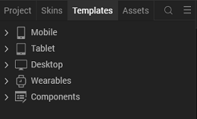

Right-click Components, and then select Import Component. The Import Component dialog box appears.
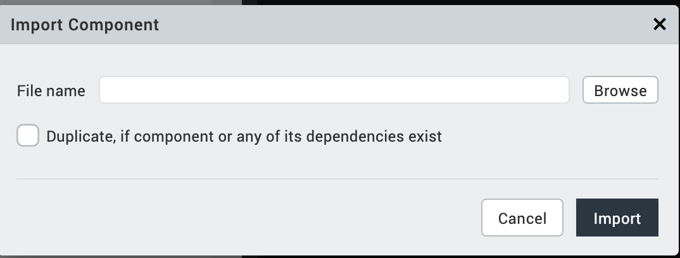

Click Browse to navigate to the location of the component, select the component, and then click Import. The component and its associated widgets and modules are added to your project.
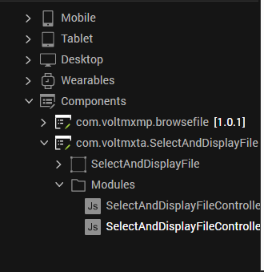
Once you have imported a component to your project, you can easily add the component to a form. For more information, refer Add a Component to a Form

Exposed methods and Events and values

File Name, File description and the Base64 value are exposed to the calling form.

On Save Click Event is exposed so you can write your own logic on what to do with the file when the user wishes to select it

Method displayFile also exposed so you can pass the file name and base64 value at anytime and get the file displayed in the browser

Enhance for more file types
By default, the component handles pdf, png, gif, jpeg, jpg, docx and xlsx file types. This list can be extended by adding in more file types in the method displayFile of the SelectAndDisplayFileController.js.

Revision History
App version 1.0.0:

Known Issues
NA

Limitations
NA

