30th June 2025

Sentiment Analysis Component

VERSION: 1.0.0

Overview
The Sentiment Analysis Component is designed to evaluate the emotional tone of user-provided text using industry-leading AI services. It integrates with Amazon Comprehend, Azure AI Language, and Google Cloud Natural Language API to detect the dominant language and assess whether the sentiment is positive, negative, neutral, or mixed. This component allows businesses to derive actionable insights from customer feedback, reviews, and textual data, helping improve user satisfaction and decision-making.

- Use Case:
- Customer Experience Management: Analyze feedback from surveys, chat logs, and reviews to understand user satisfaction and improve service quality.
- Brand Monitoring: Track sentiment trends across social media and review platforms to manage brand reputation in real-time.
- Support Prioritization: Detect negative sentiment in support tickets or live chat to automatically flag high-priority cases.
- Product Feedback Analysis: Identify emotional responses to product features or changes to inform roadmap and UX decisions.
- Employee Feedback & HR Insights: Understand the emotional climate in internal surveys to promote a healthier workplace.
- Marketing Campaign Evaluation: Measure how audiences feel about campaigns or ads based on sentiment in responses and comments.

- Percentage of re-use:
80-90%.

Getting Started

Prerequisites
Before you start using the Sentiment Analysis Component, ensure you have the following:
- HCL Foundry
- Volt MX Iris
- Google Cloud Natural Language AI - SENTIMENT ANALYSIS
- Go to the Google Cloud Console → Credentials
- Create an API Key (or use an existing one).
- Enable Cloud Natural Language API for your project.

Reference document:

https://cloud.google.com/natural-language/docs

- Azure AI Language - Sentiment Detection
- Microsoft account
- Endpoint,and api-key to use the Microsoft’s AI Language API issued by Microsoft.
Reference document:
https://learn.microsoft.com/en-us/azure/ai-services/language-service/sentiment-opinion-mining/overview
- Amazon Comprehend - BatchDetectSentiment
- Aws account
Reference document:
https://docs.aws.amazon.com/comprehend/latest/APIReference/API_BatchDetectSentiment.html

Platforms Supported

Mobile

iOS

Android

Importing the component

You can import the Forge components only into the apps that are of the Reference Architecture type.

To import the Sentiment Analysis Component, do the following:

- Open your app project in Volt MX Iris.

In the Project Explorer, click the Templates tab.

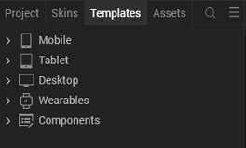

Right-click Components, and then select Import Component. The Import Component dialog box appears.
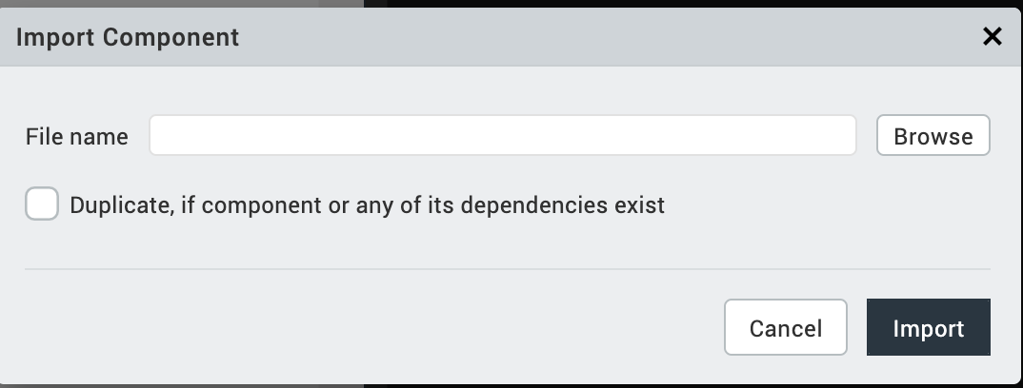

Click Browse to navigate to the location of the component, select the component and then click import. The component and its associated widgets and modules are added to your project.

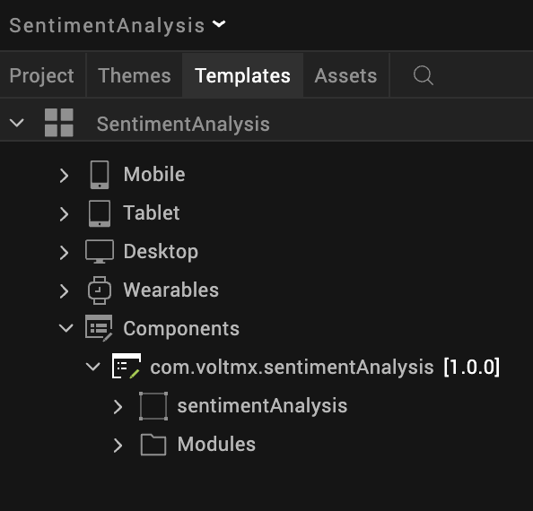
- Once you have imported a component to your project, you can easily add the component to a form. For more information, refer Add a Component to a Form

D. Building and previewing the app
After performing all the above steps, you can build your app and run it on your device. For more information, you can refer to the Building and Viewing an Application section of the Volt MX User Guide.
You can then run your app to see the Sentiment Analysis Component work in real time.
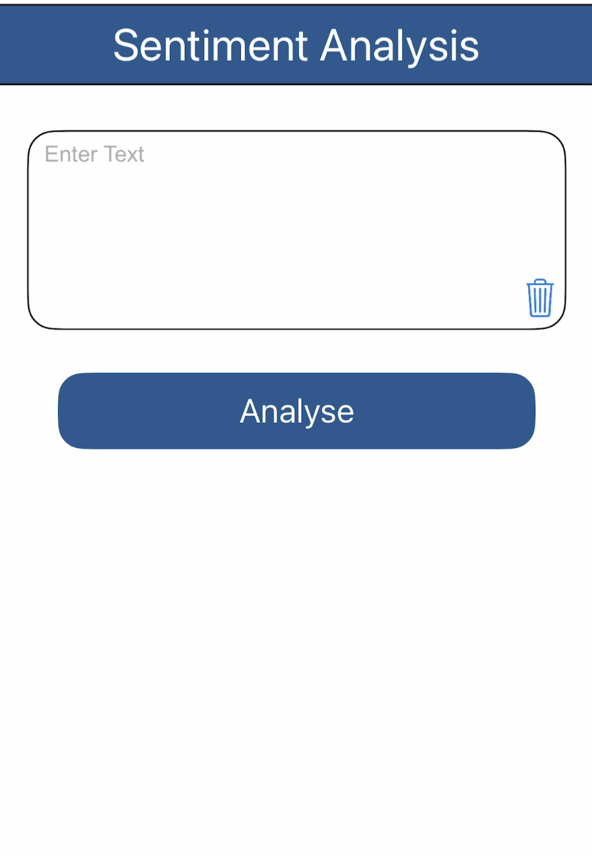

3. References

Dynamic Usage
You can also add a Sentiment Analysis Component dynamically. To do so,
- In Project Explorer, on the Projects tab, click Controllers section to access the respective Form Controller. Create a method and implement the code snippet like the sample code mentioned below.

/* creating a component's Object */
var sentimentAnalysis = new com.voltmx.sentimentAnalysis({
"height": "100%",
"id": "sentimentAnalysis",
"isVisible": true,
"left": "0dp",
"masterType": constants.MASTER_TYPE_USERWIDGET,
"isModalContainer": false,
"skin": "slFbox0",
"top": "0dp",
"width": "100%",
"zIndex": 1,
}, {
"paddingInPixel": false
}, {});

this.view.add(sentimentAnalysis);

In the code snippet, you can edit the properties of the component as per your requirement. For more information, see Setting Properties.
- Save the file

4. Properties:
The properties provided on the Component tab allow you to customize the UI elements in the Sentiment Analysis component. You can set the properties directly on the Component tab or by writing a JavaScript.

i. Service Name

Category: | Custom
Description: | Specifies the service name in the adapter.
Syntax:
  sentimentService
Type: | String
Read/Write: | Write
Example: | this.view.componentID.sentimentService = "Amazon";

ii. Set Text Value
Description: | Sets the given text into the input area of the component.
Syntax: | Text
Type: | Function
Read/Write: | Write
Example: | this.view.componentID.text = “VoltMX is good”

B. Events
You can define events to be executed when an action is performed. You can configure the events directly on the Actions tab or by writing a JavaScript. To configure the events on the Actions tab, click Edit against each event. For more information, refer Add Actions.
This section provides details about each event that help you define the actions by writing a JavaScript.

1. onSuccessCallback
Category: Custom
Description: Invoked when the user calls the onSuccessCallback.
Syntax: onSuccessCallback(successResponse)
Parameters: successResponse [Object]Contains the result of the sentiment analysis.
Example: this.view.componentID.onSuccessCallback = function(successResponse)
{
alert(successResponse.sentiment);
}.bind(this);

2. clear
Description: Invoked when the user calls the clear.
Syntax: clear
Parameters: clears the text and response
Example: this.view.componentID.text = “ ”

5. References
A. Endpoint Documentation

Sentiment Analysis
Amazon Comprehend Detect Sentiment Analysis
Google Cloud Natural Language AI - Sentiment Analysis
Azure AI Language Detect Sentiment Analysis

Language Detection
Amazon Comprehend Detect Dominant Language
Google Cloud Natural Language AI - Sentiment Analysis ( Auto Detects Language )
Azure AI Language Detect Language

5. Revision History
App version 1.0.0:

Known Issues
- No Known Issues

Limitations
- Azure AI Language's Detect Sentiment Analysis API does not return a confidence score.

