Date: Jan 4, 2026

SIGHTENGINE APPLICATION
VERSION: 1.0.0

1. OVERVIEW
Sightengine is an AI-powered content moderation platform that provides powerful APIs to automatically analyze and filter images and videos for visual threats, inappropriate content, and compliance violations. It enables businesses to scale their platforms securely by detecting content such as nudity, violence, hate speech, and spam in real-time, significantly reducing manual review effort and safeguarding user experience.

Use case:
- User-Generated Content Moderation: Automatically screen and flag content uploaded by users on social media, dating apps, and forums for inappropriate visual content.
- Real-Time Live Stream Filtering: Monitor live video feeds for sudden appearances of nudity or violence, allowing for immediate action.
- Brand Safety: Ensure ad placements and platform environments are safe for brands by identifying and filtering out objectionable material.
- Compliance and Regulation: Help platforms comply with regional content standards and legal requirements regarding harmful content.
- Profile Picture Verification: Verify the authenticity and appropriateness of user profile photos during the onboarding process.

Features:
- Multiple Detection Models: Offers specialized APIs for various categories, including NSFW (Nudity/Pornography), Gore/Violence, Face Recognition, AI-generated content detection, and more.
- Real-Time Processing: Analyzes images and short videos instantly, critical for live platforms and high-volume uploads.
- Confidence Scores: Provides detailed scores for each detected category, allowing for fine-tuned moderation policies.
- Customization: Allows training the models on specific content for highly customized moderation rules.
- Scalable API: Built to handle millions of requests per day, suitable for large and rapidly growing platforms.
- Support for Image and Video: Comprehensive support for both static images and various video formats.

2. GETTING STARTED

Prerequisites
Before you start using the Sightengine App, ensure you have the following:

- HCL Foundry
- Volt MX Iris

Devices
- Mobile

Platforms
- Android
- IOS

Importing the App
To import the Sightengine App to Volt MX Iris, do the following:
To import the Sightengine App, do the following:

- Launch Volt MX Iris.
- Click Project, and then select Import. The Import dialog box appears.
- Click From an Archive to navigate to the location of the project, select the files, and then click Import.

After you import the application, you can view the associated Foundry app connected at the Data & Services section.

Building the app
From the menu bar, go to Build and then select Build Native Local.

For Mobile, select Android and iOS. Click Build.

After the build is successful, run the app on your mobile device.

App Functionality
When you build and run the app, you can upload an image and retrieve the AI-generated moderation report.
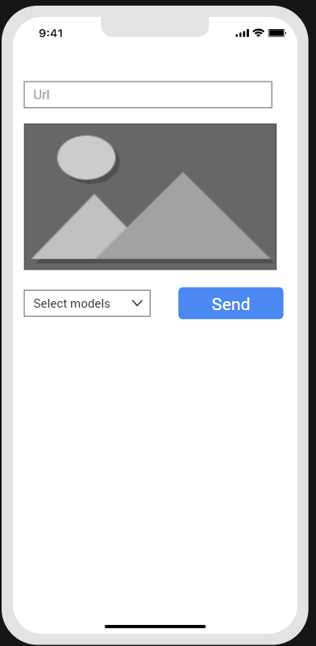

Home Screen (frmHome)
The home screen displays a clean, intuitive interface with the following elements:

- URL Input Field: A text input field where users enter the image URL to analyze
- Image Preview: Displays the uploaded image for visual reference
- Model Selection Dropdown: Allows users to choose between different moderation models (genai, weapon, violence, offensive-2.0)
- Send Button: Blue action button to submit the request
- Results Display: Shows moderation analysis with confidence scores and detection results

User Workflow
The user enters or pastes an image URL into the input field
Example: https://cdn.openai.com/dall-e-2/demos/text2im/astro.png
- The user selects a moderation model from the dropdown menu:
  - genai – AI-Generated Content Detection
  - weapon – Weapon Detection
  - violence – Violence & Gore Detection
  - offensive-2.0 – Offensive Content Moderation
- The user clicks the Send button to submit the request
- The image is immediately loaded and displayed in the preview area
- The moderation results appear below the image, displaying:
  - Detection category title
  - Confidence score (percentage)
  - Final result verdict

Sightengine API processes image inputs to generate a content moderation report.

Response Handling

- Displays the moderation score and a clear pass/fail status based on pre-set thresholds.
- Shows the uploaded image for visual reference.
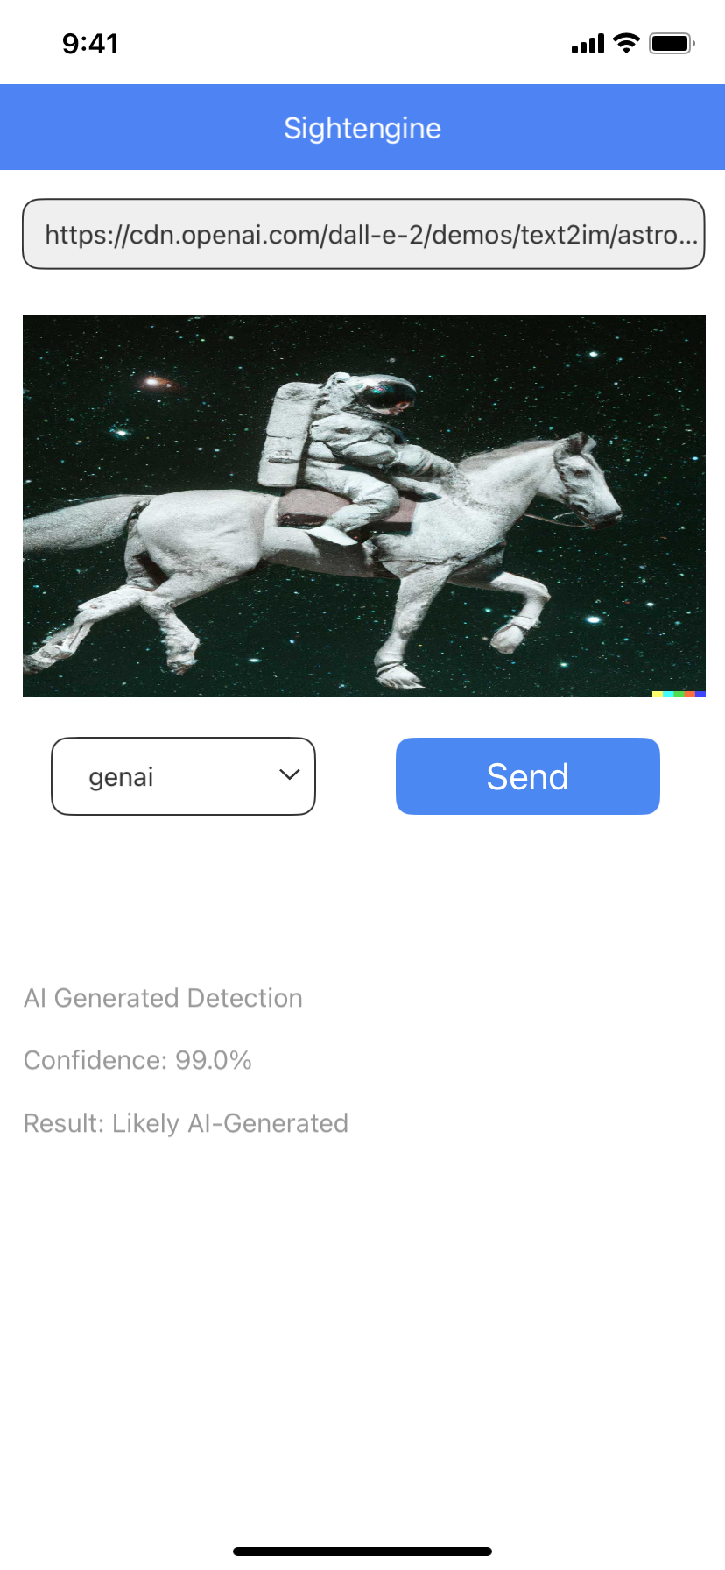

Error Handling

- If the app fails to receive a response (e.g., API key issue or network error), the app displays a failure alert and resets the input area, allowing the user to retry with a new image.

3. REVISION HISTORY
App version:1.0.0

A. Limitations
NA

B. Known Issue
NA

