27 -JAN-2026

TAVUS

VERSION: 1.0.0

OVERVIEW
Tavus is a Conversational Video AI platform that enables applications to create real-time, interactive video conversations with lifelike AI avatars. It allows businesses to deploy digital humans that can speak, listen, and respond naturally using voice and video. Tavus combines advanced AI models with WebRTC-based real-time communication to deliver low-latency, human-like interactions.

Use case:
- Conversational Video AI
- Real-time AI avatar interactions
- Multi-turn video conversations
- Virtual customer support agents
- Personalized video communication
- Knowledge-based video assistants
- Voice-enabled AI conversations

Percentage of re-use:
80% (Data can be customizable and customers need to implement UI by themselves).

Features
- AI Video Generation - Generate personalized or scripted AI videos using replicas, suitable for training, onboarding, announcements, and marketing.
- Real-Time Conversational Video AI - Enables live, interactive video conversations with AI avatars that can speak, listen, and respond naturally using voice and video.
- Persona-Based Intelligence - Define AI behavior, tone, expertise, and conversation style using personas, enabling customized interactions for different business scenarios.
- WebRTC-Based Low Latency Communication - Uses real-time WebRTC technology for smooth, secure, and low-latency video interactions.

GETTING STARTED

Prerequisites
Before you start using the Tavus Data Adapter, ensure you have the following:

- HCL Foundry
- Volt MX Iris
- Tavus Account
  - Sign up at https://platform.tavus.io/auth/sign-up to create your Tavus account.
- Tavus API Key
  - Once logged in, navigate to the API Keys section in the Tavus dashboard to generate an API key.
  - This key is required to authenticate your application when calling the Tavus APIs
- Replica and Persona Access
  - Ensure your Tavus account has access to required replicas (AI avatars) and personas for conversations and video generation.
- Conversation and Video Permissions
  - Verify that your account is enabled for:
  - Real-time conversations
  - AI video generation
  - These capabilities depend on your Tavus subscription plan.
- Project Setup
  - You can begin with the trial or free tier for testing and experimentation.
  - Upgrade to a paid plan for production deployments if required.
- Reference Documents
  - Tavus Platform Overview
  - Tavus API Documentation

Importing the data adapter
You can import Tavus Data Adapter into HCL Foundry directly from the voltmx Forge website or by importing the data adapter zip file.

To import the data adapter zip file, do the following:
- Log on to your HCL Foundry. The Dashboard page appears by default.
- In the left pane, click the API Management menu. The APIs tab opens by default.
- Click the Custom Data Adapters tab. The Custom Data Adapter page appears.
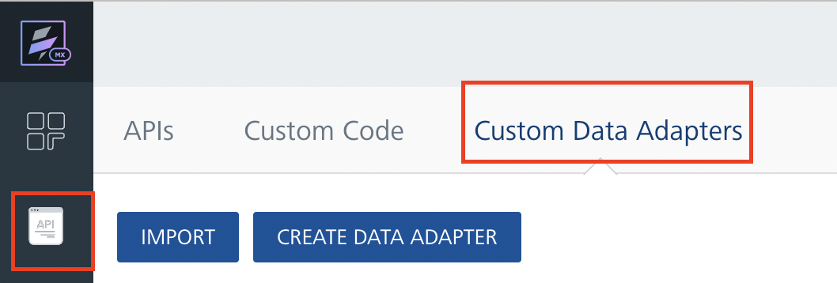
- Click Import. The Import Data Adapter dialog appears.

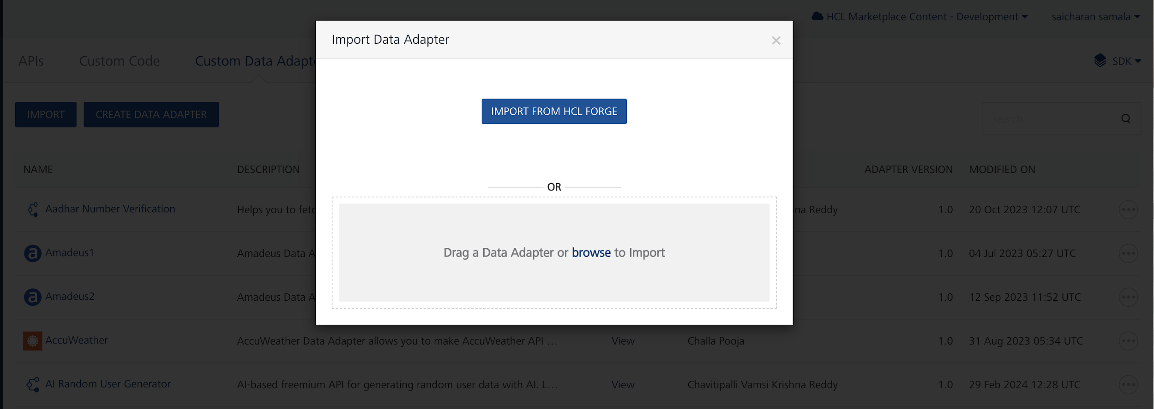

- Click IMPORT FROM HCL FORGE. The Import Data Adapter from HCL Forge dialog appears with a list of available data adapters.
- Click Import. Tavus data adapter is listed on the Custom Data Adapters page.
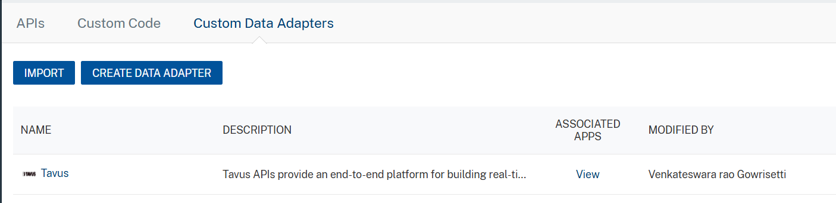

To import the data adapter zip file, do the following:
- Perform steps 1 to 4 in the above procedure
- Drag the data adapter zip file into the Drag a Data Adapter box.
Or
Click browse. The Open dialog appears.
Navigate to the location where you downloaded the data adapter (zip file) on your computer, select the data adapter, and click Open. The Import Data Adapter dialog shows the selected data adapter.

Creating an Integration Service with Tavus :
After you import Tavus Data Adapter into Foundry, you must create an integration service with service type as Tavus .
To create an integration service with Tavus, do the following:
- Log on to your HCL Foundry. The Dashboard page appears by default.
- In the left pane, click the API Management menu. The APIs tab opens by default.
- Click the Integration tab. The Integration tab opens with a list of existing integration services.
- Click CONFIGURE NEW. The Service Definition tab opens.
- In the Name box, type a unique name for your service.
- From the Service Type list, select Tavus.
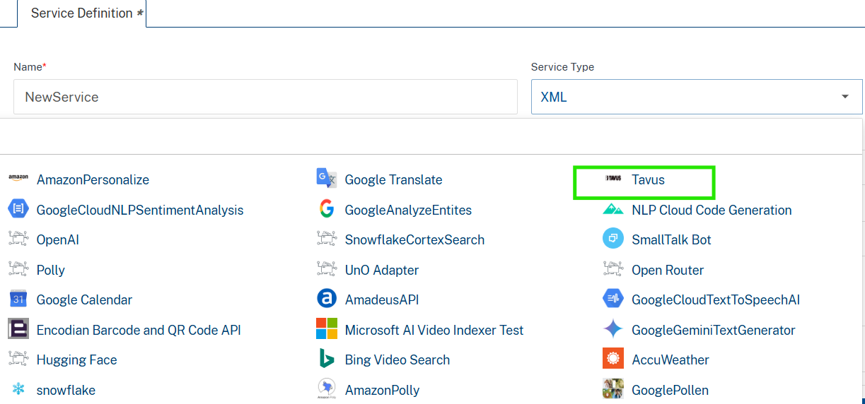
- Click Save

Creating an Operation
To make any API call in the HCL Foundry console, you must create an operation for the respective API and then execute the operation. Executing an operation involves making the API call and displaying the response.
This section provides steps to create an operation for the Tavus API.
Steps to create an operation for the Tavus API:
- Log on to your HCL Foundry. The Dashboard page appears by default.
- In the left pane, click the API Management menu. The APIs tab opens by default.
- Click the Integration tab. The Integration page appears with a list of existing integration services.
- From the list of integration services, select the integration service that you have created with service type as Tavus. The Service Definition tab of the selected integration service opens by default.
- Click the Operations List tab. The Operations List tab opens.
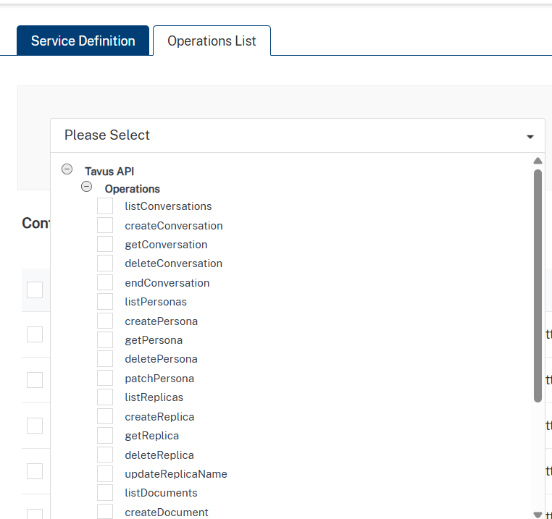
- Select createconversation and Click Add Operation.

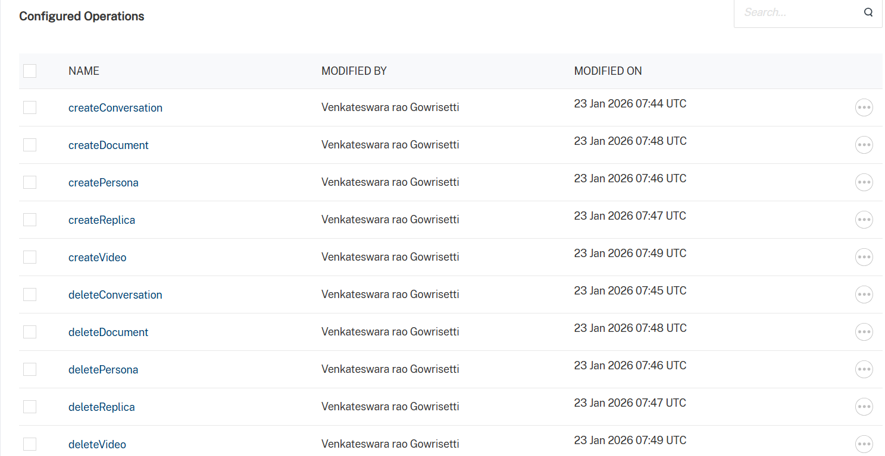

Executing Operation
Executing an operation involves making the API call by setting the necessary parameters and displaying the response. The procedure to execute any operation is same, but the request parameters of the APIs vary. This section provides steps to execute the Tavus (explained in Creating an Operation).
Steps to execute the Tavus operation:
- Log on to your Hcl Foundry. The Dashboard page appears by default.
- In the left pane, click the API Management menu. The APIs tab opens by default.
- Click the Integration tab. The Integration tab opens with a list of existing integration services.
- From the list of integration services, select the integration service that you have created with service type as Tavus. The Service Definition tab of the selected integration service opens by default.
- Click the Operations List tab.
- In the Name box, the name of the operation is displayed by default. If you want, you can change the name.
- On the Request Input tab, in the Body section, for the following parameters, specify the values in the respective boxes under the Test Value column.
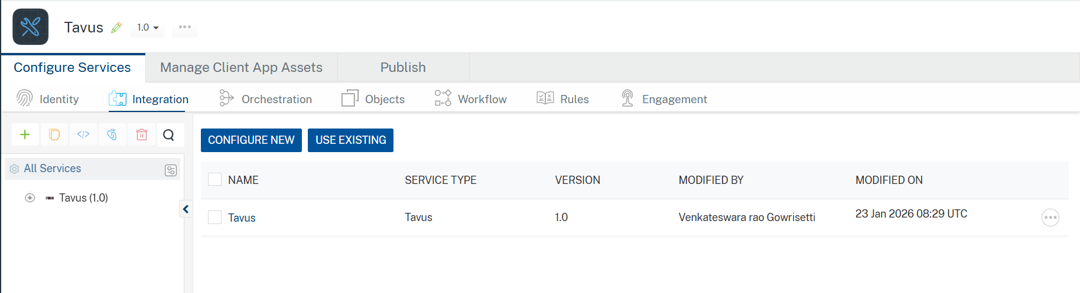
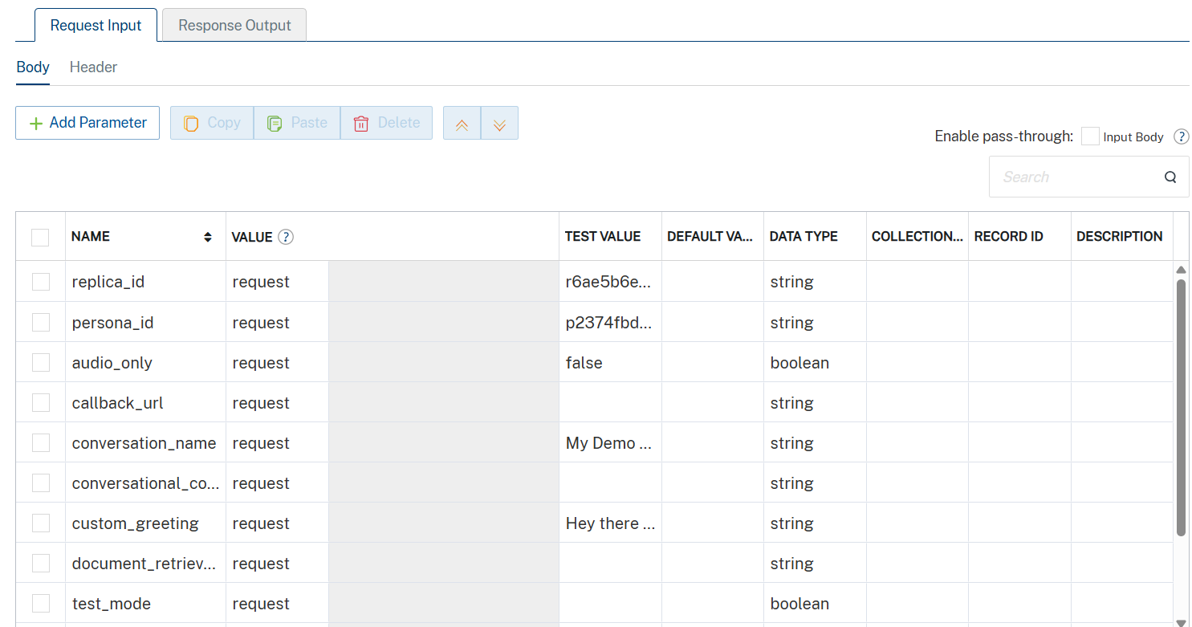

- Enter the value of x-api-key in the header part as default value
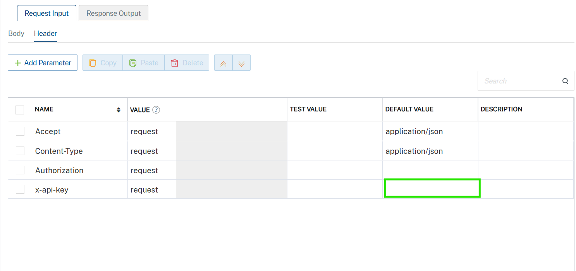
- Click SAVE AND FETCH RESPONSE. The Output Result dialog appears with the response. Otherwise, the Output Result shows an error.

.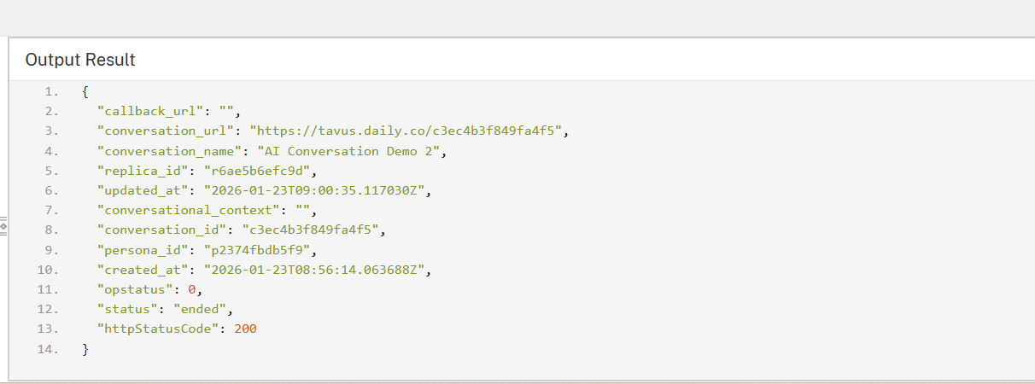

Publishing the App in VoltMX FOUNDRY:
After adding the Tavus Data Adapter to your app and configuring the necessary configurations, you must publish the app to HCL Foundry. For more information, refer to Publish a foundry app.
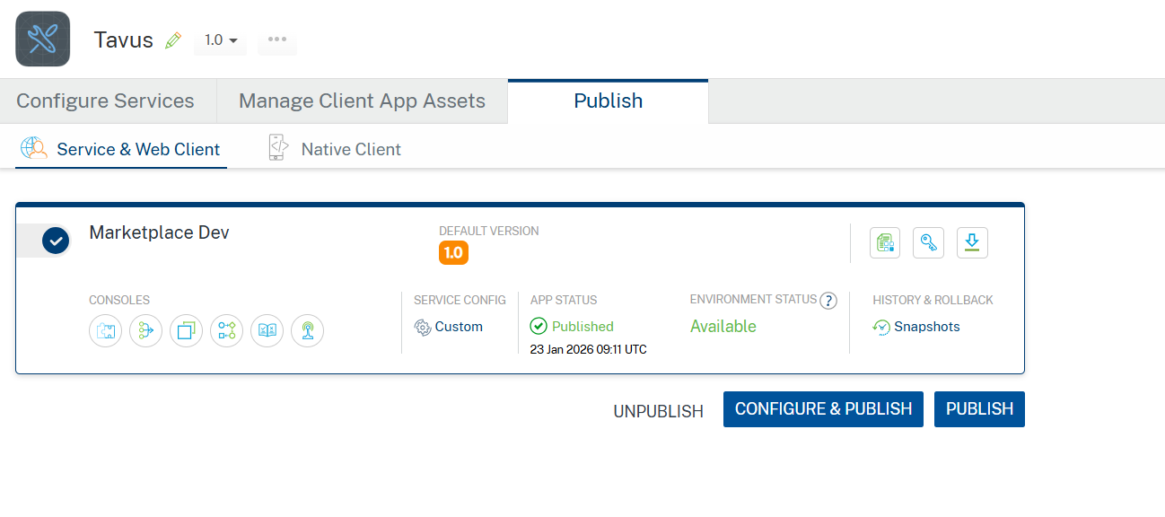

REFERENCES

Properties
- None of the properties are exposed.

Events
- None of the events are exposed.

API’s
- None of the APIs are exposed.

REVISION HISTORY
Adapter version 1.0.0:

Known Issues
None

Limitations
- AI video generation is asynchronous and does not return an immediate video output. Applications must poll the Get Video API to track video status.
- Video generation time may vary depending on script length, replica configuration, and platform load.
- Only replicas and personas configured in the Tavus platform can be used for conversations and video generation.

