Date : 28-JAN-26

TAVUS APPLICATION

VERSION: 1.0.0

Overview
The Tavus Application is a application built using HCL Volt MX to showcase the integration of Tavus Conversational Video AI APIs. The application demonstrates how real-time AI video conversations and AI-generated videos can be seamlessly embedded into enterprise mobile and web applications using a reusable data adapter.The app provides an end-to-end flow starting from user input, API invocation, status handling, and final video or conversation launch, serving as a reference implementation for users.

Purpose
This application enables users to:
- Demonstrate integration of Tavus APIs using Volt MX Foundry
- Validate real-time AI conversation creation
- Showcase AI video generation workflow with status tracking
- Provide a reusable sample for Marketplace users

Requirements:

- HCL Foundry
- Volt MX Iris
- Tavus API Key

Creating an Tavus Account and API Key:
- Go to https://platform.tavus.io/auth/sign-up
- Sign up for an account
- Navigate to the API / Dashboard section
- Generate a new API Key
- Copy and store the API key securely
(This key is required while configuring the Foundry integration service)

Devices:
- Mobile

Platforms:
- Android
- IOS

Features:
- Create AI Video Conversations - Enables users to start real-time AI conversations by selecting replicas and personas, along with custom greetings.
- Launch Real-Time Video Calls - Opens Tavus WebRTC conversation URLs in the external browser to ensure proper camera and microphone permissions.
- AI Video Generation - Allows users to generate AI videos using selected replicas and custom scripts.
- Video Playback Support - Plays generated videos using hosted or streaming URLs once processing is completed.
- Input Validation and Error Handling - Ensures mandatory fields are validated and meaningful error messages are displayed.
- Cross-Platform Support - Works across Android, iOS, and web platforms with platform-specific handling.
- Reusable Data Adapter Architecture - Uses a centralized Tavus Data Adapter for secure and scalable API integration.

App Functionality:
Initial Launch Experience
On application launch, users are presented with a Home screen that provides access to the core Tavus capabilities:
- Generate AI Video
- Start AI Conversation
Each capability is displayed as a selectable option on the home screen.
Generate AI Video Flow
- User selects Generate AI Video from the Home screen.
- The application navigates to the AI Video Generation screen.
- The user selects an available Replica (AI avatar) from the list.
- The user enters a video script in the text area.
- The user taps the Generate Video button.
- The application sends a request to the Tavus Create Video API through the Foundry data adapter.
- A loading or progress indicator appears while the video is being processed.
- The app periodically polls the Get Video API to track video status.
- Once the video status becomes ready, the application navigates to the results screen.
- The generated video is displayed using the hosted or streaming URL.
Users can repeat the process to generate additional AI videos.
Start AI Conversation Flow
- User selects Start AI Conversation from the Home screen.
- The application navigates to the Conversation Configuration screen.
- The user selects a Replica (AI avatar).
- The user selects a Persona to define the conversation behavior and tone.
- The user enters a custom greeting or conversation context.
- The user taps the Start Conversation button.
- The app sends a request to the Tavus Create Conversation API via the data adapter.
- Upon successful response with an active conversation status, a conversation URL is returned.
- The application opens the conversation URL in the device’s external browser to enable camera and microphone access.
- A real-time AI video conversation begins using WebRTC.

Importing the app:
To import the Tavus Application into your workspace, follow these steps:
- Open Volt MX Iris
- On the main menu select Forge → Browse.
- Search for the Tavus Application, and then click Import to Workspace. The app is imported to your workspace. A dialog box appears, confirming that the app has been imported. Click OK.
- Switch to your project containing the Tavus Application.. To switch to your project, click File → Open → Reference Architecture → <project name>

Building the app:
After performing all the above steps, you can build your app and run it on your device. For more information, you can refer to the Building and Viewing an Application section of the Volt MX User Guide.
You can then run your app to see the Tavus Application work in real time.

Configure the UI and settings of the Tavus Application
The Tavus Application consists of the following components:
frmHome
The Home form acts as the entry point of the Tavus sample application. It provides users with quick access to the core features supported by the integration.
Functionality:
- Displays available Tavus capabilities.
- Allows users to choose between:
  - Generate AI Video
  - Start AI Conversation
- Navigates users to the respective feature screens based on selection.
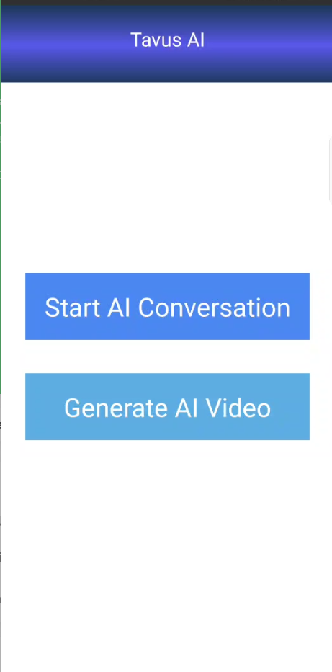

frmGenerateAIVideo
The Generate AI Video form enables users to create AI-generated videos using Tavus replicas.
Functionality:
- Allows users to select a Replica (AI avatar) from a list.
- Provides a text area for entering the video script.
- Validates required inputs before submission.
- Invokes the Create Video API through the Tavus data adapter.
- Displays video generation progress using status updates.
- Initiates polling using the Get Video API until the video is ready.
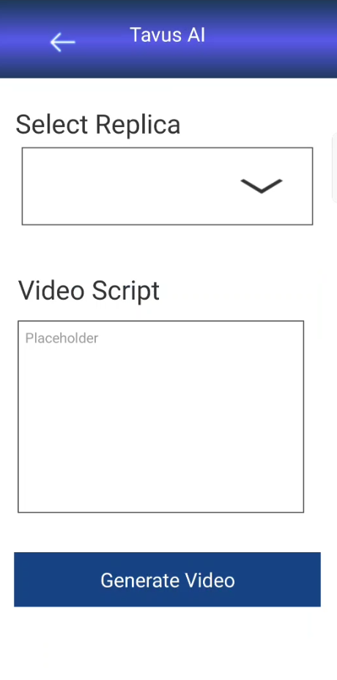
frmVideoresults
The Video Results form is used to display the final output of the generated AI video.
Functionality:
- Receives the generated video URL from the previous screen.
- Displays the video using hosted or streaming links.
- Allows users to replay the video.
- Provides navigation back to the video generation screen for new requests.
frmStartConversation
The Start Conversation form enables users to initiate real-time AI video conversations.
Functionality:
- Allows selection of a Replica (AI avatar).
- Allows selection of a Persona to define conversation behavior.
- Accepts a custom greeting or context from the user.
- Performs input validation.
- Invokes the Create Conversation API via the Tavus data adapter.
- Launches the real-time conversation using the returned conversation URL.
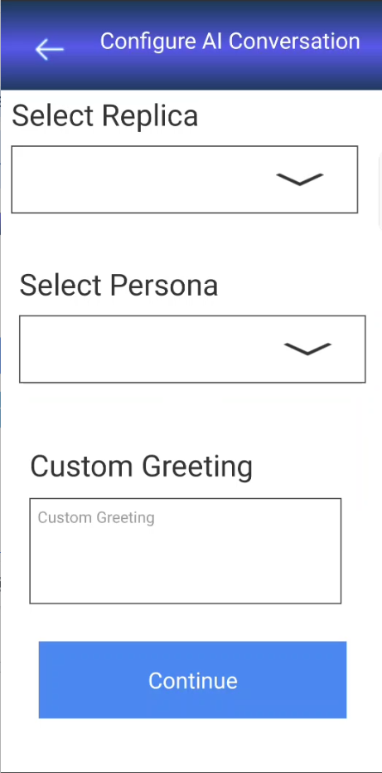

Foundry APP Setup
When you import the application into your Volt MX Iris, the HCL Volt MX Foundry services of the Tavus are added to the HCL Volt MX Foundry app, which is associated with the Volt MX Iris project. While importing the Tavus Application to your Volt MX Iris project, if there is no HCL Volt MX Foundry app associated with the existing Volt MX Iris project, a new HCL Volt MX Foundry app is automatically added to your HCL Volt MX Foundry environment and is associated with your Volt MX Iris.
To set the Foundry app, follow these steps:
- Click the HCL Volt MX Foundry app associated with your Volt MX Iris project from the Project Explorer. Click DATA & SERVICES
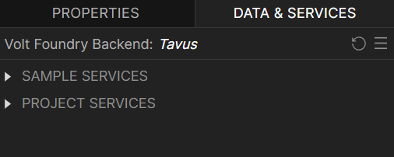
- Under the Configure Services tab, click Integration and can see the Tavus. Click on Integration service to add the operations.
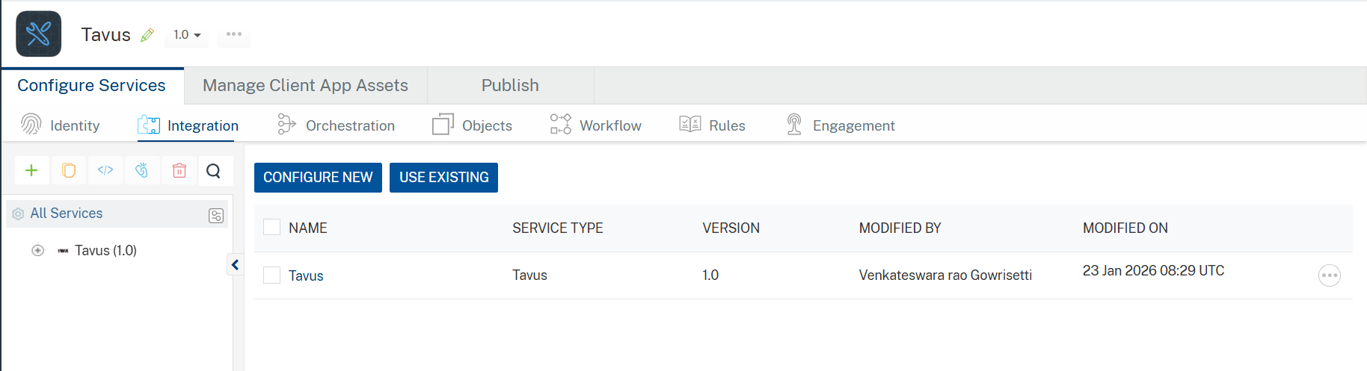
- Click the Tavus Integration service. On the right pane, expand the Tavus service and then select the createConversation operation.
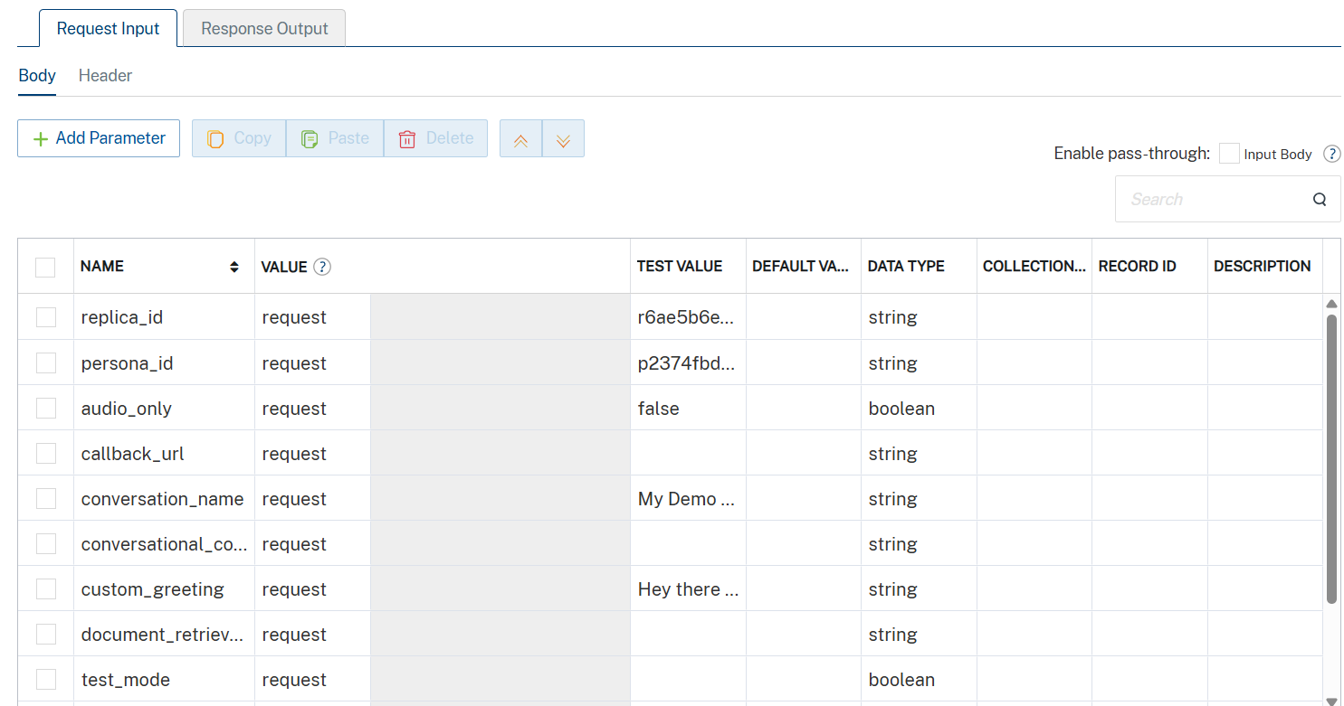
- The createConversation tab opens with the Request Input sub-tab opened by default.
- On the Request Input tab, in the Body section, for the following parameters, specify the values in the respective boxes under the Test Value column.
- Click Header sub-tab. The Header section opens.
- For x-api-key, In the box under the DEFAULT VALUE column, type the API Key generated from https://platform.tavus.io/dev/api-keys.
Syntax: Your_API_KEY
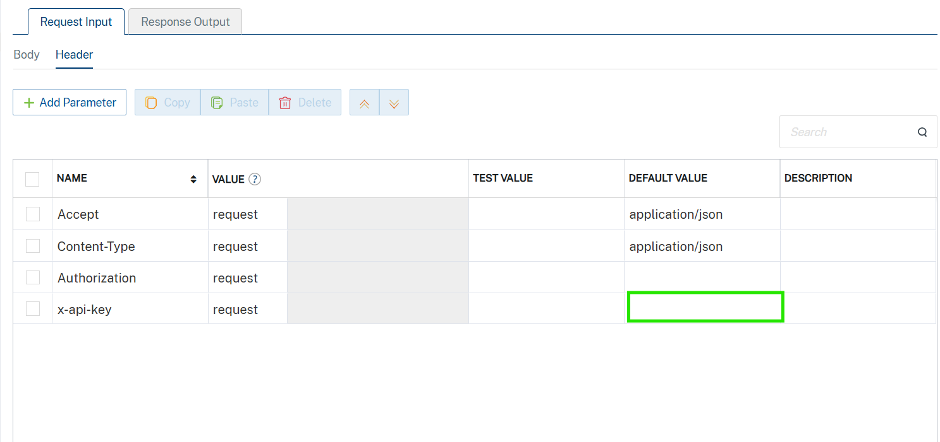
- Click SAVE AND FETCH RESPONSE. The Output Result dialog appears with the response. Otherwise, the Output Result shows an error. 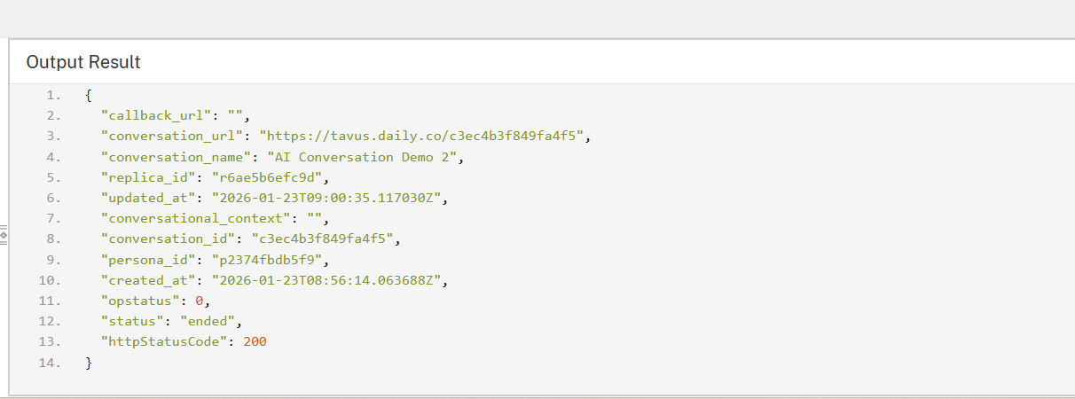
- Click the icon to go back to Volt MX Iris.

Publish the HCL Volt MX Foundry App
After you set the Operation Security Level, you must publish the HCL Volt MX Foundry app. To publish the HCL Volt MX Foundry, follow these steps:
In Volt MX Iris, click DATA & SERVICES, and then click Publish Project Services to Publish to your foundry app.
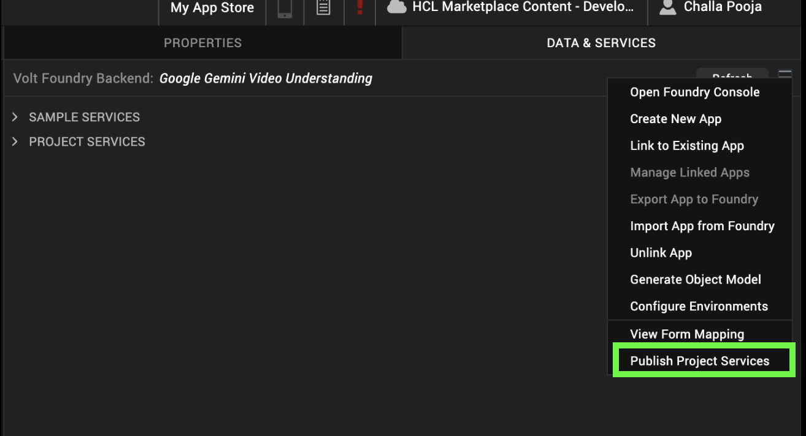
Select the environment to which you want to publish your app, and then click Publish.
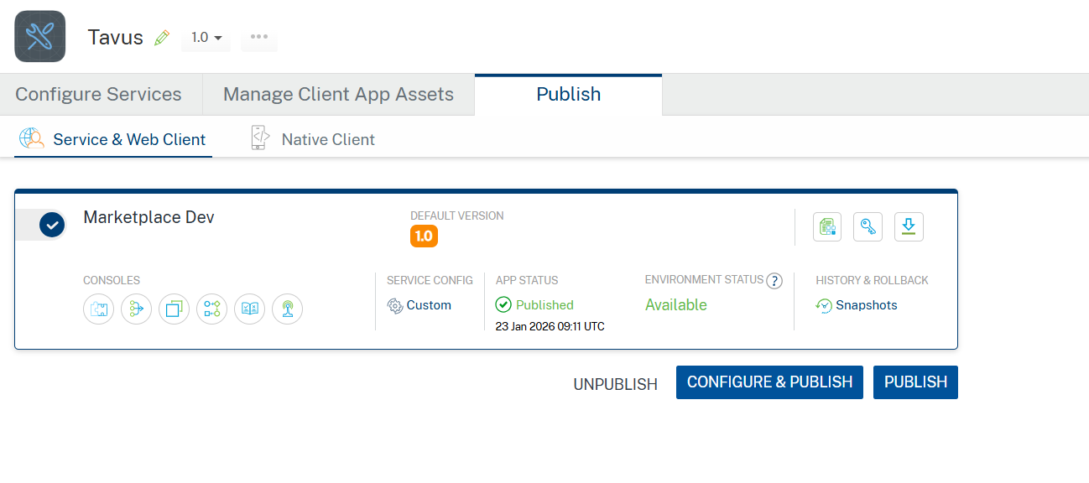
After the app is published to your environment, the following window appears confirming the publish.
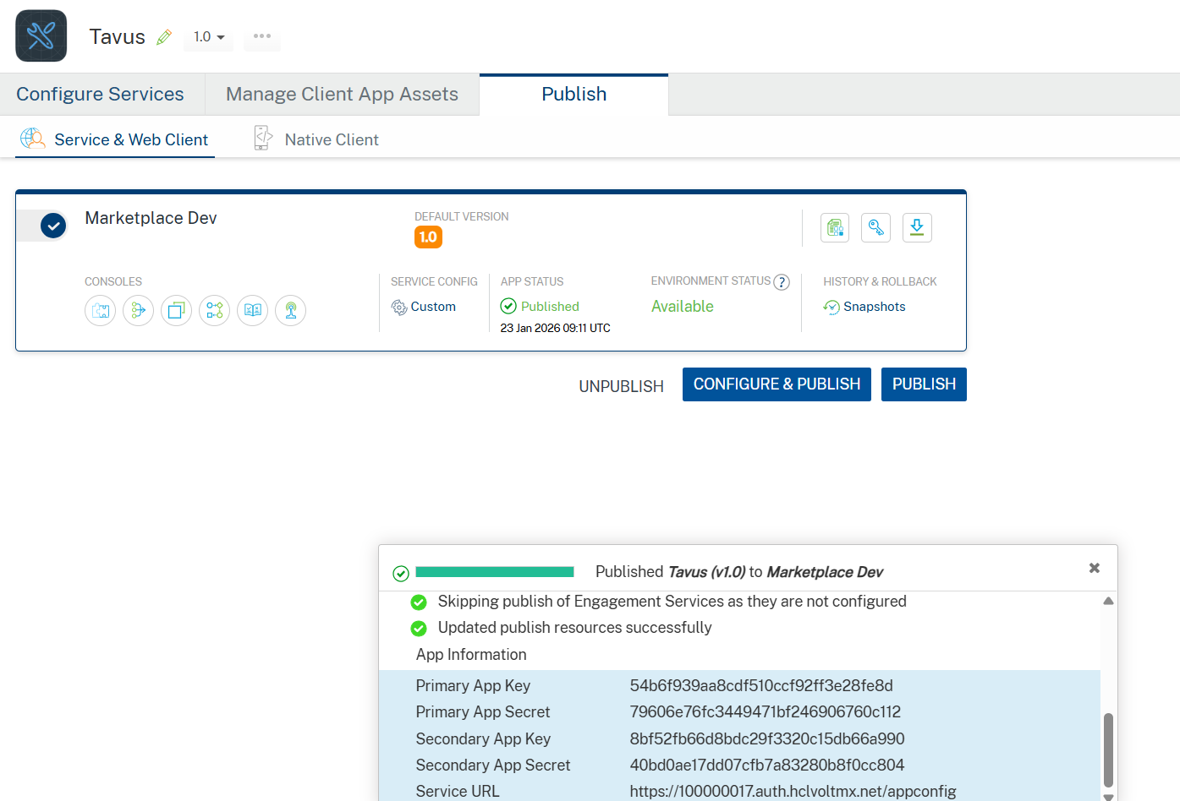

Building and previewing the app
After performing all the above steps, you can build your app and run it on your device. For more information, you can refer to the Building and Viewing an Application section of the Volt MX User Guide.
You can then run your app to see the Tavus Application work in real time.

APIs

No APIs

Events
- No Events

Reference API documentation: https://docs.tavus.io/api-reference/overview

REVISION HISTORY
Adapter version 1.0.0:

Known Issues
None

Limitations
- AI video generation is asynchronous and does not return an immediate video output. Applications must poll the Get Video API to track video status.
- Video generation time may vary depending on script length, replica configuration, and platform load.
- Only replicas and personas configured in the Tavus platform can be used for conversations and video generation.

