Date : October 22th, 2023

Timeular ADAPTER (4.4.0)

Overview
The Timeular adapter for HCL Volt Foundry’s Integration service enable the integration of Volt Foundry with the Timeular time tracking software, specifically Timeular’s Public API, V3. The adapter contains 43 operations to fully support Timeular API for authentication, Integrations, Time Tracking, User Profile, and Webhooks functionality. For detailed information on Timeular API, follow this link: https://developers.timeular.com/ .
An example use case for developing Foundry services using this Timeular adapter is a multi-channel app which support time tracking for remote workers or teams, addressing key challenges commonly faced in remote work settings. With time tracking functionality embedded in your apps, remote workers can give their managers and team members real-time visibility into their ongoing tasks and projects.

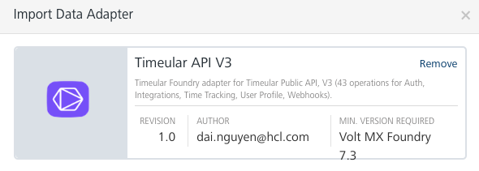

The Timeular adapter supports the following Timeular API operations:
V3 - CURRENT

Timeular API operation |  | Volt Foundry Timeular operation
Authentication
- POST - Sign-in with API Key & API Secret |  | Sign-inwithAPIKeyAPISecret
- GET - Fetch API Key |  | FetchAPIKey
- POST - Generate new API Key & API Secret |  | GeneratenewAPIKey&APISecret
- POST - Logout |  | Logout
Integrations
- GET - List enabled Integrations |  | ListenabledIntegrations
Time Tracking
Activities
- GET - List all Activities |  | ListallActivities
- POST - Create an Activity |  | CreateanActivity
- PATCH - Edit an Activity |  | EditanActivity
- DEL - Archive an Activity |  | ArchiveanActivity
- POST - Assign an Activity to Device Side |  | AssignanActivitytoDeviceSide
- DEL - Unassign an Activity from a Device Side |  | UnassignanActivityfromaDeviceSide
Devices
- GET - List all known Devices |  | ListallknownDevices
- POST - Activate Device |  | ActivateDevice
- POST - Deactivate Device |  | DeactivateDevice
- PATCH - Edit Device |  | EditDevice
- DEL - Forget Device |  | ForgetDevice
- POST - Disable Device |  | DisableDevice
- POST - Enable Device |  | EnableDevice
Current Tracking
- GET - Show current Tracking |  | ShowcurrentTracking
- POST - Start Tracking |  | EditTracking
- PATCH - Edit Tracking |  | StartTracking
- POST - Stop Tracking |  | StopTracking
Time Entries
- GET - Find Time Entries in given range |  | FindTimeEntriesingivenrange
- POST - Create Time Entry |  | CreateTimeEntry
- GET - Find Time Entry by its ID |  | FindTimeEntrybyitsID
- PATCH - Edit a Time Entry |  | EditaTimeEntry
- DEL - Delete a Time Entry |  | DeleteaTimeEntry
Reports
- GET - Generate Report |  | GenerateReport
- GET - All Data as JSON |  | AllDataasJSON
Tags & Mentions
- GET - Fetch Tags & Mentions |  | FetchTags&Mentions
- POST - Create Tag |  | CreateTag
- PATCH - Update Tag |  | UpdateTag
- DEL - Delete Tag |  | DeleteTag
- POST - Create Mention |  | CreateMention
- PATCH - Update Mention |  | UpdateMention
- DEL - Delete Mention |  | DeleteMention
User Profile
User
- GET - Me |  | Me
Space
- GET - Spaces with Members |  | SpaceswithMembers
Webhooks
- GET - List available events |  | Listavailableevents
- POST - Subscribe |  | Subscribe
- DEL - Unsubscribe |  | ListSubscriptions
- GET - List Subscriptions |  | UnsubscribeallforUser
- DEL - Unsubscribe all for User |  | Unsubscribe

For more detailed information, please follow this URL to view the Timeular Public API reference document: https://developers.timeular.com/

Getting Started

Prerequisites
- Volt Foundry
- Timeular’s account api-key and api-secret are required to generate a “Bearer” token for the Authorization input header parameter of each of the adapter operation (https://developers.timeular.com/#12de6e46-4b3a-437b-94b2-39b7782eb24c)

Third Party Dependency

At the time of this Timeular adapter creation (10/22/2023), Timeular API is at version 3. The information provided herein is dependent on Timeular permission for its API usage and thusly is subject to change by Timeular.

Importing the adapter
To import the Data Adapter to Volt Foundry, do the following:
- Sign in to the HCL Foundry.
- From the left navigation menu, select API Management.
- In API Management, select Custom Data Adapters.
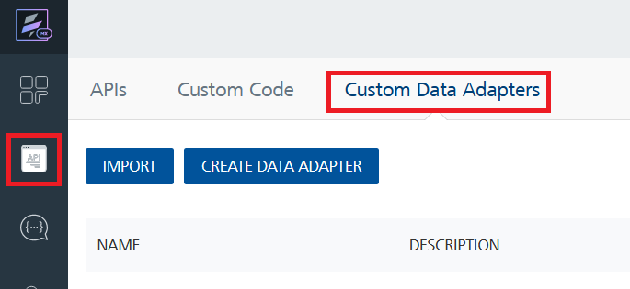
- Click IMPORT to import a custom data adapter.
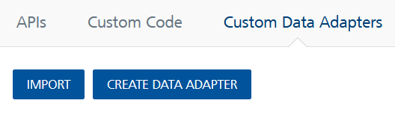
- On the Import Data Adapter dialog box, click browser to import.
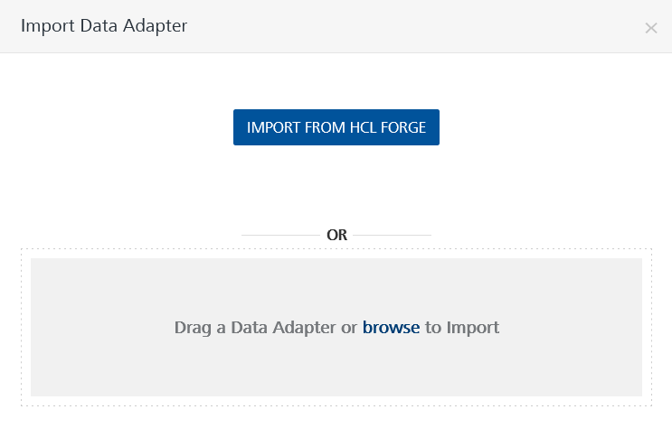
- Select TimeularAPIV3_FoundryAdapter.zip file and click IMPORT.
After you import the data adapter, Volt Foundry opens a window that shows the metadata of the data adapter.
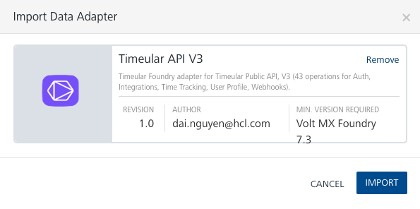
After you import the data adapter, you can view it on the Custom Data Adapters page and use it to create services on Volt Foundry.
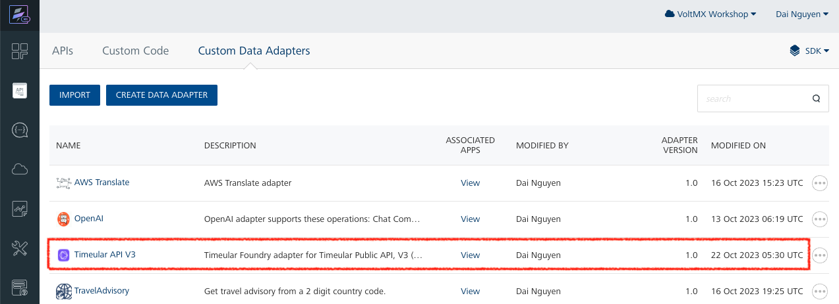

Creating an Integration service
After you import the data adapter into Volt Foundry, you can use it to create an Integration Service.
Follow the given steps to create an Integration service using the Timeular Adapter.
- Sign in to the HCL Foundry.
- From the left navigation menu, select API Management.
- In API Management, select Integration.
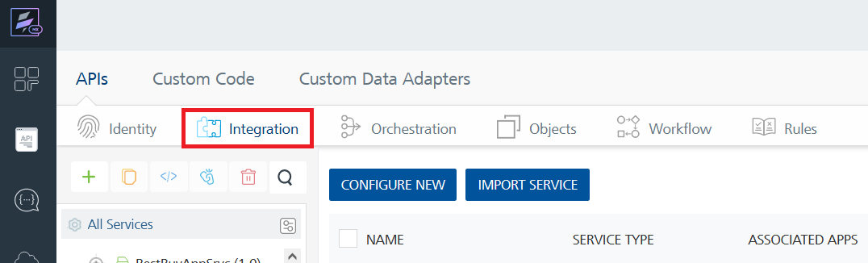
- To create a new service, click the + button or the CONFIGURE NEW button.
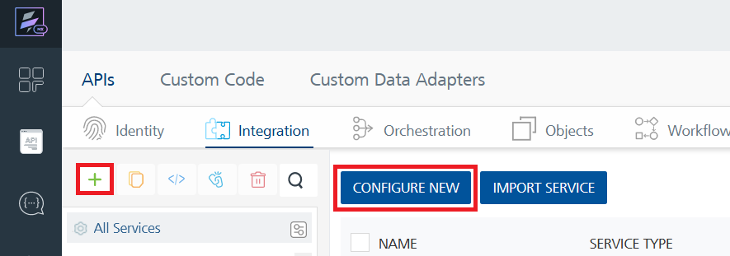
- On the Service Definition tab, select the service type as Timeular API V3, and click SAVE.
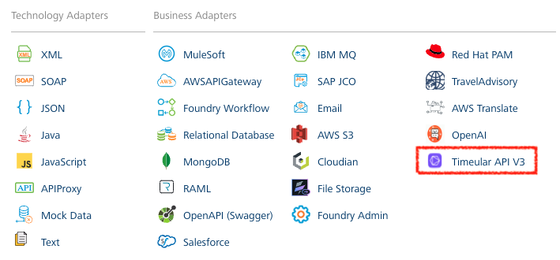
Alternatively, you can also create a Foundry app and create an Integration service inside it.

E. Creating and Executing operations
After you create an integration service, you can create and execute operations using the service.

Creating an Operation
- In API Management/Foundry app you created, in the Integration section, select the service that you created.
- After you select the service, navigate to the Operation List tab.
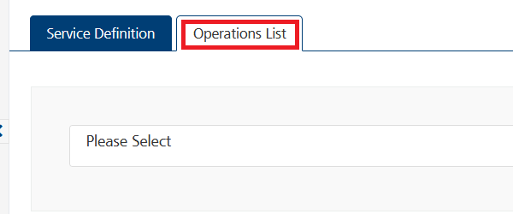
- From the drop down list, select an operation that you want to execute, and click ADD OPERATION.
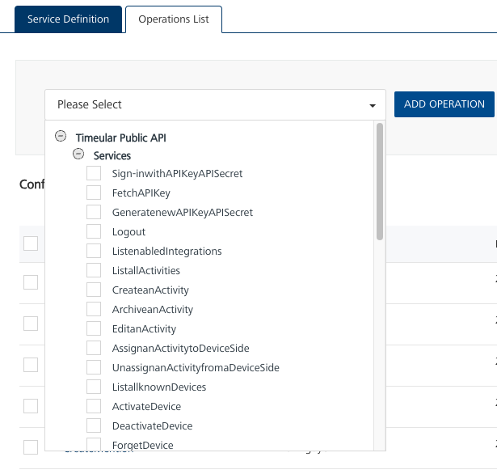

Executing the sign-in Operation
- From the Operations List tab, in the Configured Operations section, click on the operation you want to execute, in this case the Sign-inwithAPIKeyAPISecret operation.
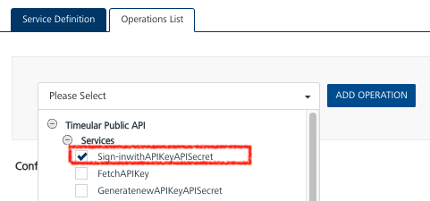

- In the initial display of the selected operation in the Operation Page, the Request Input tab will list all the input parameters available to an operation. For the Sign-inwithAPIKeyAPISecret operation, you must provide your Timeular account api-key and api-secret to generate a Bearer token:
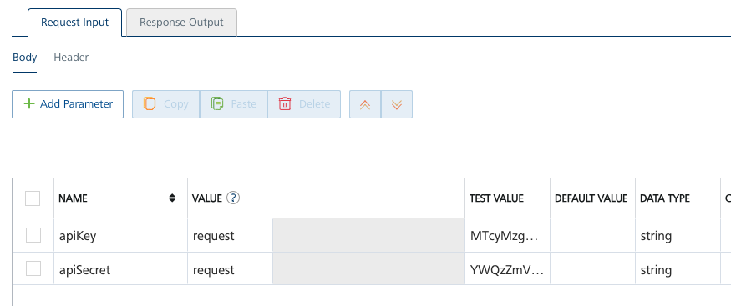
- Select a run-time environment and click Save and Fetch Response to get a response based on your inputs.

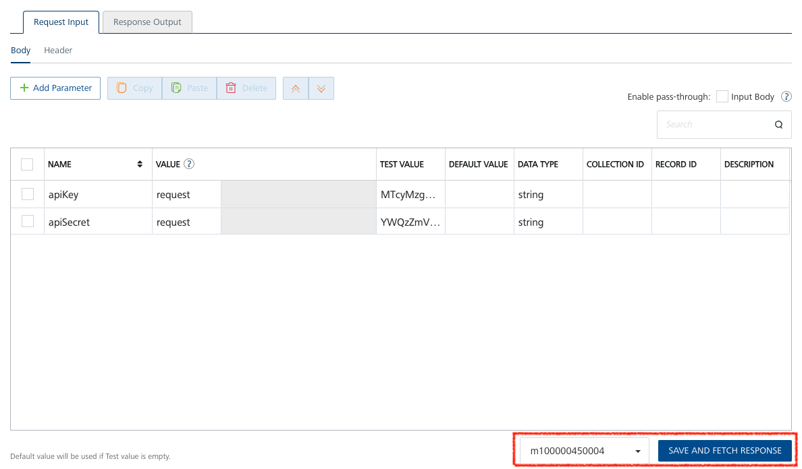

- After the operation is executed in Foundry, you will see a Test panel where the result of the operation is displayed. You will see both the request payload and the Authorization-Bearer-token. You will need this bearer token to execute all other Timeular operations.
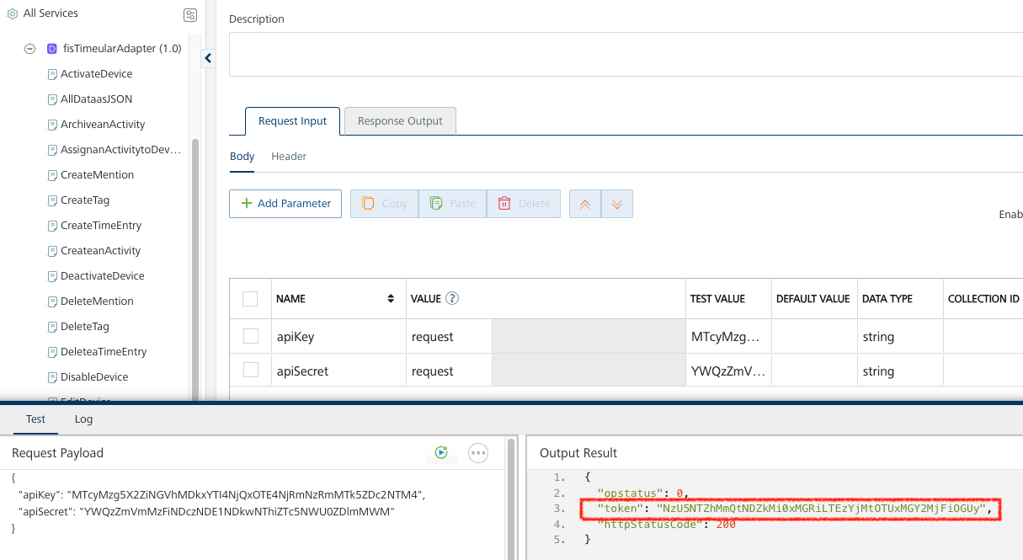

Executing other Operations, requiring the Authorization-Bearer token

All other operations, except the “sign-in”, of the Timeular API will require the “Bearer” token as the value of the operation input header parameter “Authorization”.
- From the Operations List tab, in the Configured Operations section, click on the operation you want to execute, for example CreateTimeEntry.
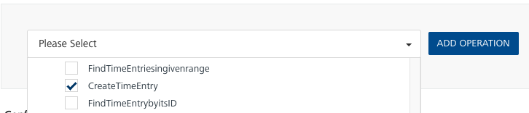

- In the initial display of the selected operation in the Operation Page, the Request Input tab will list all the input parameters available to an operation. Provide all the required parameter values to execute your operation (see the Timeular Public API V3 for the required input parameters for each operation):
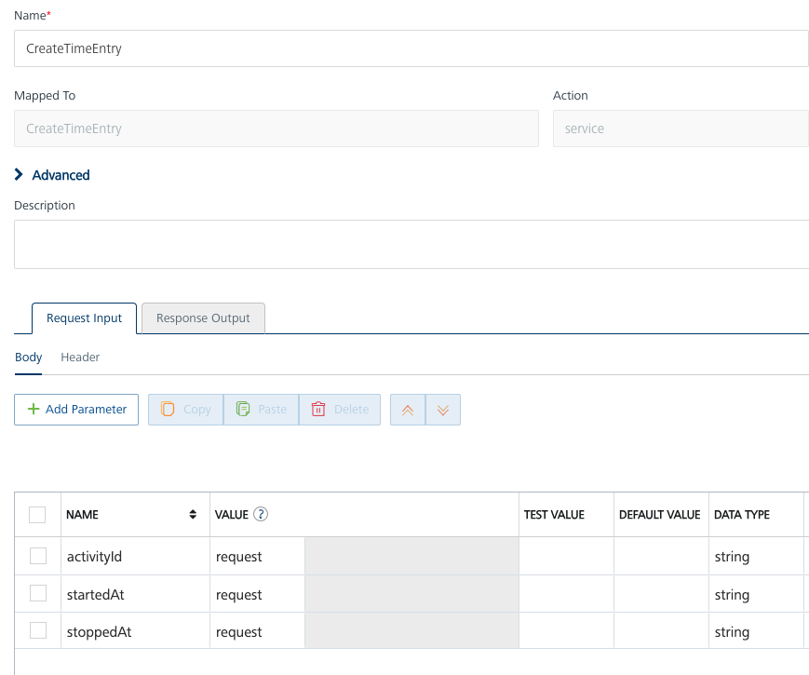
- You must provide the Authorization-Bearer token in the Request Input Header panel as the value of the Authorization. This token you received after executing the operation Sign-inwithAPIKeyAPISecret above.

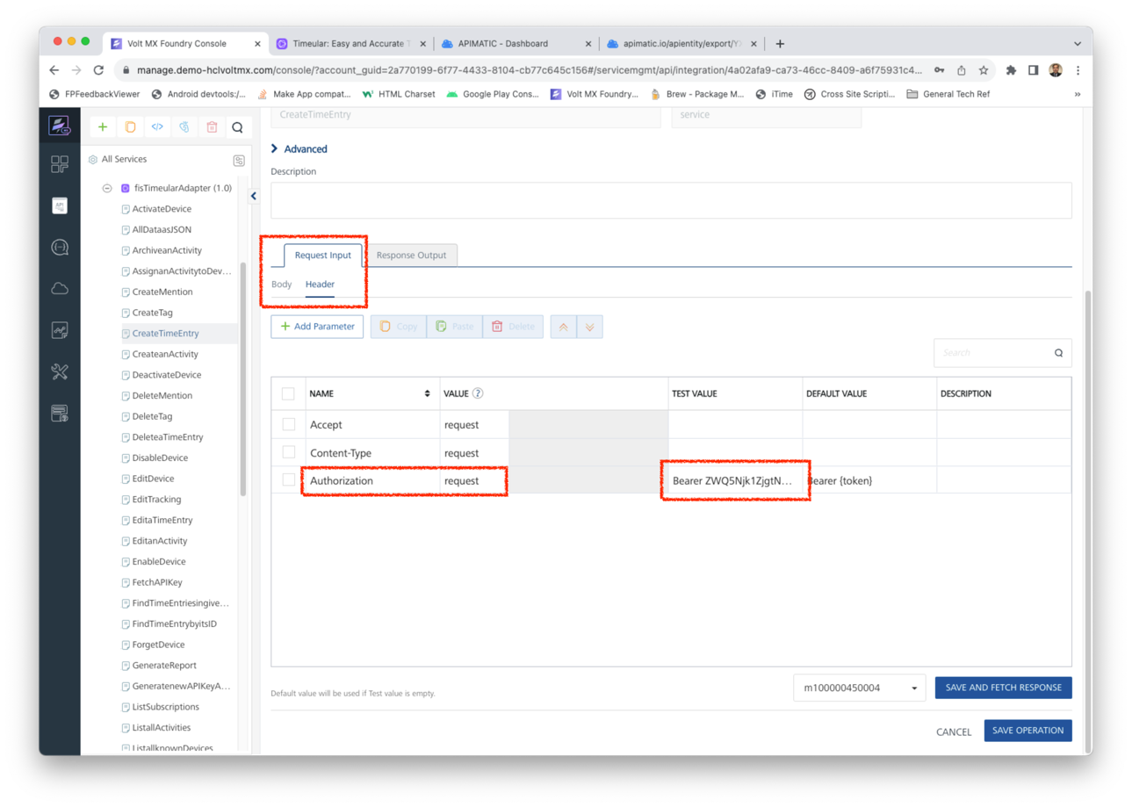

- Select a run-time environment and click Save and Fetch Response to get a response based on your inputs.

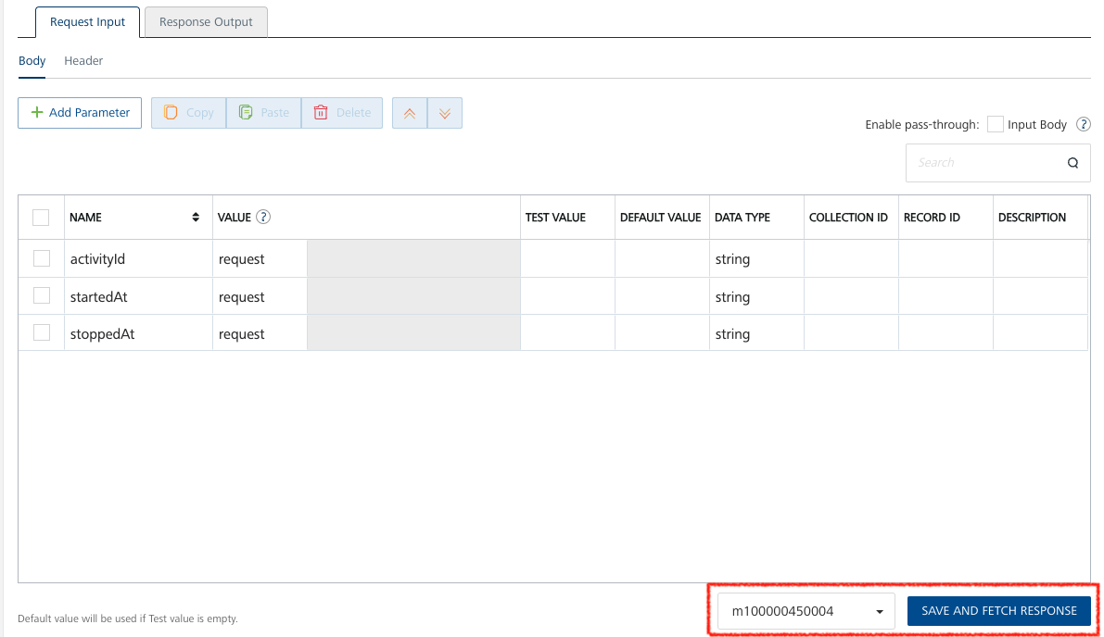

- After the operation is executed in Foundry, you will see a Test panel where the result of the operation is displayed. You will see both the request payload and the Output Result.
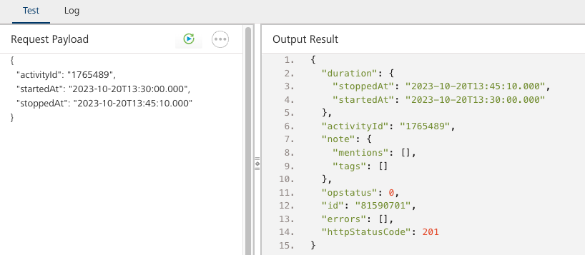

Providing the optional Note parameter as input
- Three of Timeular operations can accept an optional “note” record with a “text” parameter, as the input parameters for the operation execution. Please reference the Timeular Public API (https://developers.timeular.com/). For this reason, the optional “note” structure is not shown in the Foundry adapter Request Input -> Body parameter list by default. The 3 operations are:
  - EditTracking, Edit Tracking.
  - CreateTimeEntry, Create Time Entry.
  - EditaTimeEntry, Edit a Time Entry.
You can provide this “note” input parameter as followed:
- While in 1 of the 3 operations’ Request Input tab -> Body panel, click the Add Parameter button.
- Set the name as “note” in the new parameter row.
- Change the “note” data type from “string” to “record”.
- Click the Add Parameter button again.
- Set the name as “text” in the new parameter row.
- Set the Record ID value of this “text” parameter as “note”.

Below are the before and after snapshots of an example in how to provide this optional “note” record:

Before:
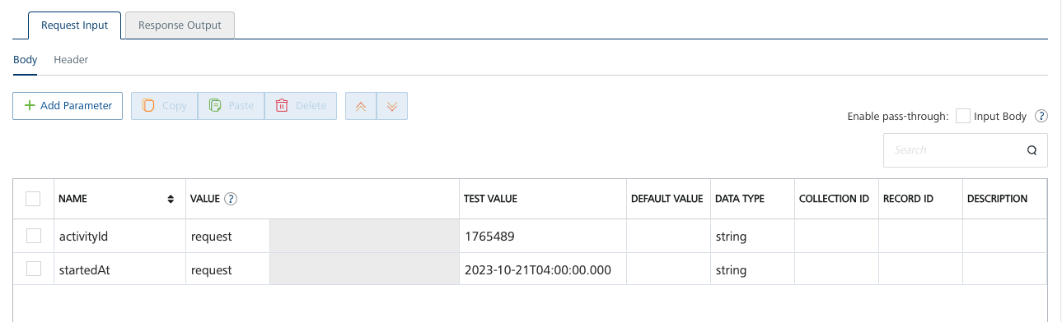
After:
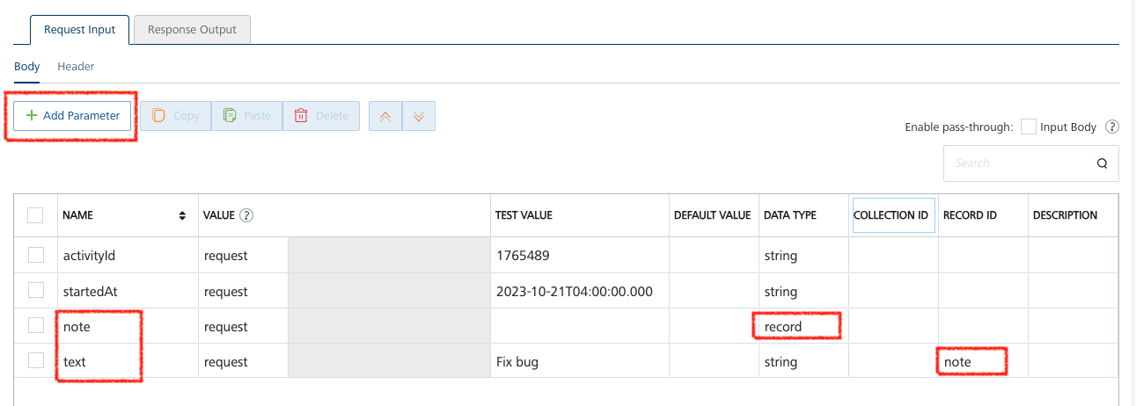

Publishing your application
If you want to use the services in client applications, you need to publish an app to a run-time environment. You can create the service (as described above) in an application or import the service into an application and publish the application.

References

List of API Endpoints
- Authentication, https://api.timeular.com/api/v3/developer.
- Integrations, https://api.timeular.com/api/v3/integrations.
- Time Tracking Activities, https://api.timeular.com/api/v3/activities.
- Time Tracking Devices, https://api.timeular.com/api/v3/devices.
- Time Tracking Current Tracking, https://api.timeular.com/api/v3/tracking.
- Time Tracking Time Entries, https://api.timeular.com/api/v3/time-entries.
- Time Tracking Reports, https://api.timeular.com/api/v3/report.
- Time Tracking Tags & Mentions, https://api.timeular.com/api/v3/tags-and-mentions.
- Time Tracking Tags, https://api.timeular.com/api/v3/tags.
- Time Tracking Mentions, https://api.timeular.com/api/v3/mentions.
- User Profile User, https://api.timeular.com/api/v3/me.
- User Profile Space, https://api.timeular.com/api/v3/space.
- Webhooks, https://api.timeular.com/api/v3/webhooks.

Revision History
Adapter version 4.4.0:

Known Issues
-List known issues

Limitations
-List limitations

