Date: 19-May-26

UCLASSIFY AI FEEDBACK ANALYSER APPLICATION

VERSION: 1.0.0

A.Overview
uClassify AI Feedback Analyzer Application is a Volt MX application designed to help users analyze and interpret customer feedback using advanced natural language processing (NLP) capabilities powered by the uClassify machine learning API platform. The application is ideal for teams seeking lightweight, production-ready solutions for sentiment analysis, topic detection, language identification, and keyword extraction without the need to develop custom machine learning models.
Feedback Analyzer offers a user-friendly interface where users can input one or more text entries, select a desired classifier, and view detailed analysis results in an intuitive and actionable format. It supports popular public classifiers such as Sentiment and Language Detector, while also enabling integration with privately trained classifiers specific to customer needs.

B.Requirements
- HCL Foundry: https://manage.hclvoltmx.com/
- Volt MX Iris
- uClassify account with API key (read key minimum): https://www.uclassify.com/account/register
UClassify – Step-by-Step Setup and Classifier Creation Guide

1. Register a New User Account
- Open the UClassify login page:
UClassify Login Page
- Click on Register or Create a New Account.
- Enter the required details such as:
  - Username
  - Email ID
  - Password
- Complete the registration process.
- After successful registration, log in using your credentials.

2. Navigate to Manage Section
- After login, open the Manage page:
UClassify Manage Page
- In the Manage section, you can access:
  - API Keys
  - Classifiers
  - Training Options

3. Get API Keys
- In the Manage page, click on the API Key section.
- You will see:
  - Read API Key
  - Write API Key
- Copy both keys.
- Store the keys securely for future reference and API integration.

4. Create a New Classifier
- In the Manage page, go to the Classifiers section.
- Click on Create.
- Enter the classifier name.
- Click Create Classifier.
- After creation, the classifier will appear in the classifier list.

5. Edit the Classifier
- Locate the created classifier.
- Click on the Edit icon.
- Inside the classifier, you can configure and train the classifier.

6. Add Classes to the Classifier
- Inside the classifier page, locate the Add Class section.
- Enter the class name.
Example:
  - Positive
  - Negative
  - Neutral
- Click on Add Class.
- The class will now be added to the classifier.

7. Train the Classifier Using Text
- Click the Edit icon for the required class.
- Add sample text data for training.
Example:
  - “This product is very good.”
  - “Service was excellent.”
- Click on the Train option to train the classifier with the entered text.

8. Train the Classifier Using Files
- Inside the class training section, select the option to upload files.
- Upload the required training file containing sample text data.
- Click on Train.
- The uploaded content will be used to train the classifier.

9. Untrain the Classifier
- Open the class training section.
- Select the trained text or file data.
- Click on Untrain.
- The selected training data will be removed from the classifier training set.

C. Devices
- Mobile

D. Platforms
- Android
- iOS

E. Features
- Sentiment Analysis: Analyze customer feedback to determine whether the sentiment is positive, negative, or neutral.
- Topic Detection: Identify key topics or themes from the text input to understand the focus of the feedback.
- Language Detection: Automatically detect the language of the input text for multilingual support.
- Keyword Extraction: Extract important keywords from the text to highlight critical points.

F. App Functionality
Feedback Analyzer App Overview
The Feedback Analyzer App is an AI-driven application that enables users to analyze text and receive instant, actionable insights using the uClassify machine learning API platform.
Features
- Analyze Text via Input Box: Enter single or multiple text inputs for analysis.
- AI-Powered Text Analysis: Instantly receive sentiment, topic, language, or keyword insights about the text.
- Custom Classifier Support: Extend functionality with privately trained classifiers tailored to specific business needs.
- Batch Processing: Analyze multiple text entries simultaneously for faster insights.
- Interactive Q&A Chat: Ask follow-up questions about the analyzed text using a chat interface powered by AI.
- Simple, Intuitive UI: Clean results and chat screens for a seamless user experience.
UI Flow
Here’s the frmHome form description in the requested format:

1. frmHome (Home Screen Form)

Purpose:
This is the landing form of the Feedback Analyzer application. It serves as the starting point for users to navigate to various features of the app, such as text analysis and results.

Key Features:
- Welcome Message: Displays a greeting and brief instructions for using the app.
- Navigation Buttons: Provides buttons to navigate to the text analysis form (`frmAnalyseText`) and other key features.
- App Overview Section: Highlights the app’s purpose and key functionalities.

Main Actions:
- onClickAnalyseText: Navigates to the `frmAnalyseText` form for text analysis.
- onClickResults: Navigates to the `frmResults` form to view previous analysis results.
- initializeHome: Sets up the UI elements and loads any necessary data for the home screen.
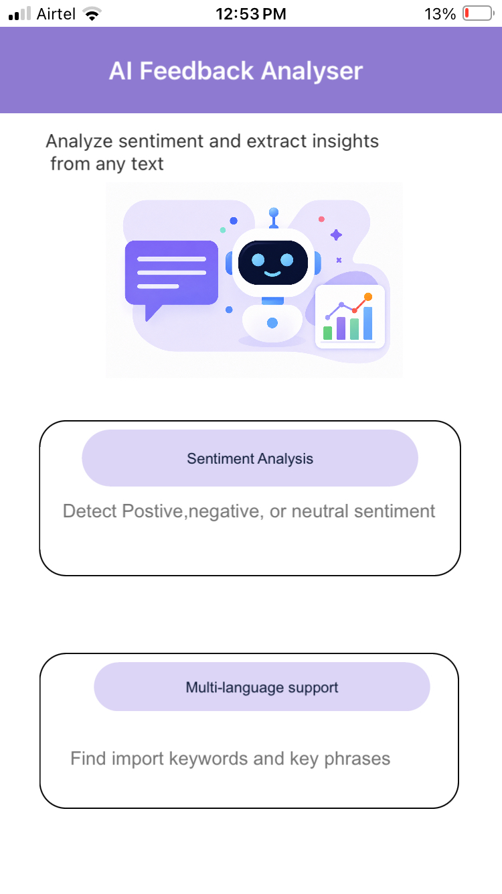

2. frmAnalyseText (Main Interaction / Text Analysis Form)

Purpose:
This is the central form where users interact with the app’s AI features. It acts as a hub for entering text, selecting classifiers, and viewing analysis results.

Key Features:

- Text Input Box: Allows users to enter one or more text inputs for analysis.
- Classifier Selection: Users can choose from predefined classifiers (e.g., Sentiment, Language Detector) or custom ones.
- Analyze Button: Submits the text for analysis and displays results.
- Chat Interface: Users can type follow-up questions about the analyzed text.

Main Actions:

- onClickAnalyze: Handles the submission of text for analysis.
- onSelectClassifier: Updates the selected classifier for analysis.
- onClickChat: Navigates to the chat form for follow-up questions.
- analyzeText: Makes API calls to the uClassify platform and handles responses.
- onAnalyzeSuccess, onAnalyzeFailure: Handle API responses and update the UI.
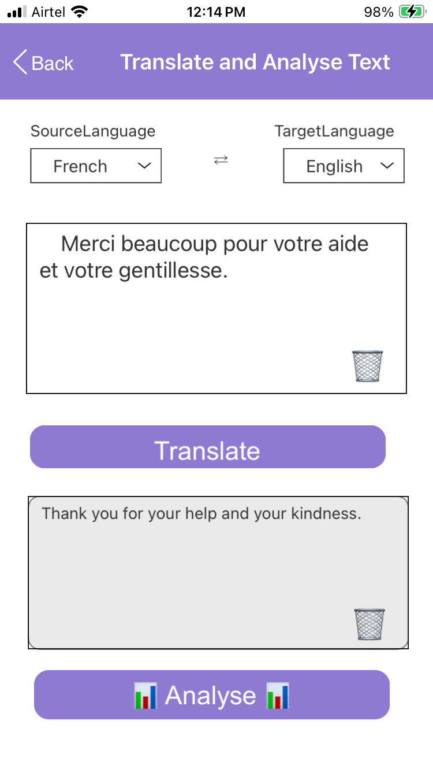

3. frmResults (Text Analysis Result Form)

Purpose:
Displays the results of the text analysis (e.g., sentiment, topics, keywords) after a user submits text for analysis.

Key Features:
- Result Display: Shows the AI-generated insights for the analyzed text.
- Classifier Details: Displays the selected classifier and its results.
- Navigation: Allows users to proceed to the chat form for follow-up questions or return to the previous screen.

Main Actions:
- onNavigate: Receives text data and analysis results from the previous form.
- displayResults: Updates the UI with the analysis results.
- onClickChat: Navigates to the chat form with the analysis results.
- onClickBack: Clears state and navigates back to the main form.

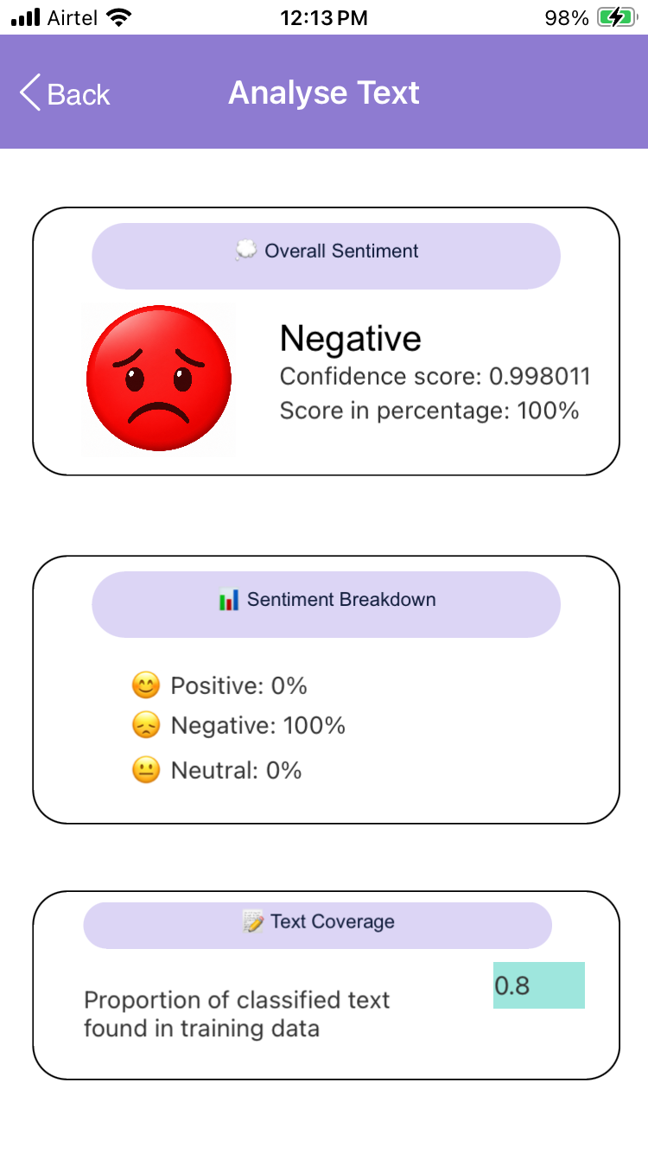
Note:
We must replace the placeholder values (YOUR_USERNAME_HERE, YOUR_CLASSIFIERNAME_HERE, and YOUR_APIKEY_HERE) with valid credentials in frmAnalyseTextController before building and running the sample application.
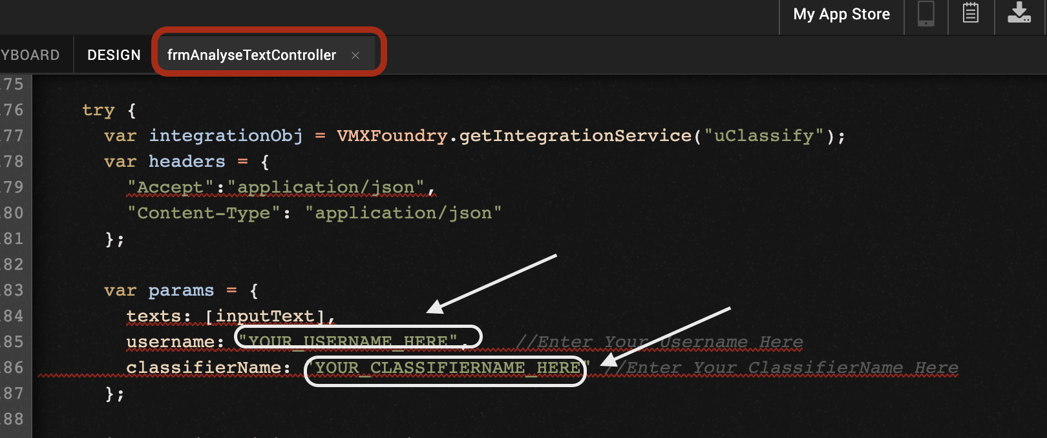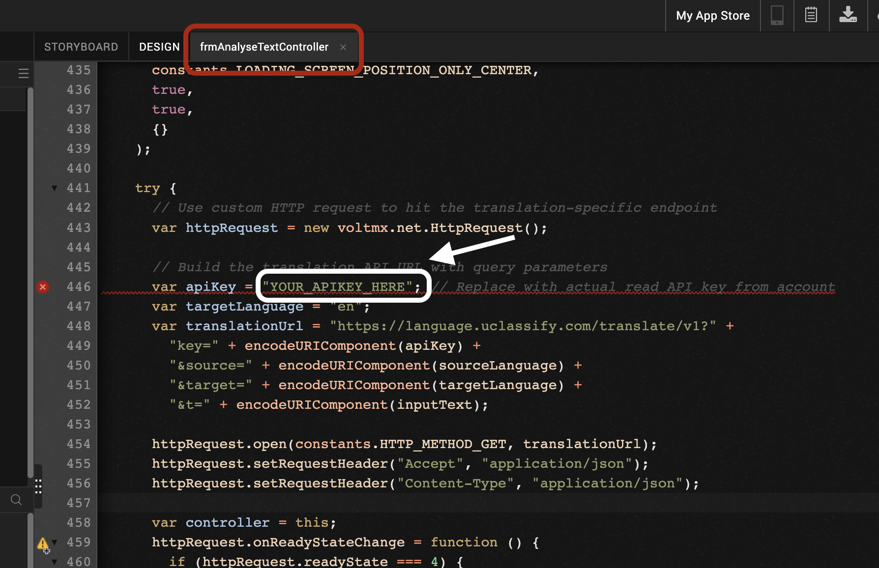

G. Foundry APP Setup
When you import the application to your Volt MX Iris project, the HCL Volt MX Foundry services of the uClassifyAIFeedbackAnalyser are added to the HCL Volt MX Foundry app, which is associated with the Volt MX Iris project. While importing the uClassifyAIFeedbackAnalyser Application to your Volt MX Iris project, if there is no HCL Volt MX Foundry app associated with the existing Volt MX Iris project, a new HCL Volt MX Foundry app is automatically added to your HCL Volt MX Foundry environment and is associated with your HCL Volt MX Iris.
To set the Foundry app, follow these steps:
- Click the HCL Volt MX Foundry app associated with your Volt MX Iris project from the Project Explorer. Click DATA & SERVICES.
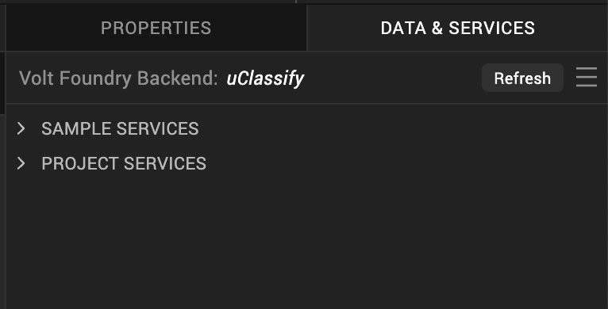

- Under the Configure Services tab, click Integration and you will see the uClassify integration service. Click on the Integration service to add the keys.
- Click on the uClassify integration service to expand the operations.
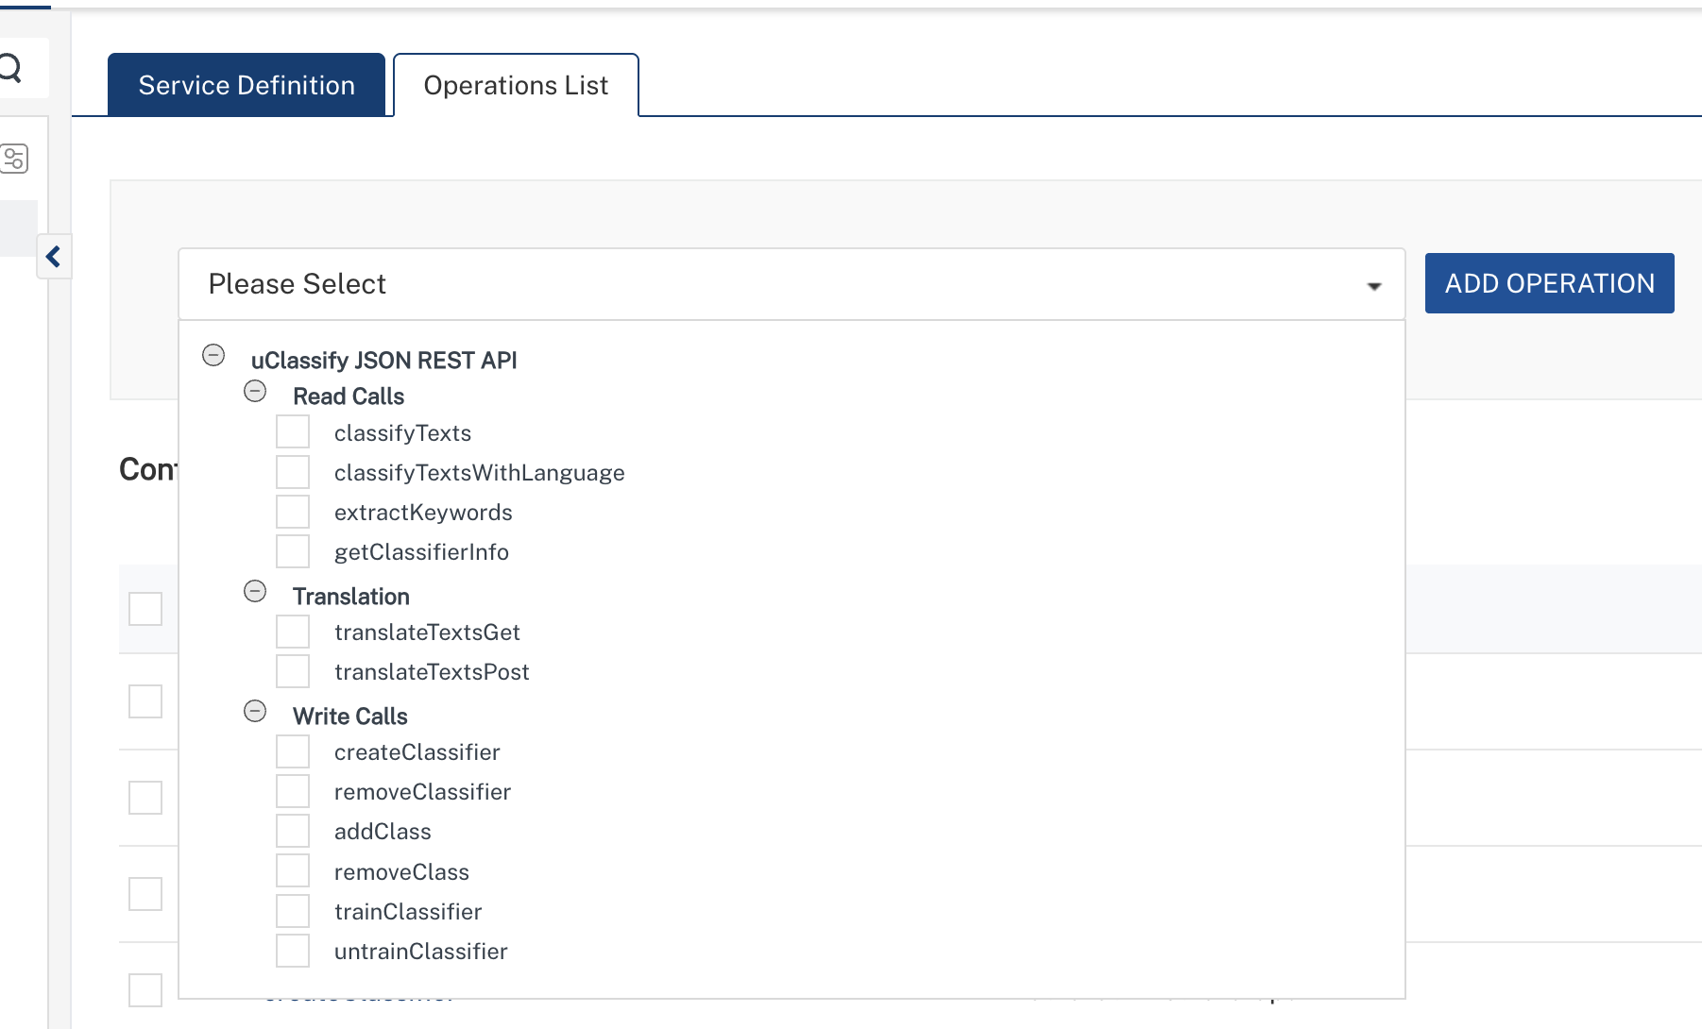
- Select classifyTexts operation, On the Request Input tab, in the Body section, specify the values in the respective boxes under the Test Value column.
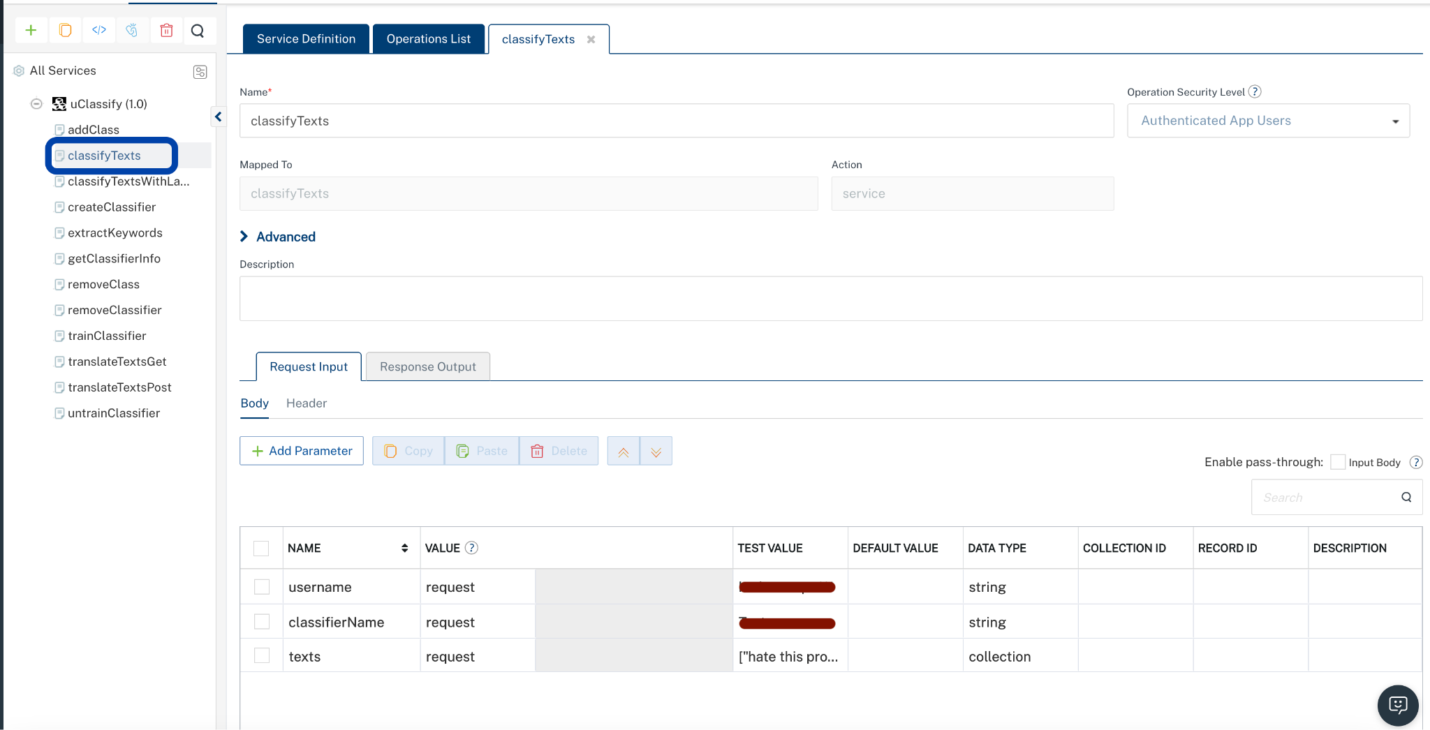

Parameter | Description | Syntax Example
texts | Enter text in a collection | "texts": ["hate this product"]
classifierName | Enter Classifier name | "classifierName":YOUR_CLASSIFIERNAME
username | We will get our username after creating an account | "username":PROVIDE_USERNAME

5. Click Header sub-tab. The Header section opens.
- For Authorization, In the box under the TEST VALUE and DEFAULT VALUE columns, type the API Key generated from uClassify | Key.
  - Authorization:<Token YOUR_READ_APIKEY_HERE>

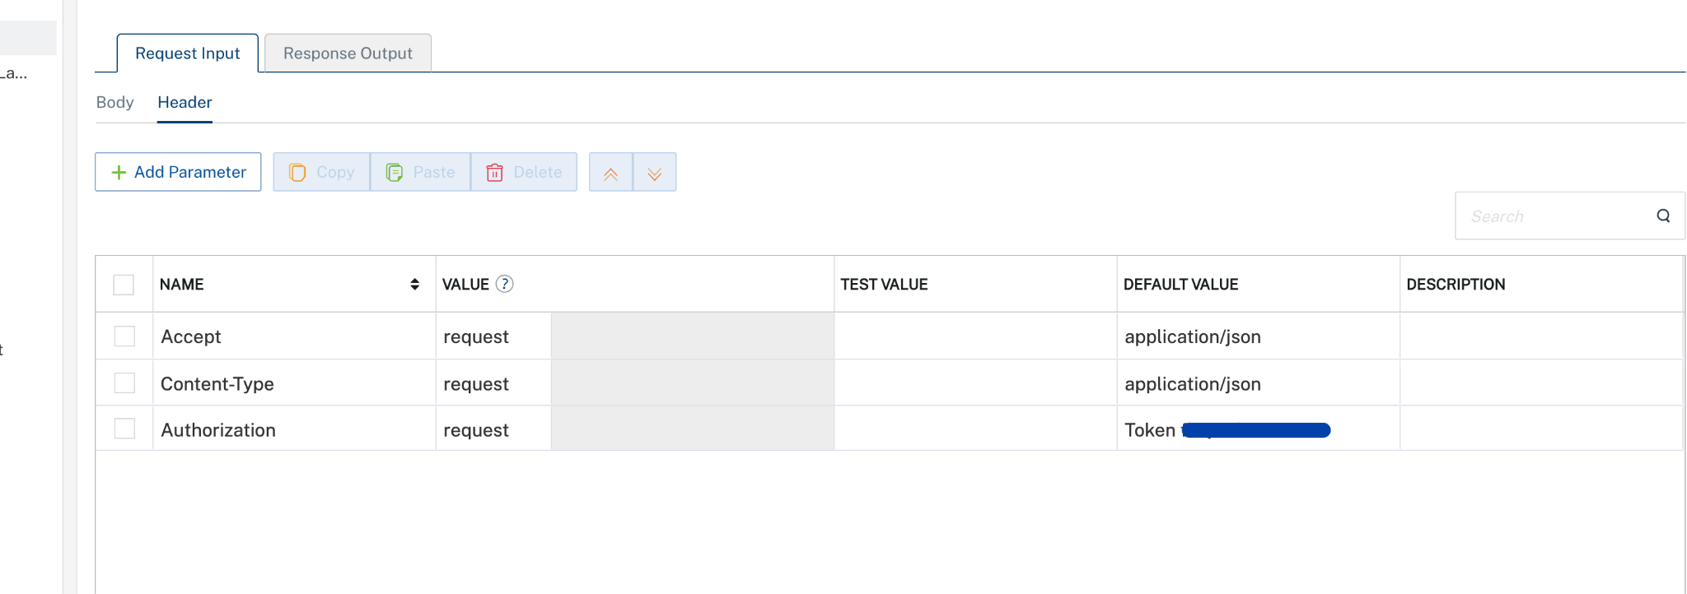

- Click SAVE AND FETCH RESPONSE. The Output Result dialog appears with the response. Otherwise, the Output Result shows an error.
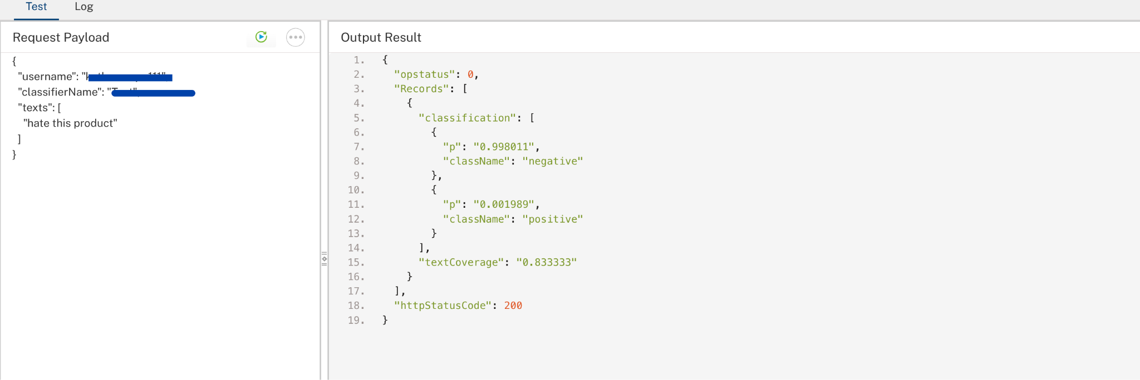
Note : For the uClassify TranslateTextGET and TranslateTextPOST endpoints, use uClassify Translation API as the endpoint URL while performing the Test Operation. This ensures that the translation requests are executed against the correct API endpoint.
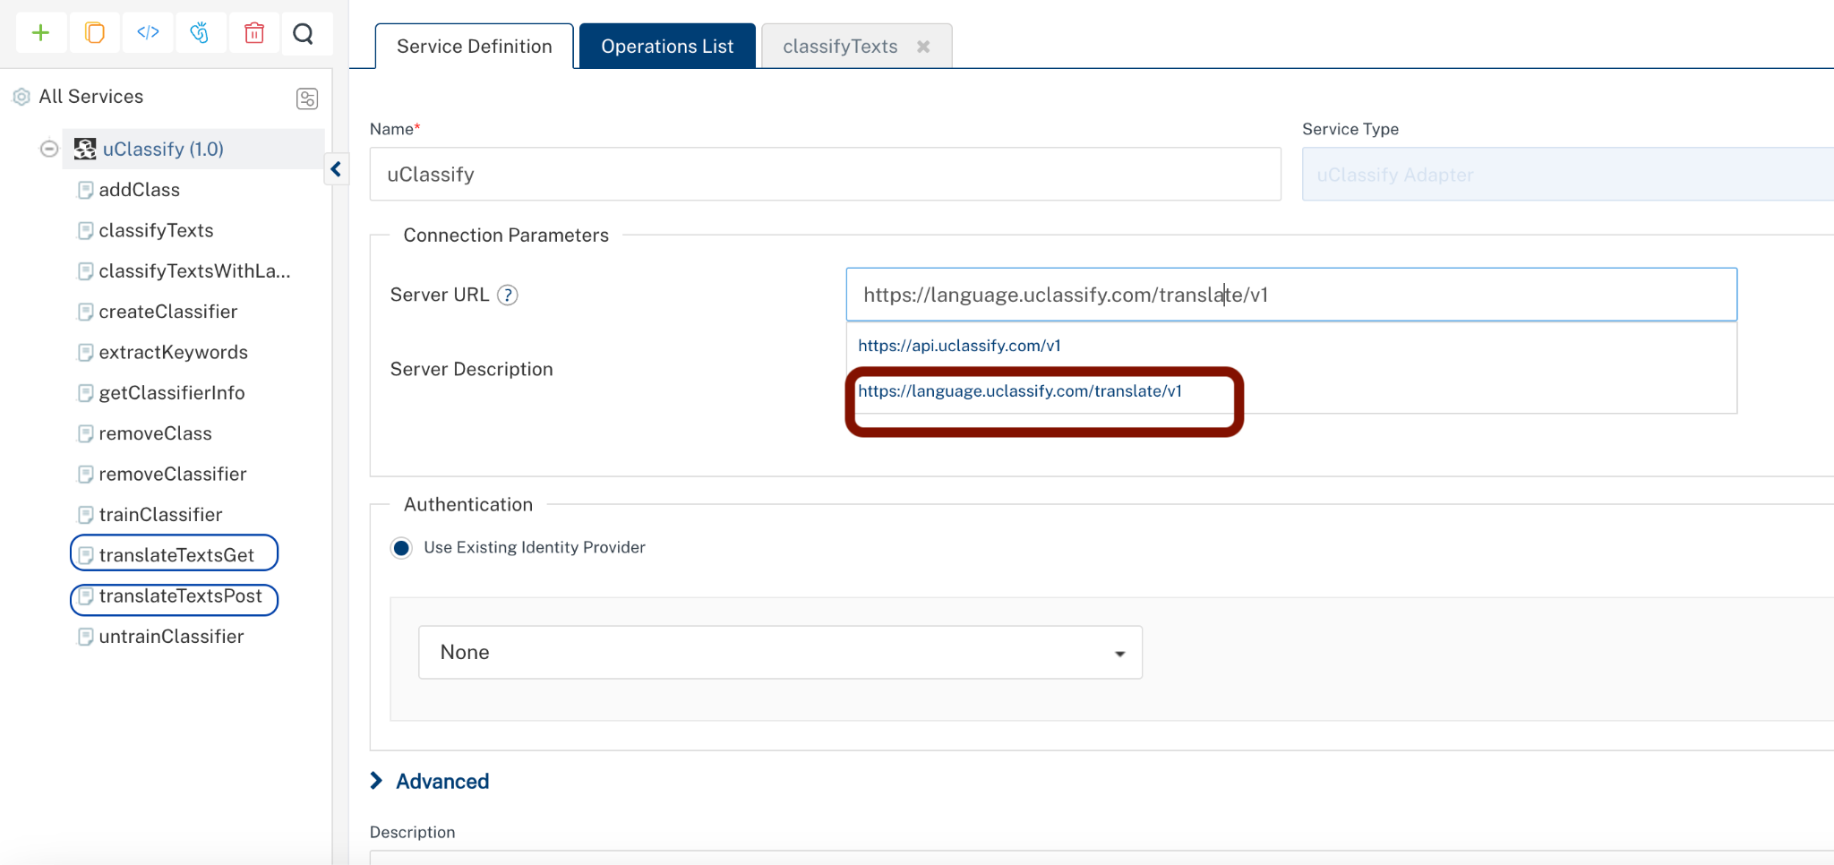

H. Building and previewing the app
After performing all the above steps, you can build your app and run it on your device. For more information, you can refer to the Building and Viewing an Application section of the Volt MX User Guide.

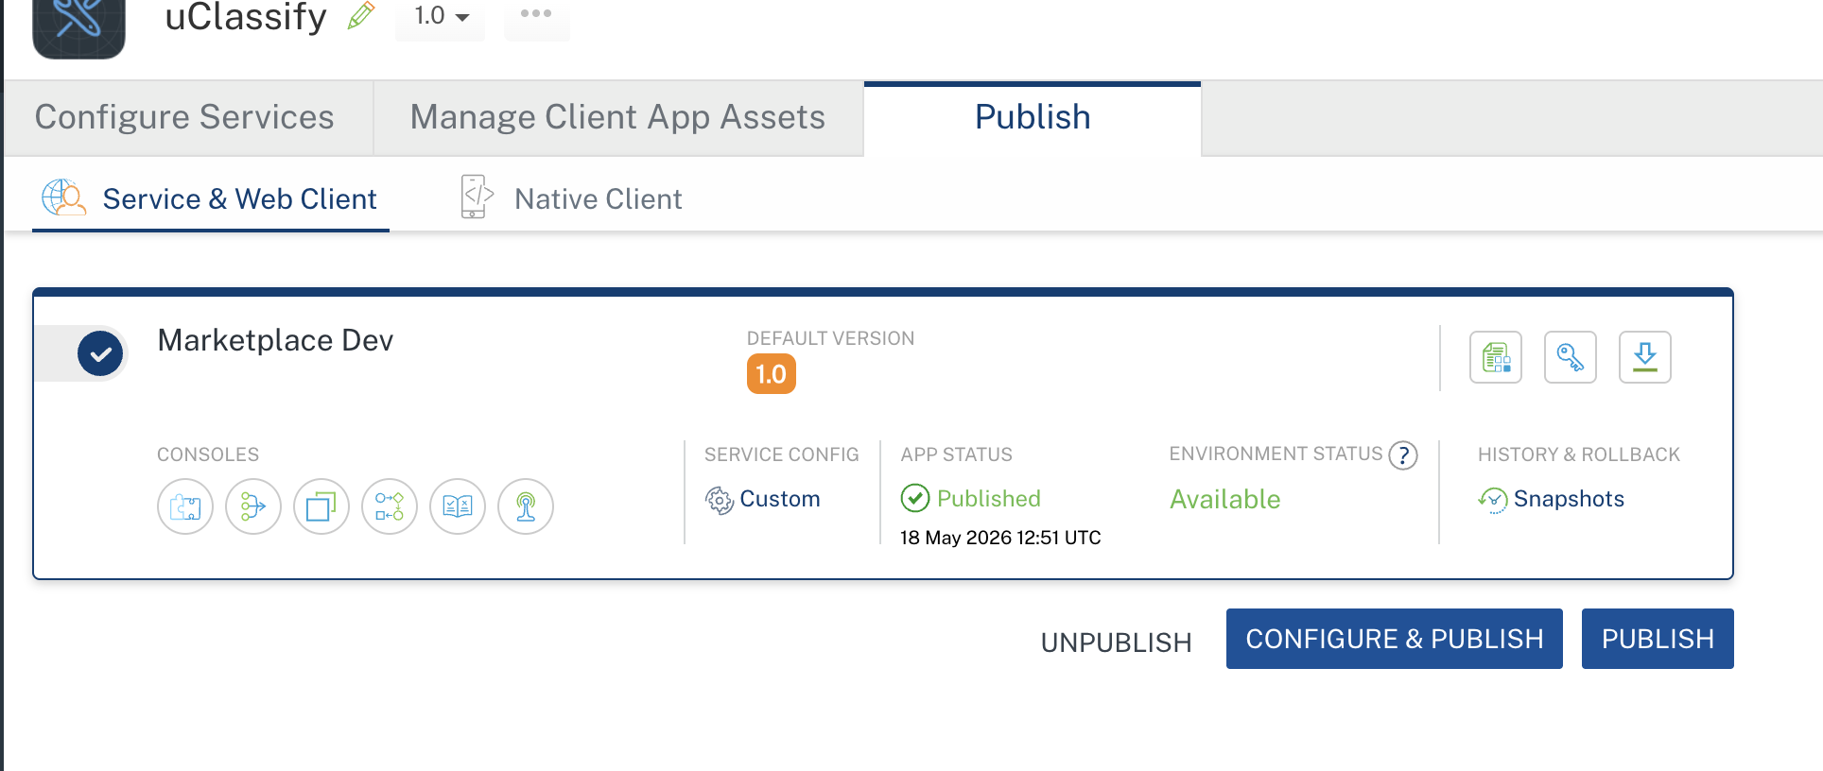

I. Reference API Documentation
- uClassify Main Site
- uClassify Web API Documentation
- uClassify API Differences / Overview
- uClassify Translation API Documentation
- uClassify Pricing & API Limits
- uClassify Technical Documentation

H.REVISION HISTORY
App version 1.0.0:

Limitations
- Dependency on uClassify API: The app relies on the uClassify platform for all text analysis, making it dependent on the availability and performance of their API.
- Limited Offline Functionality: The app requires an active internet connection to interact with the uClassify API, limiting its usability in offline scenarios.
- Classifier Constraints: The accuracy and scope of analysis are restricted to the classifiers provided by uClassify or custom-trained classifiers.
- Language Support: While the app supports multiple languages, the quality of analysis may vary depending on the language and the classifier's training data.
- Scalability: High-volume text analysis may face performance bottlenecks due to API rate limits or processing delays.
- We must properly train and configure the classifier to achieve accurate and reliable response results. Insufficient or incorrect training data may affect the quality and accuracy of predictions.

