Volt engagement demo app (1.0.0)

Asset Version: 1.0.0

Sample application that demonstrates the user engagement capabilities of VoltMX Mobile Foundry Messaging Services. You can send push, capture user profile data, define user segmentation rules, run campaigns, and trigger event messages and message history.

Requirements:

- Volt MX Iris
- Volt MX Foundry
Devices:
  - Mobile
  - Tablet

Platforms:
  - Android
  - IOS

Features:
- This engagement server demo application demonstrates the capabilities of the engagement server to connect to the engagement server, create subscriptions, and receive the push, from events and campaigns.
- Registering a user as an audience member.
- Subscribing to push messages.
- Sending adhoc Push notifications.
- Receiving campaign messages.
- Ability to trigger event and receive event notifications.

Overview :
Volt Engagement Demo App allows users to demonstrate the capabilities of the engagement server to connect to the engagement server, create subscriptions, and receive pushes from events and campaigns.
For information on how to import Volt Engagement Demo App to Volt MX Iris and run the app, visit the Getting Started page.

App Functionality :
The Volt Engagement Server app provides generic notification service that allows us to send and receive push notifications from events and campaigns to devices running on different platforms (eg, IOS, Android).

The Login Screen of this app provides the feature to Login or Continue Without Login. If you Login using Foundry Credentials you will be able to Trigger Adhoc Pushes and Events.

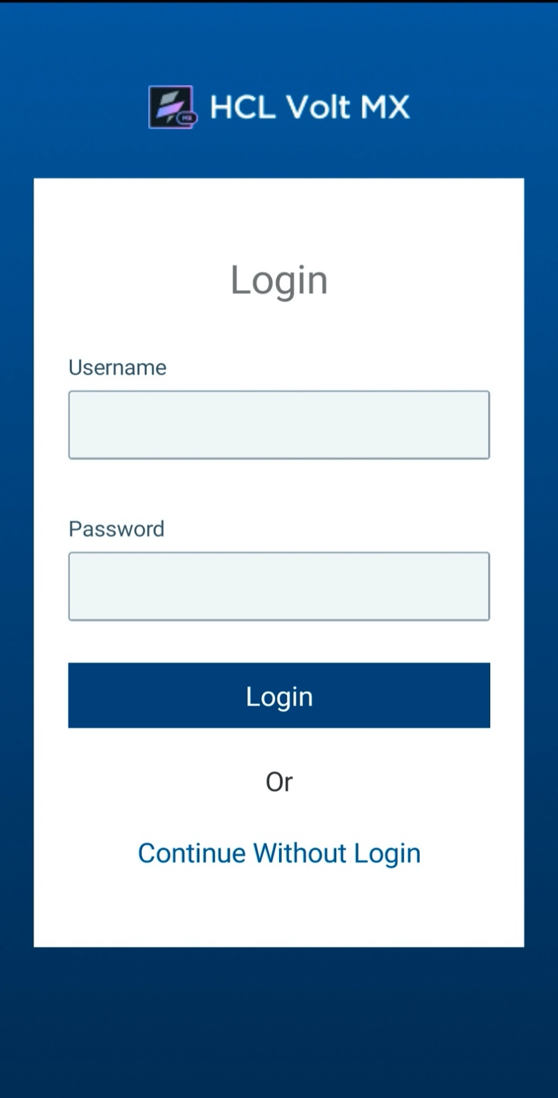
To send Push notifications to your device, the first step is to complete Registration and Subscription. After successful subscription it will navigate to the landing page. During registration Android devices will require the Sender Id field. This field may be updated as per the certificate used for testing.
Android IOS
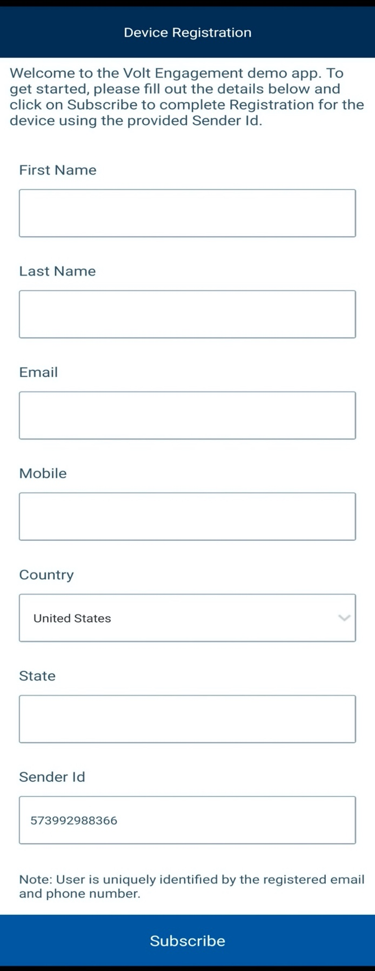
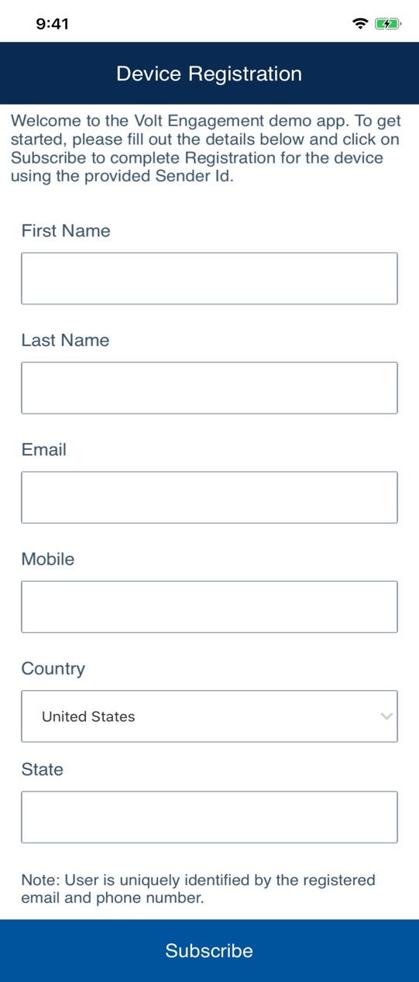
The landing page of Volt Engagement app shows various types of features such as Ad hoc Push, Trigger Event, Campaign Push, Push History.

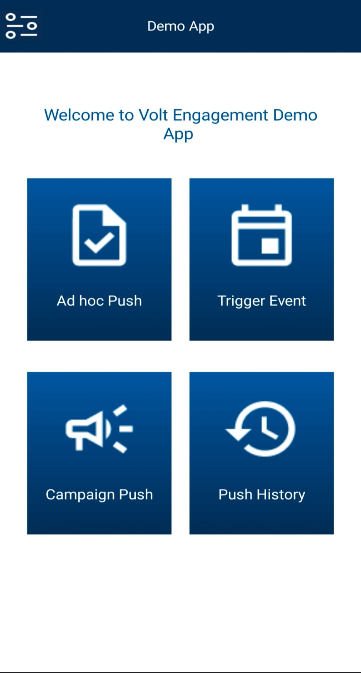

Ad hoc Push :
The Adhoc screen enables you to configure and send Push Messages manually. The Push Message feature allows you to configure and send push messages based on the preferences and personalization attributes for the targeted subscribers or segments. Push messages are sent only to subscribed apps that are active and installed on devices.
After clicking on Ad hoc push, it will navigate to Trigger Ad hoc Push screen.
Note: To access this feature user should login with their Foundry credentials.

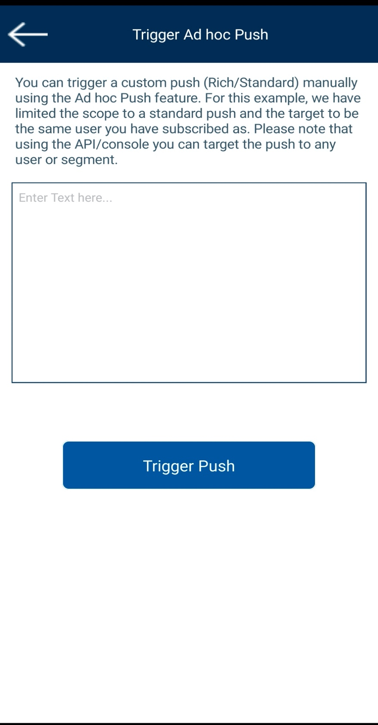

Events :
There are times when you want to trigger a specific message to be sent to one or more users based on some event occurring– this is what we call an Event Message.
An Event Message is nothing more than a pre-configured message that you can trigger remotely to deliver the message to the user.
For an example, we'll want to notify our employees every time their paycheck has been successfully deposited into their bank account.
After clicking on Trigger Event, it will navigate to Trigger Event screen.
Note: To access this feature user should login with their Foundry credentials.

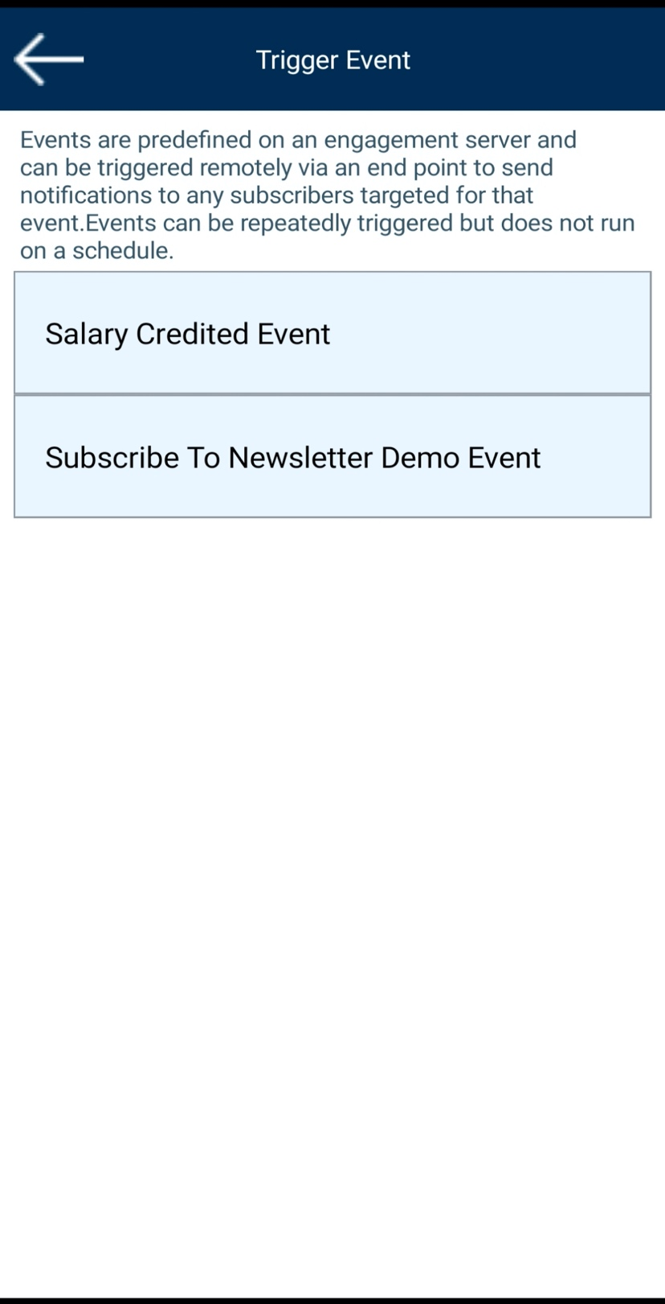
Campaigns :
A campaign pertains to specific activities designed to promote a service. For example, let us assume, any ecommerce app wants to run a campaign to send festive offers to their customers.
A campaign operates on segments. The segments include users who are subscribed to a particular application. For example, VoltMX Product Release campaign includes a segment named as VoltMX Product Segment. The VoltMX Product Segment includes users who are subscribed to the VoltMX app.
Based on your requirement, you can add one or more segments to a campaign. You can also define the start date, end date, frequency of notifications. The VoltMX Product campaign sends push notifications, email, SMS or passes to all users when the campaign starts and at the specified frequency thereafter. A campaign also periodically checks for new users and sends them messages.
After clicking on Campaign push, it will navigate to Trigger Campaign screen.

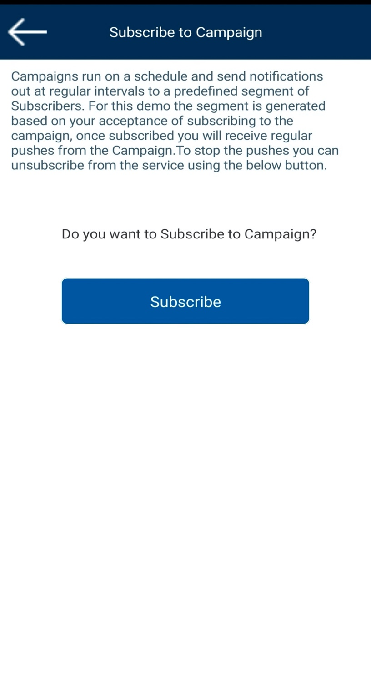
Push History :
It lists all push messages along with message status.
On clicking on each entry, a pop up with full message content will be displayed.

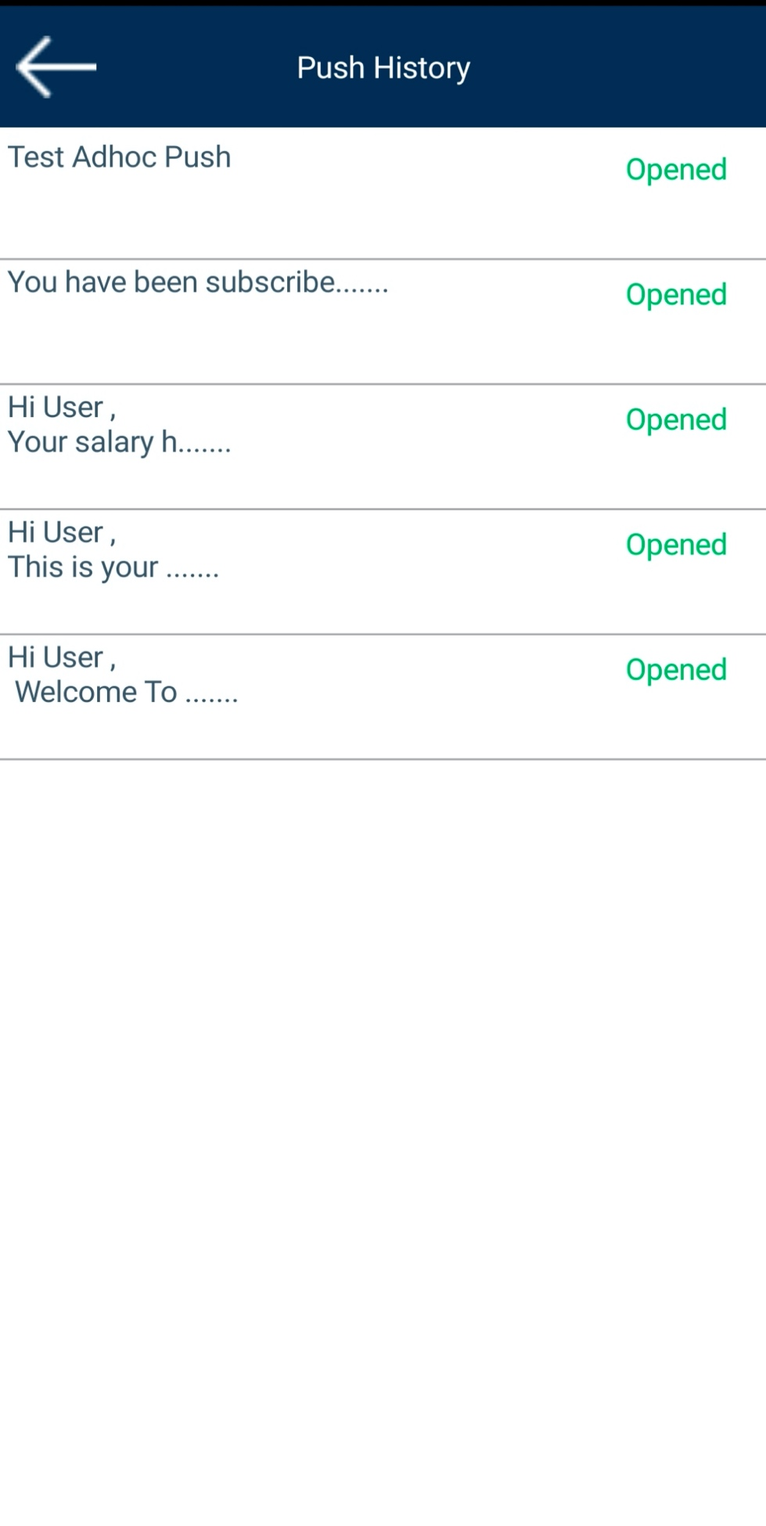

Reset App:
This screen allows the Subscribers to Unsubscribe their device.

Import the App
To import the Volt Engagement Demo App into your workspace, follow these steps:
- Open Volt MX Iris
- On the main menu select Forge → Browse.
- Search for the Volt Engagement Demo App, and then click Import to Workspace. The app is imported to your workspace.
A dialog box appears, confirming that the app has been imported. Click OK.
- Switch to your project containing the Volt Engagement Demo App. To switch to your project, click File → Open → Reference Architecture → <project name>

Live Preview
After importing the Volt Engagement Demo App, you can preview the app on any channel by using Live Preview.
Note: To preview the app on your mobile or tablet device, ensure that you install the latest version of the Volt MX Iris App Viewer app on your mobile or tablet device from the App Store or from Google Play.
To preview the app by using Live Preview, follow these steps:
- In Volt MX Iris, click Build → Live Preview Settings from the main menu. The Live Preview Settings window opens.
- Select any application channel such as Mobile Native, Tablet Native, or Responsive Web along with the respective platform(s) on which you want to preview the app. Click Save & Run.
After a successful preview build for Mobile and Tablet channels, a window appears containing a QR code. You can scan this QR code from the Volt MX Iris App Viewer application on your mobile or tablet device to preview the app.
For more information on Volt MX Iris App Viewer, you can refer the Volt MX Iris App Viewer Documentation.

Engagement Server Configurations :
To enable push notifications, you need to add a new application into Voltmx Foundry Engagement services and publish the application. Only published applications can be used to send push notifications to customers.
To add an application, follow these steps:
- Log in to the Voltmx Foundry console. From the Apps menu select Add New.
- From the Configure Services tab, go to Engagement

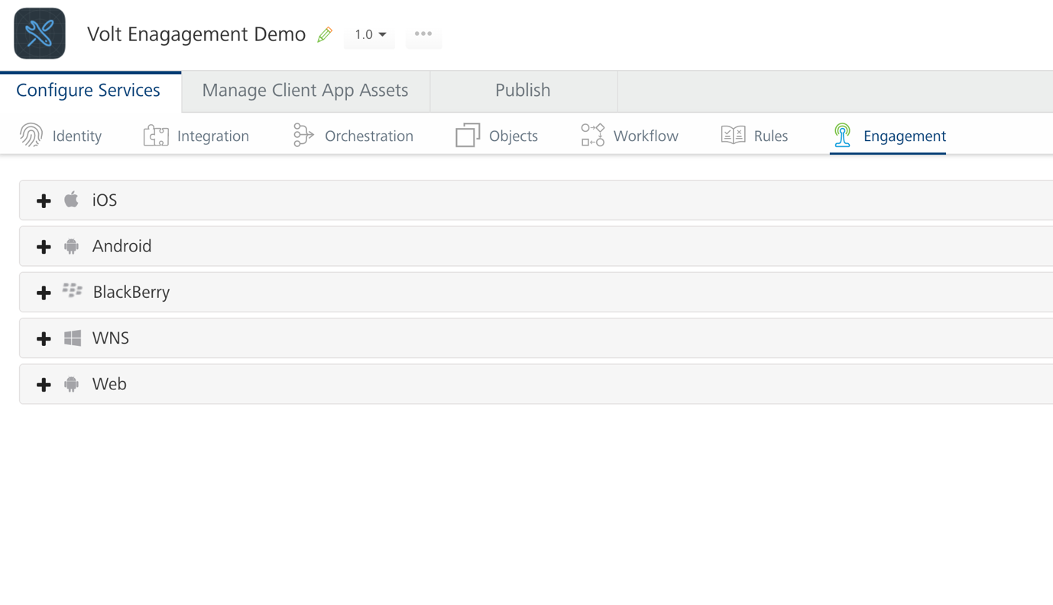

- To configure the new app for the Android platform, follow these steps:
  - From the Configure Services tab, go to Engagement. Expand Android.
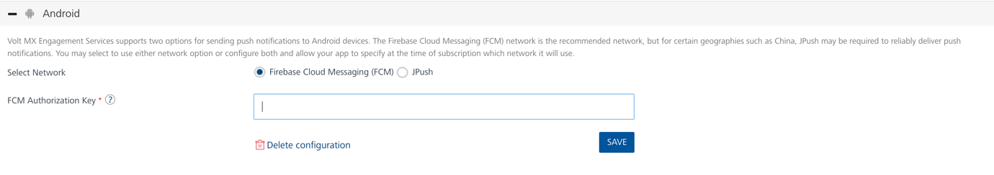
  - FCM Authorization Key: Enter the FCM Authorization Key.
  - Click Save.

- To configure the new app for the IOS platform, follow these steps:
  - From the Configure Services tab, go to Engagement. Expand IOS.
  - Select the Application mode and upload the Push Certificate for iPhone and iPad
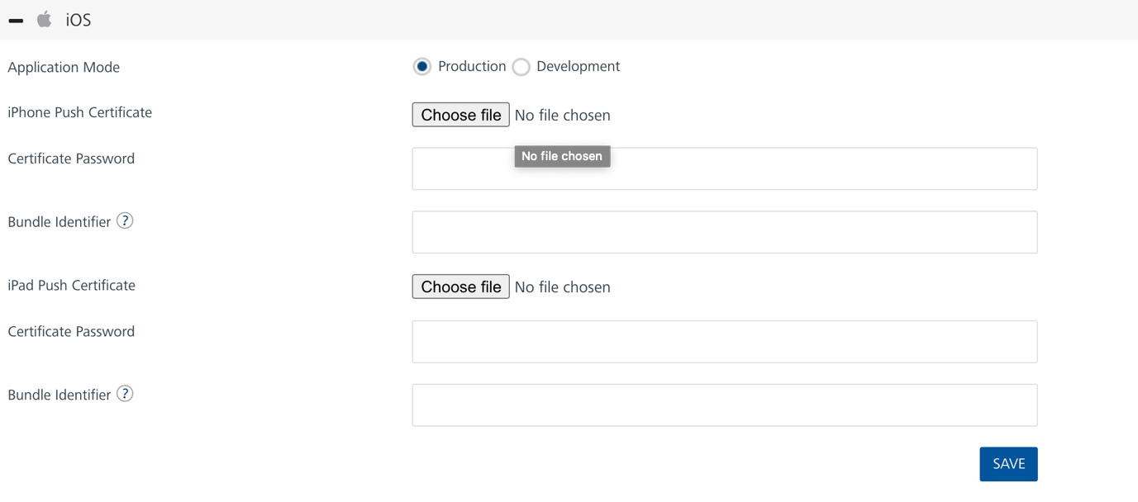

  - Click Save.
- Publish the application. Only published applications can be used to send push notifications to customers. After that the application is added into the Engagement console.
- Adding Segments: Based on a user's attributes, you can create new segments.
To add Segments, follow these steps:
- On the Segments page, click the Add Segment button.
The Add Segment page appears. The Add Segment page includes two sections: Segment Information and Define Conditions.
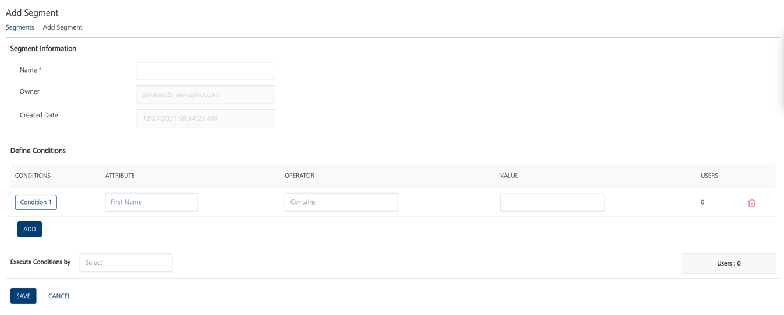

Segment Information
- In the Segment Information section, do the following:
- Name (mandatory): Enter a name for the segment that you want to define. Your segment name should include alphanumeric characters only. The Name is a mandatory field.
- Owner: The field is populated automatically with the segment owner's name.
- Created Date: The field is populated automatically with the server's current date and time.
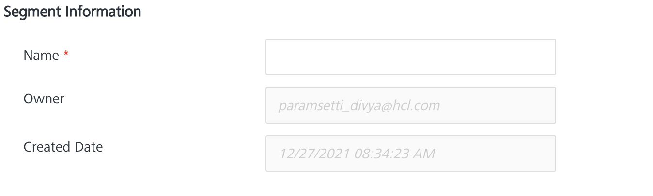

Define Conditions
In the Define Conditions section, do the following:
- The Define Conditions list view contains the following fields:
- Conditions: Click Add to add a new condition row
- Attributes: Under the Attributes column, select the attribute from the drop-down list. You can select any user attributes or platforms as required.

- Execute Conditions by: Select the required condition from the drop-down list to define the segment definition.
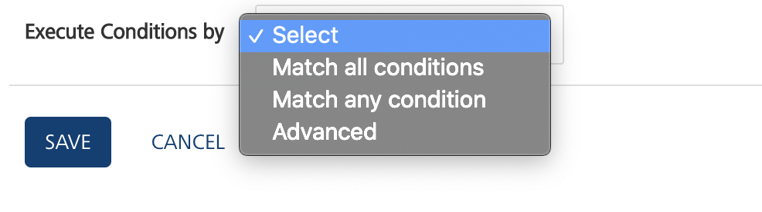

- Select the execute condition as Match all conditions or Match any condition. Based on the fulfilled condition, the system inserts the number of users that qualify for the segment under the Users column.

- Click the Save button. The system adds the new segment into the segments list view with a confirmation message that the segment is saved successfully.

- Adding Campaign: You can add a campaign to promote a service. You can also save a campaign to send it in the future or execute the campaign immediately after filling details.
To add a campaign, follow these steps:
- In the Campaigns screen, click the Add Campaign button. The Add Campaign screen appears. The Add Campaign screen includes following tabs:
Campaign Information
Select Users
Define Message
- Campaign Information By default, the Campaign Information tab is set to active.
- Enter following details in the Campaign Information section.

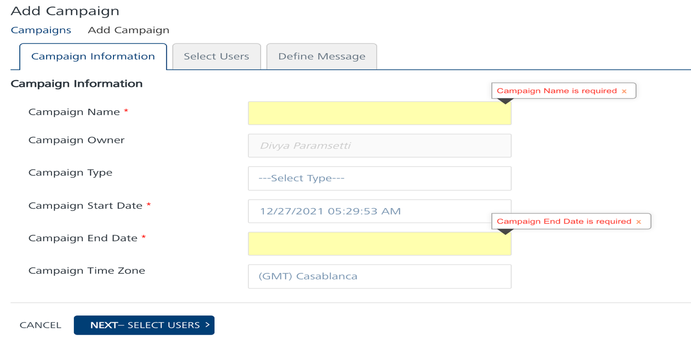

  - Campaign Name: Enter a campaign name of no more than 255 characters. This is a mandatory field.
  - Campaign Owner: This field displays the name of the person who creates the campaign. You cannot change the owner details.
  - Campaign Type: Select the appropriate campaign type from the drop-down list.
  - Campaign Start Date: This field is auto-populated with the current date and the current time, when a campaign is created. Based on when the campaign execution must start, you can modify the start date of the campaign.
  - Campaign End Date: To select the campaign end date, click in the text field.
The system displays the standard calendar. This is a mandatory field.
Select the date you want to end the campaign and click Done. The system inserts the date in the Campaign End Date field.
  - You cannot select a Campaign End Date prior to the Campaign Start Date.

- Click Next - Select Users to navigate to the Select Users screen
Note: You cannot move to the Select Users screen without providing the Campaign Name and Campaign End Date. The following error will be displayed on the screen.

Select Users
The Select Users page displays the Select Users list-view with two columns: Segments(s) and Segment Users with default number of segment users. The list-view includes the Delete option to delete segments from the list-view. There is a drop-down list below Segment(s) column to select an already created segment or create a new segment
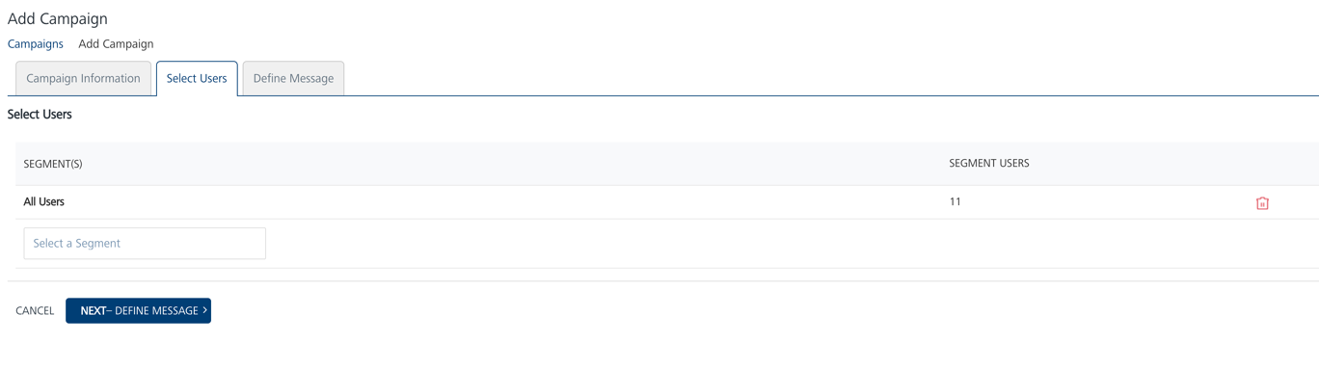

- Select the following details in the Select Users screen:
- Select a Segment: Provide the segment definition that suits your campaign. You can add a new segment or select a published segment from the drop-down list. The Engagement services does not allow you to pre-defined segment a campaign without a segment.
- The selected segment appears in the SEGMENT(S) list view with the total number of associated users.

- Click Next - Define Message to navigate to the Define Message screen.
Define Message
You can create a multi-channel campaign to send to users. To send a campaign message, you can choose from one or more of the four notification types. For the notification to be delivered the corresponding notification type should be configured on the engagement server. This demo is pre-configured with push notifications only.

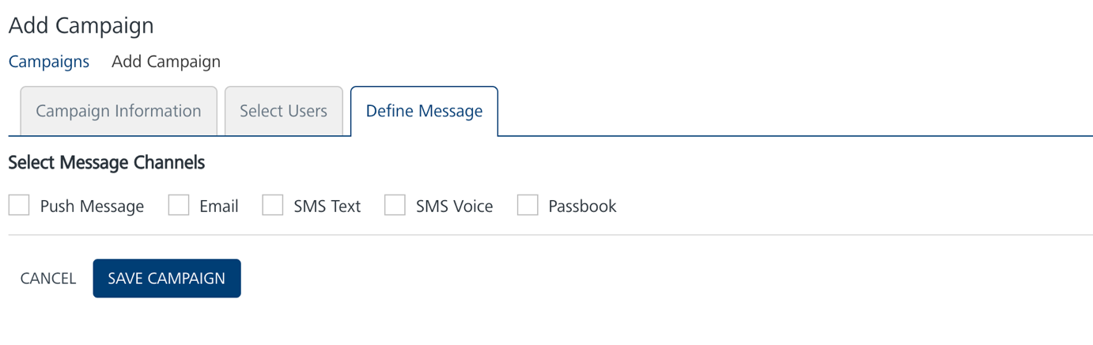
- To add the message for a campaign:
Select Message Channels: Select the type of notification and click the Compose Message button to compose a new push message for a campaign.
- Click Save Campaign to save the campaign. The saved campaign appears in the Campaigns list view with the confirmation message that campaign is saved successfully.
- Adding Event- To add an event, follow these steps:
- On the Events home page, click the Add Event button. The Add Event page appears. The Add Event page includes two tabs: Event Information and Define Message. By default, the Event Information tab is set to Active.
  - Event Information
  - Define Message
  - API Payload

Event Information
- In the Details section, enter details for the following fields:

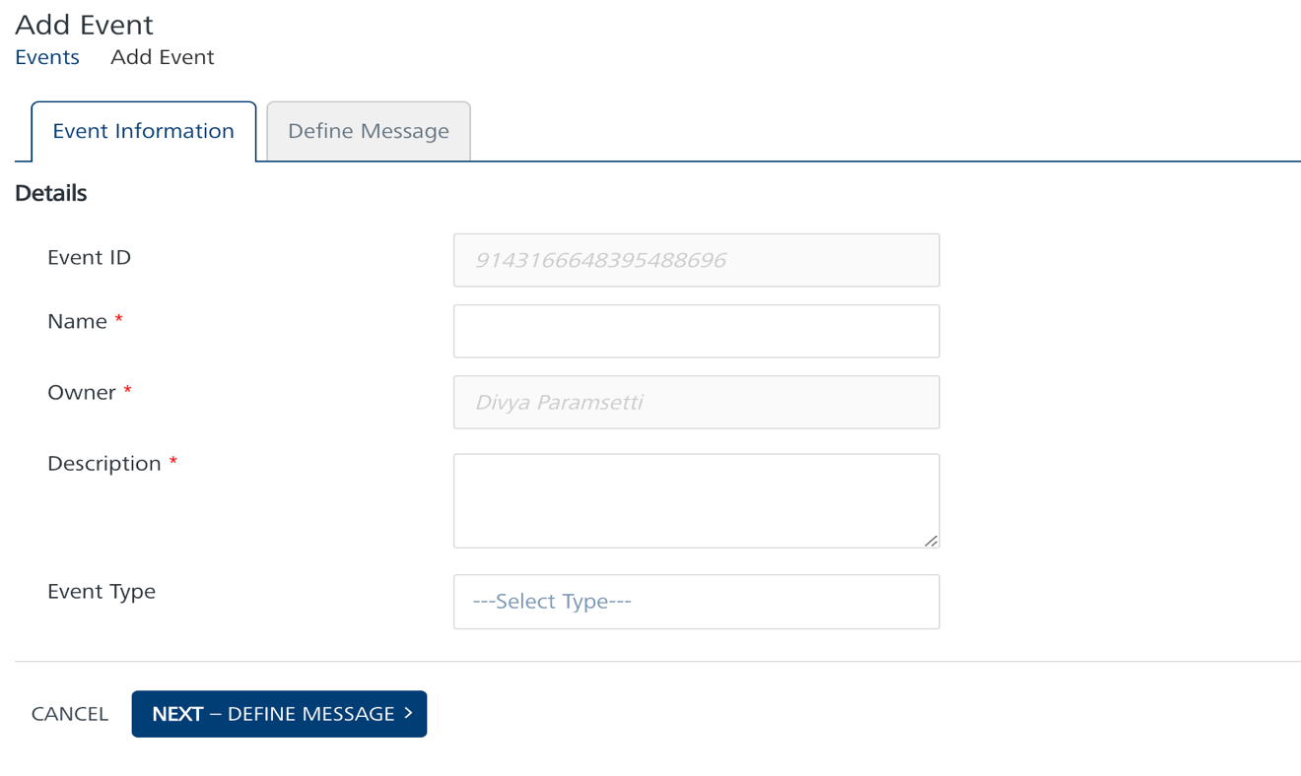
- Event ID: The field displays the system-generated event identification number. You cannot modify an event ID.
- Name: Enter a name of the event. The event name can be a maximum of 50 characters.
- Owner: The field displays the name of an event creator. You cannot change the owner details.
- Description: Enter the event description. You can enter only alphanumeric characters. If the description exceeds the existing message box area, a scroll bar appears.
- Event Type: Select the event type from the Event Type drop-down list.
- Click Next-Define Message to continue.
Define Message:
- In the Select Message Channels section, based on your requirement, select a channel to compose an event message. You need to select at least one channel: push, email, SMS, or pass to send event notifications
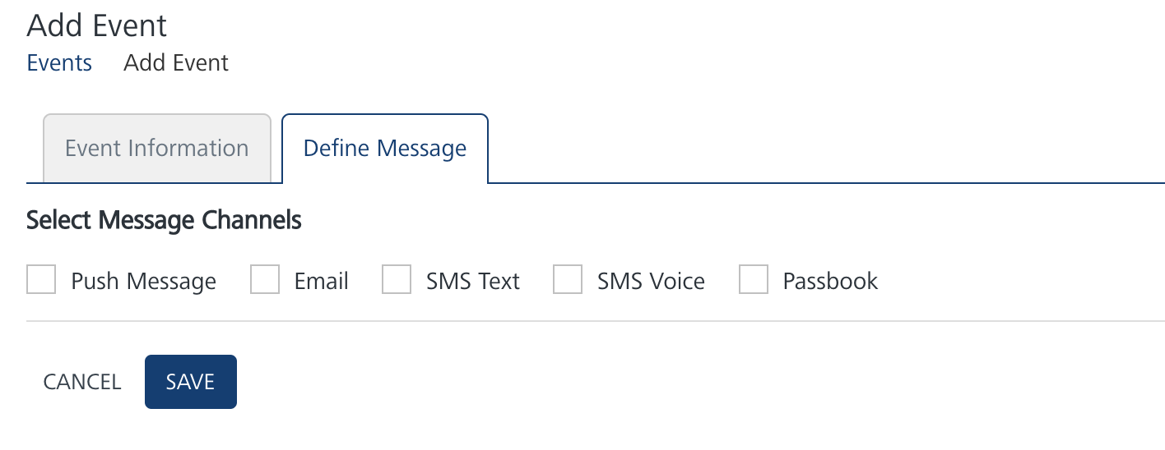
- After composing an event message, Click Save to save the composed message. The saved push message appears in the push message list-view under the Define Message tab on the Add Event home page
- Save the Event.

Volt Engagement Demo App Foundry Services:
The Engagement demo app contains an Integration Service :
- msgHistory: This service is used to fetch the push messages that were sent to device.
Operations :
  - fetchPushMessages - Used to fetch all the push messages details along with their status. To retrieve details of all the push messages, you need to pass ksid as input parameter in the request payload.
The URL for Fetch All Messages from Volt Foundry Engagement Services API is:
https://<host or ip>:<port>/api/v1/messages/fetch
  - getPushMessageFullContent - Used to fetch message content from Voltmx Foundry Engagement server. To retrieve content of the push messages you need to pass pushId as input parameter in the request payload. The push ID can be obtained from the push received on the device.
The HTTP URL for Fetch Message Content from Volt Foundry Engagement Services API is:
https://<host or ip>:<port>/api/v1/messages/content/<PushID>
  - getPushPayload – Used to get the sent push message details.
The HTTP URL for Fetch Push Sent Payload API is:
https://<hostname/ip>:<port>/api/v1/messages/payload/<PushID>
  - getRichPushMessageContent - Used to fetch rich push message content from Voltmx Foundry Engagement server. To retrieve content of the push messages you need to pass pushId as input parameter in the request payload. The push ID can be obtained from the push received on the device.
The HTTP URL for Get Rich Content API is:
https://<host>:<port>/api/v1/messages/rich/<pushId>

- MessagingService
Operations :
- createUpdateUser – Used to create a new user and adds that user to the list. This operation also updates parameter details of a user.
The HTTP URL for Subscribe Users (Create or Update) API is:
https://<<host>>:<<port>>/api/v1/subscribeaudience/

- getAllEvents – Used to get the all event details.
The HTTP URL for Get All Event Details API is:
https://<host>:<port>/api/v1/events?start=0

- triggerAdhocPush – Used to send push messages to the subscribed app users.
The URL for Push Message API is:
https://<hostname/IP>:<port>/api/v1/messages/push

- triggerEvent – Used to send push messages to the subscribed app users.
The URL for Event Push Message API is:
https://<host>:<port>/api/v1/events/push
For more information on REST APIs for Volt MX Foundry Messaging system, visit the Rest APIs Page.

Known Issues :
- In IOS devices when you select "Don't allow" from Notification permissions pop up it will behave unexpectedly.
- In IOS devices if the image is embedded in rich push content it might not display correctly in push history.

