Date : 01-Mar-24

worldtime (1.0.0)

Overview
- The World Time API provides the current date and time for any city, latitude/longitude coordinates or timezone in the world.

Getting Started

Prerequisites

Before you start using the Air Quality API data adapter, ensure you have the following:

- HCL Foundry
- Volt MX Iris
- An account with Api Ninjas and API Key

Platforms Supported

Mobile

iOS

Android

Tablets

PWA

Importing the adapter
To import the Data Adapter to Volt Foundry, do the following:
- Sign in to the HCL Foundry.
- From the left navigation menu, select API Management.
- In API Management, select Custom Data Adapters.
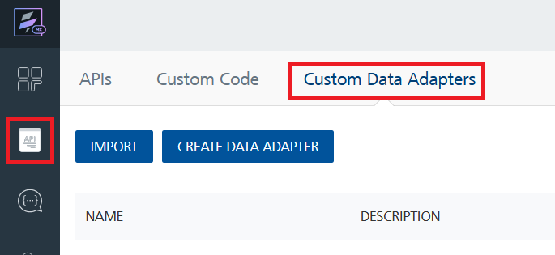
- Click IMPORT to import a custom data adapter.
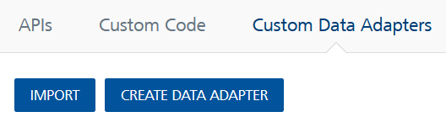
- On the Import Data Adapter dialog box, click browse to import.
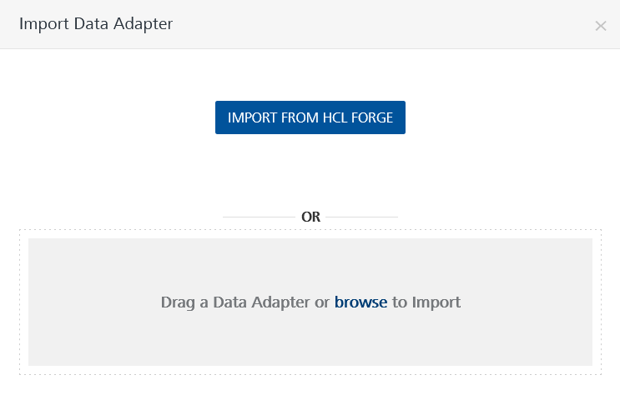
- Select data adapter zip file and click IMPORT.
After importing the Air Quality API data adapter, Volt Foundry opens a window that shows the metadata of the data adapter.

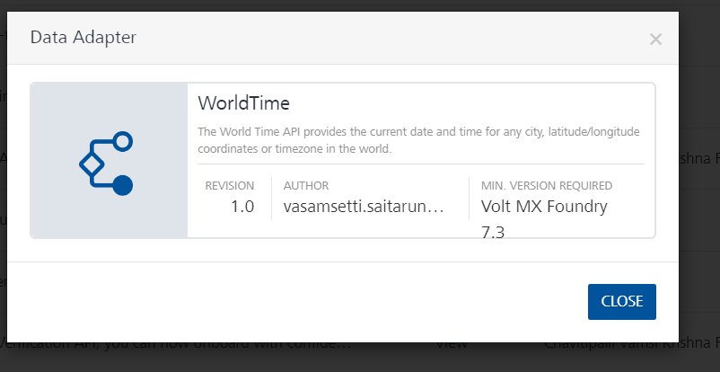
After you import the data adapter, you can view it on the Custom Data Adapters page and use it to create services on VoltMX Foundry.

Creating an Integration service
Follow the given steps to create an Integration service using the Air Quality API Data Adapter.
- Sign in to the HCL Foundry.
- From the left navigation menu, select API Management.
- In API Management, select Integration.
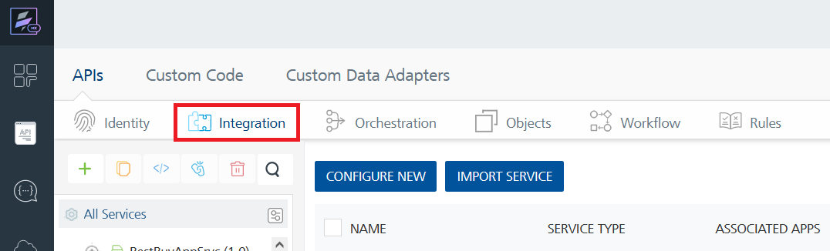
- To create a new service, click the + button or the CONFIGURE NEW button.
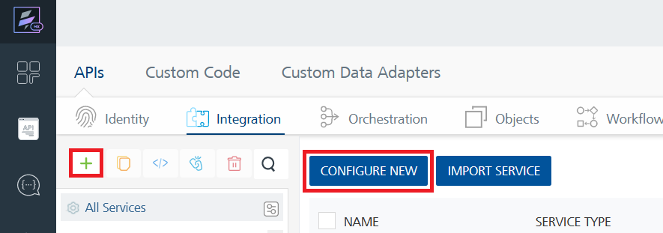
- On the Service Definition tab, select the service type as Swift Code API , and click SAVE.
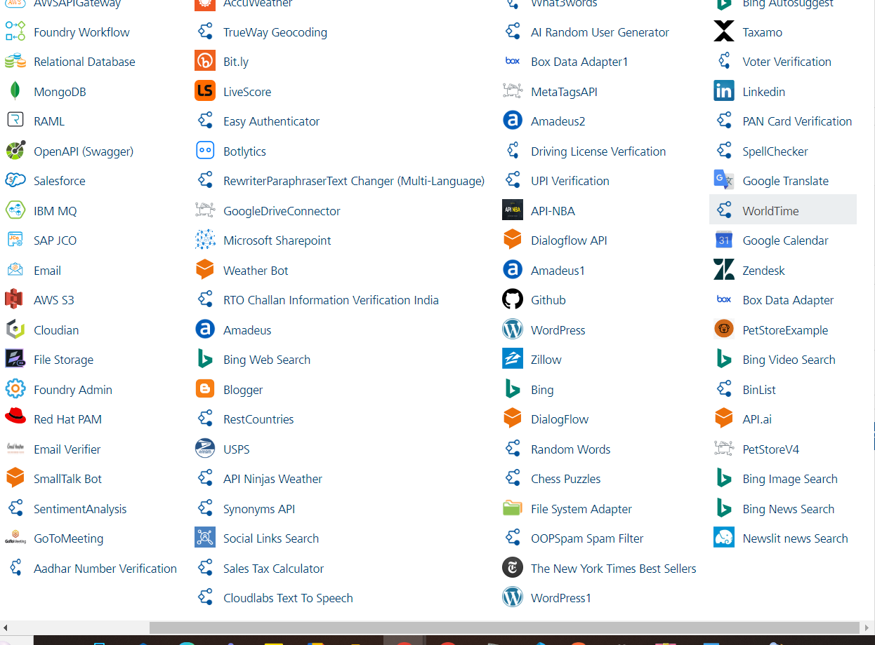

Creating and Executing operations
After you create an integration service, you can create and execute operations using the service.

Creating an operation
- In the API Management/Foundry app you created, in the Integration section, select the service that you created.
- After you select the service, navigate to the Operation List tab.
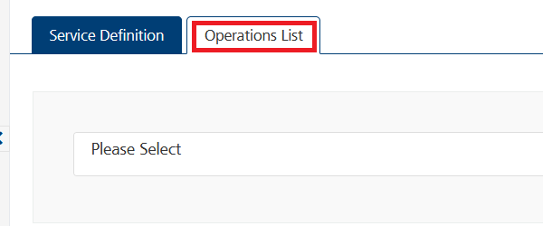
- From the drop-down list, select an operation that you want to execute, and click ADD OPERATION.
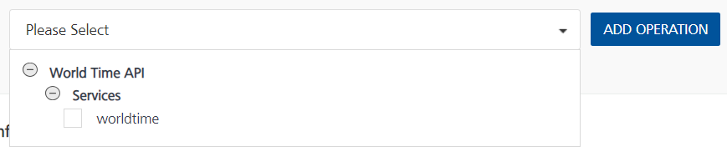

Executing an Operation
- From the Operations List tab, in the Configured Operations section, select the operation you want to execute and click on ADD OPERATION button.
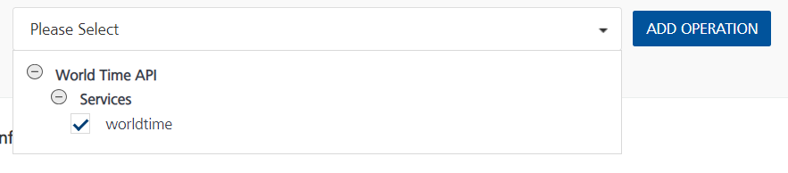
- On the Operation Page, in the Request Input tab, enter a TEST VALUE for all the fields.
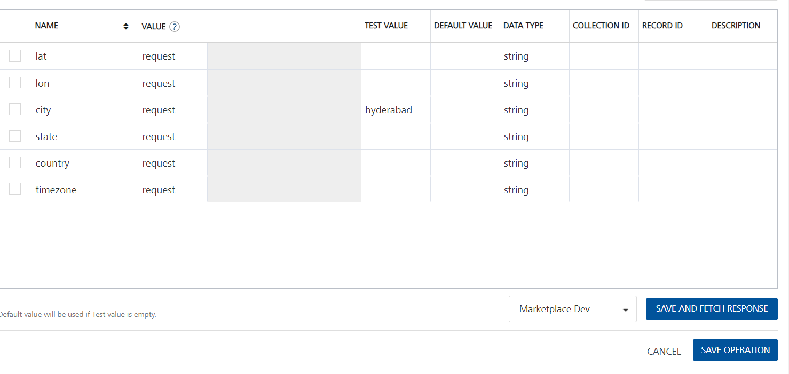
Request Header:
Authorization: X-API-Key [in header]: API Key associated with your Api-ninjas account, required for authentication. To get keys – Login in to API Ninjas Account -> You can view your keys.
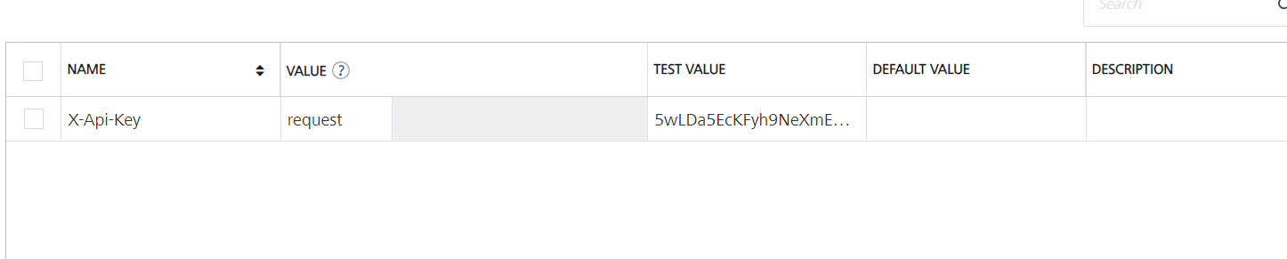
- Select a run-time environment and click Save and Fetch Response to get a response based on your inputs.
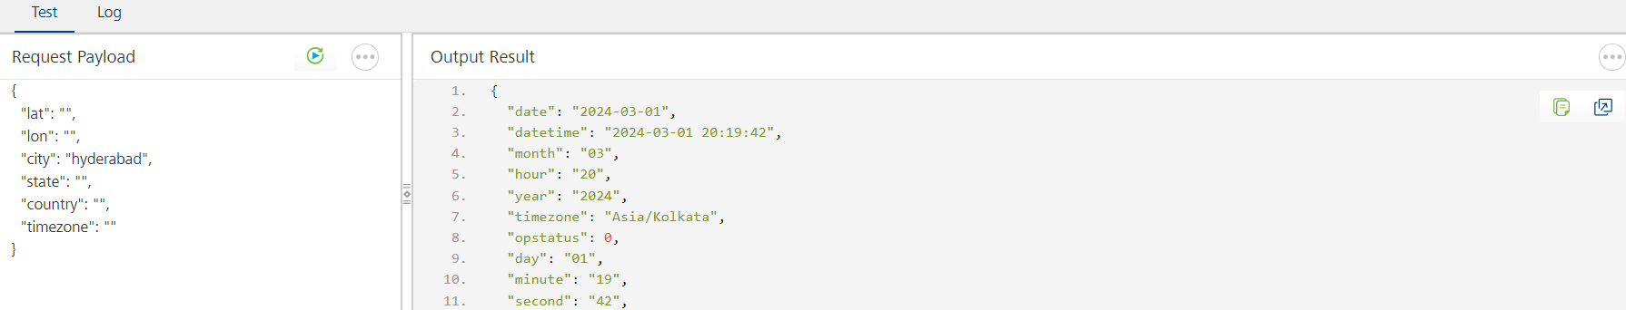

Publishing your application
If you want to use the services in client applications, you need to publish an app to a run-time environment. You can create the service (as described above) in an application or import the service into an application and publish the application.

References
Base url : https://api.api-ninjas.com

Endpoint Documentation
Endpoints | Input params-Type | Description
/v1/airquality | PARAMETERS:  - lat (required)  - lon(required)  (Or)  - city(required)  - state (optional)  - country (optional)  (Or)  - timezone  HEADERS:  X-Api-Key (required) | Get the current date and time by city/state/country, location coordinates (latitude/longitude), or timezone

Refer the link for more information about API endpoints.

Revision History
Adapter version 1.0.0

